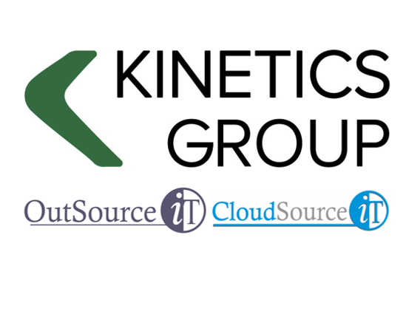


PROPOSAL
What client problem does this
proposal solve?

prepared for
INSERT COMPANY NAME

prepared by
Jassen Elliott

DATE: 4/02/2026

Contents

1. Executive Summary 3
2. Our Understanding of Your Needs 7
3. Kinetics KARE Benefits 8
4. Cybersecurity Framework Alignment 10
5. Plan Comparisons 12
6. Pricing 14
7. Appendix 17

Document History

Date | Details | Author
Insert Date

Terms and Conditions
Kinetics Terms and Conditions are listed on our website; www.kinetics.co.nz
In the event of any inconsistency between the Kinetic Terms and Conditions as listed on the website and the terms included in this proposal, the terms included in this proposal shall take precedence

Executive Summary
Select the Type of Client

Select the Contract
The next step is for us to go through these options with you and your team.

Our Understanding of Your Needs
Based on our discussions and the information shared, we understand that your organisation is seeking to enhance its IT environment with a focus on simplicity, reliability, and strategic alignment with existing Microsoft 365 investments. The following key themes have emerged:

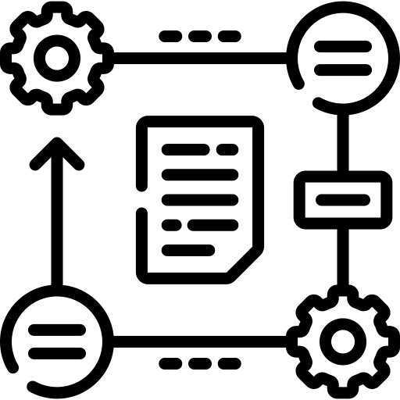 | Strategic Priorities  - Streamline IT operations to reduce complexity and improve user experience.  - Strengthen cybersecurity posture with modern, scalable solutions.  - Align IT services with business goals and compliance requirements.
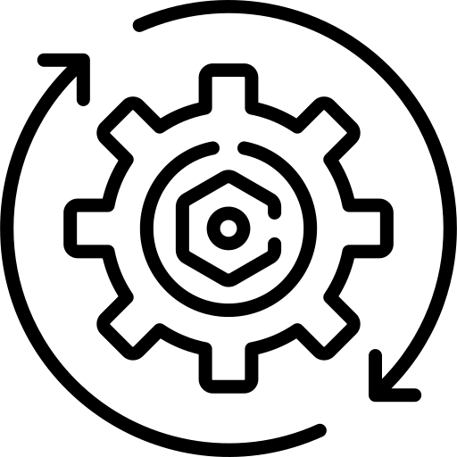 | Operational Requirements  - Ensure reliable patching, endpoint protection, and email security.  - Maintain high availability and performance across all locations.  - Provide responsive support, both remote and on-site, as needed.
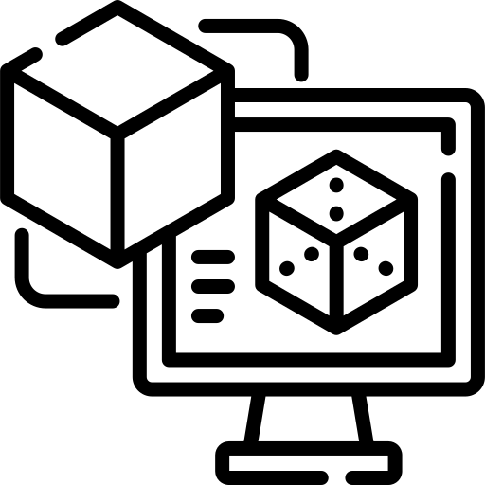 | Platform Alignment  - Maximise the value of Microsoft 365 Business Premium.  - Leverage built-in tools like Intune, Defender, and SharePoint.  - Remain open to third-party tools where they offer clear value.
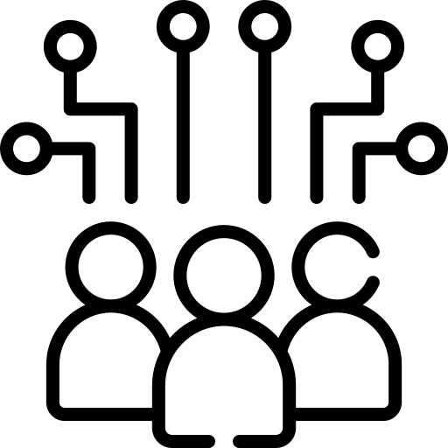 | Support & Visibility  - Access to expert engineering support and proactive helpdesk services.  - Transparent reporting, regular reviews, and clear escalation paths.  - Tools and processes that support continuous improvement.
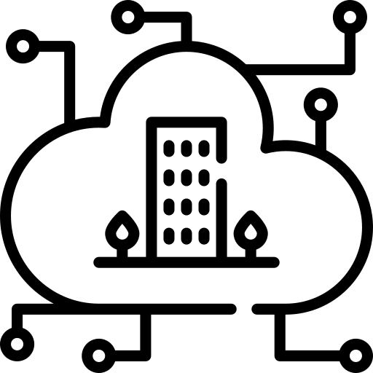 | Future Readiness  - Support for evolving needs example ISP transitions, infrastructure upgrades, and cloud optimisation.  - Guidance on emerging Microsoft 365 features and Copilot integration.  - Flexibility to scale services and adapt to business growth.

Kinetics KARE Benefits
Reliable and secure IT matters. You rely on IT to drive your organisation and to protect the data that is important to you and your stakeholders. Today’s IT is always on, with your people expecting to work anytime, from anywhere, using a variety of devices.
The levels of protection that used to be adequate are no longer enough. Today’s organisations need to do more to pass the test of taking all reasonable precautions. The reality is that neither we, nor any provider, can guarantee that you won’t be hacked, but we can make it a great deal harder.
Above all, we need to understand your organisation and what is important to you, so we can give you the best possible advice and support. The “Kinetics Method” is a comprehensive framework for us to learn about and understand your business with our “FlightPlan” tool, and then to map your IT services to match your business strategy and be accountable through regular Quarterly Reviews.
KARE Foundation Overview
 |  | System Monitoring and Maintenance  - System monitoring, including servers (physical and cloud-hosted), PCs, and firewall.  - Software patching for Microsoft Operating Systems & Software and common non-Microsoft patches (monthly) for servers and PCs.
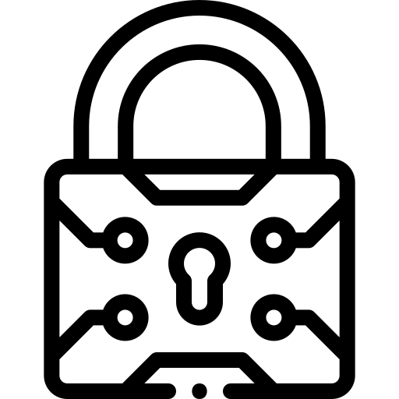 |  | Cybersecurity and Threat Protection  - Safe Links and Safe Attachments - Mail Attachment and Link Protection.  - Web Browser Protection (DNS Filtering / Scrubbing).  - MFA management.  - Microsoft 365 Exception Alerting.  - Shadow IT detection.  - “EDR” deep scan end-point virus and malware protection.
 |  | Strategic IT Planning and Review  - “FlightPlan” strategic IT planning workshops.
 |  | Training and Awareness  - Quarterly phishing testing.  - Quarterly cybersecurity e-learning.  - Annual security briefing.
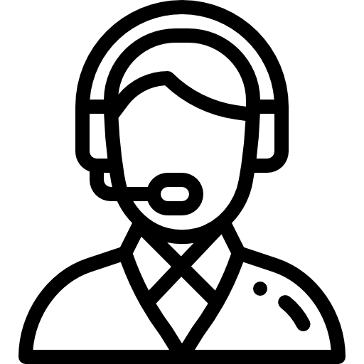 | Support and Service Management  - Remote control support.  - Discounted hourly rates.

Select KARE Plan Benefits
Select KARE Plan Benefits

KARE clients get priority over other Kinetics clients.

Problem  Severity | Initial Response Time | Escalation | Expected Time to Resolve
Emergency (all hours) | 2 hours | N/A | Determined by the nature of the event
Critical | 4 hours / next business day | 2 hours | Determined by the nature of the event
Normal | 8 hours / next business day | 4 hours | Determined by the nature of the event
Cosmetic | 16 hours / 2nd business day | 4 hours | Determined by the nature of the event

Note:
We are not responsible for third parties unless otherwise specifically agreed.
Any supplemental services provided by Kinetics Group, which are outside the terms of this Kinetics KARE Agreement shall be charged to INSERT COMPANY NAME as an additional charge.
Any additional billing charges will be invoiced at the end of each month, with payment expected by the 20th of the month following invoice.
Manufacturer warranty parts and labour/services are outside the scope of this Kinetics KARE Agreement.

Cybersecurity Framework Alignment
Kinetics offers a range of plans to suit businesses depending on their risk profile. The plans are built against recognised frameworks to provide a layered approach to cyber security and flexibility towards to client budget demands.
Businesses are describing an increasing need to demonstrate alignment with some or all of these standards, such as for cyber-insurance. The standards typically have different levels – such as bronze, silver or gold. Our KARE plans provide flexibility to match the standards you need, and a clear roadmap to progress to more demanding or evolving standards.
Framework Alignment Overview
To help clients understand how each plan aligns with recognised cybersecurity standards, we’ve mapped them against three widely adopted frameworks. These frameworks provide practical guidance for improving cyber resilience and are especially relevant for small and medium-sized businesses.
NCSC Critical Controls (New Zealand)
These are prioritised security practices based on real-world threats. They emphasise essentials like secure backups, strong access controls, and staff awareness. The controls are updated regularly and help organizations focus on what matters most.
Essential Eight (Australia)
Developed by the Australian Government, the Essential Eight outlines eight key strategies to prevent cyber-attacks. It uses a maturity model (Levels 0–3) and focuses on practical actions like patching, restricting admin access, and enabling multi-factor authentication.
SMB1001:2025
A five-level certification tailored for SMBs, SMB1001 helps businesses build cybersecurity maturity step-by-step from basic protections like antivirus and firewalls to advanced governance and risk management. It’s flexible, affordable, and aligns with global standards like ISO 27001.
NIST
Each of these frameworks provides practical guidance that complements the NIST framework's core functions of Identify, Protect, Detect, Respond, and Recover, making them especially relevant for small and medium-sized businesses.
The NCSC Critical Controls (New Zealand) align with the NIST framework's emphasis on identifying and protecting critical assets through secure backups, strong access controls, and staff awareness. The Essential Eight aligns with the NIST framework's focus on protecting and detecting threats through practical actions like patching, restricting admin access, and enabling multi-factor authentication.
The SMB1001:2025 certification aligns with the NIST framework's approach to building cybersecurity maturity step-by-step, from basic protections like antivirus and firewalls to advanced governance and risk management.

Microsoft Secure Score
Microsoft Secure Score is a metric that should be included with your 365 subscriptions. Our webinar explains this in more detail. It is specific to the security of your M365 tenancy. Microsoft update this regularly and the score is subject to the various plans that you subscribe to.
A more sophisticated plan with enhanced data protection tools requires those tools to be actively used to maintain a strong security score. We report on your Microsoft Secure Score every month and work with you to improve this important metric over time. In practice, we routinely see clients achieve 10–20% gains in their Microsoft 365 security simply through the implementation of our KARE plans.
Framework Alignment Summary Table
Framework | KARE  Foundation Basic | KARE  Foundation SME | KARE  Foundation
NCSC Critical Controls  (NZ) | Level 1  Basic protections like antivirus, firewalls, and backups. | Level 2  Adds access controls and basic policies. | Level 3–4  Includes risk management and governance practices.
Essential Eight  (AU) | Partial (Level 1)  Covers patching and MFA. | Level 2  Stronger alignment with admin controls and threat protection. | Level 3  Broad coverage of all eight strategies.
SMB1001:2025 | Basic Controls  Covers backups, antivirus, and password hygiene. | Intermediate Controls Adds user access and monitoring. | Best Controls  Includes training, policies, and advanced protections.

How to Read This Table
- Level 1 / Basic Controls: Covers essential protections like antivirus, firewalls, backups, and basic password hygiene. Suitable for businesses starting their cybersecurity journey.
- Level 2 / Intermediate Controls: Adds structured access management, multi-factor authentication, and basic policy implementation.
- Level 3–4 / Advanced Controls: Includes broader risk management, governance, staff training, and monitoring aligned with more mature cybersecurity standards.
- Partial: Indicates the plan includes some but not all recommended controls from the framework.
- Best Controls: Indicates strong alignment with the framework’s key recommendations.

Plan Comparisons |  | KARE FOUNDATION PLANS |  |  | Security Framework Alignment
 |  | Basic | SME | Foundation | NZ Critical Controls | SMB 1001:2026 | Essential  Eight
Core Monitoring and Protection | 365 Account and Endpoint Monitoring | Yes | Yes | Yes |  |  | 
 | Backup Service | Personal Docs | Server | Server |  |  | 
 | Advanced EDR (Endpoint Detection and Response) | Yes | Yes | Yes |  |  | 
 | Anti-Malware – Deepscan monitored protection | Yes | Yes | Yes |  | 
 | Safe Links and Safe Attachments - Mail Attachment & Link Protection | Yes ^{*1} | Yes | Yes
 | MFA Management and Reporting | Yes ^{*1} | Yes | Yes |  |  | 
 | Patching - Microsoft OS & Software and common freeware patches | Yes | Yes | Yes |  |  | 
PC Protection | Web Browser Protection (DNS Filtering / Scrubbing) | Yes | Yes | Yes
 | Web Browser AI Security - analyse, detect and block threats, & protect | Yes | Yes | Yes
Advanced Monitoring | Darkweb Reporting | - | Yes | Yes
 | Shadow IT Detection | - | - | Yes
 | Active Directory Privileges Group Monitoring ^{*2} | N/A | - | Yes |  |  | 
 | Managed Detection and Response (MDR) | Yes | Yes | Yes
 | Identity Threat Detection and Response (ITDR) | Yes | Yes | Yes
Cyber Training | Quarterly Phishing Testing | Yes | Yes | Yes |  | 
 | Quarterly Cybersecurity E-Learning | Yes | Yes | Yes |  | 
 | Annual Security Briefing | Recording | Recording | Yes  (in person) |  | 
Planning and Reporting | IT Review / FlightPlan | - | - | Yes
 | Quarterly Reviews | - | Yes | Yes
 | Monthly Report | Basic | Detailed | Detailed

Options List |  | NZ Critical Controls |  | SMB  1001:2026 | Essential  Eight
Kinetics supplied and managed Firewall with Total Security | Optional |  |  | 
365 Cloud Backup | Optional |  |  |  | 
Password Vault | Optional |  |  | 
Advanced Email Scrubbing | Optional
Email Domain compliance and security with Sendmarc | Optional |  |  | 
Backup and Business Continuity Services | Optional |  |  |  | 
Monthly Internal Network Scanning ^{*2} | Optional
Deep Vulnerability Scans ^{*2} | Optional
Penetration and Security Testing | Optional
Compliance Framework i.e. SOC 2, GDPR, SMB1001, ISO27001, PCI DSS, CIS, & NIST | Optional
CloudSource Hosted Services | Optional
Fractional Leadership VISO (Virtual Information Security Officer) | Optional
Fractional Leadership ITMaaS (IT Manager as a Services) | Optional
Policies, planning, readiness and testing | Optional
Compliance and Security Services can be developed as required,
or to clients’ specific requirements.
Note:
*1 are only available if user has a Microsoft Defender for Office P1 and Microsoft Entra ID P1 account. These licenses are in addition to the plan.
*2 applied for onsite server infrastructure

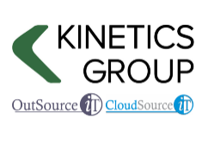

Pricing
Our security and support options are estimated below, with an estimated setup fee of $X,XXX.XX + GST

KARE Security and Support option | Monthly Estimate
KARE Plan  [insert Screenshot from calculator] | $X, XXX + GST
KARE Fixed Monthly Support  [insert Screenshot from calculator] | $X, XXX + GST

Service Option | Monthly Estimate
24x7 Vigilance | $X, XXX + GST

[Delete this and table below if not applicable]
KARE Foundation requires specific Microsoft 365 licensing and we are recommending the following.

License | Quantity | Unit Cost | Monthly Total
Microsoft 365 Business Premium

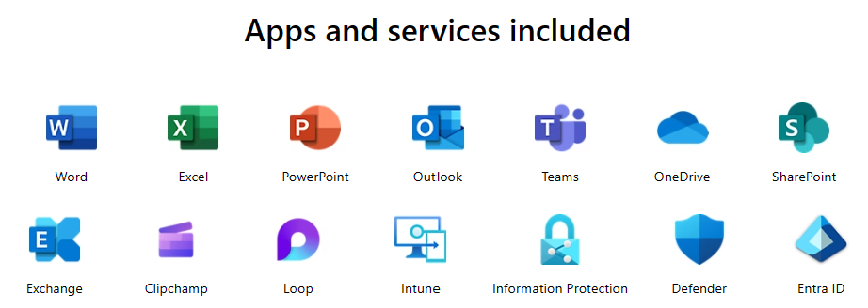
Microsoft Business Basic for admin
Microsoft Teams Calling Licenses
Power BI Pro licenses as required
TOTAL

Note:
This plan represents a significant uplift to INSERT COMPANY NAME’s cybersecurity posture. While no solution can offer absolute protection from cyber incidents, our approach is designed to materially reduce risk by applying practical, well-proven security measures that strengthen your environment and improve resilience.
This proposal outlines the measures we recommend to safeguard INSERT COMPANY NAME with details of these precautions and a comparison of plan options included in the document appendix.

Non-agreement work
Select the Rate Card

Urgent Support
No one likes surprises. But sometimes things do go wrong unexpectedly, and when they do, you need urgent help.
If 24/7 is important to you, Kinetics has on-call engineers assigned around the clock. Call our main number afterhours, and you will be directed to a paging service that will contact our rostered after-hours engineer.


Appendix
FAQs & Service Details

Appendix
What is a FlightPlan Annual Strategic IT Planning Workshop?
FlightPlan is a comprehensive IT best practice review service. Best practice is defined as a method or technique that has consistently shown results superior to those achieved with other means, and that is used as a benchmark.
In an age of digital transformation FlightPlan helps businesses answer critical questions:
- Where are we now?
- Where do we want to go?
- How do we use IT to take us there?
Kinetics will work with your senior management team to provide the helicopter view of your business from an IT perspective

 |  |  |  | 
REVIEW  your business goals |  | REIMAGINE  what is possible |  | REMAP  your IT path to success
In accordance with your business goals we review, benchmark and measure critical factors such as  - Information Protection  - Cybersecurity Protection  - Disaster Recovery  - IT Governance  - Staff Capability  - Digital Transformation |  | Discover how to leverage the best of digital transformation strategies and technilogies to propel your business forward, engage your staff and stregthen your security posture. |  | We don’t just review what you have got. We remap wat you could be doing with IT to improve your business.  - Must do  - Should do  - Could do

Each recommendation will include the effort required to complete as well as the business benefit (business as usual / added value / bleeding edge). A recommendation may include an indicative cost budget.

Why MDR and ITDR are needed
MDR (Managed Detection and Response)
MDR is the modern evolution of endpoint protection. Instead of relying on signatures or basic behavioural rules, MDR combines advanced analytics, AI, and human threat hunters to identify and contain threats in real time. It continuously monitors endpoints, cloud services and user activity to recognise patterns, anomalies and active attacks as they happen.
Traditional antivirus focuses only on known threats. MDR goes further by detecting unknown or emerging threats, correlating behaviour across devices, and actively responding on your behalf. Because it is both proactive and human‑led, MDR offers far more comprehensive protection than legacy antivirus tools, especially as the number of endpoints and the sophistication of attacks continue to increase.
A major advantage of MDR is the human element. Analysts can investigate alerts, validate activity, contain threats within minutes and guide remediation. This significantly reduces dwell time and limits the spread of malware, ransomware or other attacks across your environment.
ITDR (Identity Threat Detection and Response)
Identity has become the primary target in modern attacks. Password theft, MFA bypass, compromised sessions and privilege misuse are now more common than traditional system exploitation. ITDR addresses this by monitoring identity systems, login behaviour, access patterns and privilege changes to detect identity‑based attacks in real time.
While MDR focuses on endpoints and system activity, ITDR protects the identity layer itself. It identifies abnormal logins (for example, impossible travel), suspicious privilege escalation, lateral movement attempts, or unusual access to cloud resources. When detected, ITDR can trigger controls such as MFA challenges, access restrictions or automated revocation of tokens.
This matters because attackers increasingly “log in, not break in”. With most breaches now involving compromised credentials, ITDR fills a gap that antivirus and even EDR cannot address. It ensures your directory, accounts and identities cannot be misused as a pathway into your environment.
Why MDR + ITDR together?
By combining MDR and ITDR, KARE provides both endpoint‑level protection and identity‑level protection. This aligns with modern security frameworks and mitigates the two most common attack vectors: compromised devices and compromised credentials.
MDR stops malicious behaviour. ITDR stops malicious access.
Together, they deliver a cohesive, modern defence far beyond what antivirus or traditional endpoint tools can provide.

What is included in the Security Awareness Education?

Security presentation – One session every Year
Staff security awareness sessions presented by a Kinetics consultant covering 10 tips to keep yourself safe.

Topics include:
- Password Security | - Recognising Scams by phone or email
- Privacy | - Backups
- Updates and Patches | - Security of devices
- What to do if you make a mistake

The session includes a reference information for all attendees. The duration is 45 min to 1 hour and we customise the session based on your setup – for example under your contract we cover backups and windows patching so when we get to that session on the presentation, we tell people about it but then tell them that we have it in hand.

eLearning- Quarterly
An e-learning module covering topics from the staff awareness session for new starters or staff that could not make the security session.

Phishing Testing - Quarterly
Quarterly Phishing simulation tests and reporting to identify areas for improvement

What are SafeLinks and Safe Attachments?

DNS / Web filtering
These days, using the internet is a high-risk activity for every business, regardless of size. From users browsing inadvertently to websites that deliver malware, to drive-by downloads that immediately drop ransomware and other malware from a command-and-control server, uncontrolled web usage can be very risky.
By installing an agent on your PCs, we can protect them both inside and outside of your network. DNS Protection provides an additional layer of web filtering protection from sites that host malware or spyware and provides far more granular control over the types of domains you can access. It provides real-time protection against known malicious threats, unauthorized network access, and distributed denial of service (DDoS) attacks, while drastically improving their visibility and control over internet access.

Advanced Threat Protection (ATP)
ATP focuses on behavioural analysis to determine if a file is malicious, identifying and submitting suspicious files to a cloud-based sandbox where the code is emulated, executed, and analysed to determine its threat potential. If the suspected file is found to be malicious, ATP Blocker quickly takes action to ensure your network and digital assets stay secure.
APT (Advanced Persistent Threat) can be enabled at the firewall level (dependant on your firewalls capability) as well as on Office365 protecting your email, SharePoint, and OneDrive while you are outside of the office.

Why is MFA Setup and Management needed?
High-profile breaches are making headlines weekly, and the number of incidents continues to rise. Multi-Factor Authentication (MFA) has become the standard to prevent unauthorised users from accessing corporate data with passwords alone. MFA used a variety of methods to verify your identity, from text messages to authenticator apps on your mobile device. We work with you to implement the appropriate level of MFA that balances usability and security.
Please note, there are two levels of MFA.
- Basic – This is included in most 365 licenses and allows us to enable MFA in your Microsoft 365 environment (Exchange, SharePoint, Teams etc)
- Advanced – This is available in 365 higher plans and allows us to do things like add MFA to a Remote Desktop connection or “whitelist” certain locations to not prompt
We will enable and configure the appropriate level of MFA based on the license you have.

What is included in the Microsoft 365 Exception Reporting?
- Monitoring, alerting and initial investigation of 365 changes and behaviour.
- Email forwards, accounts accessed from infrequently locations (out of country), unusual files access or deletion volumes, exchange privilege elevation
- Regular review of available alerting parameters and implementation.
- Quarterly reporting on mail forwards, external identities, full mailbox rights and Azure management group membership.

What is Darkweb monitoring?
“Pwned” is the term given to personal information that has been stolen or leaked and is now available on the Dark Web. This information is typically stolen from online services with well-known examples including LinkedIn and Sony.
These are not breaches of your company security. However, the information gathered can be used to form a picture of the user, with the hacker using that information to either masquerade as the user or to try to guess their passwords on other sites.
Kinetics KARE Foundation uses your primary email domain and checks for leaks associated with those email addresses and alerts staff involved so they can ensure their passwords are changed.

Explain “Shadow IT”
If you don’t know where data is stored, you can’t assess the risks to that data or even determine if your policies are being followed.
Shadow IT refers to the practice of users or departments subscribing to (free or paid) services over the internet without going through a formal IT process. These might be accessed via a web-browser, thus requiring no formal IT support. In using the service, the operator will often upload data as part of the normal operation of the tool.
The informal nature of acquisition means that the organisation will not be aware of all the (cloud) software in use. Shadow IT Discovery sets out to identify these occurrences. This is important because a key component of security is managing risk. Before you can manage risk, you need to know what risk you have.
“Dropbox” is a classic example of a Shadow IT application. Employees maybe using Dropbox to share and store sensitive documents, often without the company’s knowledge. Quite often these will be under a personal account of Dropbox as well, so if the employee leaves the organisation, they retain access to these files
If a business does not know what applications are in use, they cannot be sure that security policies such as password and multifactor authentication are applied.
KARE Foundation includes a Shadow IT tracker. An agent is installed on all Windows devices which uses an advanced log file analysis framework to identify SaaS applications in use. That data is then compared against a SaaS Application database which includes over 22,000+ vendors and applications. By using an advanced application classification algorithm, discovery will provide you with actionable data in the areas of finance, security, and productivity.

AI Powered Browser Security
Note: Included in the KARE Foundation plan.
AI-Powered Browser Security converts your browser into a secure browser, mitigating ransomware and credential theft. It identifies login pages and compares these with known login pages and restricts credential harvesting sites.
- AI identified risky sites and blocks where appropriate.
- AI identifies risky site, and open in a “Sandbox” safe environment eliminating the risk on the user’s device. This allows the user to still view the site, without risk to your organization.
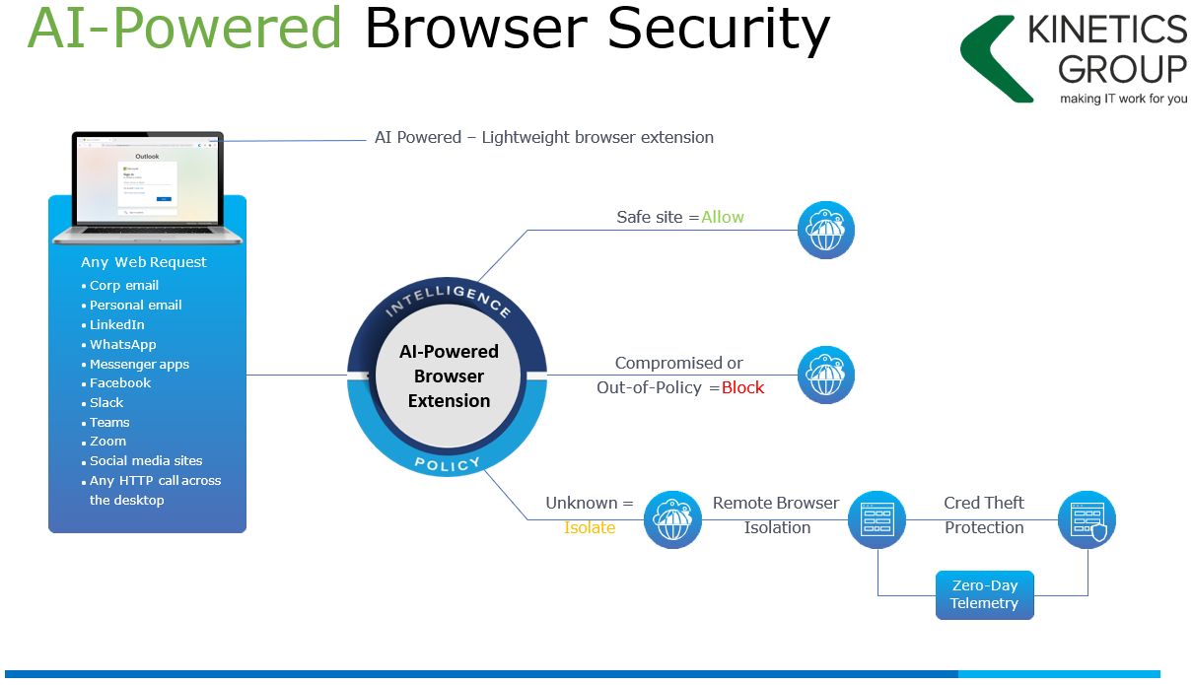

Why/When is 365 Online Backup needed?
Note: Select the KARE Security Plus plan to get this capability.
Microsoft 365 Software as a Service (SaaS) do a great job of looking after your information. Their data centres have countless layers of security and georedundancies to ensure your data is protected. In addition to this, Kinetics have several layers of protection in place to ensure your data is safe. There are however factors outside of our control that can result in data loss. The most common causes of data loss being:
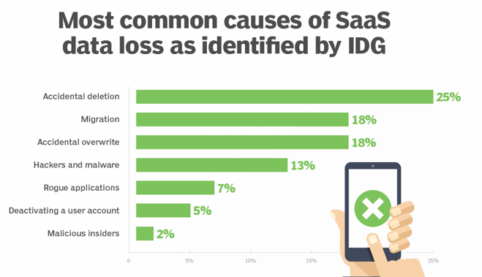

Microsoft have clearly laid out data protection responsibilities and their Service Level Agreement (SLA) states:

“We strive to keep the Services up and running; however, all online services suffer occasional disruptions and outages, and Microsoft is not liable for any disruption or loss you may suffer as a result. In the event of an outage, you may not be able to retrieve Your Content or Data that you’ve stored. We recommend that you regularly backup Your Content and Data that you store on the Services or store using Third-Party Apps and Services.”
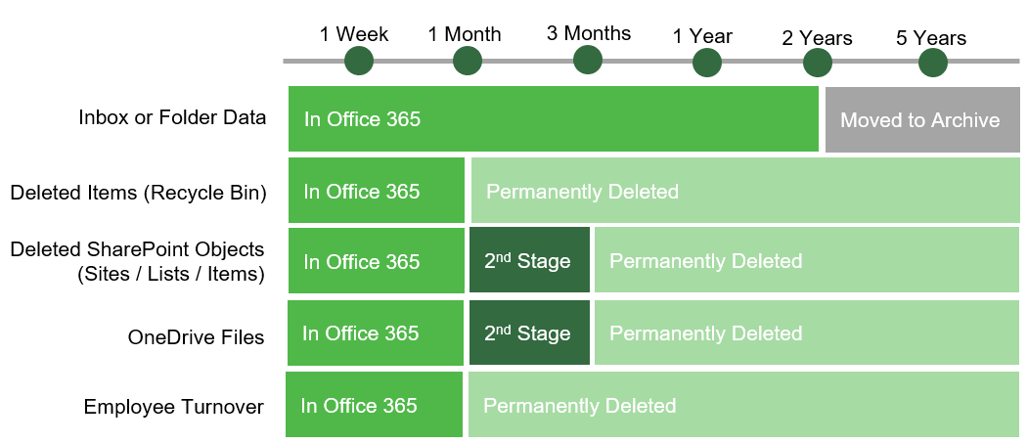

It is for this reason that we recommend using the KARE Cloud SaaS backup service to ensure your information is fully protected, featuring:
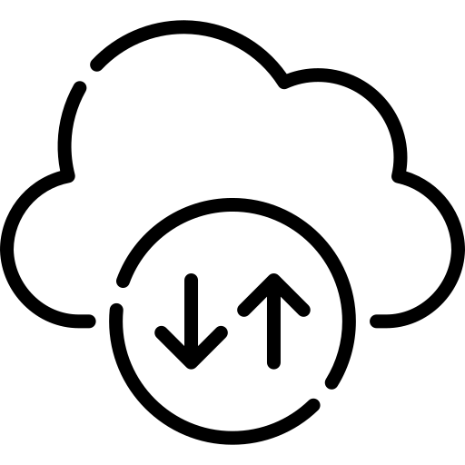 | Continuous backups  Protect Exchange, OneDrive, SharePoint, and Teams with 3x daily backups
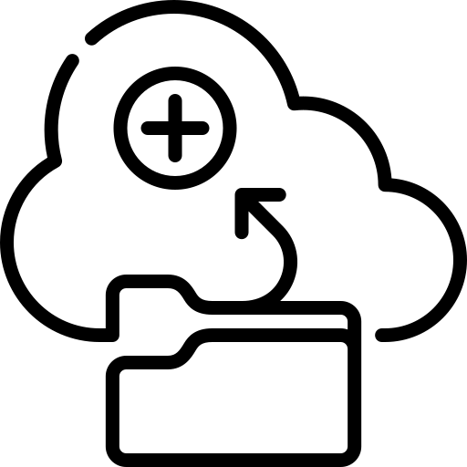 | On demand backup  Run additional backups when needed.
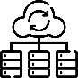 | Point-in-time restore and export  Quickly restore or export data from a specific point-in-time.
 | Non-destructive restore process  Quickly identify and recover individual objects or entire accounts with related records and folder structure intact.
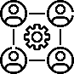 | Cross-user restore  Restore data from one Microsoft 365 user account into another.
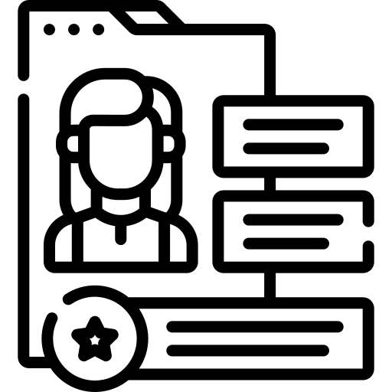 | Retain user data  Save money and effort by preserving inactive Microsoft 365 user data with SaaS Protection for as long as you need it.
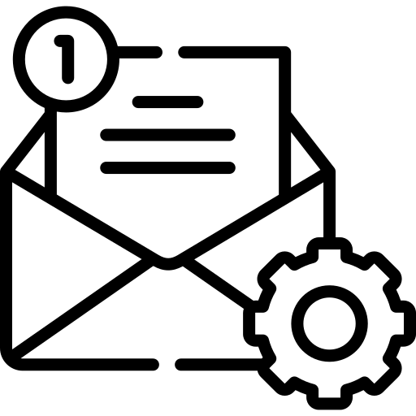 | Shared Mailboxes  Are backed up at no cost. Unless a 365 mailbox/SharePoint license is assigned, in which case it is chargeable.
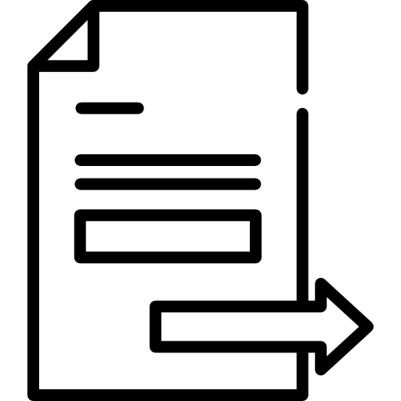 | Easy export  Export entire accounts or specific items in standard file formats.
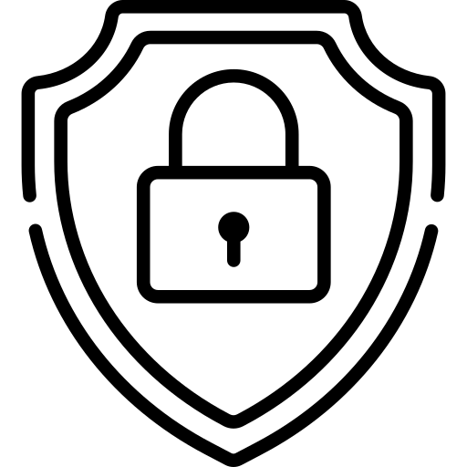 | Security and compliance  SaaS Protection backs up data in compliance with Service Organization Control (SOC 1/ SSAE 16 and SOC 2 Type II) reporting standards and supports your HIPAA and GDPR compliance needs.

All Microsoft 365 data associated with the selected accounts including:
- Exchange | - Tasks | - Calendar | - Contacts
- OneDrive | - SharePoint | - Teams

At the time of writing Microsoft do not allow access to backup:
- Public Folders | - Archived Emails
- Profile Pictures | - Shared / Group contacts
- Shared & Group Documents | - Shared / Group Calendars
- OneNote Documents | - OneDrive image libraries
- Attachments referencing OneDrive objects

The 365 SharePoint backup captures:
- Document Libraries | - Site Templates
- Site Assets | - Site Pages
- Site Collections  Microsoft sites which admins have created that do not fall into the SharePoint Root Site collections | - Site Lists  Generic List, Document Library,  Web Page Library

Backup is for the duration of your contract with Kinetics. If a mailbox is to be deleted, it should be exported or converted to a Shared mailbox.
- 3X daily backups are retained for 30 days
- 1X dailies are kept after 30 days
- 1X weeklies are kept after 90 days
- 1X monthlies are kept after a year, then stored for the selected retention period.
Daily backup windows are in Eastern Standard Time.
Between  12 AM and 8 AM | Between  8 AM and 4 PM | Between  4 PM and 11:59 PM

What is a Password Vault?
The use of password vaults has grown as people recognise the need for strong, unique passwords across all the systems they access. Without a provided solution, staff often choose free tools or store passwords in browsers, creating security risks you cannot control. Shared accounts make this even worse, as passwords are usually simple, reused and rarely changed.
KARE Password Vault solves this by giving every user a secure personal vault and your business a controlled, shared company vault. It prevents unsafe storage in browsers or free online tools, protects sensitive credentials, and enables secure sharing where needed. The vault is private to your organisation – Kinetics cannot see your company vault, and you cannot access employees’ personal vaults. Staff can also export their personal vault if they leave.
Options for training and support to help you set up your company vault structure correctly are available.

Features at a glance:
- No more remembering dozens of passwords  - Faster access to websites and applications  - Password generator  - Centralised system for both corporate and personal passwords  - Folders to organize and categorise credentials  - Generation of audits and reports to help with tracking and compliance  - Granularly grant employee access to systems and networks  - Manage access to shared passwords by department or role  - Native mobile apps on iOS and Android  - Compatible with Chrome, Firefox, Edge, and Chromium-based browsers.  - Ability to share company vault passwords with Kinetics. | 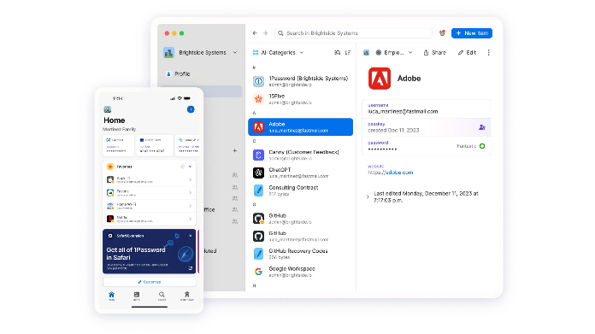

Breach Activity Scans, Monthly Internal Network/Security Assessment and Deep Vulnerability Scans

Breach Activity Scans
There are some changes on your network that you would want to know about immediately. For example, suspicious activities around logins and accounts, as these may indicate that a bad actor is looking around or preparing the way for others. Breach Activity alerts on some signs of potential breach activity. The Breach Alerted is focused on Windows operating systems and accounts. Each site is set up with a virtual device which searches out the network looking for changes and alerting Kinetics to suspicious activity which may indicate a breach or changes which could introduce vulnerabilities.
The Daily Scan looks for activity by reading events and logs:
- Changes specific to the Default Domain Policy
- Removal or addition of users from the domain.
- New user profiles appearing on devices.
- Local Computer, accounts elevated to administrator
- Users logging into multiple computers
- Accounts promoted network administration
- Non approved users accessing sensitive computers *
- Suspicious logons to computers **
- Suspicious logons by users **
- Devices added to restricted networks***
- Automatic screen lock not enabled for sensitive computers or users.
- Changes made to devices tagged as locked down (typically servers)

*Devices can be tagged as Business owners, Accounts or Cardholder data devices. Alerts are generated when non approved accounts logon to these devices.
**Computers or users logging on outside of normal work patterns.
***Applies only to tightly locked down networks.

Monthly Internal Network/Security Assessment Scan
Breach activity is focused on specific activities taking place now. But in IT, nothing is static. All systems are complex and in constant flux. The monthly cycle focuses on your identity management and access control systems. We run software installed onsite on a server to gather information and pass it back to our systems.
Note: For remote workers, we ask that they run a scan manually and return the results to us.
The Monthly Internal Network/Security Assessment Scan looks at:
- Domain Controllers: Identifies domain controllers and with FSMO Role Analysis.
- AD Organization Units and Security Groups: Lists the organizational units and security groups (with members).
- AD User Analysis: Lists the users in AD, status, and last login/use, which helps identify potential security risks.
- Detect Local Mail and Time Servers on the network. Identifying rogue devices and services
- Discover and report on network shares by device.
- Applications: Detects all major apps / versions and counts the number of installations.
- Detailed Domain Controller Event Log Analysis: Lists the event log entries from the past 24 hours for the directory service, DNS server and file replication service event logs.
- SQL Server Analysis: Lists the SQL Servers and associated database(s).
- Internet Domain Analysis: Queries company domain(s) via a WHOIS lookup.
- Password Strength Analysis: Uses MBSA to identify computers with weak passwords that may pose a security risk.
- System Protocol Leakage: Detects outbound protocols that should not be allowed.
- Unrestricted Protocols: Detects system controls for protocols that should be allowed but restricted.
- Domain Security Policy: Documents domain computer and domain controller security policies.
- Local Security Policy: Documents and assesses consistency of local security policies.
- Network Share Permissions: Documents access to file system shares.
- Logon History: Documents login history by device and logon failures.
- Scan of your public IP’s. Performs a detailed External Vulnerability Scan. Lists and categorizes externally accessible security threats.

It is recommended that scan is run across the local site. For each site we need access to a device (preferably a server) from which the scans can be run, as each site will also have our breach detection device. Then you will already have the infrastructure in place or alternatively we can supply a suitable device as a cost.

Deep Vulnerability Scans
Risk comes from more than just PCs and servers. They can come from any connected device (including phone systems, security cameras, and even baby monitors). The monthly scan does a ‘deep dive’ on the public IP addresses. Normally, it takes days to do that on the whole of the network. At least 3 times a year, we run full scans layer, 2/3 scans and vulnerability scans. Data is collected and reviewed; recommendations made.
For a deep scan, we bring onsite a device which over several days that will gather data for deep analysis. The deep scan looks at all device types, including those that you may not normally associate with networking. The monthly scan focuses on your Microsoft network.
There is a reason that cyber insurance assessment forms ask if you undertake regular vulnerability scans. They know that today’s best practice can easily become tomorrow’s weakest link and they know how complex a modern network can be.
Vulnerabilities scans go beyond PCs, servers and patching. They are based around CVE (Common Vulnerability and Exposures) and CVSS (Common Vulnerability Scoring System) and are maintained by First.org, a global forum for response and security teams. CVE’s can describe vulnerabilities in software on any connected device, from baby monitors to virtual appliances. CVE’s can be found everywhere and anywhere.
The deep vulnerability scan is intensive. In addition to scanning devices, it will attempt to use common login and passwords to brute-force hack devices. To manage network traffic when the scan occurs, we may need to run it overnight or on a weekend. It is not vital that all devices like laptops are onsite. The two scans which make up a deep vulnerability scan are targeted at devices which offer services (like servers) and hardware devices (phone systems, printers, switches).
A vulnerability scan will help detect issues which may otherwise be missed.
Example 1: | You may regularly be applying updates to servers and deploying the latest version of your Line of Business software from your supplier. A vulnerability scan can help identify that your Line of Business supplier is using a weak version of Apache web server in their deployment.

Example 2: | When the application was originally deployed, it followed the best practice and vendor guidance available at the time. Since then, security standards have evolved and current recommendations now require older TLS protocols to be disabled. A vulnerability scan may highlight that the application is still accepting connections using these outdated protocols, indicating the need to update its configuration to meet today’s security expectations.

Example 3: | When a new printer, copier, scanner was installed, there was a lack of available ports. The technician supplied a mini switch to overcome this. The switch was left on the default admin password and is connected to the internet.

When the deep scan is completed, we produce a report for each site with recommendations of changes and explanations of the issues found.

What is included with a KARE Managed Firewall
Note: Select the KARE Managed Firewall plan to get this capability.
KARE Managed Firewall is the supply and management of a “WatchGuard” firewall, which includes:

- Quarterly firmware upgrade
- Alerting and resolution of all subscription services.
- Weekly security review.
- Maintenance of global white/blacklists.
- Monitoring and alerting on botnet, flood attacks, virus, intrusion and APT
- Business hours investigation of alerts.

The firewall remains the property of Kinetics Group.
KARE Security Plus
Additional cyber-security protection for organizations that value it, including 24 x 7 protection, because the ‘cloud’ is always ‘on’
- 24 x 7 EDR active monitoring
- 24 x 7 365 Activity monitoring

Security events are collated from agents running on your Windows and Mac devices, Honey Pot Networks (If you have Hyper-V or VMware infrastructure), Microsoft Active Directory Domain Controls, KARE EDR and your Microsoft Azure/365 Environment.
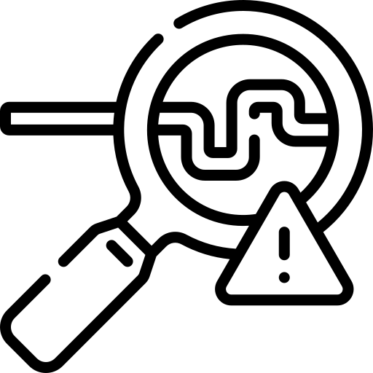 | Real-Time Detection Alerts  Automated analysis and response, speeds up detection, shortens the time to react and stay ahead of hackers.
 | Comprehensive Response Capabilities  Experienced security analysts undertake threat hunting 24x7x365, taking protective action to secure your devices and data.
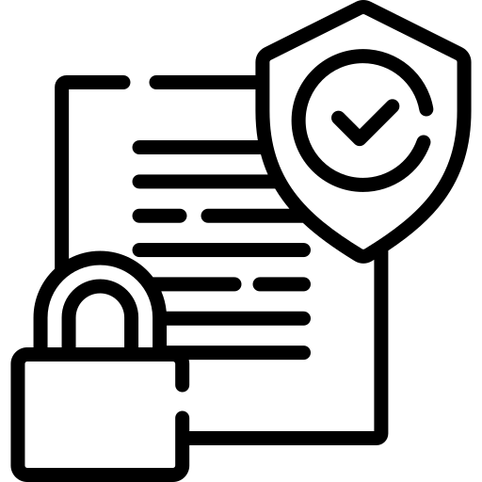 | Achieving Compliance Requirements  Automated compliance reporting is available for PCI DSS, NIST and HIPAA.
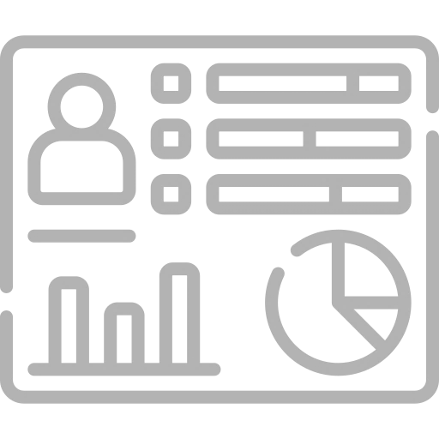 | Privilege Analysis of Network Accounts, Systems & Groups  Privilege analysis of every account, system, user can know who access what and when.
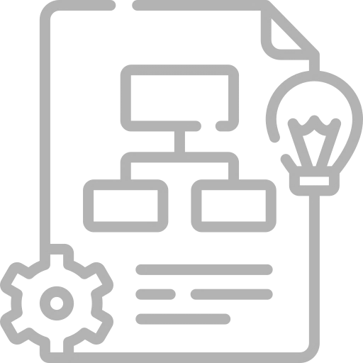 | Analysis and Recommendations  Expert analysis and recommendations for confirmed incidents including timely and appropriate counter measures.

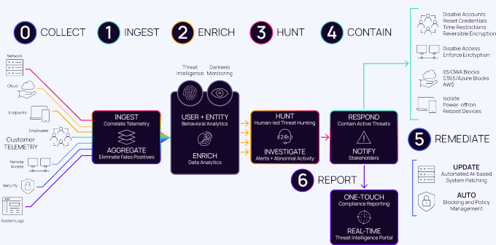

Security events are held for 30 days. An option is available for 90-day retention.
Security Events Gathered and Analysed.
At the centre of KARE Vigilance is the SIEM. This is where security events come together. Analysis is of events from all sources and devices giving a rich contextual view of what is happening on your network. Analysis makes use of Machine Learning and AI to identify suspicious patterns and behaviours.
Powerful automated systems are supported by security experts. They can undertake further analysis and threat hunting. Included in KARE Vigilance is protective action. Automation and/or experts can isolate machines, lock down/out accounts. They will then contact Kinetics providing details about further actions or improvements.
Windows and MacOS Agents
The lightweight agent runs on your Windows and Mac devices (A Linux agent is also available). It gathers security events which are then sent to the SIEM for analysis. The agent is also Windows Domain aware and gathers security information from your Windows Active Directory.
Honey Pots
A Honey Pot is a virtual network device that runs in your environment. To hackers it looks like a tempting target. The KARE Vigilance Honey Pot can run in a Hyper-V or VMware Environment. Attempts to scan the Honey Pot will trigger events with in the SIEM.
KARE EDR
KARE EDR (Endpoint Detection and Response) is a state-of-the-art protective software solution. Security events from KARE EDR are also imported into the SIEM. Combined with Endpoint, Honey Pot, Active Directory and Microsoft 365 events. The SIEM can identify lateral movement and abnormal events.

Promises. Kept.

We know IT is vital for your business. We know it needs to work, for you.

We deliver to promise, on time, on budget and on specification

www.kinetics.co.nz

https://www.microsoft.com/en-us/servicesagreement section 6b – Service Availability

