Kinetics Group
Innovation Hubs — attendee registration flows
A visual guide to what an attendee sees from first invitation through response.
Executive summary • A recurring Hub uses a public interest form first, then a no-login meeting RSVP link. A One-Off event goes directly to a private invitation/RSVP link and does not use public registration.

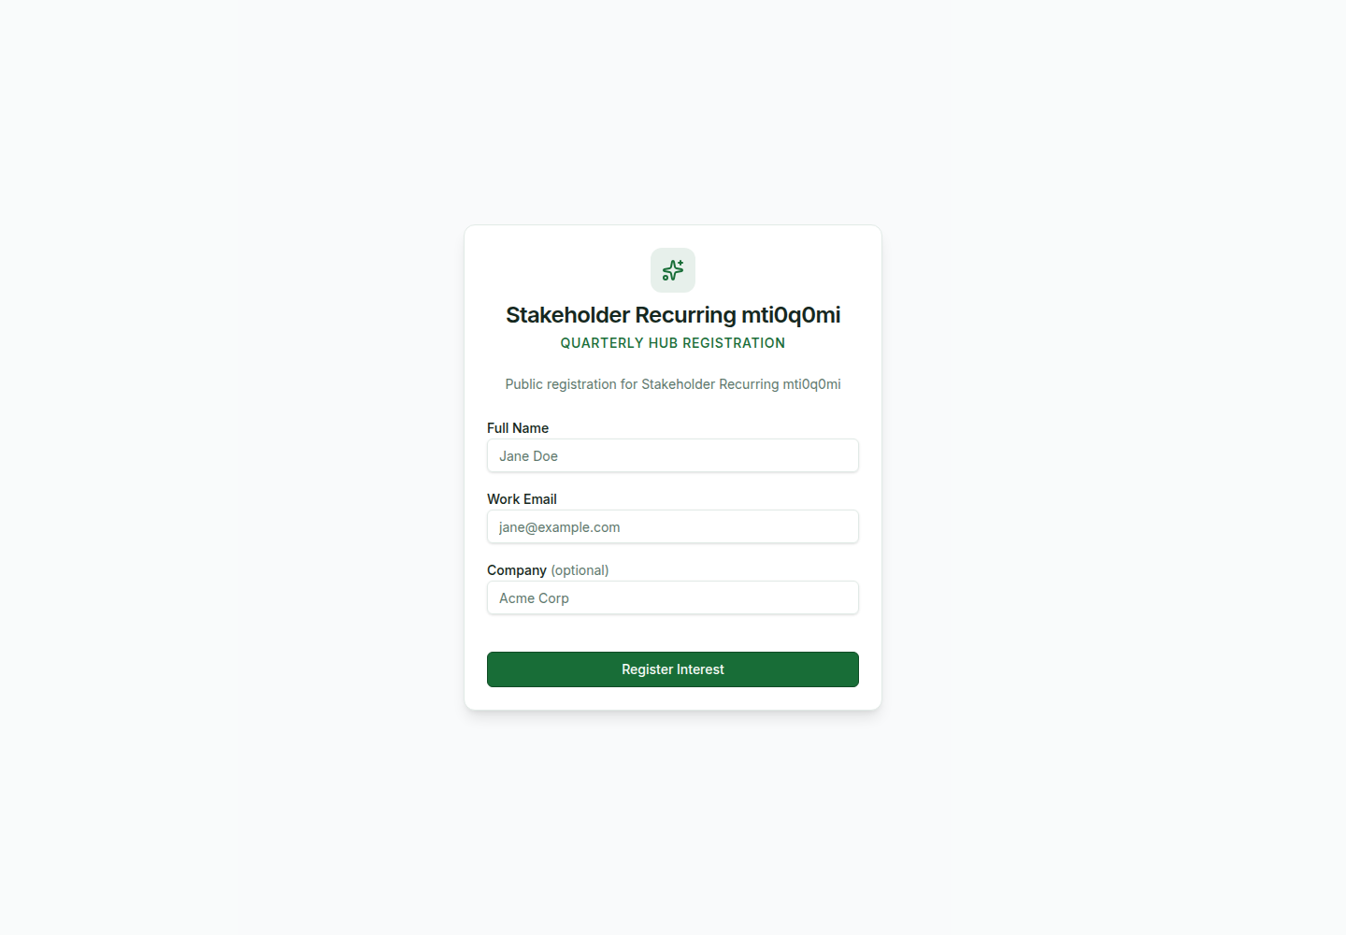
Open Hub registration form
Representative UI captures use isolated test content; the screens and interactions are the actual application.

1. At a glance
 | Recurring Hub | One-Off event
Starting point | Public registration link | Direct private invitation
Login needed to respond | No | No
Creates an attendee immediately | No — creates a pending registration | Yes — attendee is invited directly
RSVP page | Personalised recurring meeting RSVP | Personalised One-Off RSVP
Full workspace | Available after magic-link sign-in | Not part of the One-Off flow

2. Recurring Hub registration flow
Step 1 — Open the registration link. An attendee opens a Hub-specific link shared by Kinetics. The page is public and does not ask them to create an account.
  Open Hub registration form | 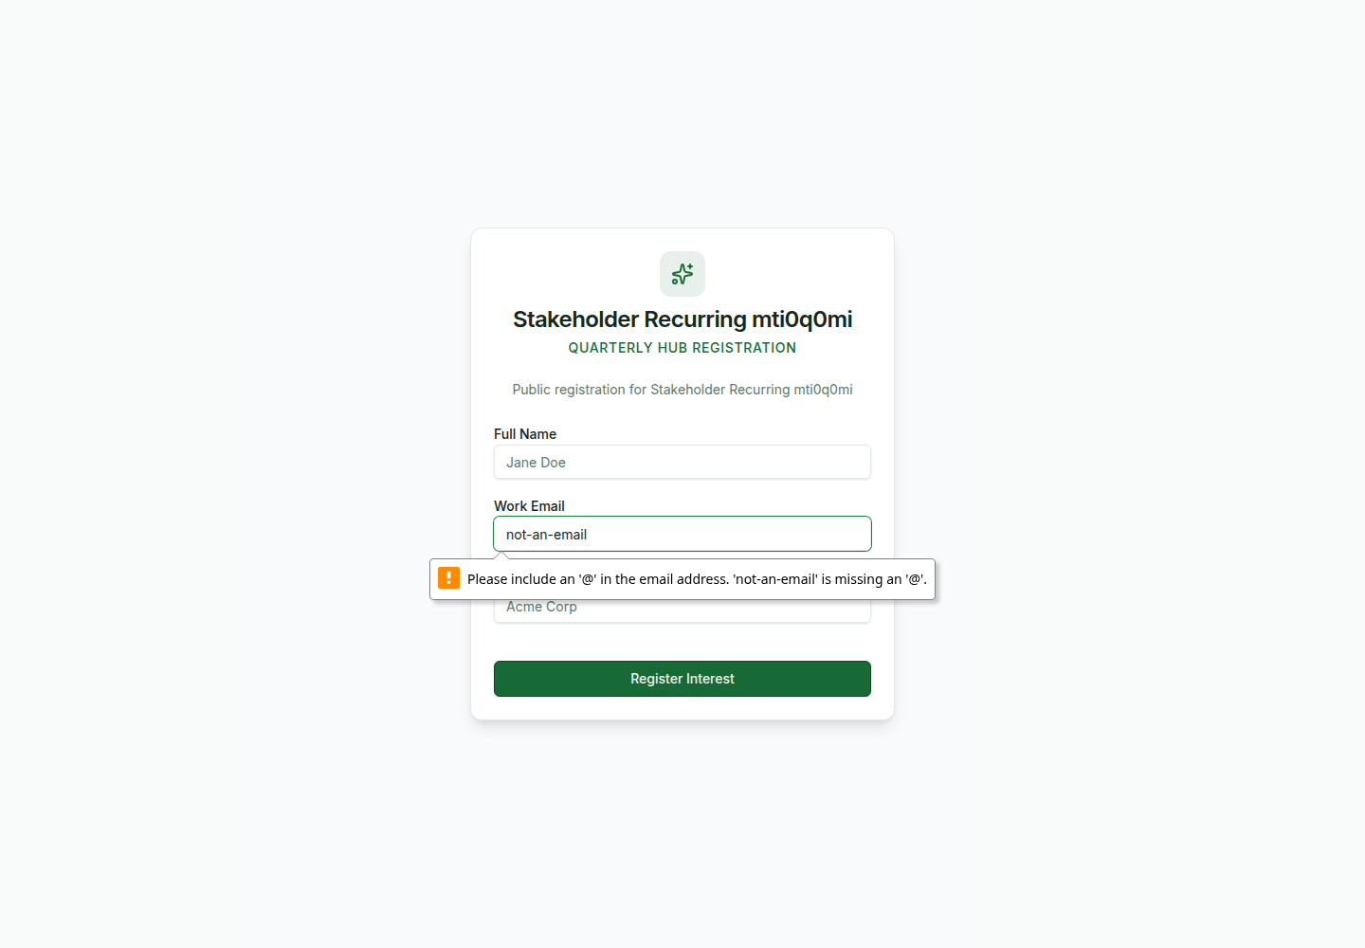  Inline form validation

Step 2 — Submit interest. The attendee enters Full Name, Work Email, and optional Company, then selects Register Interest. Validation appears inline on the form; there is no popup.
Step 3 — See confirmation. The success card confirms Interest Registered. The attendee is not signed in and no login link is sent at this stage.
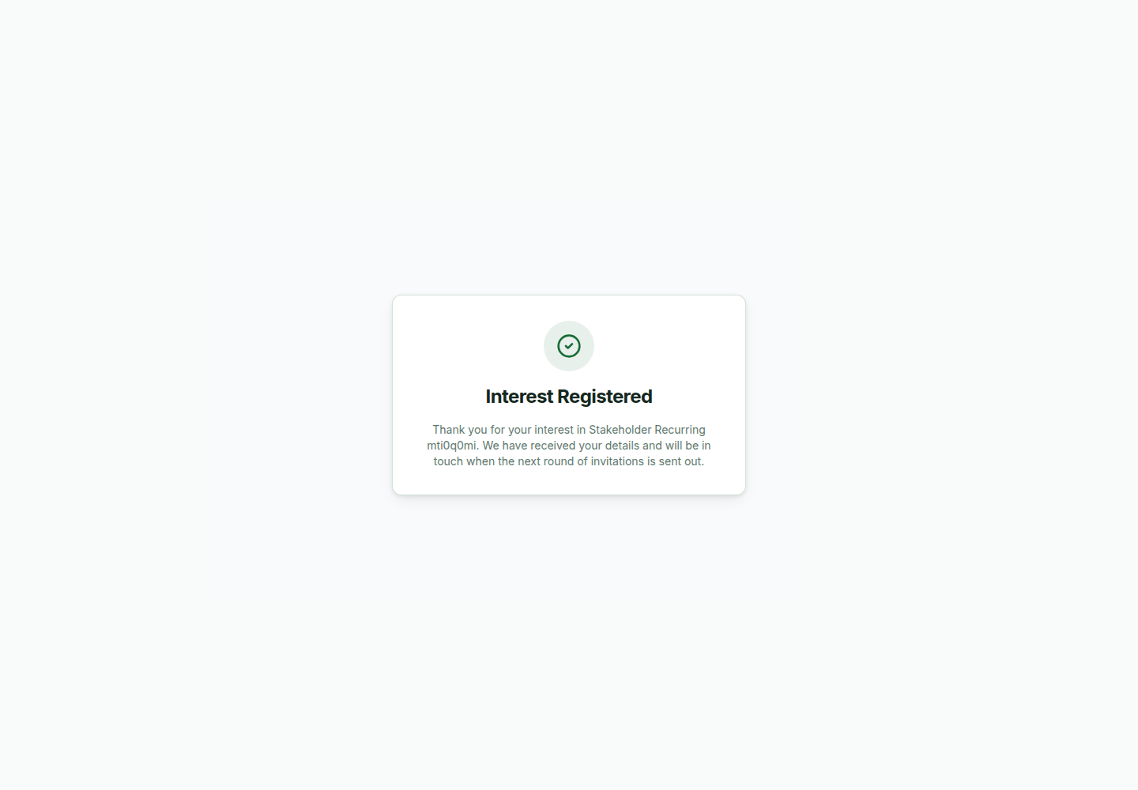
Registration confirmation
What happens next: the submission stays in the Hub’s pending Public Registrations queue. When the Hub is ready, an administrator can promote the person into a meeting and send the meeting invitation.

3. Hub meeting invitation and attendee workspace
Step 4 — Respond to the meeting invitation. Once invited to a recurring meeting, the attendee receives a personalised RSVP link. The response page is still no-login: the secure token in the link identifies the invitee.
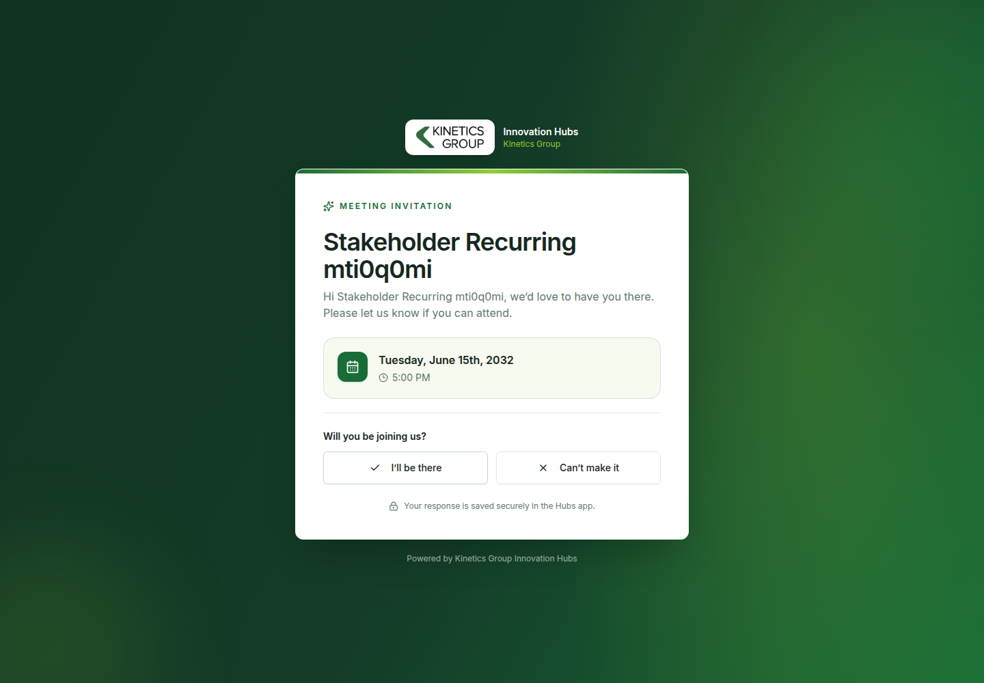  Recurring meeting invitation | 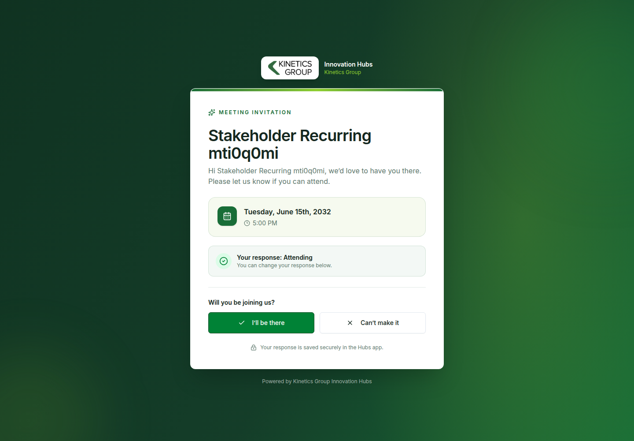  Recurring RSVP after attending

The attendee chooses I’ll be there or Can’t make it. The page saves the response, updates the status banner, and allows the attendee to change their response later using the same link.
Step 5 — Optional sign-in for the full Hub workspace. The attendee can sign in through the magic-link page to access their recurring Hub workspace, including meetings, goals, suggestions, and invitations.
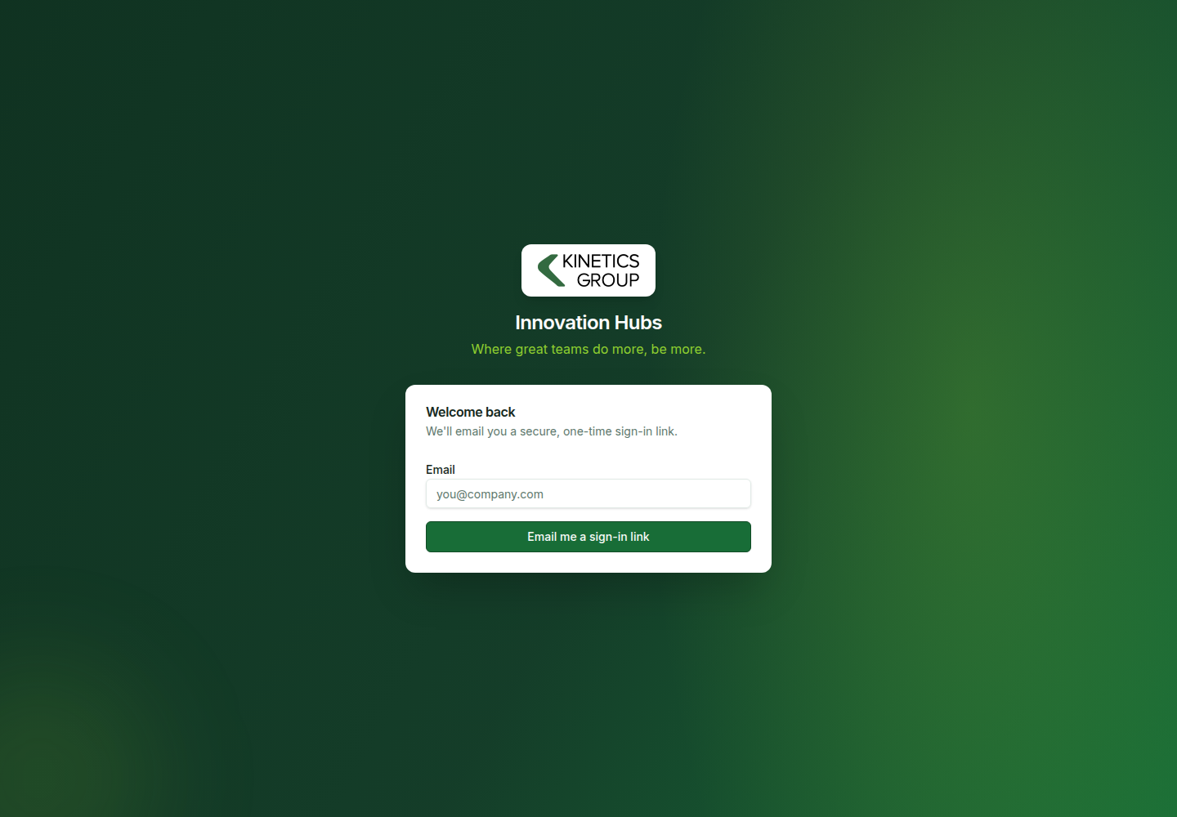  Magic-link sign-in page | 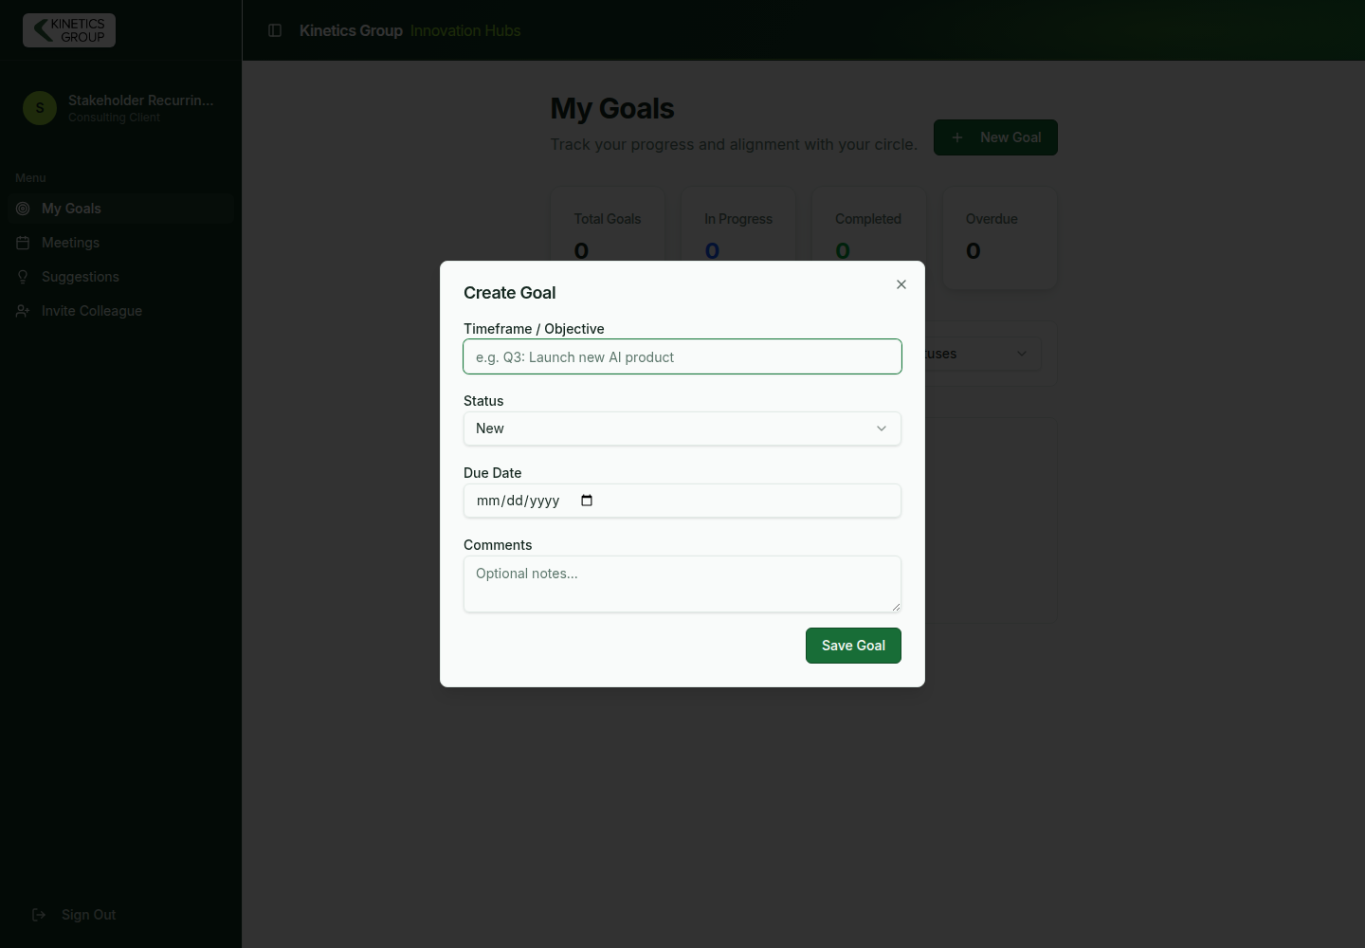  Attendee workspace: Create Goal dialog

Popup/dialog note: the Create Goal dialog is an authenticated workspace interaction. The public registration and RSVP flows use full-page cards and inline feedback rather than modal popups.

4. One-Off event flow
Step 1 — Open the direct invitation. A One-Off attendee receives a private, personalised link. There is no public Hub registration form and no login requirement.
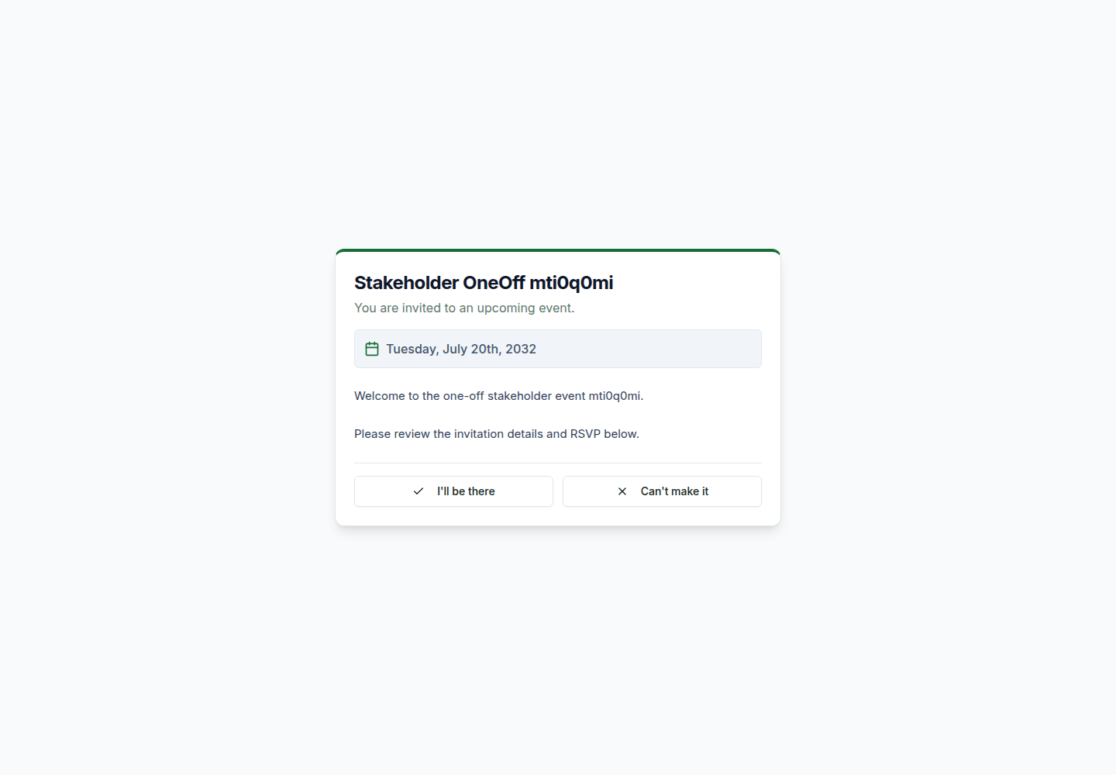  One-Off invitation and RSVP | 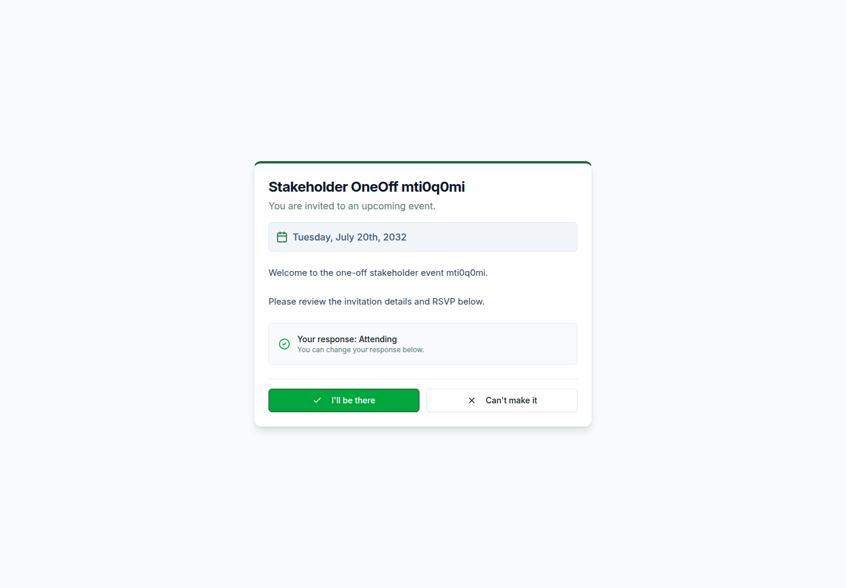  One-Off RSVP after attending

Step 2 — Read the invitation and respond. The page shows the event name, date, any invitation message, and the same two RSVP choices. After submitting, the response banner confirms Attending or Not Attending.
One-Off boundary: the attendee does not receive an automatic sign-in link. The token-only RSVP page is the intended experience for the event.

5. Mobile experience
Both public entry points are designed for links opened from email on a phone. Cards remain centred, fields remain full width, and RSVP actions stack vertically for easy tapping.
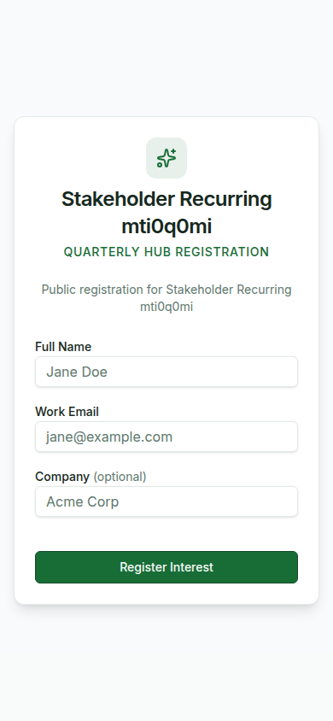  Hub registration on mobile | 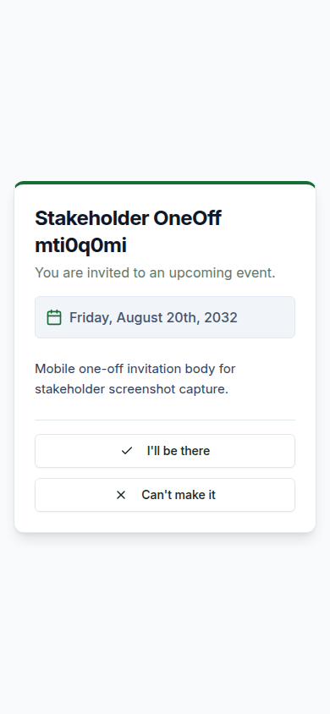  One-Off RSVP on mobile

6. Popup and feedback summary
- Hub registration: no popup; inline required-field validation and a dedicated Interest Registered confirmation card.
- Recurring RSVP: no popup; selected response state, Saving your response… progress text, and a saved-response banner.
- One-Off RSVP: no popup; selected response state and a saved-response banner.
- Magic-link sign-in: no popup; the page changes to a Check your inbox confirmation state.
- Authenticated attendee workspace: modal dialogs are used for actions such as Create Goal.
- Invalid or expired links: a dedicated unavailable card explains that the link can no longer be used.

