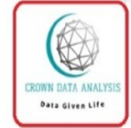 **CROWN DATA ANALYSIS & CONSULTANCY LLC**

**Empowering Organizations through Robust IT & Analytics Solutions**

**Mission**

**To provide our clients with high quality training and other services in time at a fair price both locally & internationally.**

**Vision**

**To be world class data analysis and consultancy center through expansion of our services in all parts of the world.**

**What we do?**

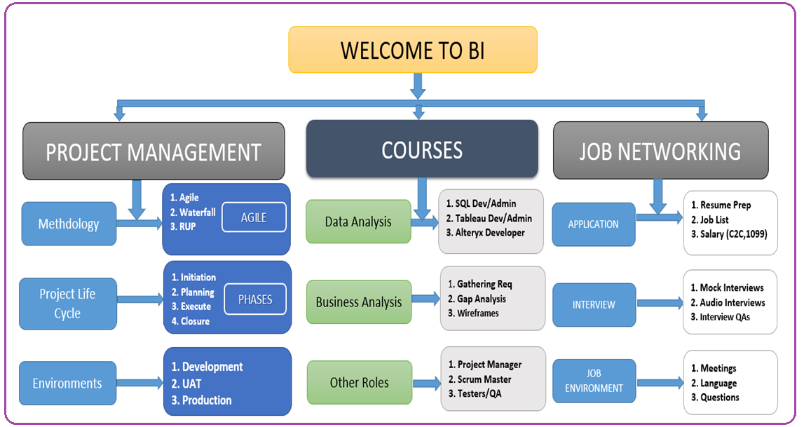

**Why US?**

There are 3 key reasons why you should work with us.

**A. Team :** We have been training and helping change professions and Careers for the last 3 years now. Our team consist of a seasoned coach who has worked in different domains financial, health and IT domains.Former students and now professionals in the field. A broad based support network to aid you get into the market.

**B. Training Model :** Our model is project based training, where we bring real life projects at the center of our classwork and learn by responding to key business questions.

**C. Application Process :**We guide all our students in resume and interview preparation for hands on experience on the state of the market.

**Why You Should Buy**

**There are 3 reasons why you should consider changing your career for Data Analysis.**

**A. Demand:** Companies and all businesses are increasingly making their decisions based on data and the current wave of information hence the increasing demand in the field of Data Analysis. There is a higher demand for millions of jobs than there are professionals to do those jobs.

**B. The Pay:** Due to high demand, the salary range is between 80k to 140k a year in the US.

**C. Wide Applicability of BI Knowledge :** The Knowledge gained in the course allows you to get in various jobs and apply the Knowledge in your life and business.For example:

a. As a Business Analyst, you can gather and documents requirements for you, your business and other companies and for developers to create applications that can help them respond to company challenges.

b. You can work as an ETL Developer, helping companies in data preparation making it easier to generate reports for management consumption.

b. Reporting: You can have the opportunity to work as a reporting developer in the representation of information in a way that you and your team can understand.

c. Database: Finally you can work to help companies keep and store information in databases in a more organized fashion for easy of retrieval, performance and security.

**Where to get More Information**

1. **How Much? :**

Course runs for 3 months from October 1st 2020 to December 15th 2020 during the Weekends(Saturday and Sunday from 10 am to 4 pm EST)

1. **How to Pay?:**

You can visit and pay through the website and [www.codanalytics.net](http://www.codanalytics.net) or through cashapp, venmo and other methods offered on our website**.**

**C. Website?:**  You can visit [www.codanalytics.net](http://www.codanalytics.net) for more information.