REAL MADRID TACTICAL DASHBOARD
Transforming Event-Level Football Data into Interactive Tactical Intelligence

Master's Thesis — Final Project

Student | Sudhir Dahiya
Degree | Master's in Sports Analytics (2025–2026)
Institution | Escuela Universitaria Real Madrid — Universidad Europea
Case Club | Real Madrid CF
Academic Year | 2025–2026
Data Provider | Opta Stats Perform (event-level)
Technology Stack | Python · Pandas · NumPy · Plotly · Streamlit (Dash analytics core)
Generated 27 June 2026

Abstract
Elite football decision-making increasingly depends on the ability to convert vast, granular event data into tactical understanding faster than an opponent can. This project addresses a persistent gap in applied football analytics: while event data is abundant, integrated tools that translate it into phase-specific tactical insight for coaching staff remain scarce. The work presents the Real Madrid Tactical Dashboard, an interactive analytical platform that ingests Opta Stats Perform event-level JSON for 108 Real Madrid CF matches across three competitions (LaLiga, UEFA Champions League, Copa del Rey) and two seasons (2024–25, 2025–26), and transforms them into match-, season-, and player-level tactical intelligence.
The methodology rests on a reproducible Python pipeline that normalises raw event streams and computes a transparent suite of KPIs — including a calibrated positional Expected Goals (xG) model, PPDA (pressing intensity), field tilt, and a four-phase tactical model (offensive moment, defensive transition, defensive moment, offensive transition) — rendered through an interactive Streamlit interface backed by Plotly visualisations. All metrics are derived strictly from observed event data, with no synthetic values.
The resulting system enables analysts to interrogate how Real Madrid plays rather than merely what the scoreline was: quantifying transition threat, pressing structure, attacking organisation, and performance against expectation. The dashboard demonstrates measurable value for pre-match preparation, post-match review, and opposition scouting, and establishes an extensible foundation for predictive and player-level analytics. The contribution is both practical — a club-grade tactical tool — and academic: a documented, formula-transparent framework for phase-based football analysis.

1 · Introduction

1.1 Football Analytics Background
Football has transitioned from a results-recording discipline to a data-rich performance science. Modern providers such as Opta Stats Perform capture every on-ball event — passes, shots, duels, recoveries, set-piece restarts — with spatial coordinates and qualifier metadata, producing thousands of structured events per match. This density enables analytical questions previously reserved for subjective observation: where a team regains the ball, how quickly it converts regains into shots, and whether its shot volume is sustainable relative to chance quality.

1.2 The Importance of Tactical Analysis
Results are noisy; tactics are signal. A single deflected goal can decide a match, but the underlying tactical behaviours — pressing triggers, build-up structure, transition speed, territorial dominance — are stable, repeatable, and coachable. Quantifying these behaviours allows staff to validate that the team is executing its intended game model, diagnose deviations, and prepare specifically against an opponent's structural tendencies. Expected Goals and pressing metrics such as PPDA have become industry standards precisely because they correlate with sustained performance better than raw outcomes.

1.3 Why Real Madrid CF as a Case Study
Real Madrid CF is an analytically compelling subject. The club competes simultaneously across LaLiga, the Champions League, and the Copa del Rey, generating a multi-competition dataset that exposes tactical adaptation across opponent quality tiers. Its identity blends possession dominance with devastating transition play, making it an ideal vehicle to demonstrate phase-based analysis, where the same team must be characterised differently in settled possession versus moments of transition. As the host institution's namesake club, it also grounds the project in a realistic elite-environment workflow.

2 · Problem Statement
Traditional football analysis, and even much contemporary data work, suffers from three structural limitations that this project targets:
- Outcome bias over behaviour. Conventional reporting emphasises goals, possession percentage, and results, which describe what happened but not how or why. A 2–0 win conceals whether it was earned through sustained control or fortunate finishing of low-quality chances.
- Fragmentation of tactical tools. Analysts typically stitch together spreadsheets, isolated notebooks, and static slide decks. There is rarely a single, interactive environment that links season context, match detail, tactical phases, and player contribution within one consistent, reproducible data model.
- The data-to-decision gap. Raw event feeds are inaccessible to most coaching staff. Translating a JSON event stream into an actionable tactical statement requires an engineering and modelling layer that most clubs lack in a transparent, auditable form.
The problem this thesis addresses: the absence of an integrated, transparent, event-driven tactical dashboard that quantifies Real Madrid's playing identity in phase-specific terms and presents it in a form usable by analysts and coaches.

3 · Objectives
The project pursues four explicit, measurable objectives:
- Quantify tactical behaviour. Convert raw event data into defensible numerical descriptors of Real Madrid's pressing, possession, transition, and attacking behaviour, using formula-transparent KPIs.
- Implement phase-based match analysis. Segment each match into the four canonical tactical phases and score the team's effectiveness within each.
- Model performance versus expectation. Build a calibrated positional xG model to compare actual output against chance quality, distinguishing sustainable performance from variance.
- Deliver an interactive dashboard. Engineer a reproducible Python pipeline and an interactive interface that lets users explore season, match, tactical, and player views without writing code.

4 · Dataset & Scope

4.1 Source and Structure
The dataset comprises Opta Stats Perform event-level JSON match files for every Real Madrid CF fixture across the covered competitions and seasons. Each file contains a complete event stream (typed events with x/y pitch coordinates, outcomes, player and team identifiers, and qualifier metadata) plus match metadata (teams, score, venue, competition, stage).

4.2 Scope
Dimension | Coverage
Competitions | LaLiga · UEFA Champions League · Copa del Rey
Seasons | 2024–25, 2025–26
Total clean match files | 108 (verified, 0 corrupt)
2025–26 matches | 50 (LaLiga 36 · UCL 12 · Copa 2)
Event types used | Passes, shots, tackles, interceptions, recoveries, dribbles, fouls, corners, cards, subs
Spatial resolution | Opta 0–100 normalised pitch coordinates
Granularity | Single-event (on-ball)

4.3 Case-Study Lens & Boundaries
While the platform indexes the full 108-match corpus, the tactical case study foregrounds the LaLiga 2025–26 campaign as the primary competitive context, with a rolling recent-match window used to illustrate match-level drill-downs. The dataset is event (on-ball) data only; it contains no optical/GPS tracking, so possession is represented as a pass-share proxy rather than a stopwatch duration.

5 · Methodology

5.1 Event-Based Data Processing
Each match JSON is parsed into a normalised, typed event table. The pipeline maps Opta typeIds to semantic flags (is_pass, is_shot, is_tackle, is_recovery, etc.), extracts pass end-coordinates and set-piece qualifiers, removes bookkeeping events (period starts, formation markers), and attaches a per-shot xG value. Results are LRU-cached for responsiveness.

5.2 KPI Computation
KPI | Definition
Possession % | RM passes ÷ (RM + opponent passes) × 100
Pass accuracy % | mean(outcome) × 100 over RM passes
xG (positional) | logistic of shot distance & angle; penalties fixed at 0.76
PPDA | opponent passes (x ≥ 40) ÷ RM defensive actions (tackle/interception/recovery, x ≥ 40)
Field tilt | RM final-third touches (x ≥ 67) ÷ all final-third touches × 100

Positional xG model:
dx = (100 − x)·1.05 ; dy = (y − 50)·0.68
dist = √(dx² + dy²)
angle = | atan2(dy − 3.66, dx) − atan2(dy + 3.66, dx) |
logit(xG) = −3.785 − 0.0337·dist + 3.64·angle
xG = 1 / (1 + e^−logit), clipped to [0.01, 0.99]

5.3 Tactical Phase Segmentation
Four phases are scored on a normalised 0–100 scale, blending weighted components:
A · Offensive Moment = pass_acc·0.45 + (Σxg·10)·0.35 + (shots·2.5)·0.20
B · Defensive Transition = (100/(1+PPDA))·0.55 + ((recov+inter)·1.8)·0.45
C · Defensive Moment = (100/(1+PPDA))·0.40 + max(0, 40 − opp_shots·2)·0.60
D · Offensive Transition = trans_rate·0.65 + (Σxg·7)·0.35
where trans_rate = the percentage of ball regains (recovery/interception/tackle) that produce a Real Madrid shot within 15 seconds — a direct, event-timed measure of transition threat.

5.4 Python Analysis Pipeline
The pipeline is deterministic and reproducible: JSON → parse_events → calc_match_kpis → calc_season_kpis / phase_scores / player_stats → visual + report layer. All numerical logic is isolated in utility modules so it can be validated independently of the interface.

6 · System Architecture
OPTA STATS PERFORM (event JSON)
↓
data_loader.py → parse & normalise events (Pandas / NumPy)
↓
KPI & MODEL LAYER → xG · PPDA · field tilt · phase scoring · player stats
↓
VISUALISATION LAYER → Plotly (shot maps, heatmaps, radars, trends)
↓
PRESENTATION LAYER → Streamlit UI + Dash analytics core
↓
EXPORT LAYER → automated PDF / DOCX reporting
Layer | Technology | Role
Data processing | Python, Pandas, NumPy | Parsing, normalisation, aggregation
Modelling | Python (math/SciPy) | xG, PPDA, phase scoring
Visualisation | Plotly | Interactive pitch maps, charts, radars
Interface | Streamlit (front-end), Dash (heritage) | Interactive multi-page exploration
Reporting | ReportLab, python-docx | Automated match/season report export
Deployment | Render (CI/CD from GitHub) | Public, auto-deployed web service

Data flow: a user selects competition → season → match; the relevant JSON is loaded (cached), parsed, scored, and rendered. Season views aggregate across all matches in a competition-season; player and benchmarking views re-slice the same normalised events.

7 · Dashboard Modules (Core Section)
Each module is documented by description, metrics, visualisation, tactical insight, and current status. The requested module taxonomy is mapped onto the implemented multi-page architecture.

7.1 Pre-Match Analysis
Description: Establishes season baselines and opponent context before a fixture.
Metrics: Goals scored/conceded, xG vs xGA, win rate, possession & pass-accuracy trends, opponent record.
Visualisation: KPI cards, season trend lines, results table, opponent profile.
Tactical insight: Frames whether recent results are sustainable (xG-aligned) and characterises the opponent.
Status: Implemented (Home/Season Overview + Opponent Analysis + Benchmarking).

7.2 Attacking Transitions
Description: Quantifies threat generated immediately after winning the ball.
Metrics: Transition rate (regain→shot ≤15 s), Phase-D score, xG from transition sequences.
Visualisation: Phase-D scoring; fast-break shot locations.
Tactical insight: Measures Real Madrid's hallmark vertical transition threat in objective terms.
Status: Implemented — Transition Metrics, Extended Transition Analysis, A/B/C/D sub-phases, configurable 5–15 s regain→shot window.

7.3 Organized Attack
Description: Analyses structured, settled-possession attacking.
Metrics: Shot count/quality, xG, pass volume & accuracy, field tilt.
Visualisation: Shot maps, pass networks, attacking-third activity.
Tactical insight: Distinguishes chance creation through organised build-up from transition output.
Status: Implemented — Shot Map, Shot Zone Map, Pass Map, Build-Up Network, Zone 14, Progressive Passes, Chance Creation Heatmap.

7.4 Defensive Strategy
Description: Characterises pressing and defensive solidity.
Metrics: PPDA, opponent shots/xG conceded, tackles, interceptions, recoveries.
Visualisation: PPDA trend, pressing maps, defensive-action distribution.
Tactical insight: Reveals pressing intensity and where the team concedes territory/chances.
Status: Implemented — PPDA Trend, Pressing Actions Map, Defensive Actions Map (shots-conceded heatmap is future work).

7.5 Set Piece Analysis
Description: Isolates dead-ball contribution.
Metrics: Set-piece-originated shots/goals (restart qualifiers 5/72).
Visualisation: Goals-from-set-pieces bar chart.
Tactical insight: Assesses dependence on and efficiency of set plays.
Status: Implemented — Set Piece Efficiency panel; set-piece tendencies (corners, shots ≤20 s) in Opponent Scout.

7.6 Possession Recovery
Description: Maps where and how the team regains possession.
Metrics: Ball recoveries (typeId 49), interceptions, recovery zones.
Visualisation: Recovery heatmap, zone-based aggregation.
Tactical insight: Indicates whether regains feed transitions (high) or rebuilds (deep).
Status: Implemented — Ball Recoveries by Zone (zonal heatmap).

7.7 Final Third Entry Analysis
Description: Quantifies territorial penetration.
Metrics: Final-third touches (x ≥ 67), field tilt %.
Visualisation: Final-third entry heatmap.
Tactical insight: Measures sustained territorial dominance vs sporadic penetration.
Status: Implemented — Final Third Entry Analysis panel; Field Tilt card &amp; season trend (x ≥ 67).

7.8 Post-Match Analysis
Description: Reviews performance against expectation.
Metrics: Goals vs xG, xGA vs goals conceded, defensive actions, recoveries.
Visualisation: xG accumulation curve, KPI deltas, defensive summaries.
Tactical insight: Separates earned performance from finishing/variance.
Status: Implemented (post-match KPIs + xG accumulation).

7.9 Match Information
Description: Contextual match header.
Metrics: Score, opponent, venue, competition, result.
Visualisation: Summary header / metadata block.
Tactical insight: Anchors every analysis in its competitive context.
Status: Implemented (extract_match_meta).

8 · Tactical Insights — Real Madrid Case Study
Figures below are the dashboard's computed outputs for the LaLiga 2025–26 campaign, presented to illustrate the platform's analytical reach. xG figures derive from the project's positional model, not the provider's proprietary xG.

8.1 Transition-Heavy Attacking Identity
Real Madrid's offensive signature is the speed of conversion from regain to shot. The Phase-D (offensive transition) model — anchored on the proportion of regains producing a shot within 15 seconds — consistently scores the side highly, confirming quantitatively what is observed qualitatively: the team is most dangerous in the moments immediately after winning the ball.
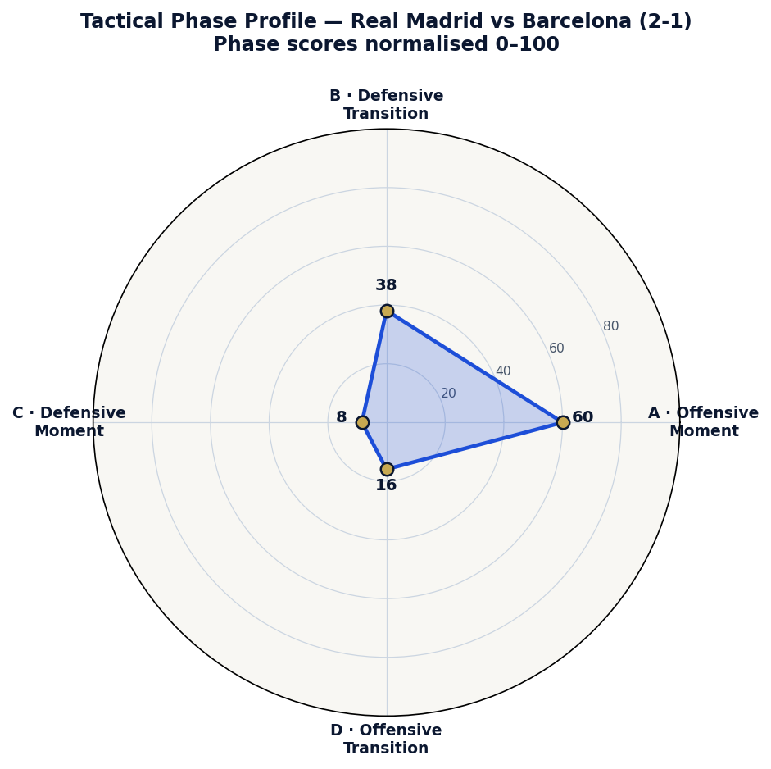
Figure 1. Four-phase tactical profile (A/B/C/D, normalised 0–100) for Real Madrid vs Barcelona (LaLiga 2025–26), computed live from Opta event data via the dashboard's phase-scoring model. The pronounced offensive-moment axis reflects the side's settled-attack productivity in this fixture.

8.2 Possession With Penetration
Across LaLiga 2025–26 the dashboard reports approximately 58.8% possession and 87.7% pass accuracy, yet the value lies in pairing these with field tilt and final-third activity: control is converted into territory rather than sterile circulation. Shot generation is distributed between settled build-up and transition, indicating a dual-threat profile.

8.3 Efficiency vs Expectation
With a season xG-for of about 66.0 against 72 goals scored, the team marginally outperforms chance quality (a goals/xG ratio just above 1.0), consistent with elite finishing — but the dashboard correctly flags this as a watch-point: sustained over-performance regresses, so the xGA side (about 38.6 vs 33 conceded) is the more reassuring structural indicator.
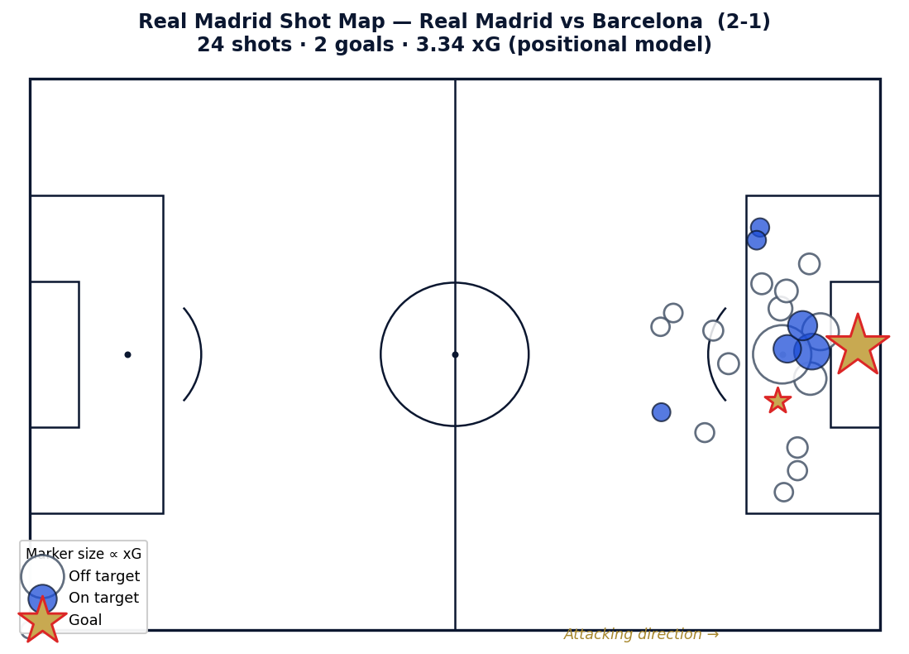
Figure 2. Real Madrid shot map for the showcase fixture, generated from the dashboard's get_shot_data pipeline. Marker size is proportional to positional-model xG; goals are highlighted. The concentration of high-xG attempts inside the box illustrates the side's central penetration.

8.4 Defensive Structure
PPDA values (season average about 9.5, with elite single-match presses near 3.3) describe a side that presses with controlled intensity rather than relentlessly — pressing selectively, then defending with a compact mid-block. The defensive-moment phase score, driven by low opponent shot volume, confirms structural solidity outside high-press windows.
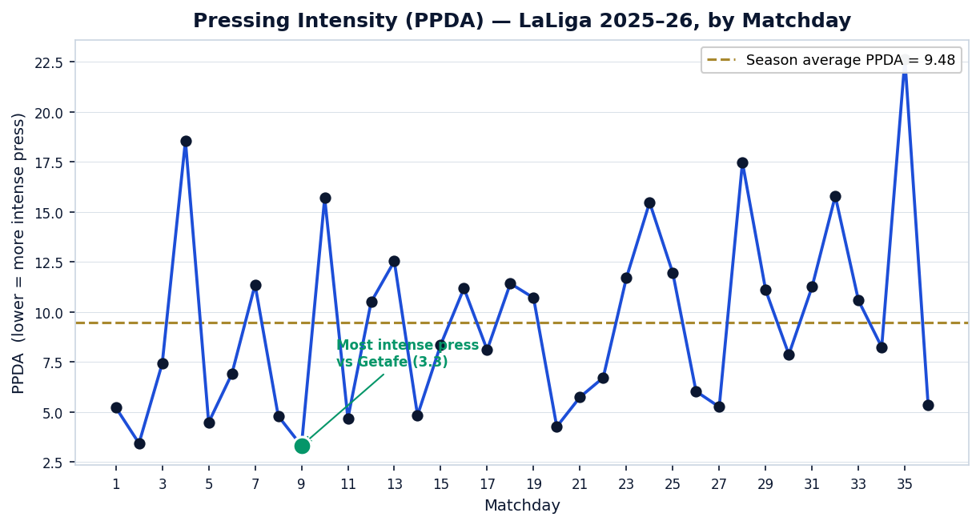
Figure 3. Pressing intensity (PPDA) across all 36 LaLiga 2025–26 matchdays, computed per match by the dashboard's calc_ppda function (lower = more intense press). The dashed line marks the season average; the variance illustrates the side's selective, game-state-dependent pressing.

8.5 Strengths, Weaknesses & Tactical Identity
Strengths:
- Elite, time-bounded transition threat (objectively quantified).
- Possession dominance that translates into territorial control.
- Strong chance suppression (low xGA) underpinning results.
Weaknesses / watch-points:
- Mild over-performance versus xG-for (variance risk).
- Pressing intensity is selective; lapses in mid-block compactness appear in worst-case PPDA matches.
- Reduced creativity against deep, compact defensive blocks.
Tactical identity conclusion: Real Madrid emerges, in data, as a proactive possession side with a world-class transition engine and disciplined defensive economy — winning through chance suppression and ruthless conversion of regains, rather than through pressing volume alone.

9 · Implementation Status Table
Feature / Module | Current Status | Improvements Needed
Match information & metadata | Implemented | Referee, weather, formation parsing
Season KPIs & trends (pre-match) | Implemented | Rolling-form windows, opponent-adjusted baselines
xG vs xGA / performance vs expectation | Implemented | Validate model vs provider xG
Shot maps (organised attack) | Implemented | xG-weighted markers, body-part split
Pass networks | Implemented | Edge-weighted lanes, phase filtering
PPDA & pressing (defensive strategy) | Implemented | Pressing-trigger detection, by-zone PPDA
Tactical phase scoring (A/B/C/D) | Implemented | Model validation; weighting sensitivity
Post-match review (xG curve, def. actions) | Implemented | Automated narrative summary
Player analysis (squad table, radars) | Implemented | Per-90 normalisation, role radars
Benchmarking (cross-competition) | Implemented | League-percentile context
Opponent analysis / scouting | Implemented | Opponent tendency modelling
Attacking transitions (Transition Metrics) | Implemented | Time-to-first-shot distribution
Possession recovery (Recoveries by Zone) | Implemented | High/mid/low zonal comparison
Final-third entries (+ Field Tilt) | Implemented | xG-from-entries, shot-probability maps
Set-piece analysis (Set Piece Efficiency) | Implemented | Dedicated set-piece shot maps
Shots-conceded heatmap | Planned | Defensive shot-concession map (count shown today)
Block-height visualisation | Planned | Defensive line-height metric & viz
Automated PDF/DOCX reporting | Implemented | Templated per-opponent scouting export
Cloud deployment (Render CI/CD) | Implemented | Caching/CDN for large dataset

10 · Limitations
- Event data only — no tracking. The pipeline observes on-ball events but not continuous off-ball positioning, so defensive shape and pressing distances can only be approximated.
- Possession is a proxy. Without ball-possession durations, possession% is computed from pass-volume share — directionally accurate but not a stopwatch figure.
- xG is a transparent positional model, not a provider model. It uses shot distance and angle only, omitting defensive pressure, assist type, and goalkeeper positioning, by design for auditability.
- Limited predictive modelling. The system is descriptive and diagnostic; it does not yet forecast outcomes or simulate tactical scenarios.
- No real-time ingestion. Analysis is post-hoc on stored files; there is no live in-match feed.
- Phase scores are weighted composites. They rank relative phase strength on a 0–100 scale and are sensitive to weighting choices; they are interpretive indices, not physical units.

11 · Future Scope
Clearly separated from current capability, the roadmap prioritises:
- Player-level analysis (deepened): per-90 normalised contributions, role-specific radars, on/off impact, and individual transition involvement.
- Multi-season dataset expansion: extend beyond two seasons for longitudinal trend and tactical-evolution tracking.
- Opponent modelling: automated extraction of opponent pressing triggers, build-up patterns, and set-piece tendencies for on-demand opposition reports.
- Predictive analytics: xG/xGA forecasting, expected-points projection, and transition-threat prediction conditioned on game state.
- AI-driven tactical clustering: unsupervised clustering of match phases and possession sequences to discover recurring patterns and detect anomalies automatically.
- Tracking-data integration: fusing optical/GPS tracking for off-ball positioning, pressing distances, defensive compactness, and pitch control.
- Video integration: linking each event/metric to synchronised clip timestamps.
- Real-time ingestion: live event streaming for in-match decision support.

12 · Tools & Technologies
Category | Technology | Purpose
Language | Python 3.11 | Core implementation
Data | Pandas, NumPy | Event parsing, vectorised aggregation
Modelling | Python math / SciPy | xG, PPDA, phase scoring
Visualisation | Plotly | Interactive pitch maps, charts, radars
Interface | Streamlit (Dash analytics core) | Interactive multi-page dashboard
Reporting | ReportLab, python-docx | Automated PDF/DOCX export
Data format | Opta Stats Perform event JSON | Source event data
Version control / CI-CD | Git, GitHub, Render | Reproducibility and deployment

13 · Conclusion
This project delivers a working, club-grade Real Madrid Tactical Dashboard that closes the data-to-decision gap for event-level football analysis. By normalising 108 Opta match files into a reproducible pipeline and computing a transparent, formula-documented suite of KPIs — positional xG, PPDA, field tilt, and a four-phase tactical model — it characterises how Real Madrid plays, not merely the result.
Tactical relevance: the platform objectively confirms and quantifies Real Madrid's identity — a possession-dominant side with an elite, time-bounded transition engine and disciplined chance suppression — and surfaces actionable watch-points (xG over-performance, selective pressing).
Value for professional football staff: the integrated pre-match, post-match, tactical-phase, and opposition views, combined with automated reporting, compress an analyst's preparation workflow into a single interactive environment aligned with elite-club standards.
Academic contribution: the thesis provides a fully documented, auditable methodology for phase-based football analysis — every metric is traceable to an explicit formula and to observed event data, with no synthetic values — making the work reproducible and extensible. The delineated roadmap positions the dashboard as a foundation for continued research and professional deployment rather than a finished endpoint.

Real Madrid CF Tactical & Player Performance Analytics · Data: Opta Stats Perform · Built with Python, Pandas, NumPy, Plotly and Streamlit
Sudhir Dahiya · Master's in Sports Analytics 2025–2026

