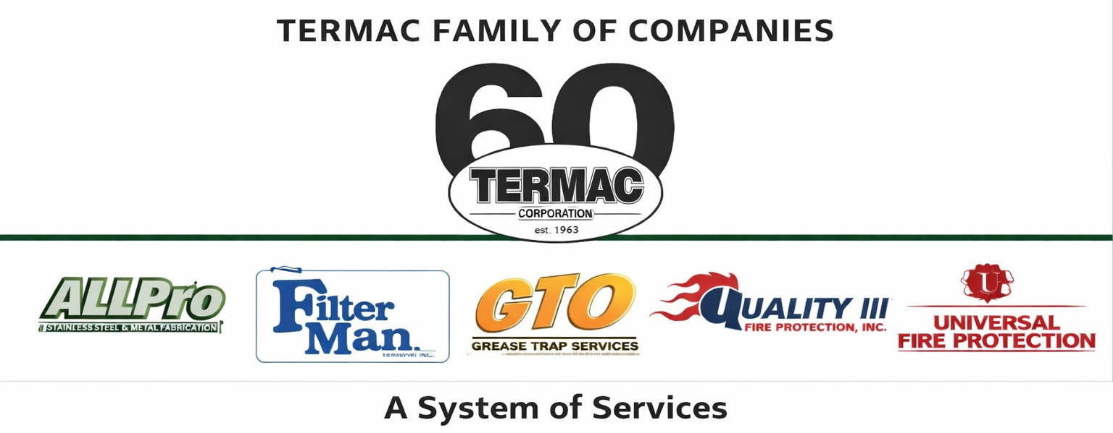

Delivery Driver
Termac · Driver · Termac Family of Companies
Effective Date: ________________ | Last Revised: ________________
Position Overview
The Delivery Driver is responsible for delivering chemicals, supplies, and equipment to Termac customer accounts across the service territory. This role requires safe vehicle operation, accurate delivery documentation, and professional customer interaction.
Key Responsibilities
- Load delivery vehicle accurately from warehouse pick list; verify quantities before departure
- Deliver products to customer locations on assigned route
- Obtain customer signature and log all deliveries in Termac OS
- Collect empty containers, return cores, and any defective equipment
- Report any road, vehicle, or customer issues to supervisor immediately
- Maintain clean, organized vehicle; perform pre-trip safety inspection daily
- Represent Termac professionally at every customer stop
Qualifications
- Valid driver's license with clean DMV record required
- DOT medical card required
- Ability to lift 50 lbs and operate a hand truck
- Prior delivery or route driver experience preferred
- Basic smartphone proficiency for Termac OS delivery logging
DOT Compliance
- Pre-trip inspection required before every shift
- Hours of service log maintained for vehicles subject to DOT regulations
- Post-accident drug/alcohol testing as required by company policy
- All vehicle incidents must be reported to supervisor immediately
Performance Metrics
- Delivery accuracy — zero short shipments or wrong deliveries
- On-time delivery rate
- Customer signatures captured on 100% of deliveries
- Vehicle inspection compliance
- Zero preventable accidents
ACKNOWLEDGMENT
I acknowledge receipt of this document and agree to comply with all provisions.
Employee Name (Print): _________________________________
Signature: _________________________________ Date: ____________
Manager Signature: _________________________________ Date: ____________

