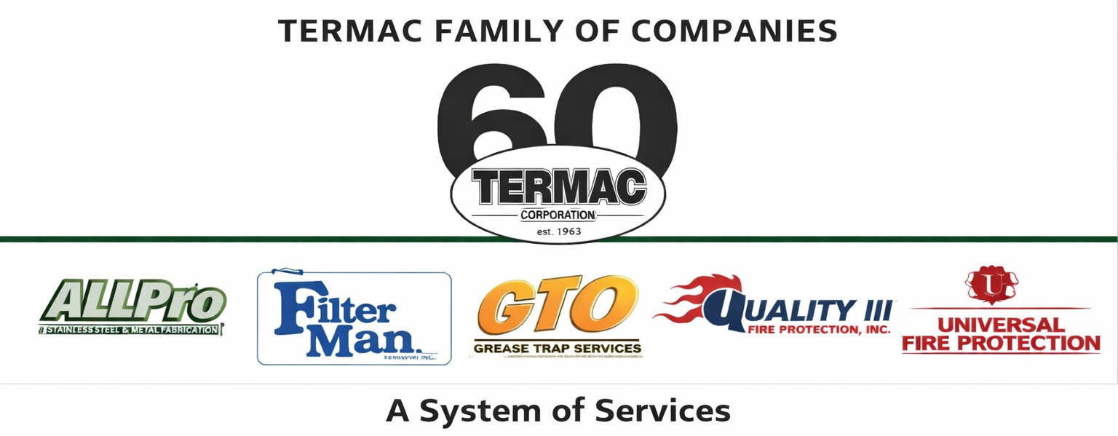

Division Manager
All Divisions · Management · Termac Family of Companies
Effective Date: ________________ | Last Revised: ________________
Position Overview
The Division Manager is the P&L owner and operational leader for their assigned Termac division. This role is responsible for revenue, team performance, customer retention, compliance, and operational efficiency within their division while supporting cross-divisional initiatives.
Key Responsibilities
- Own division P&L — revenue, direct costs, gross margin, and EBITDA contribution
- Lead division field team — technicians, scheduler, and support staff
- Maintain a healthy sales pipeline for the division and coordinate with the sales team on new accounts
- Ensure all field work is performed to NFPA and company compliance standards
- Monitor tech performance metrics — wrench time, first-fix rate, compliance documentation
- Manage division customer relationships; resolve escalations and maintain retention
- Coordinate with warehouse on inventory, kitting, and reorder for division-specific parts
- Report weekly to ownership and Sr. Account & Ops Manager on division health
Qualifications
- 5+ years experience in field service operations or related industry
- Demonstrated P&L management experience
- Strong team development and coaching skills
- Industry-specific knowledge for assigned division preferred (fire protection, grease services, fabrication)
- Valid driver's license; ability to perform field ride-alongs and customer visits
Performance Metrics
- Division revenue vs. target
- Gross margin vs. budget
- Customer retention rate (target 90%+)
- Tech utilization and wrench time
- Compliance documentation accuracy
- Team certification compliance rate
ACKNOWLEDGMENT
I acknowledge receipt of this document and agree to comply with all provisions.
Employee Name (Print): _________________________________
Signature: _________________________________ Date: ____________
Manager Signature: _________________________________ Date: ____________

