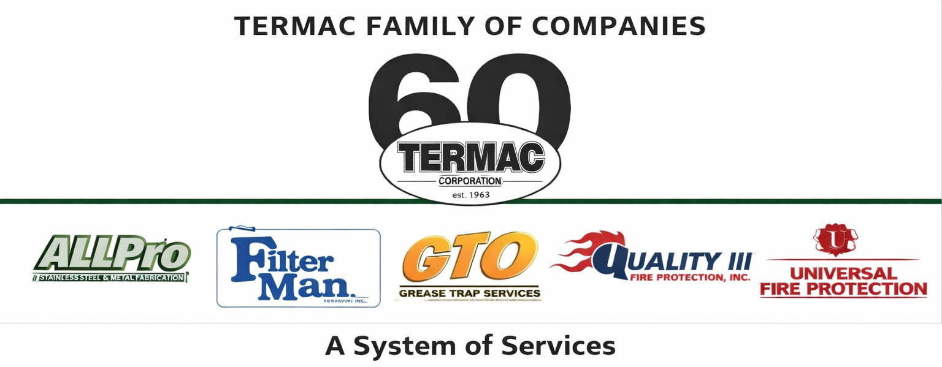

Field Technician
Termac Family of Companies — Job Description
Effective Date: ________________ | Last Revised: ________________

Position Overview
The Field Technician performs on-site fire protection inspections, commercial kitchen equipment service, grease trap operations, and hood filter exchanges for Termac's commercial accounts across the Eastern PA, NJ, DE, MD, and Washington D.C. territory. The tech is the face of Termac to the customer.

Key Responsibilities
- Perform fire extinguisher inspections, tagging, and recharging per NFPA 10 standards
- Inspect and service hood suppression systems per NFPA 17A and NFPA 96
- Conduct fire alarm testing, sprinkler inspections, and exit/emergency lighting surveys
- Perform grease trap pumping, cleaning, and FOG compliance documentation
- Execute hood filter exchanges on scheduled intervals per Filter Man protocols
- Document all inspections, deficiencies, and service findings in Termac OS
- Identify and report cross-sell opportunities; submit referral leads from the field
- Maintain assigned vehicle, tools, and equipment inventory

Qualifications
- High school diploma or equivalent required
- Valid driver's license with clean driving record required
- NICET certification preferred; company-sponsored training available
- Physical ability to lift 50 lbs, work at heights, and operate in commercial kitchen environments
- Strong attention to detail and documentation accuracy

Certifications Required
- First Aid / CPR / AED (company-provided training)
- OSHA 10 within first 90 days of employment
- Division-specific NFPA certifications as assigned
- DOT medical card if operating commercial vehicle over 10,001 lbs GVWR

Performance Metrics
- Jobs completed per day vs. route target
- First-time fix rate (target 90%+)
- Documentation accuracy and compliance cert turnaround
- Cross-sell referrals submitted (converted referrals earn $10–$20 bonus)
- Customer satisfaction — zero unresolved escalations
ACKNOWLEDGMENT
I acknowledge receipt of this document and agree to comply with all provisions.
Employee Name (Print): _________________________________
Signature: _________________________________ Date: ____________
Manager Signature: _________________________________ Date: ____________

