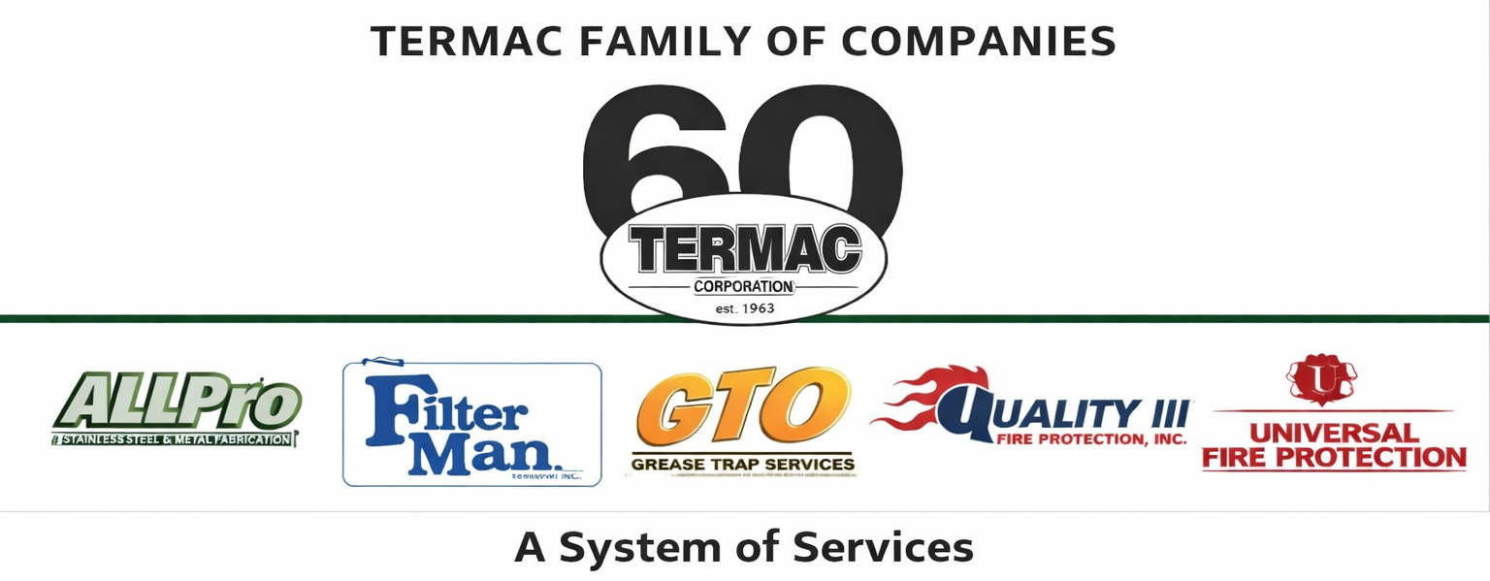

GTO Service Technician
GTO — Grease Trap Operations · Field Tech · Termac Family of Companies
Effective Date: ________________ | Last Revised: ________________
Position Overview
The GTO Service Technician performs commercial grease trap pumping, cleaning, and FOG (Fats, Oils & Grease) compliance documentation for Termac's GTO division accounts across the territory. This is a physically demanding field role with direct customer interaction and regulatory accountability.
Key Responsibilities
- Perform grease trap pump-outs and full cleanings per scheduled service intervals
- Complete and submit FOG compliance manifests for every service
- Inspect trap condition and report any structural or compliance issues
- Operate vacuum truck and associated equipment safely and per DOT requirements
- Log all service details, photos, and manifest numbers in Termac OS
- Maintain clean, professional appearance and interact directly with customer facilities staff
- Identify cross-sell opportunities for other Termac divisions and submit referral leads
Qualifications
- Valid driver's license required; CDL preferred for vacuum truck operation
- DOT medical certification required
- Ability to work outdoors in varying conditions; physical ability to handle vacuum hoses and equipment
- Prior grease trap or environmental services experience preferred
- Strong documentation habits
Certifications Required
- DOT Medical Card
- CDL Class B or willingness to obtain within 90 days
- Local FOG compliance training (company-provided)
- OSHA 10 within first 90 days
Performance Metrics
- Jobs completed per day vs. route target
- Manifest submission accuracy and timeliness
- Zero missed compliance documentation
- Customer satisfaction — no complaints on professionalism or access
- Cross-sell referrals submitted
ACKNOWLEDGMENT
I acknowledge receipt of this document and agree to comply with all provisions.
Employee Name (Print): _________________________________
Signature: _________________________________ Date: ____________
Manager Signature: _________________________________ Date: ____________

