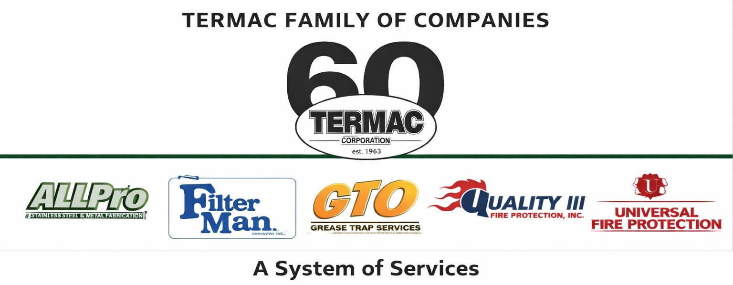

Office Administrator
Termac Family of Companies — Job Description
Effective Date: ________________ | Last Revised: ________________

Position Overview
The Office Administrator manages compliance documentation, customer communication, invoicing, and account record management for the Termac Family of Companies. This role is the compliance backbone of the organization — ensuring every service generates accurate records, every customer receives their documentation, and every deadline is tracked.

Key Responsibilities
- Process and issue inspection certificates within 48 hours of completed service
- Manage deficiency documentation and route quotes to customers within 5 business days
- Handle inbound customer calls and correspondence; return all calls within 2 hours
- Process service invoices with accuracy; coordinate with billing for AR follow-up
- Maintain account files, agreements, and contact records in Termac OS
- Flag compliance deadlines to the scheduling team before accounts lapse
- Support new account onboarding — collect signed agreements, Square setup, and account data entry

Qualifications
- High school diploma or equivalent required; associate's degree or higher preferred
- Strong organizational skills and attention to detail
- Professional phone and written communication
- Proficiency in Microsoft Office; CRM experience preferred
- Experience in service industry, compliance, or administrative operations a plus

Performance Metrics
- Certificate turnaround (target 48 hours)
- Deficiency quote follow-up (target 5 business days)
- Invoice accuracy (zero corrections needed)
- Customer call response time (target 2 hours)
- Zero accounts lapsed past compliance deadline without scheduler notification
ACKNOWLEDGMENT
I acknowledge receipt of this document and agree to comply with all provisions.
Employee Name (Print): _________________________________
Signature: _________________________________ Date: ____________
Manager Signature: _________________________________ Date: ____________

