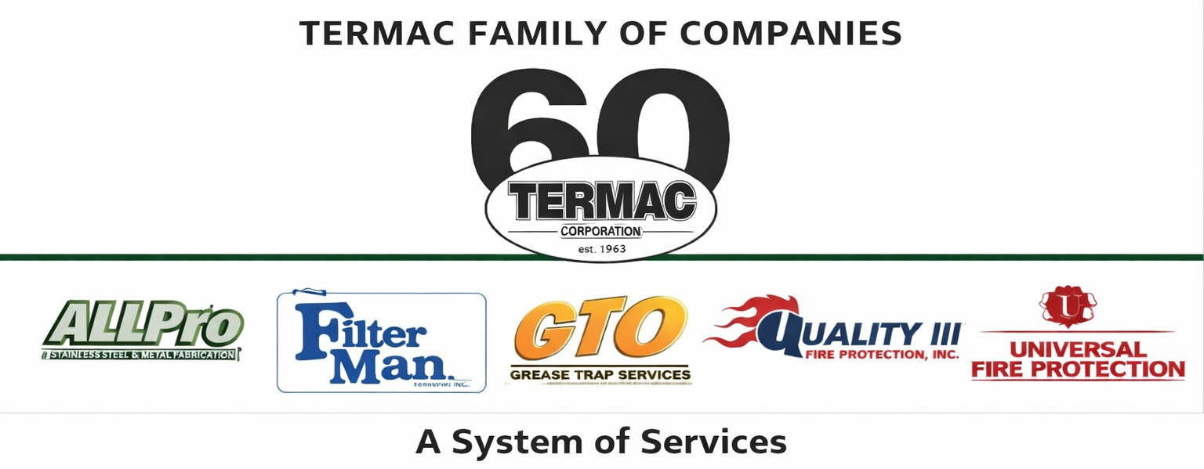

Sr. Account & Operations Manager
Corporate · Management · Termac Family of Companies
Effective Date: ________________ | Last Revised: ________________
Position Overview
The Senior Account and Operations Manager oversees sales operations, account management, and cross-divisional operational performance for the Termac Family of Companies. This role bridges sales strategy and field execution, ensures high-value accounts are retained and grown, and drives operational efficiency across all six divisions.
Key Responsibilities
- Lead and develop the sales team across assigned divisions; drive pipeline health and quota attainment
- Manage key accounts — maintain relationships, identify expansion opportunities, ensure satisfaction
- Oversee operational performance metrics: scheduling efficiency, tech utilization, wrench time
- Lead the development and maintenance of Termac One Revenue OS and related platforms
- Partner with ownership on compensation structures, IP agreements, and strategic initiatives
- Monitor divisional P&L performance; surface cost and revenue variances to ownership
- Coordinate cross-divisional initiatives — bundled contracts, shared accounts, territory optimization
- Represent Termac at key customer sites, partnership meetings, and strategic presentations
Qualifications
- 5+ years in B2B sales management or operations management
- Demonstrated ability to build and manage high-performing field sales teams
- Strong analytical skills — P&L literacy, pipeline management, performance metrics
- Experience with CRM development or platform building a strong plus
- Excellent communication and negotiation skills
- Fire protection, commercial kitchen, or field services industry experience preferred
Performance Metrics
- Team revenue vs. quota
- Key account retention rate (target 95%+)
- Divisional operational efficiency — tech utilization, wrench time, route efficiency
- Platform development milestones (Termac One Revenue OS)
- Cross-divisional bundled contract rate
ACKNOWLEDGMENT
I acknowledge receipt of this document and agree to comply with all provisions.
Employee Name (Print): _________________________________
Signature: _________________________________ Date: ____________
Manager Signature: _________________________________ Date: ____________

