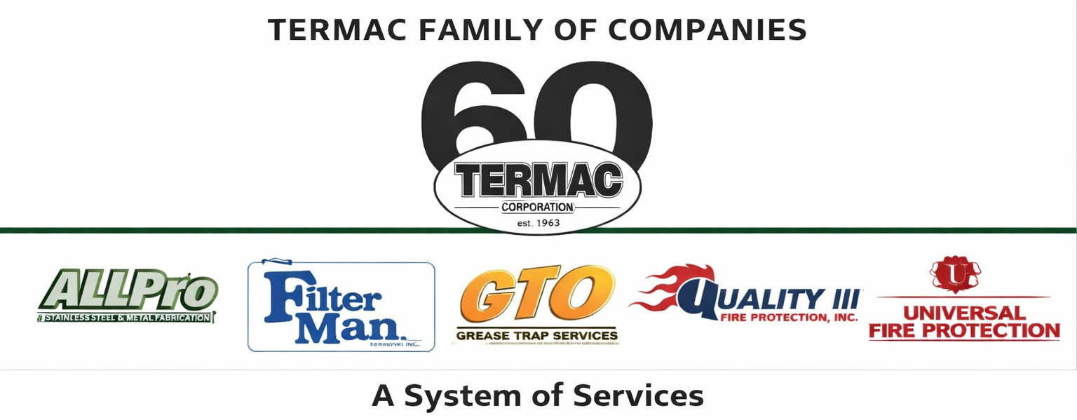

Stainless Steel Fabricator
AllPro · Skilled Trade · Termac Family of Companies
Effective Date: ________________ | Last Revised: ________________
Position Overview
The Stainless Steel Fabricator designs and produces custom commercial kitchen stainless steel equipment and components for AllPro division clients. Work includes sheet metal fabrication, welding, and finish work to NSF commercial kitchen standards.
Key Responsibilities
- Fabricate custom stainless steel equipment from customer specs and shop drawings
- Operate shears, brakes, welders, grinders, and polishers
- Ensure all finished products meet NSF/ANSI commercial kitchen standards
- Maintain accurate cut lists and material usage logs for COGS tracking
- Inspect completed work for weld quality, finish, and dimensional accuracy
- Coordinate with office on delivery scheduling and installation requirements
- Keep fabrication area clean, organized, and OSHA-compliant
Qualifications
- 2+ years stainless steel fabrication experience required
- MIG/TIG welding certification preferred
- Ability to read shop drawings and work from customer specifications
- Knowledge of NSF standards for commercial food service equipment
- Physical ability to lift 75 lbs and work with heavy gauge sheet stock
Performance Metrics
- Fabrication accuracy — zero rework on completed jobs
- Material waste percentage vs. target
- Jobs completed on schedule
- Quality inspection pass rate
- NSF compliance on all commercial kitchen items
ACKNOWLEDGMENT
I acknowledge receipt of this document and agree to comply with all provisions.
Employee Name (Print): _________________________________
Signature: _________________________________ Date: ____________
Manager Signature: _________________________________ Date: ____________

