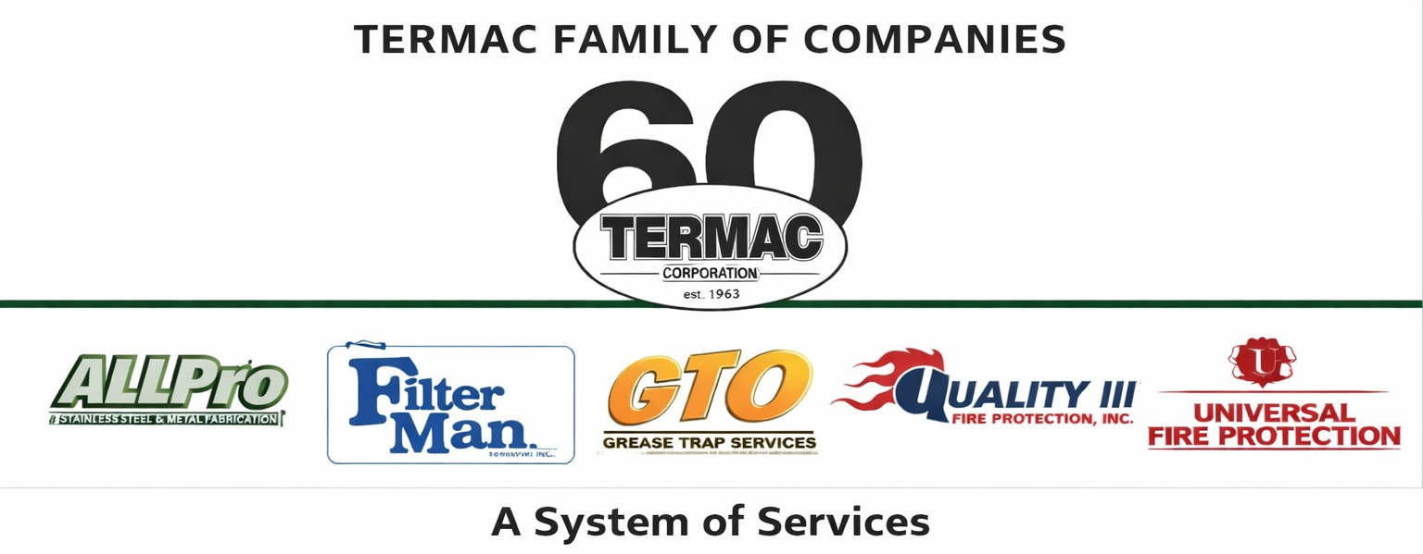

Warehouse Associate
Corporate · Warehouse · Termac Family of Companies
Effective Date: ________________ | Last Revised: ________________
Position Overview
The Warehouse Associate manages receiving, storage, kitting, and inventory accuracy across Termac's warehouse operations. This role supports all service divisions by ensuring the right parts are in the right place at the right time.
Key Responsibilities
- Receive and inspect all incoming inventory; log to correct division bin in Termac OS
- Pick and kit parts for scheduled field jobs based on technician work orders
- Process returns from field techs; restock van inventory after each return
- Conduct weekly cycle counts and reconcile discrepancies with the WMS
- Monitor reorder points and generate purchase requests when par levels are reached
- Maintain warehouse organization, bin labeling, and FIFO rotation
- Support fleet readiness — ensure vehicles are stocked per division kit standards
- Operate material handling equipment safely
Qualifications
- Warehouse or inventory experience preferred
- Physical ability to lift 50+ lbs and work on ladders
- Valid driver's license required
- Forklift certification preferred or willingness to obtain
- Basic computer proficiency for inventory system use
Performance Metrics
- Kitting accuracy (target zero field returns due to incorrect parts)
- Cycle count accuracy rate
- Reorder response time — no stockouts on high-velocity items
- Warehouse audit readiness score
ACKNOWLEDGMENT
I acknowledge receipt of this document and agree to comply with all provisions.
Employee Name (Print): _________________________________
Signature: _________________________________ Date: ____________
Manager Signature: _________________________________ Date: ____________

