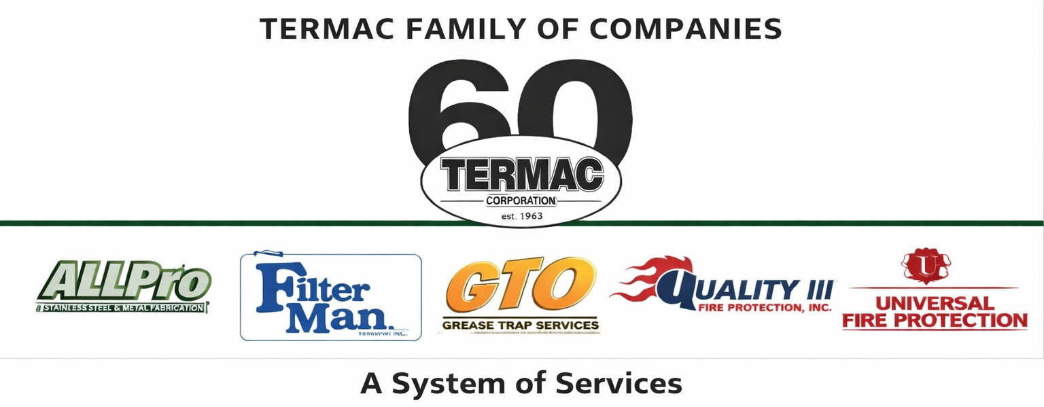

Warehouse / Inventory Technician
Termac Family of Companies — Job Description
Effective Date: ________________ | Last Revised: ________________

Position Overview
The Warehouse/Inventory Technician manages parts, supplies, and equipment inventory across Termac's service divisions. This role ensures field technicians are equipped for every job, kitting is accurate, reorder levels are maintained, and the warehouse is organized and audit-ready.

Key Responsibilities
- Receive, inspect, and log all incoming inventory to the correct division bins
- Pick and kit parts for scheduled jobs based on technician work orders
- Process return items and restock van inventory after field returns
- Conduct weekly cycle counts and flag discrepancies for manager review
- Maintain reorder triggers; generate purchase requests when par levels are reached
- Keep the warehouse organized, labeled, and inspection-ready at all times
- Support fleet readiness — ensure vehicles are stocked per division kit standards

Qualifications
- Warehouse or inventory experience preferred
- Physical ability to lift 50+ lbs and operate on ladders and dock equipment
- Valid driver's license required
- Forklift certification preferred or willingness to obtain
- Basic computer proficiency for inventory system entry

Performance Metrics
- Kitting accuracy (zero field returns due to incorrect parts)
- Cycle count accuracy rate
- Reorder response time — no stockouts on high-velocity items
- Warehouse audit readiness score
ACKNOWLEDGMENT
I acknowledge receipt of this document and agree to comply with all provisions.
Employee Name (Print): _________________________________
Signature: _________________________________ Date: ____________
Manager Signature: _________________________________ Date: ____________

