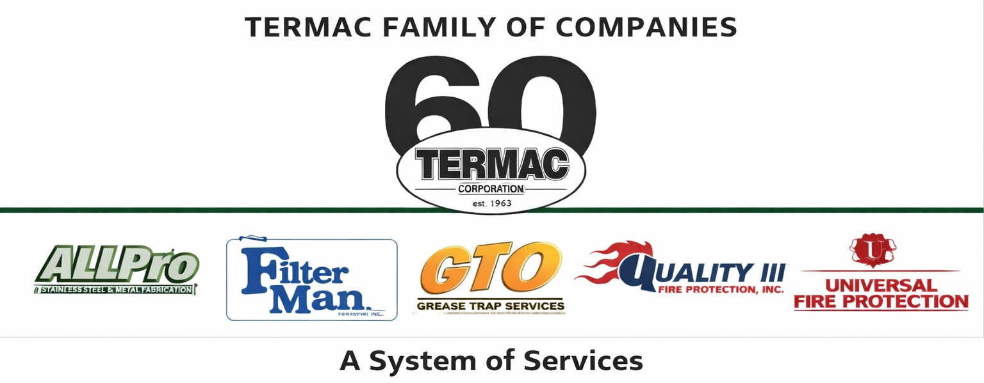

At-Will Employment Policy
Termac Family of Companies — Company Policy
Effective Date: ________________ | Last Revised: ________________

Policy Statement
Employment at Termac Family of Companies is at-will for all employees unless a written employment agreement expressly provides otherwise. At-will employment means either the company or the employee may terminate the employment relationship at any time, for any lawful reason, or for no reason, with or without notice.

What This Means
- Nothing in this handbook, any verbal statement, or any course of conduct creates a contract of employment for a specific duration.
- The at-will relationship can only be modified by a written agreement signed by the company's authorized representative.
- Policies and procedures described in this handbook are not promises of continued employment.

Mutual Courtesy
While employment is at-will, the company asks employees to provide at least two weeks written notice of resignation when possible, to allow for transition planning. The company will endeavor to provide reasonable notice of termination except in cases of gross misconduct.
ACKNOWLEDGMENT
I acknowledge receipt of this document and agree to comply with all provisions.
Employee Name (Print): _________________________________
Signature: _________________________________ Date: ____________
Manager Signature: _________________________________ Date: ____________

