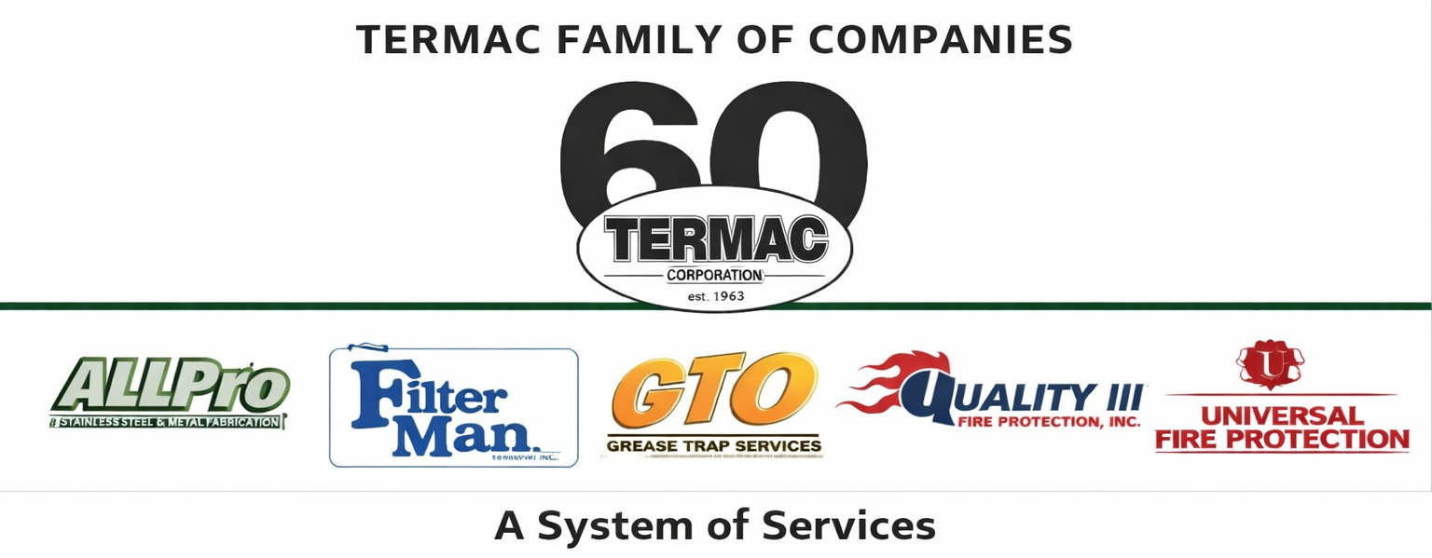

Drug-Free Workplace Policy
Termac Family of Companies — Company Policy
Effective Date: ________________ | Last Revised: ________________

Policy Statement
Termac Family of Companies maintains a drug-free workplace. The use, possession, distribution, or sale of illegal drugs or controlled substances on company property, in company vehicles, or while performing company business is strictly prohibited. Employees must report to work free from the influence of alcohol or any substance that impairs job performance.

Testing
- Pre-employment drug testing is required for all new hires.
- Post-accident testing may be required following any workplace incident or vehicle accident.
- Reasonable suspicion testing may be conducted when a supervisor has documented grounds to believe an employee is impaired.
- Random testing may be conducted for safety-sensitive positions.

Consequences
A positive drug test, refusal to test, or adulteration of a sample will result in disciplinary action up to and including immediate termination. Employees with prescription medications that may affect job performance must notify HR and their supervisor prior to beginning work.

Prescription Medication
- Legal prescription medications used as prescribed are permitted but must be disclosed if they affect the employee's ability to perform safety-sensitive duties.
- Employees operating company vehicles or heavy equipment while taking impairing medication must notify their supervisor before beginning their route.
ACKNOWLEDGMENT
I acknowledge receipt of this document and agree to comply with all provisions.
Employee Name (Print): _________________________________
Signature: _________________________________ Date: ____________
Manager Signature: _________________________________ Date: ____________

