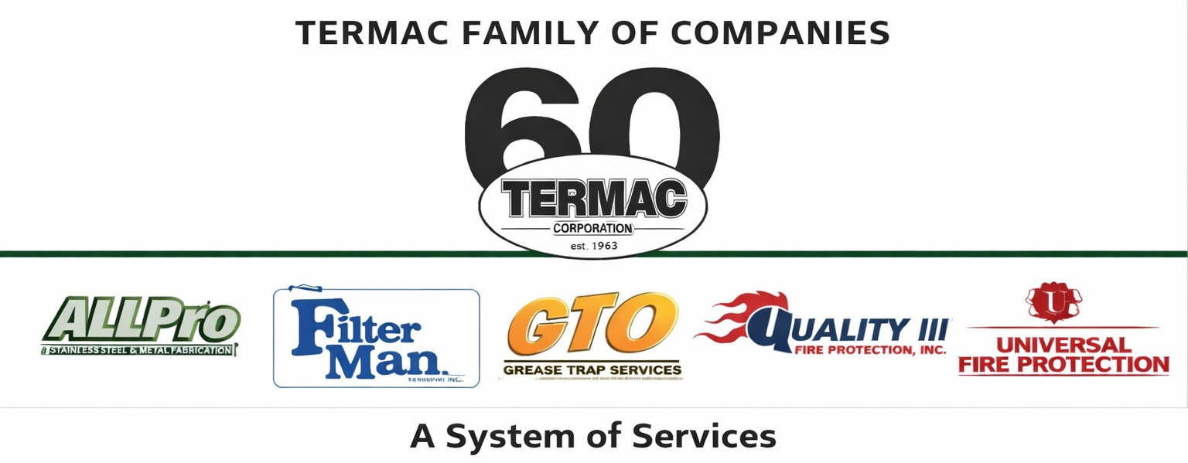

Employee Handbook — Introduction
Termac Family of Companies — Company Policy
Effective Date: ________________ | Last Revised: ________________

Welcome to the Termac Family of Companies
This handbook is your guide to employment at Termac. It describes our policies, expectations, and the standards we hold ourselves to every day. Read it completely and keep it accessible — it applies to every employee across all Termac divisions.

Our Mission
Termac exists to protect commercial businesses through reliable, compliant, expert service. We show up when scheduled. We document what we find. We stand behind our work. That mission requires every person on this team to take their role seriously.

How to Use This Handbook
- This handbook is not a contract of employment. It is a statement of current policies subject to change.
- Questions about specific policies should be directed to your direct supervisor or HR.
- Updates to this handbook will be communicated via Termac OS and require signed acknowledgment.
- Division-specific supplements may apply in addition to company-wide policies.

Core Values
- Show up — on time, prepared, and ready to work
- Do the job right — compliance is not optional
- Document everything — records protect customers and the company
- Be honest — with customers, teammates, and management
- Represent the brand — every interaction reflects on every employee
ACKNOWLEDGMENT
I acknowledge receipt of this document and agree to comply with all provisions.
Employee Name (Print): _________________________________
Signature: _________________________________ Date: ____________
Manager Signature: _________________________________ Date: ____________

