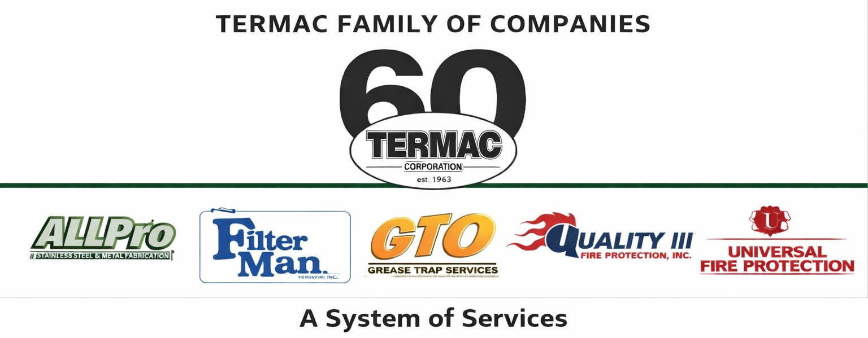

NFPA Code Compliance Standards
Termac Family of Companies — Company Policy
Effective Date: ________________ | Last Revised: ________________

Policy Statement
All Termac field personnel are required to perform inspections, installations, and service in accordance with applicable National Fire Protection Association (NFPA) standards. Compliance with NFPA codes is not optional — it protects our customers, protects the company from liability, and upholds our professional licensing.

Applicable Standards by Division

UniPro / Quality III (Fire Protection)
- NFPA 10 — Portable Fire Extinguishers: annual inspection, 6-year maintenance, 12-year hydrotesting
- NFPA 25 — Inspection, Testing and Maintenance of Water-Based Fire Protection Systems
- NFPA 72 — National Fire Alarm and Signaling Code
- NFPA 101 — Life Safety Code (exit/emergency lighting)

AllPro (Hood Suppression)
- NFPA 17A — Wet Chemical Extinguishing Systems: semi-annual inspection required
- NFPA 96 — Standard for Ventilation Control and Fire Protection of Commercial Cooking Operations

Filter Man (Hood Filter Exchange)
- NFPA 96 — grease accumulation standards
- Baffle filter orientation and installation per manufacturer specification

GTO (Grease Trap)
- Local FOG (Fats, Oils, Grease) ordinance compliance
- Manifest documentation required for all pump-outs

Documentation Requirements
- All inspection results must be documented in Termac OS immediately upon job completion
- Deficiencies must be logged with description, NFPA reference, and recommended corrective action
- Inspection certificates must be issued within 48 hours of completed service
- Records must be retained for a minimum of 3 years and be accessible for AHJ review upon request
ACKNOWLEDGMENT
I acknowledge receipt of this document and agree to comply with all provisions.
Employee Name (Print): _________________________________
Signature: _________________________________ Date: ____________
Manager Signature: _________________________________ Date: ____________

