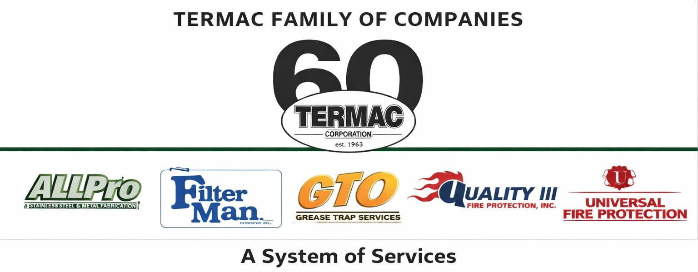

Progressive Discipline Procedure
Termac Family of Companies — Company Policy
Effective Date: ________________ | Last Revised: ________________

Policy Statement
Termac Family of Companies uses a progressive discipline process to address performance and conduct issues fairly and consistently. The goal of progressive discipline is correction and improvement, not punishment. However, the severity of the offense may warrant skipping steps, up to and including immediate termination.

Discipline Steps

Step 1: Verbal Warning
A documented conversation between the employee and supervisor identifying the issue, expected behavior, and timeline for improvement. A written summary is placed in the employee's HR file.

Step 2: Written Warning
A formal written notice describing the violation, prior discussions, required corrective action, and consequences of continued non-compliance. Employee signature is required (signature indicates receipt, not agreement).

Step 3: Final Written Warning / Suspension
A final documented warning with a clear statement that termination will follow if the behavior continues. May include unpaid suspension at management's discretion.

Step 4: Termination
Separation from employment following failure to correct the identified issue, or for a single serious offense warranting immediate termination.

Immediate Termination Offenses
- Theft, fraud, or dishonesty
- Violence or threats of violence
- Positive drug test or refusal to test
- Gross safety violation resulting in injury or significant risk
- Disclosure of confidential information to a competitor
- Sexual harassment or discriminatory conduct
ACKNOWLEDGMENT
I acknowledge receipt of this document and agree to comply with all provisions.
Employee Name (Print): _________________________________
Signature: _________________________________ Date: ____________
Manager Signature: _________________________________ Date: ____________

