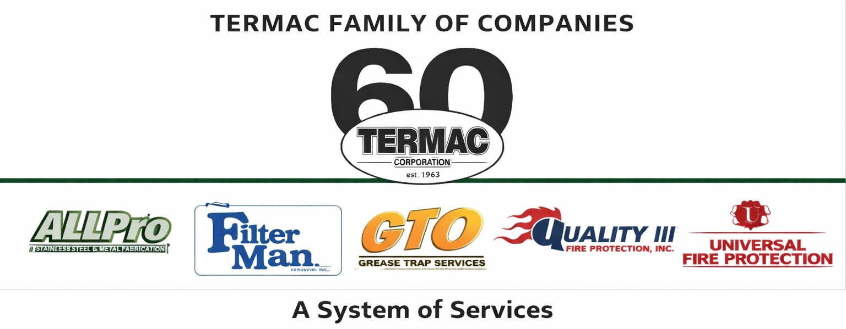

Safety & OSHA Compliance Policy
Termac Family of Companies — Company Policy
Effective Date: ________________ | Last Revised: ________________

Policy Statement
Termac Family of Companies is committed to maintaining a safe and healthy work environment in compliance with OSHA standards and all applicable federal, state, and local safety regulations. Safety is every employee's responsibility — there is no job worth performing at the cost of personal or coworker safety.

Employee Responsibilities
- Follow all safety rules, procedures, and OSHA regulations applicable to your role
- Use required PPE at all times in designated areas or when performing designated tasks
- Report all injuries, near-misses, and unsafe conditions to a supervisor immediately
- Participate in required safety training and maintain current certifications
- Never disable or bypass safety equipment or procedures

PPE Requirements by Role

Field Technicians
- Safety-toe footwear on all job sites
- Cut-resistant gloves when handling filters, sheet metal, or equipment
- Eye protection when working with chemicals or pressurized systems
- Respiratory protection when entering confined spaces or working with chemical agents

Warehouse Staff
- Safety-toe footwear
- High-visibility vest when operating near vehicle traffic
- Gloves for handling equipment and materials

Incident Reporting
All workplace injuries must be reported to the supervisor within 24 hours and documented on the company incident report form. OSHA recordable injuries will be logged on the OSHA 300 log maintained by HR. Employees are never to be discouraged from reporting injuries.
ACKNOWLEDGMENT
I acknowledge receipt of this document and agree to comply with all provisions.
Employee Name (Print): _________________________________
Signature: _________________________________ Date: ____________
Manager Signature: _________________________________ Date: ____________

