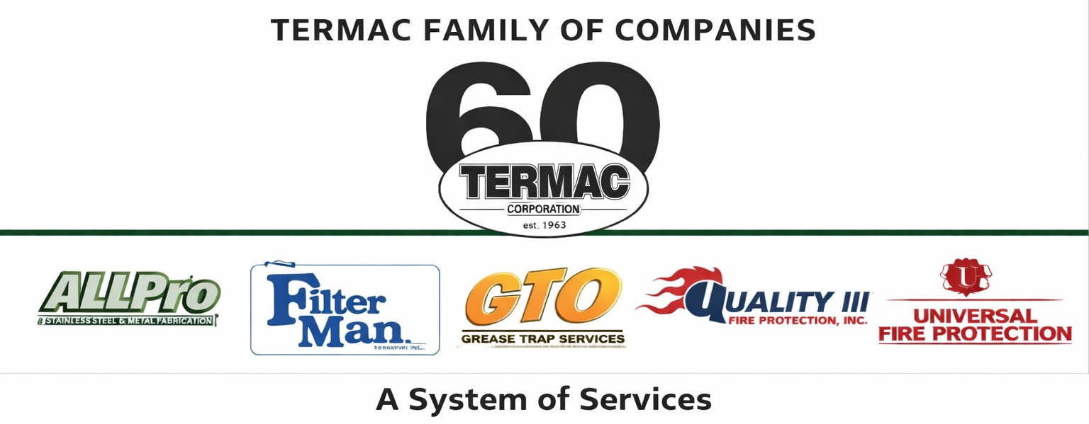

Benefits Overview
Termac Family of Companies — Company Policy
Effective Date: ________________ | Last Revised: ________________

Overview
- Termac Family of Companies offers a benefits package designed to support the health, financial wellbeing, and work-life balance of our employees. Benefits eligibility and details are subject to current plan documents, which supersede this summary.

Health & Wellness
- Medical insurance — company-sponsored health insurance available to full-time employees after the eligibility waiting period.
- Dental insurance — dental coverage available as part of the benefits package.
- Vision insurance — vision coverage available as part of the benefits package.
- Employees may add eligible dependents to their coverage during open enrollment or qualifying life events.

Financial Benefits
- 401(k) retirement plan — eligible employees may participate in the company retirement savings plan. Details on company match provided separately.
- Life insurance — company-provided basic life insurance for eligible full-time employees.
- Paid Time Off — refer to the PTO, Sick Leave & Vacation Policy for details.

Additional Benefits
- Paid holidays — company observes standard paid holidays as published annually.
- Direct deposit — all employees are encouraged to enroll in direct deposit for payroll.
- Employee referral program — employees who refer candidates who are hired and complete 90 days receive a referral bonus per current program terms.

Changes to Benefits
- Benefits may change annually during open enrollment. Employees will be notified of any material changes.
- In the event of any conflict between this summary and the official plan documents, the official plan documents govern.

ACKNOWLEDGMENT
I acknowledge receipt of this document and agree to comply with all provisions.

Employee Name (Print): _________________________________

Signature: _________________________________ Date: ____________

Manager Signature: _________________________________ Date: ____________

