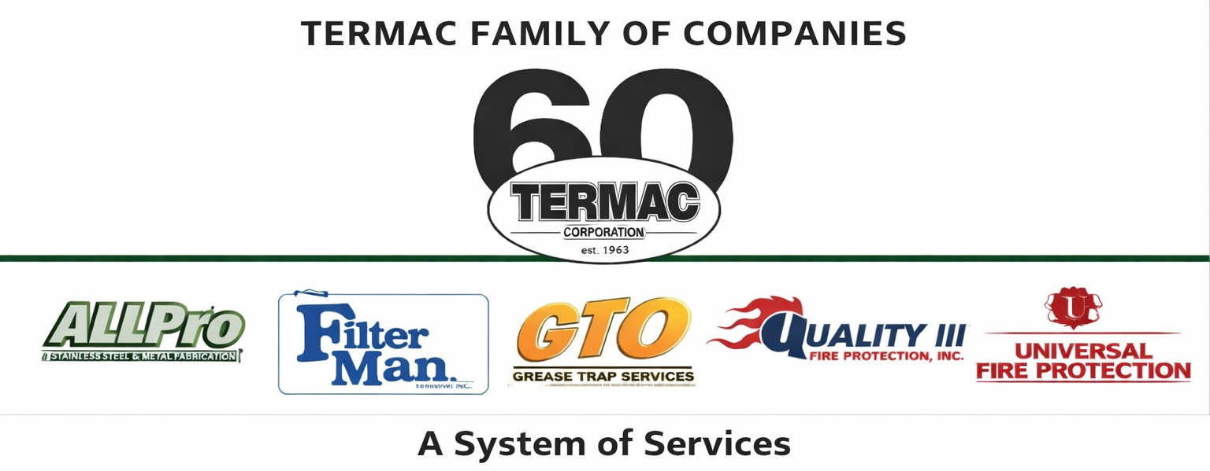

DOT / CDL Driver Requirements Policy
Termac Family of Companies — Company Policy
Effective Date: ________________ | Last Revised: ________________

Scope
- This policy applies to all employees who operate commercial motor vehicles (CMVs) requiring a Commercial Driver's License (CDL) in the course of their duties for Termac Family of Companies.

Licensing Requirements
- All drivers must maintain a valid CDL appropriate for the class of vehicle operated.
- CDL must be current and in good standing at all times while on duty.
- Drivers must immediately notify their supervisor of any license suspension, revocation, or restriction.

DOT Physical Requirements
- All CDL drivers must maintain a current DOT Medical Examiner's Certificate.
- Medical certificates must be renewed before expiration — failure to do so results in removal from driving duties.
- The company tracks DOT physical expiration dates and will provide 60-day advance notice.

Hours of Service
- Drivers must comply with all FMCSA Hours of Service regulations.
- Drivers are responsible for maintaining accurate logs and may not falsify records.
- Violations of HOS regulations will result in disciplinary action up to and including termination.

Drug & Alcohol Testing
- All CDL drivers are subject to DOT-mandated pre-employment, random, post-accident, and return-to-duty drug and alcohol testing.
- A positive test result or refusal to test results in immediate removal from driving duties and termination.

ACKNOWLEDGMENT
I acknowledge receipt of this document and agree to comply with all provisions.

Employee Name (Print): _________________________________

Signature: _________________________________ Date: ____________

Manager Signature: _________________________________ Date: ____________

