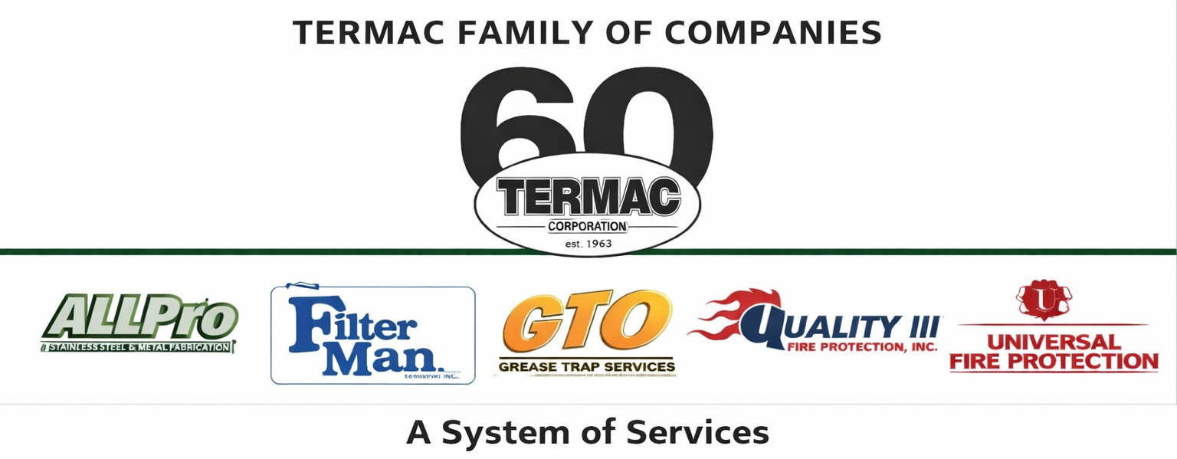

Expense Reimbursement Policy
Termac Family of Companies — Company Policy
Effective Date: ________________ | Last Revised: ________________

Policy Statement
- Termac Family of Companies will reimburse employees for reasonable, necessary, and properly documented business expenses incurred in the performance of their job duties.

Covered Expenses
- Mileage — reimbursed at the current IRS standard mileage rate for business travel in personal vehicles (not applicable to employees with company vehicles).
- Tolls and parking — reimbursed with receipt.
- Business meals — reimbursed with receipt and a description of the business purpose and attendees. Alcohol is not reimbursable.
- Supplies and materials — pre-approved job-related purchases reimbursed with receipt.

Submission Requirements
- All expenses must be submitted within 30 days of being incurred.
- Receipts are required for all expenses over $10.
- Mileage must be logged with origin, destination, and purpose.
- Submit expense reports to your manager for approval prior to submission to accounting.

Non-Reimbursable Expenses
- Personal expenses, fines, or traffic violations.
- Alcohol or entertainment not pre-approved by management.
- Expenses incurred outside the scope of employment.
- Any expense not supported by a receipt (unless mileage).

ACKNOWLEDGMENT
I acknowledge receipt of this document and agree to comply with all provisions.

Employee Name (Print): _________________________________

Signature: _________________________________ Date: ____________

Manager Signature: _________________________________ Date: ____________

