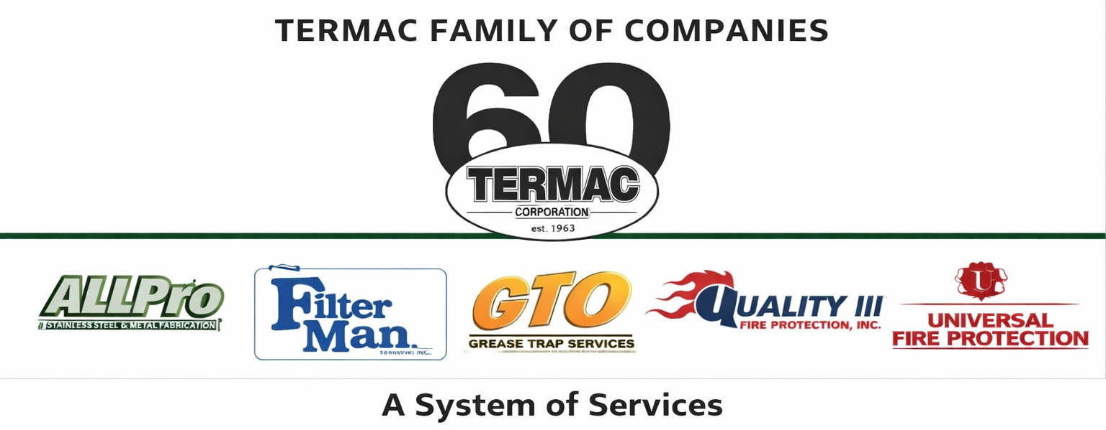

Grievance & Complaint Procedure
Termac Family of Companies — Company Policy
Effective Date: ________________ | Last Revised: ________________

Policy Statement
- Termac Family of Companies is committed to resolving workplace concerns promptly and fairly. Employees are encouraged to raise concerns without fear of retaliation.

Informal Resolution
- Employees are encouraged to first attempt informal resolution by discussing the concern directly with their immediate supervisor.
- If the concern involves the supervisor, or if informal resolution fails, the employee should proceed to the formal grievance process.

Formal Grievance Process
Step 1 — Employee submits a written grievance to HR Manager or senior management describing the issue, relevant dates, individuals involved, and desired resolution.
Step 2 — HR Manager or designee reviews the grievance and schedules a meeting with the employee within 5 business days.
Step 3 — Investigation is conducted. A written response is provided within 10 business days of the initial meeting.
Step 4 — If the employee is not satisfied with the response, the matter may be escalated to the company owner or authorized executive.

Non-Retaliation
- No employee will be retaliated against for filing a good-faith grievance.
- Retaliation is a separate and serious violation subject to disciplinary action up to and including termination.

ACKNOWLEDGMENT
I acknowledge receipt of this document and agree to comply with all provisions.

Employee Name (Print): _________________________________

Signature: _________________________________ Date: ____________

Manager Signature: _________________________________ Date: ____________

