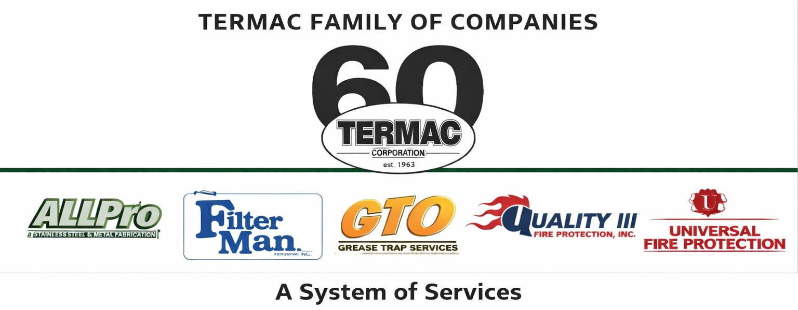

PPE & Personal Protective Equipment Policy
Termac Family of Companies — Company Policy
Effective Date: ________________ | Last Revised: ________________

Policy Statement
- Termac Family of Companies is committed to providing a safe working environment. Personal Protective Equipment (PPE) will be provided and must be worn when required for the job.

Required PPE by Role
- Field Technicians (UniPro, GTO, Filter Man) — safety glasses, gloves, steel-toed boots, and high-visibility vest when required by site or NFPA regulations.
- Stainless Steel Fabricators (AllPro) — safety glasses, face shield when grinding, cut-resistant gloves, steel-toed boots, and hearing protection as required.
- Delivery Drivers — steel-toed boots and high-visibility vest when making deliveries.
- Warehouse Associates — safety glasses, gloves, and steel-toed boots at all times in the warehouse.

Employee Responsibilities
- Wear all required PPE at all times in designated areas or when performing designated tasks.
- Inspect PPE before each use and report damaged or defective equipment immediately.
- Never modify PPE or use damaged equipment.
- Store PPE properly when not in use.

Company Responsibilities
- Provide required PPE at no cost to the employee.
- Train employees on proper PPE use, care, and limitations.
- Replace worn or damaged PPE promptly.

Non-Compliance
- Failure to wear required PPE is a serious safety violation subject to disciplinary action up to and including termination.

ACKNOWLEDGMENT
I acknowledge receipt of this document and agree to comply with all provisions.

Employee Name (Print): _________________________________

Signature: _________________________________ Date: ____________

Manager Signature: _________________________________ Date: ____________

