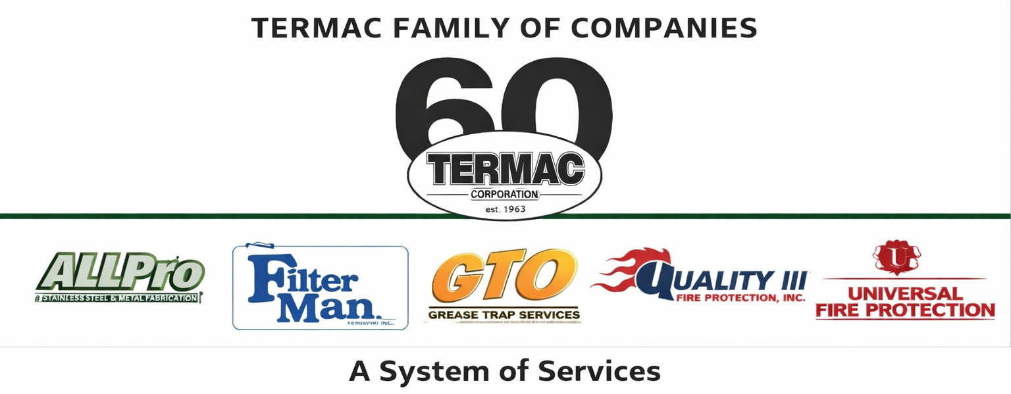

Social Media Policy
Termac Family of Companies — Company Policy
Effective Date: ________________ | Last Revised: ________________

Policy Statement
- Social media use — both personal and professional — can impact the reputation of Termac Family of Companies. This policy establishes expectations for responsible social media conduct.

Personal Social Media
- Employees may use personal social media accounts on personal time using personal devices.
- Do not post confidential company information, customer data, pricing, or proprietary processes.
- Do not make statements that could be construed as speaking on behalf of Termac unless specifically authorized.
- Do not post negative, disparaging, or inflammatory comments about the company, customers, colleagues, or competitors.

Company Social Media
- Only authorized employees may post on behalf of Termac Family of Companies social media accounts.
- All company posts must be approved by management before publishing.
- Customer photos, site photos, or job-site content must not be posted without explicit written customer consent.

Prohibited Content
- Confidential business information, trade secrets, or customer data.
- Harassment, discrimination, or defamatory statements.
- Content that violates any law or company policy.
- Photos or video from customer sites without written consent.

Violations
- Violations of this policy may result in disciplinary action up to and including termination, and may expose the employee to personal legal liability.

ACKNOWLEDGMENT
I acknowledge receipt of this document and agree to comply with all provisions.

Employee Name (Print): _________________________________

Signature: _________________________________ Date: ____________

Manager Signature: _________________________________ Date: ____________

