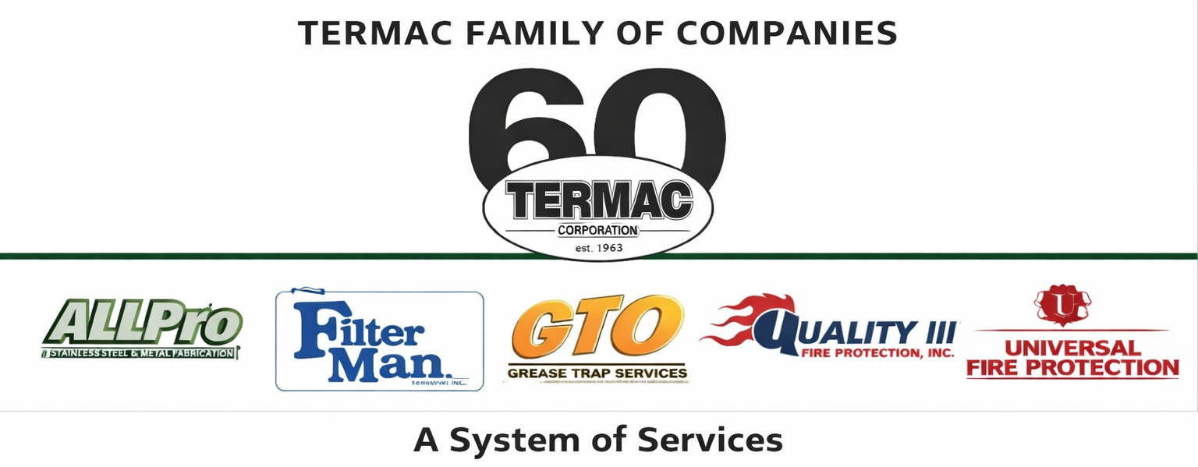

Uniform & Appearance Standards Policy
Termac Family of Companies — Company Policy
Effective Date: ________________ | Last Revised: ________________

Policy Statement
- Termac Family of Companies employees represent our brand in the field and at customer locations every day. A professional appearance reinforces trust and reflects the quality of our services.

Field & Technical Employees
- Company-issued uniform shirts and pants must be worn at all times when on duty or at customer locations.
- Uniforms must be clean, pressed, and in good repair. Torn, stained, or damaged uniforms must be replaced.
- Company-issued ID badge must be visible at all times when on a customer site.
- Steel-toed boots are required for all field roles — must be clean and in safe condition.

Office Employees
- Business casual attire is the standard for office employees.
- Clothing must be clean, professional, and appropriate for a workplace environment.
- Attire that is torn, excessively casual, or bearing offensive graphics or language is not permitted.

Personal Grooming
- Personal hygiene and grooming must meet professional workplace standards.
- Tattoos that are visible must not be offensive or inappropriate.
- Excessive fragrance (cologne/perfume) should be avoided in the workplace and especially at customer sites.

Non-Compliance
- Employees who report to work out of uniform or in violation of appearance standards may be sent home without pay to change.
- Repeated violations are subject to progressive disciplinary action.

ACKNOWLEDGMENT
I acknowledge receipt of this document and agree to comply with all provisions.

Employee Name (Print): _________________________________

Signature: _________________________________ Date: ____________

Manager Signature: _________________________________ Date: ____________

