BOHLALE GRC
Administrator Guide
Setting up, configuring, and managing your organisation
Govern. Protect. Comply.

Contents

1. Introduction
Bohlale GRC is a governance, risk and compliance workspace built around a South Africa-first Framework Library (POPIA, PAIA, King IV, and international standards like ISO/IEC 27001 and NIST CSF), guided PDCA implementation journeys, a risk register, a control library with Statement of Applicability, evidence management, audits, and management review.
This guide is for the people who set up and administer a Bohlale GRC tenant: creating the organisation, inviting colleagues, assigning roles, and managing the Framework Library. If you're looking for day-to-day usage of the individual modules (risks, controls, audits, etc.), see the companion User Guide instead.
Every screenshot in this guide was captured from a live instance running the current codebase, so what you see here matches what you'll see in the product.

2. Getting Started

2.1 Signing in
Every user signs in with their email address and password at the login screen. There is no separate "admin" login URL — administrator privileges are granted per-organisation via roles (see section 3.2), not by a different login path.
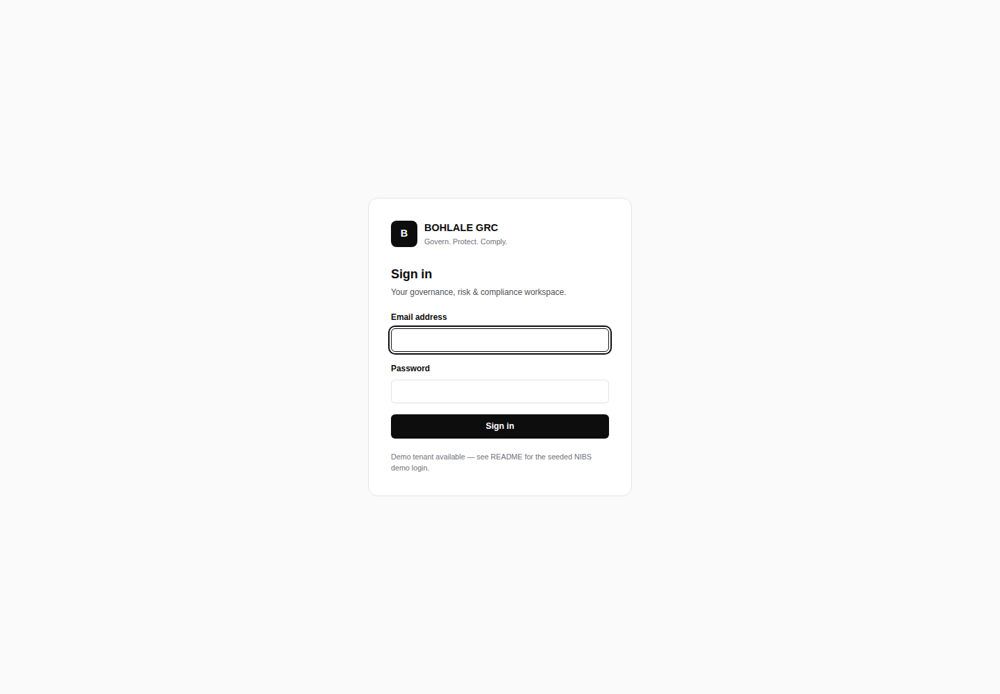
Figure 1 — Sign-in screen

2.2 Creating your organisation
The first thing any new account does is create an organisation (a tenant). Every piece of data in Bohlale GRC — risks, controls, documents, evidence — belongs to exactly one organisation, and users only ever see data for the organisation(s) they're a member of.
Only the organisation Name is required; industry, registration number, province, size and a logo can all be filled in later from Settings. The user who creates the organisation automatically becomes its first Org Admin.
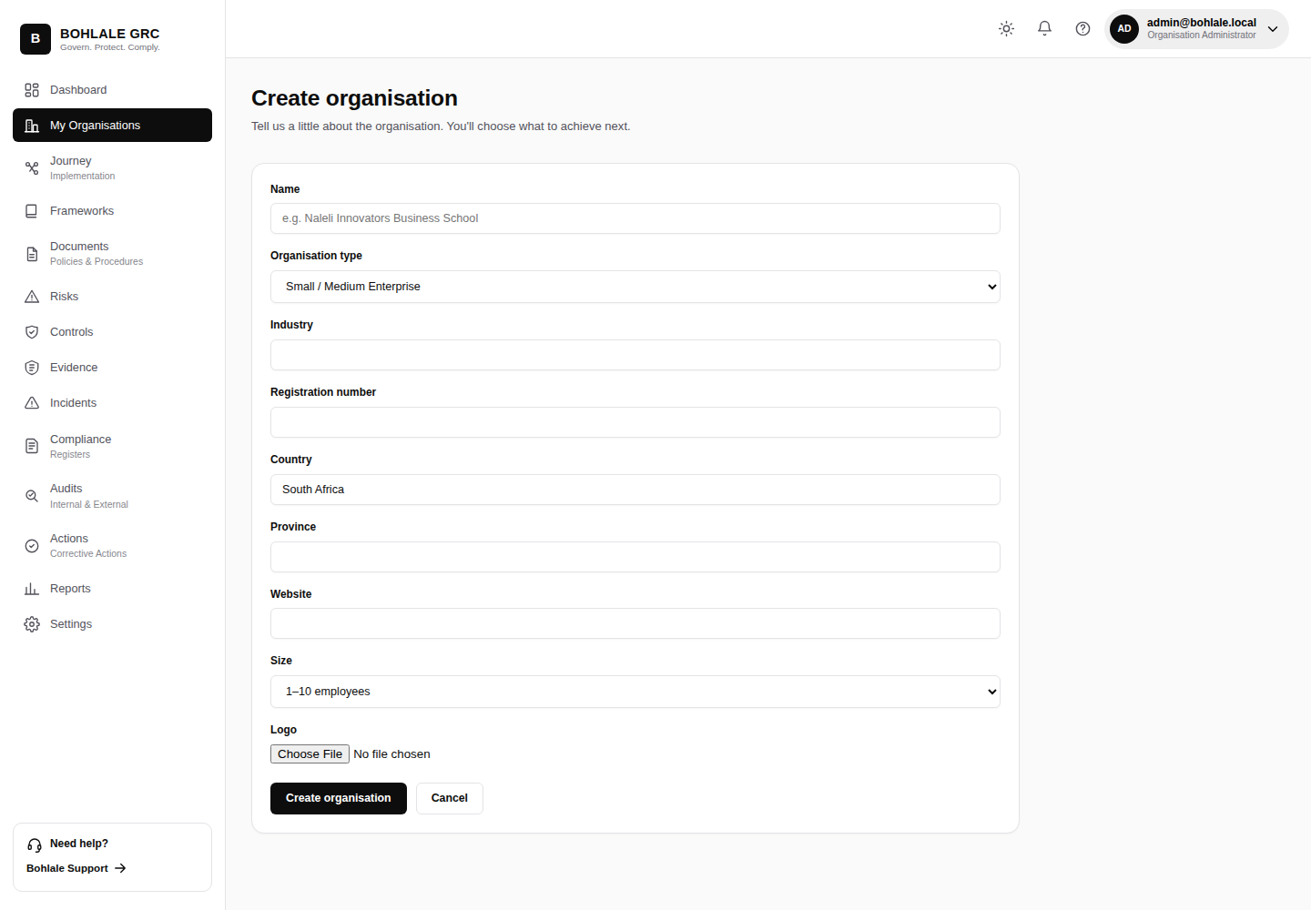
Figure 2 — Create organisation form

2.3 Onboarding: choosing a goal and framework(s)
Immediately after creating the organisation, the onboarding wizard asks what the organisation is trying to achieve (build a management system from scratch, run a gap assessment, prepare for certification, assess POPIA compliance, import an existing framework, etc.). Depending on the goal, it then presents the Framework Library so one or more frameworks can be selected.
The first framework selected becomes the organisation's primary guided journey; any additional frameworks chosen are added straight to the Framework Library for tracking, without starting a second guided journey. This lets an administrator adopt a broad baseline (e.g. ISO 27001 plus POPIA plus King IV) in a single step.
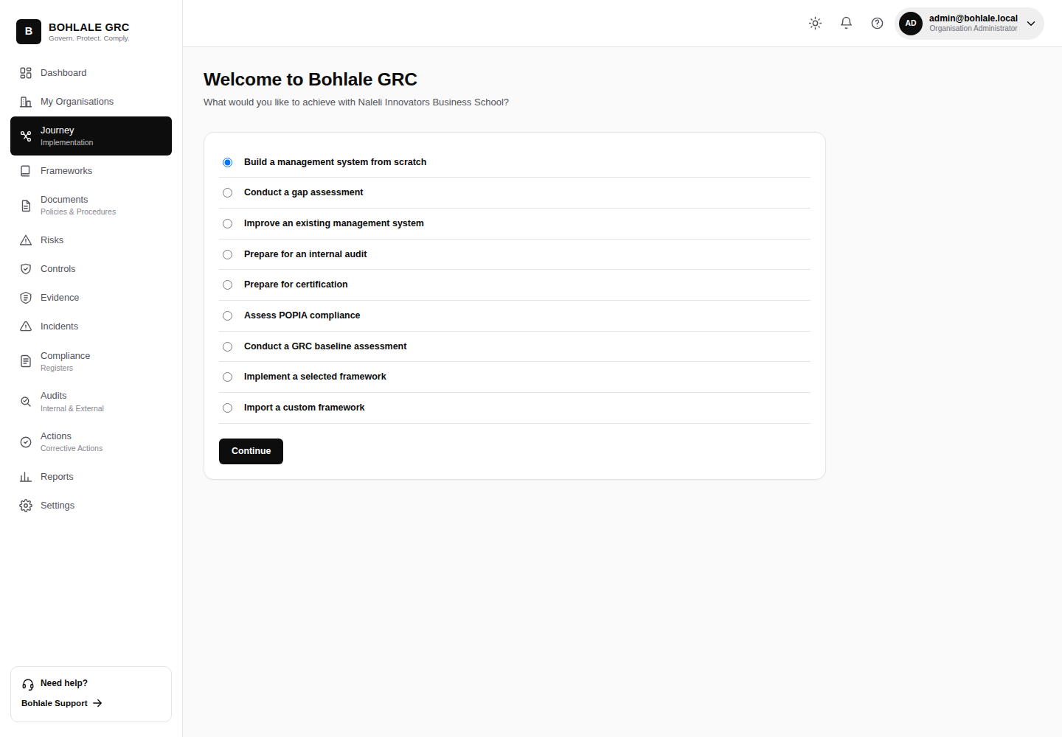
Figure 3 — Onboarding: choose a goal

3. Organisation & User Management

3.1 Settings
Settings (sidebar → Settings, or /organisations/settings/) is the organisation-admin control centre: the member list, pending invitations, and role management all live here.
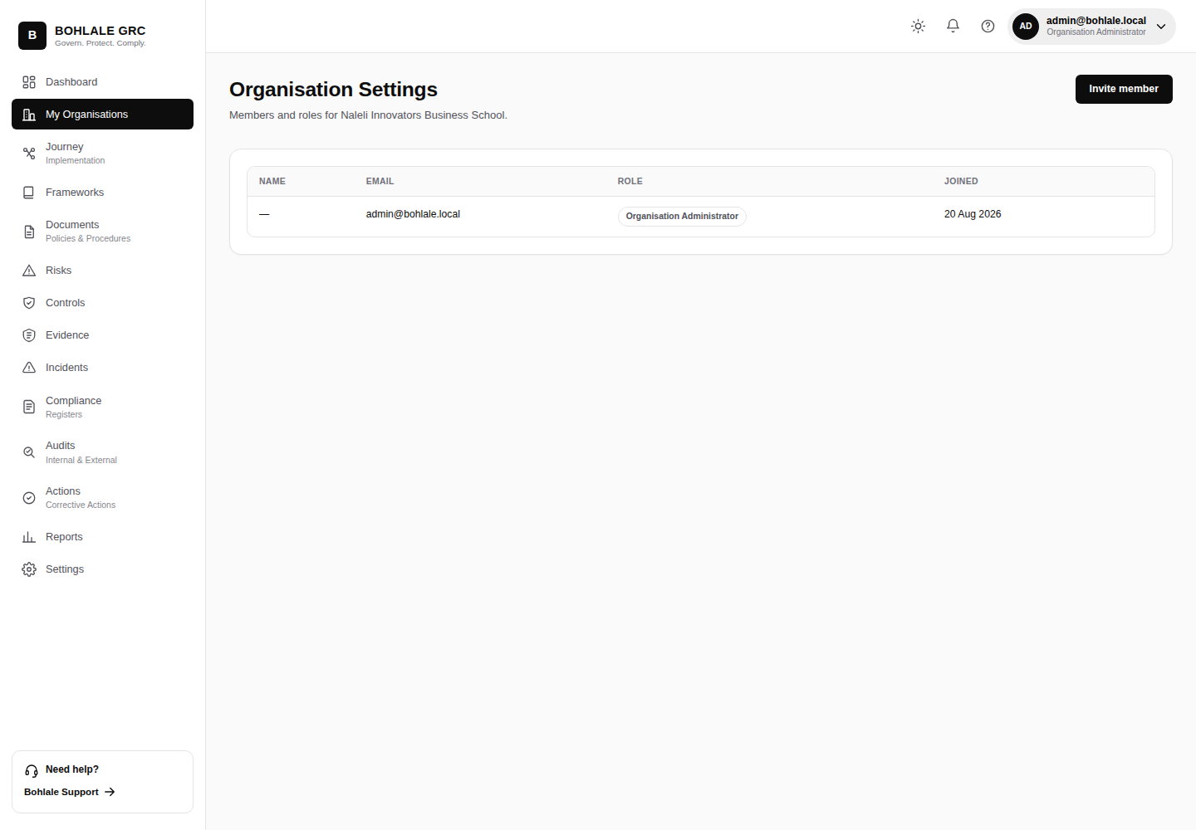
Figure 4 — Settings: members & invitations

3.2 Roles (RBAC)
Bohlale GRC uses row-level, per-organisation role-based access control. A person's role is a property of their membership in a specific organisation — the same person can hold different roles in different organisations.
Role | Can do
Org Admin | Everything: invite/remove members, change roles, manage organisation settings, plus full read/write access to every module.
Editor / Contributor | Create and edit records across the modules they're granted (risks, controls, evidence, documents, etc.) but cannot manage members or organisation settings.
Viewer | Read-only access — can see records and reports but cannot create, edit, or approve anything.

Only an Org Admin can invite new members or change anyone's role — the invite and role-change actions raise a permission error for anyone else, both in the UI and if attempted directly via URL.

3.3 Inviting a member
From Settings, an Org Admin enters the new member's email address and selects a role; Bohlale GRC creates a pending invitation. The invited person receives an email invite and, on accepting it, is added to the organisation with the assigned role. Pending invitations can be revoked from the same screen before they're accepted.

3.4 Removing a member or changing a role
Both actions are available inline on the Settings member list, and both are restricted to Org Admins. Removing a member deactivates their membership — it does not delete their user account or any records they authored, which remain attributed to them for audit purposes.

4. Framework Library Administration

4.1 The built-in Framework Library
Bohlale GRC ships with a South Africa-first Framework Library, auto-seeded on every deployment: POPIA, PAIA, and King IV are grouped first under South African Compliance, alongside international standards — ISO/IEC 27001, ISO/IEC 27701, ISO 22301, ISO 9001, ISO 31000, NIST Cybersecurity Framework, and CIS Controls v8. These built-in frameworks are shared, read-only templates — organisations adopt them rather than editing them directly, so the underlying control text stays consistent for every tenant.
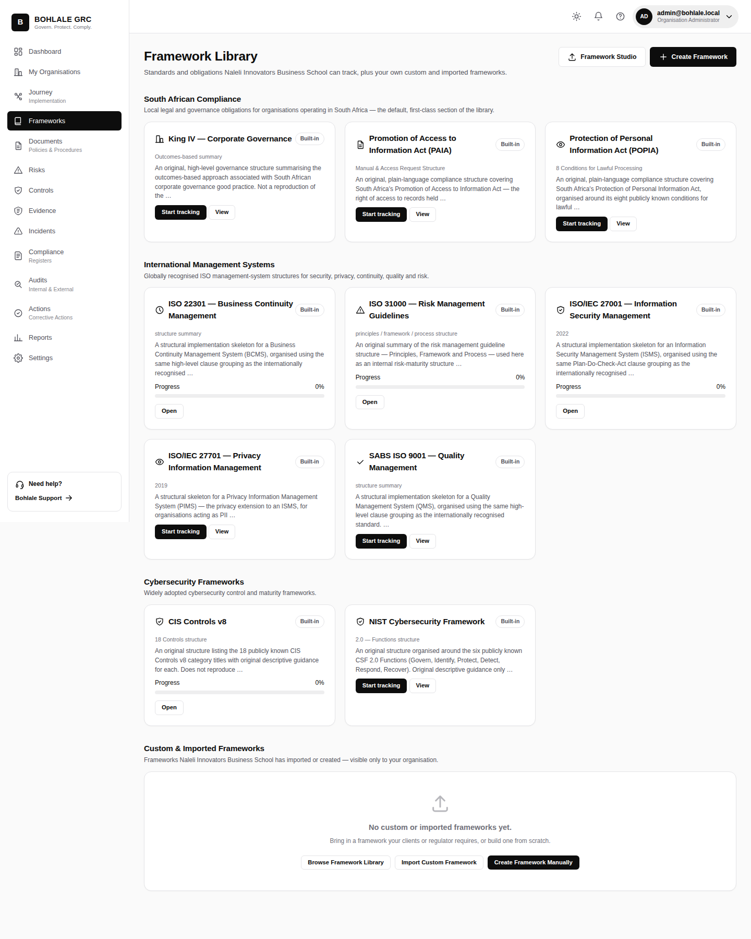
Figure 5 — Framework Library, grouped by category

4.2 Framework detail & adoption
Opening a framework shows its domains and requirements, which other frameworks share overlapping controls with (cross-framework control mapping), and — once adopted — the organisation's implementation progress against it. An administrator adopts a framework directly from this page if it wasn't picked during onboarding.
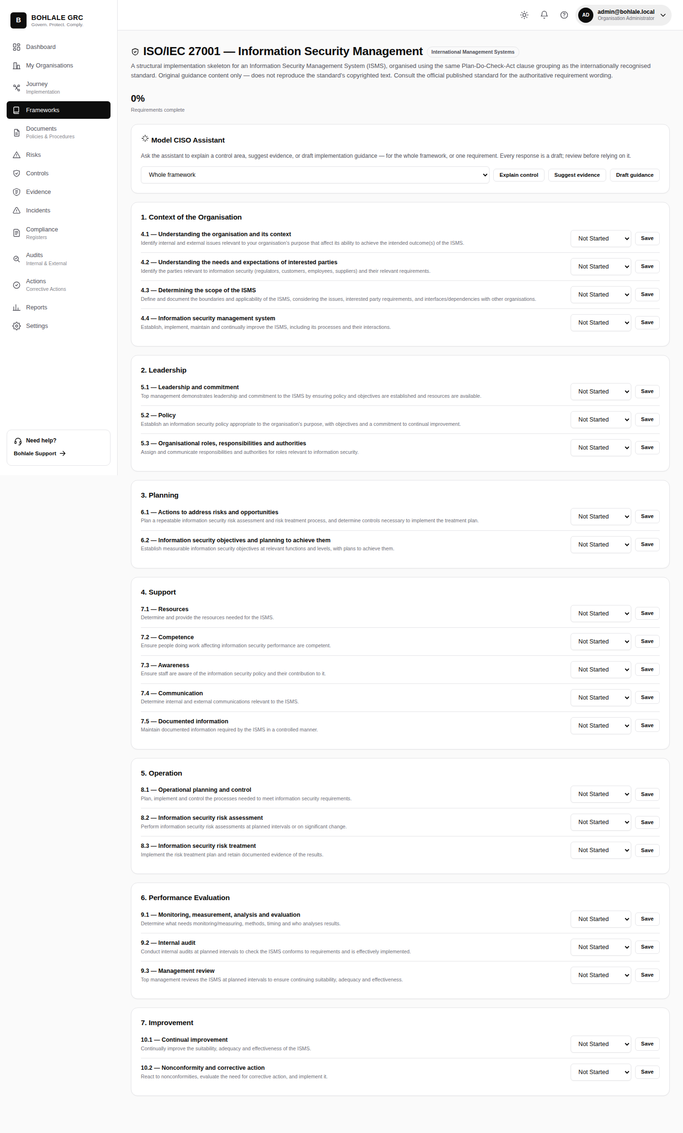
Figure 6 — Framework detail: ISO/IEC 27001

4.3 Creating a custom framework
Beyond the built-in library, an administrator can define an organisation-specific framework from scratch — its own domains and requirements — for an internal policy set or a standard not in the built-in list. This is entirely additive: it never modifies the shared built-in frameworks.
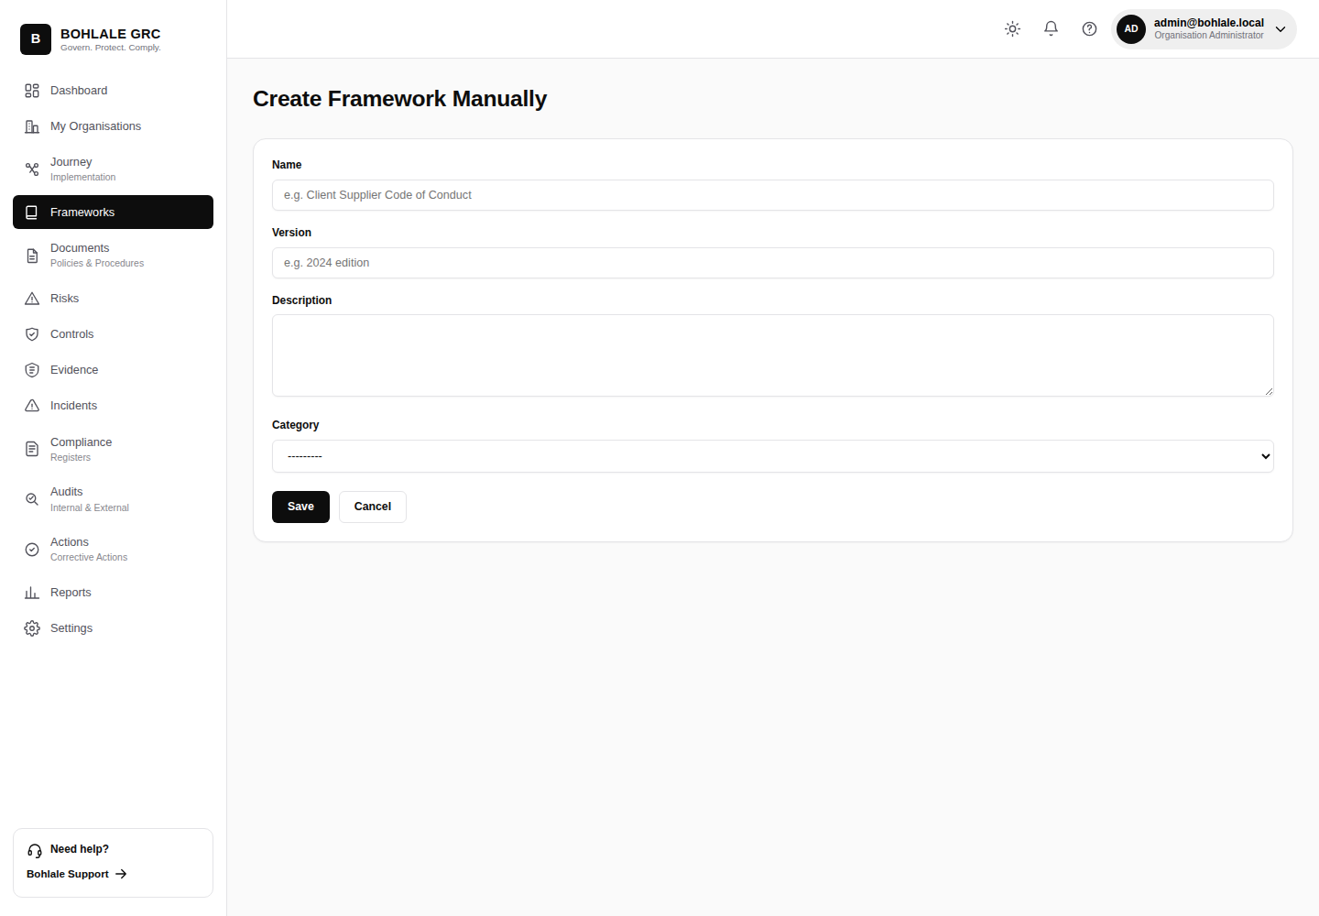
Figure 7 — Create a framework manually

4.4 Importing a framework (Framework Studio)
Framework Studio is the guided import path for turning an existing document (e.g. a policy standard your organisation already follows) into a structured framework: upload a source file, the AI-assisted analyser proposes a domain/requirement structure, an administrator reviews and edits that structure, then publishes it. Published imports behave like any other organisation framework — trackable, reportable, and available for cross-framework mapping.
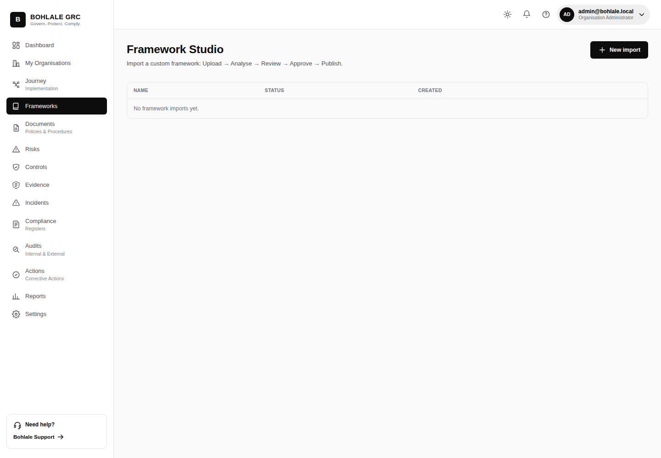
Figure 8 — Framework Studio: imports

5. Django Admin Backend
A superuser account (created via the DJANGO_SUPERUSER_EMAIL / DJANGO_SUPERUSER_PASSWORD environment variables on first deploy, or manage.py createsuperuser) has access to Django's built-in administration backend at /admin/. This is a lower-level, cross-tenant view of every database table — useful for support and data-correction tasks, but it bypasses the application's own tenant-scoping and role checks, so it should be limited to trusted platform administrators, not handed out as a general admin tool.
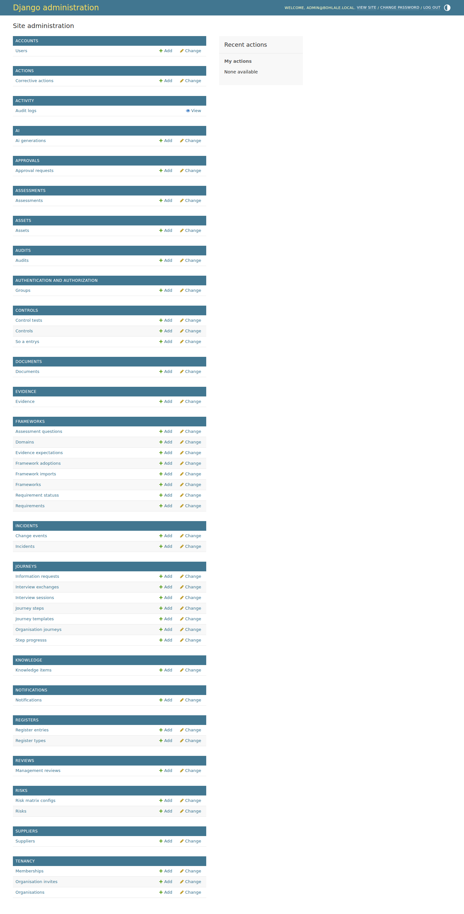
Figure 9 — Django admin backend

6. Module Reference
Every module below is reachable from the sidebar once an organisation is active. Day-to-day usage of each is covered in the User Guide; this table is a quick administrator-facing map of what each module is for.
Module | Purpose
Dashboard | At-a-glance compliance posture across all adopted frameworks.
Frameworks | Browse, adopt, create, and import frameworks; the Framework Library.
Journey | Guided PDCA (Plan-Do-Check-Act) implementation for the active framework.
Knowledge | The Organisation Knowledge Profile that other AI-assisted features draw context from.
AI Assistant | The Model CISO Assistant — explains controls and drafts guidance.
Documents / Approvals | Policy document management with versioning and e-signature approval workflow.
Risks | The risk register.
Controls | The control library and Statement of Applicability (SoA).
Evidence | Uploaded evidence linked to controls and requirements.
Assessments | Gap assessments and readiness scoring.
Assets / Suppliers | Asset inventory and third-party supplier register.
Incidents | Incident and change-event logging.
Registers | A unified hub for every register-style module.
Audits | Internal audit planning and findings.
Actions | Corrective and preventive action tracking.
Reviews | Management review records.
Reports | Cross-module compliance and readiness reporting.
Activity | The organisation-wide audit log — every create/update/delete is recorded here.
Notifications | In-app notifications for assignments, approvals, and due dates.

7. Deployment & Environment Administration
This section is for the person operating the server, not day-to-day application administrators. Bohlale GRC is a Django application deployed via Docker; the container's entrypoint automatically runs migrations, seeds the Framework Library, collects static assets, and (optionally) creates a superuser on every start.

7.1 Required environment variables
Variable | Purpose
DJANGO_SECRET_KEY | A real, random secret — required whenever DJANGO_DEBUG=False.
DJANGO_DEBUG | Must be False in production.
DJANGO_ALLOWED_HOSTS | Comma-separated list of hostnames the app will serve, e.g. your domain.
DB_ENGINE | Must be postgres in production — if unset, the app silently falls back to SQLite.
DB_HOST / DB_PORT / DB_NAME / DB_USER / DB_PASSWORD | PostgreSQL connection details.
DJANGO_SUPERUSER_EMAIL / DJANGO_SUPERUSER_PASSWORD | Optional — auto-creates an admin account on first start.

7.2 Startup safety checks
- Migration-drift guard: the container refuses to start if any model has changed without a matching migration file, preventing the class of failure where a schema change reaches production without the database being updated to match.
- Idempotent Framework Library seeding: safe to run on every deploy — it only creates frameworks that don't already exist.
- A real database round-trip health check at /health/, used by the container's HEALTHCHECK and any external uptime monitor.
Full deployment procedures, Coolify-specific notes, and troubleshooting live in this repository's DEPLOYMENT.md, deployment/README.md, and DEPLOYMENT_CHECKLIST.md.

