BOHLALE GRC
User Guide
Day-to-day use of every module
Govern. Protect. Comply.

Contents

1. Introduction
This guide walks through everyday use of Bohlale GRC, module by module, in the order you'll typically encounter them. If you need to set up an organisation, invite colleagues, or manage the Framework Library, see the companion Administrator Guide instead.

2. Signing In & Your Dashboard

2.1 Signing in
Use your email address and password at the login screen. If your organisation invited you, you'll have set your password when you accepted the invitation.
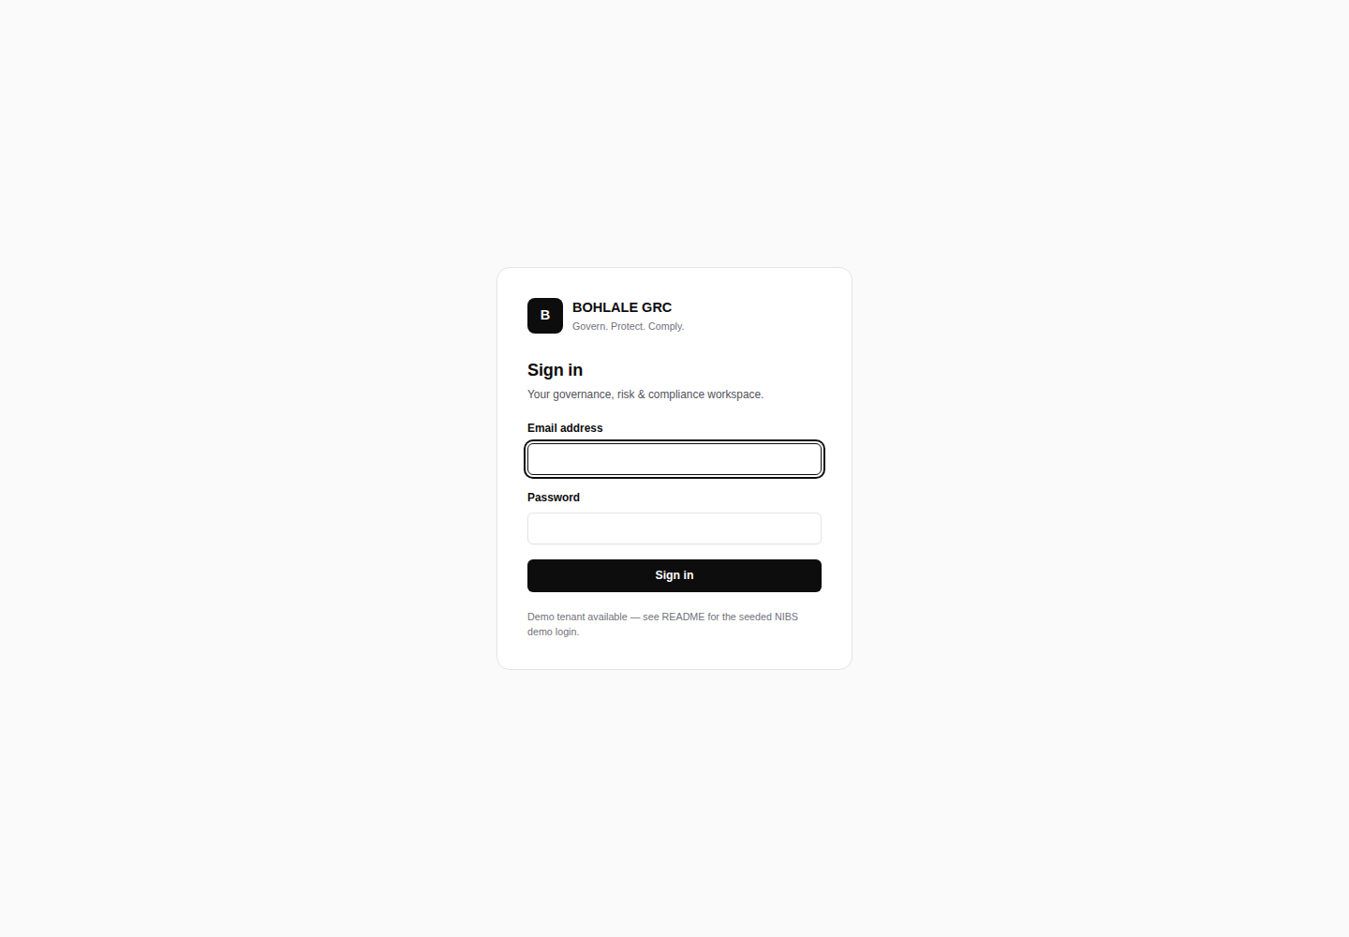
Figure 1 — Sign-in screen

2.2 The Dashboard
The Dashboard is your home screen: a live summary of compliance posture across every framework your organisation has adopted, outstanding actions, recent activity, and quick links into the modules you use most.
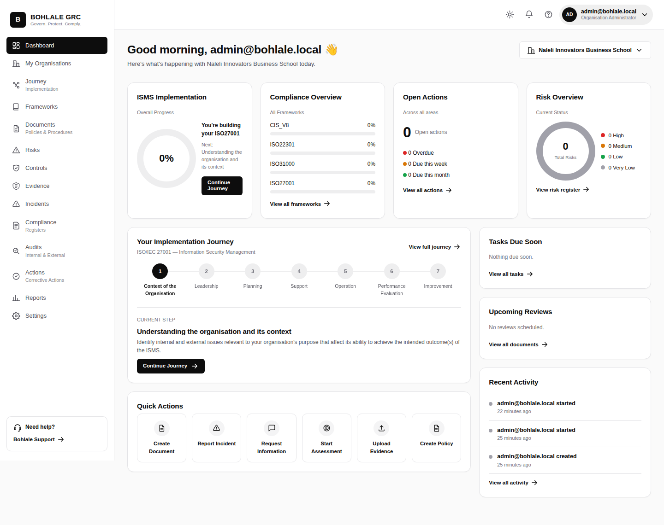
Figure 2 — Dashboard

2.3 Your profile
From the top-right user menu, Profile lets you update your own details, and includes options to export your personal data or deactivate your own account, in line with POPIA data-subject rights.
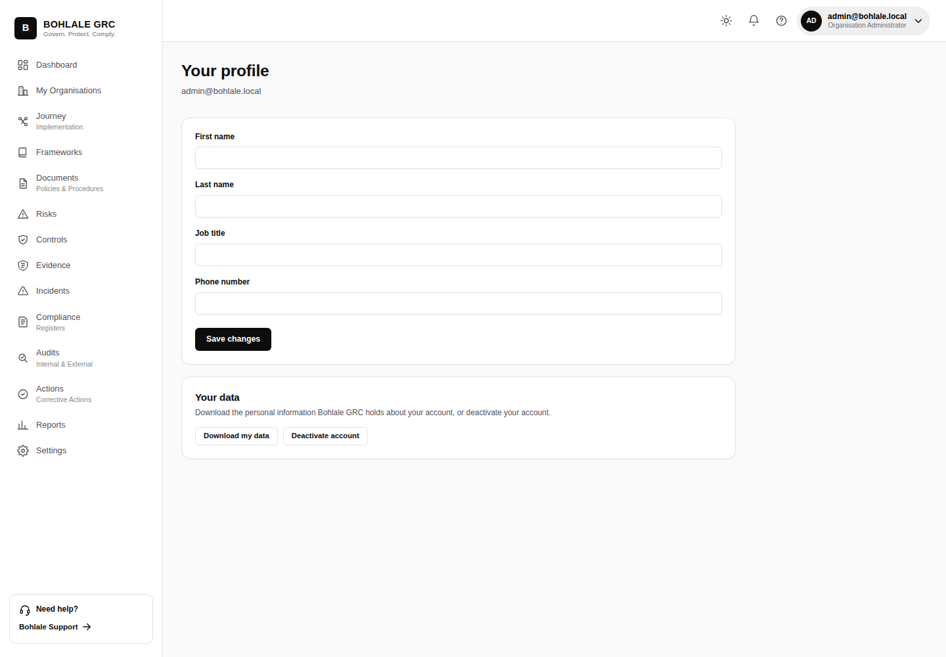
Figure 3 — Profile

3. Frameworks
The Framework Library is where every standard your organisation tracks lives — South African Compliance frameworks (POPIA, PAIA, King IV) grouped first, alongside international standards like ISO/IEC 27001 and NIST CSF.
Opening a framework shows its domains and requirements, your organisation's progress against each, and which other adopted frameworks share overlapping controls — so work done for one standard visibly counts toward another.
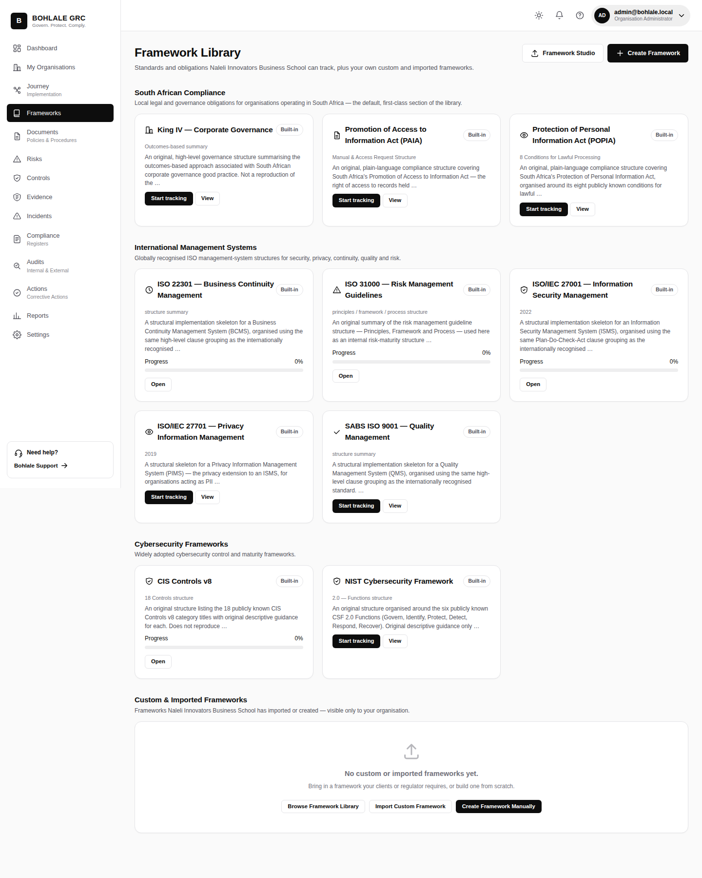
Figure 4 — Framework Library
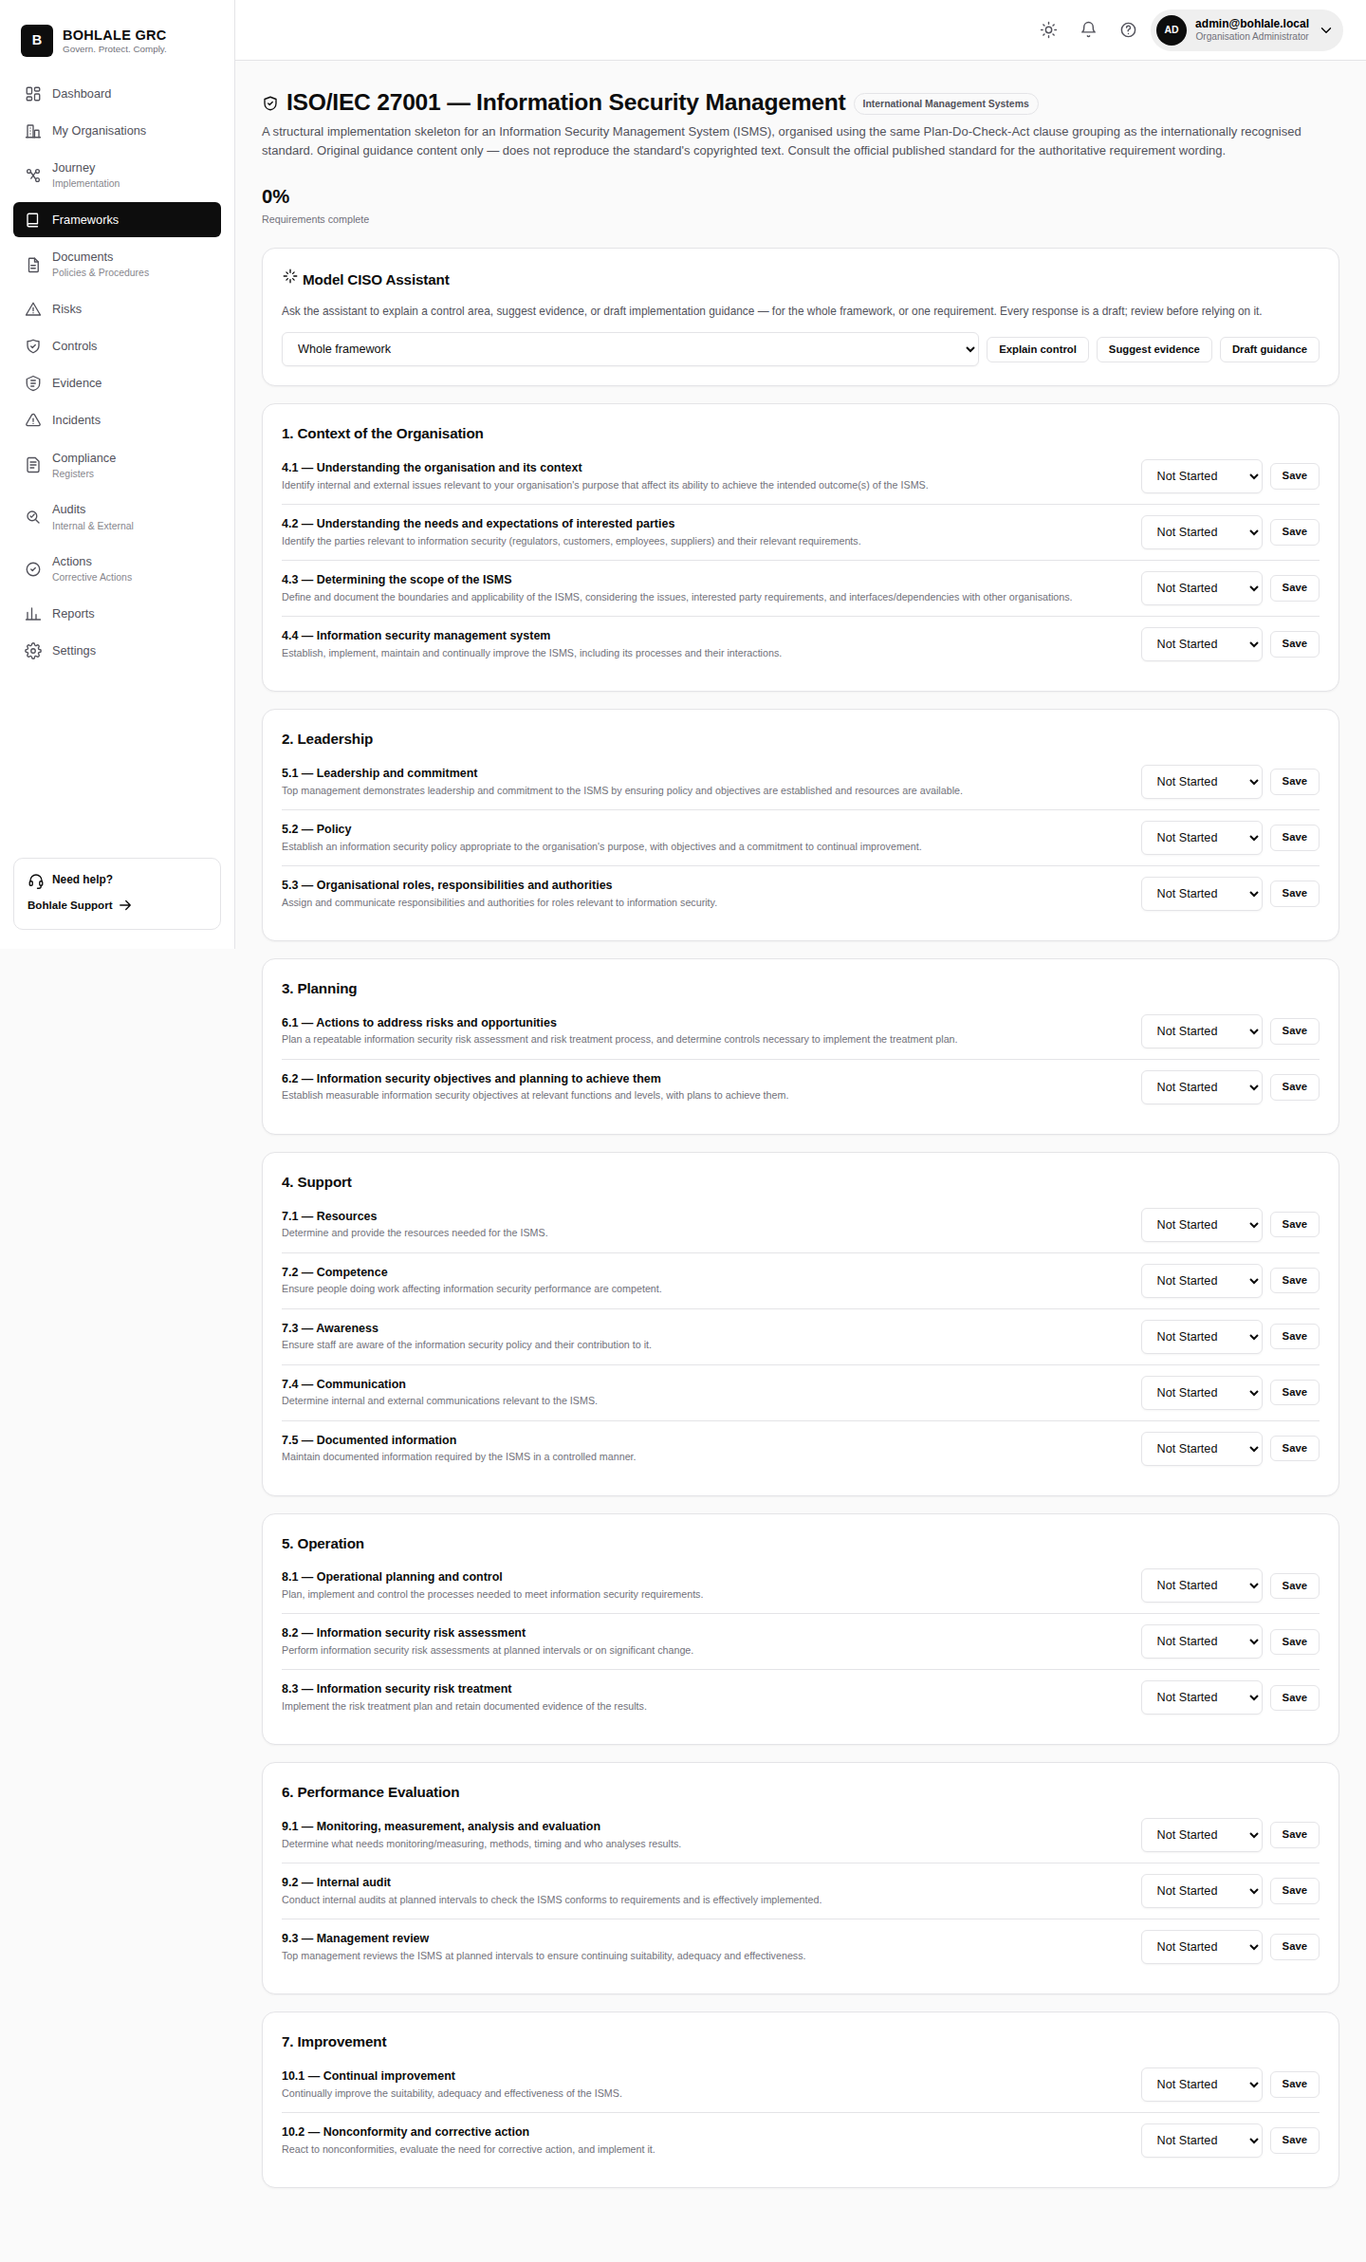
Figure 5 — Framework detail: ISO/IEC 27001, showing domains and requirements

4. Journey (Guided Implementation)
Journey is the guided, step-by-step implementation path for your primary framework, organised around the PDCA cycle — Plan, Do, Check, Act. Each stage groups the steps needed to get there: what's required, why it matters, what to do, and what evidence or documents to produce.
A step shows as done, current, or upcoming; the journey always highlights exactly one current step so it's never ambiguous what to work on next.
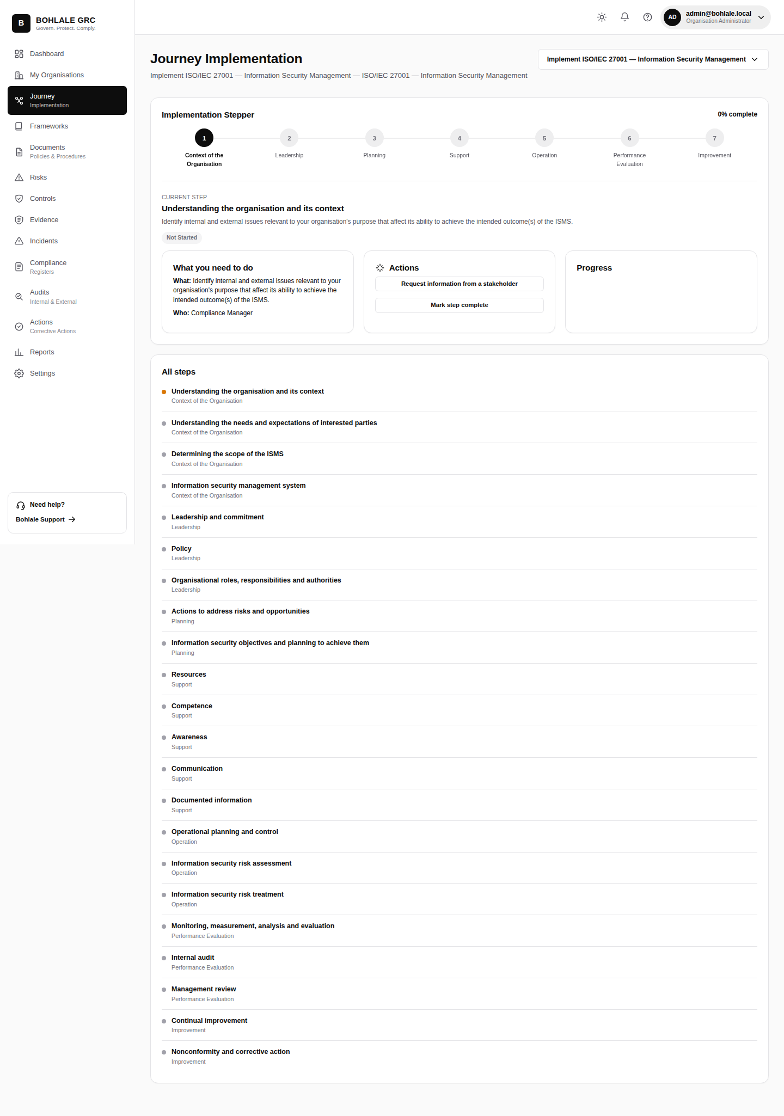
Figure 6 — Guided journey: PDCA stepper

5. Knowledge (Organisation Knowledge Profile)
The Knowledge Profile captures context about your organisation — industry, size, systems in use, data processed — that the AI Assistant and guided journey both draw on to tailor their suggestions. The more complete this profile, the more relevant the guidance elsewhere in the app.
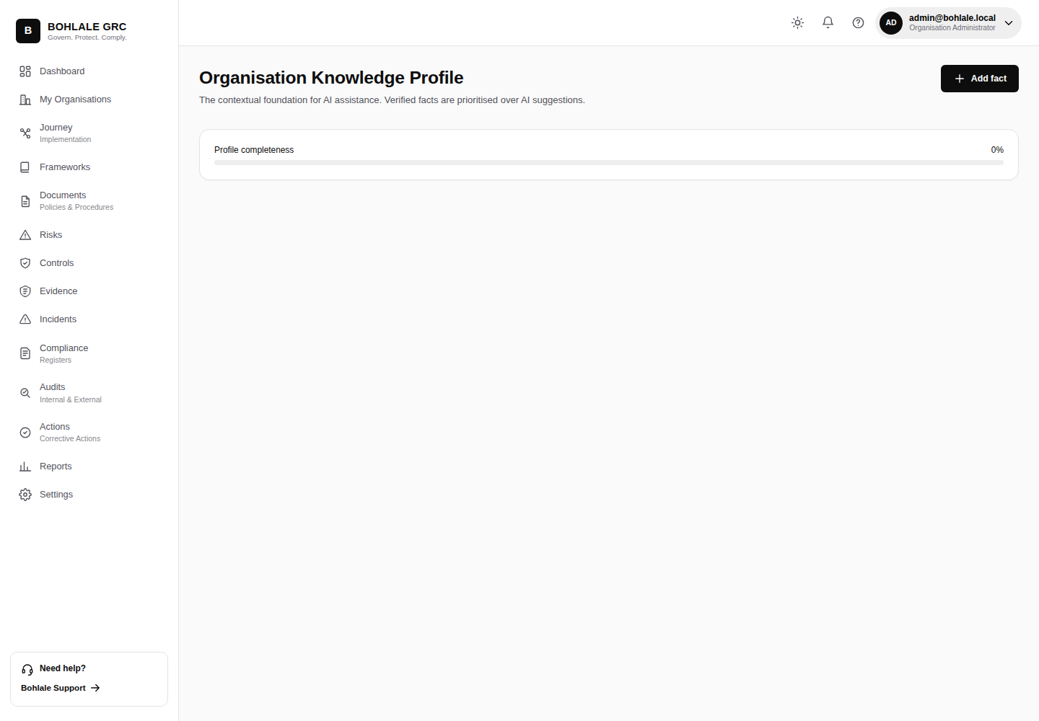
Figure 7 — Organisation Knowledge Profile

6. AI Assistant (Model CISO)
The Model CISO Assistant explains what a control or requirement actually means in plain language, suggests what evidence would satisfy it, and drafts guidance text — available inline wherever you're working with a framework or requirement, and from this central hub.
AI suggestions are a starting point, not a substitute for judgement — always review generated text before relying on it, especially for anything that will be presented to an auditor or regulator.
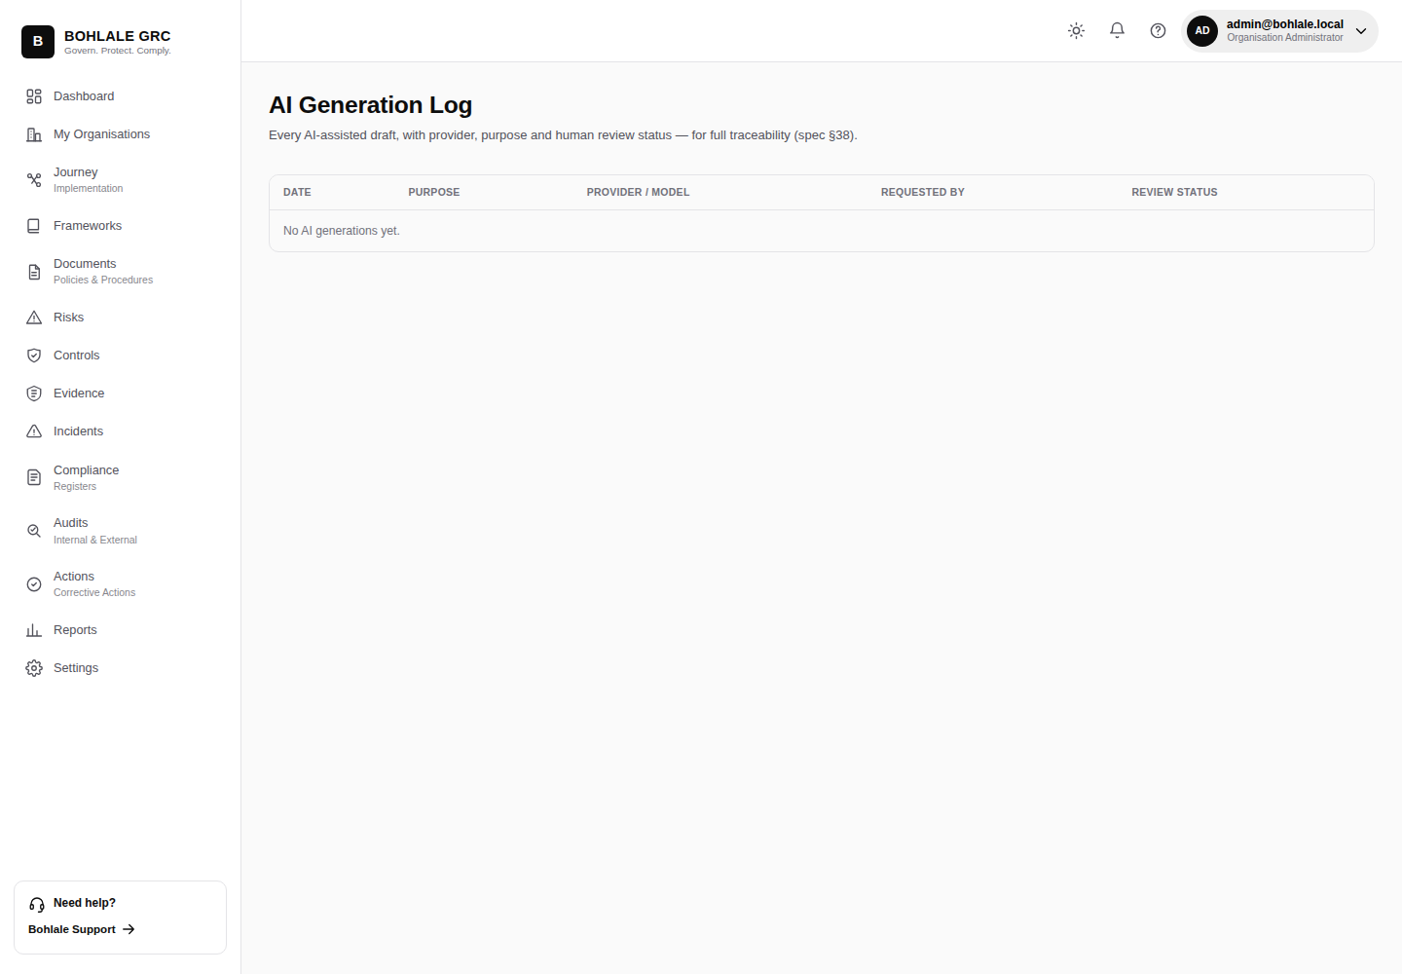
Figure 8 — AI Assistant

7. Documents & Approvals
Documents manages policies and other governance documents with full version history. Approvals is the e-signature workflow that routes a document to the right reviewers before it becomes the organisation's current, in-force version.
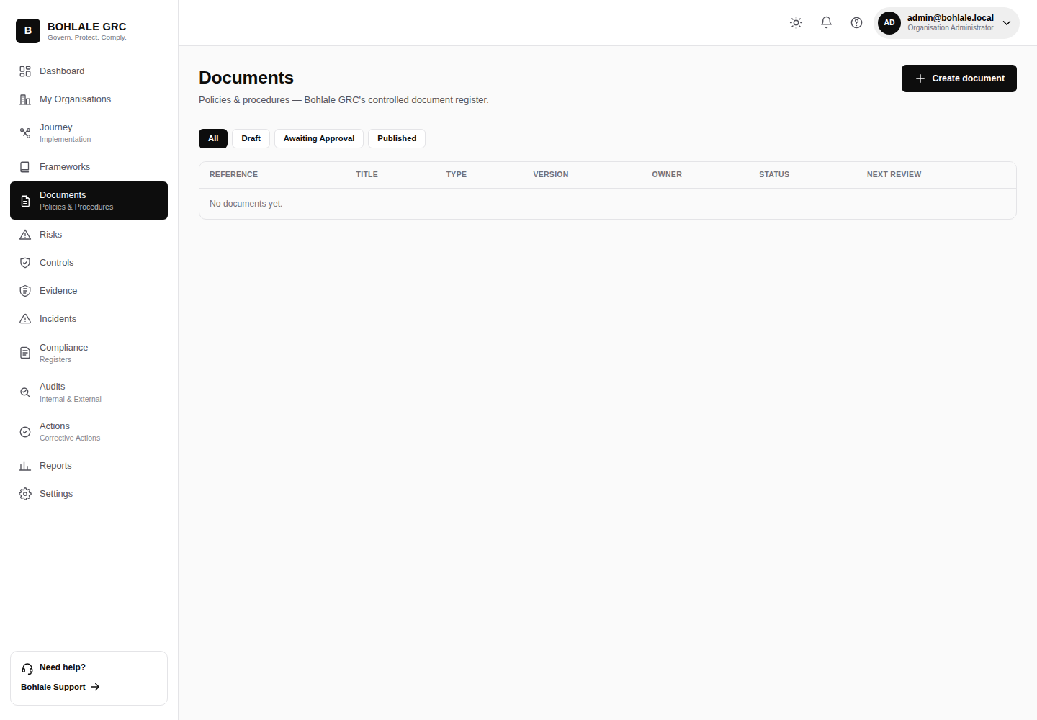
Figure 9 — Documents
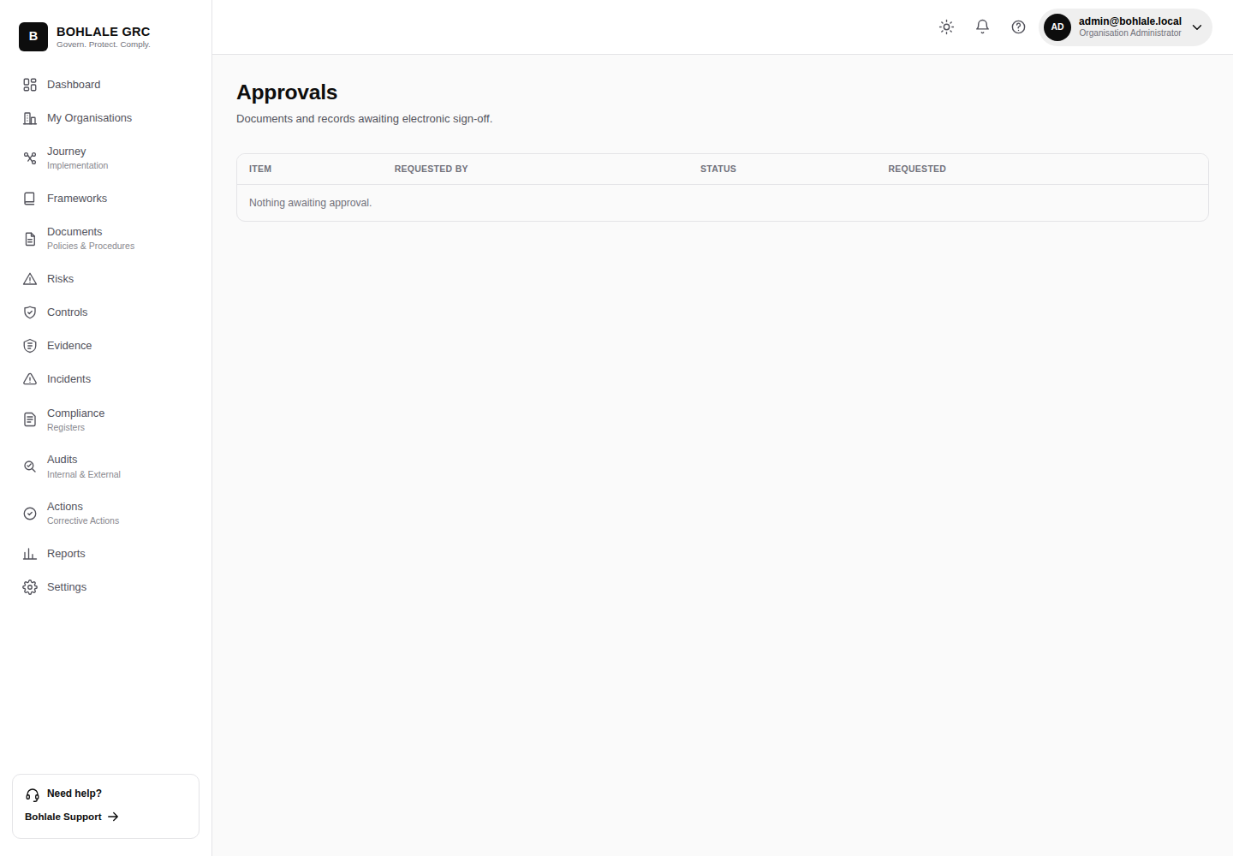
Figure 10 — Approvals

8. Risks
The risk register is where identified risks are logged, scored, and tracked to treatment. Each risk can be linked to the controls that mitigate it and the assets or processes it affects.
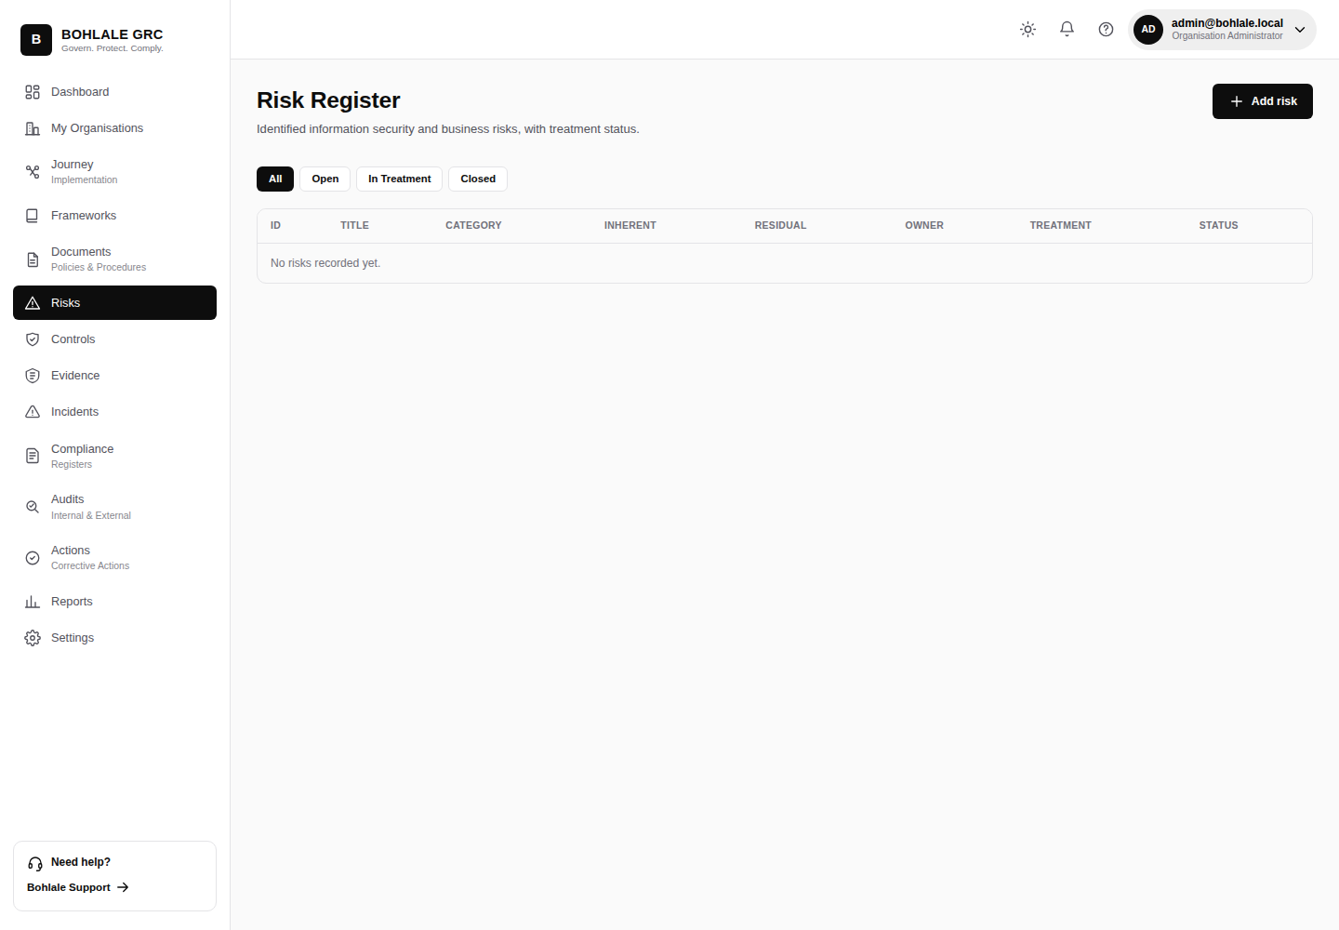
Figure 11 — Risk register

9. Controls & Statement of Applicability
The control library holds every control your organisation has adopted, along with which framework requirement(s) each one satisfies — a control implemented once for ISO 27001 can also satisfy an overlapping POPIA or NIST requirement automatically. The Statement of Applicability (SoA) is the formal record of which controls apply, and why.
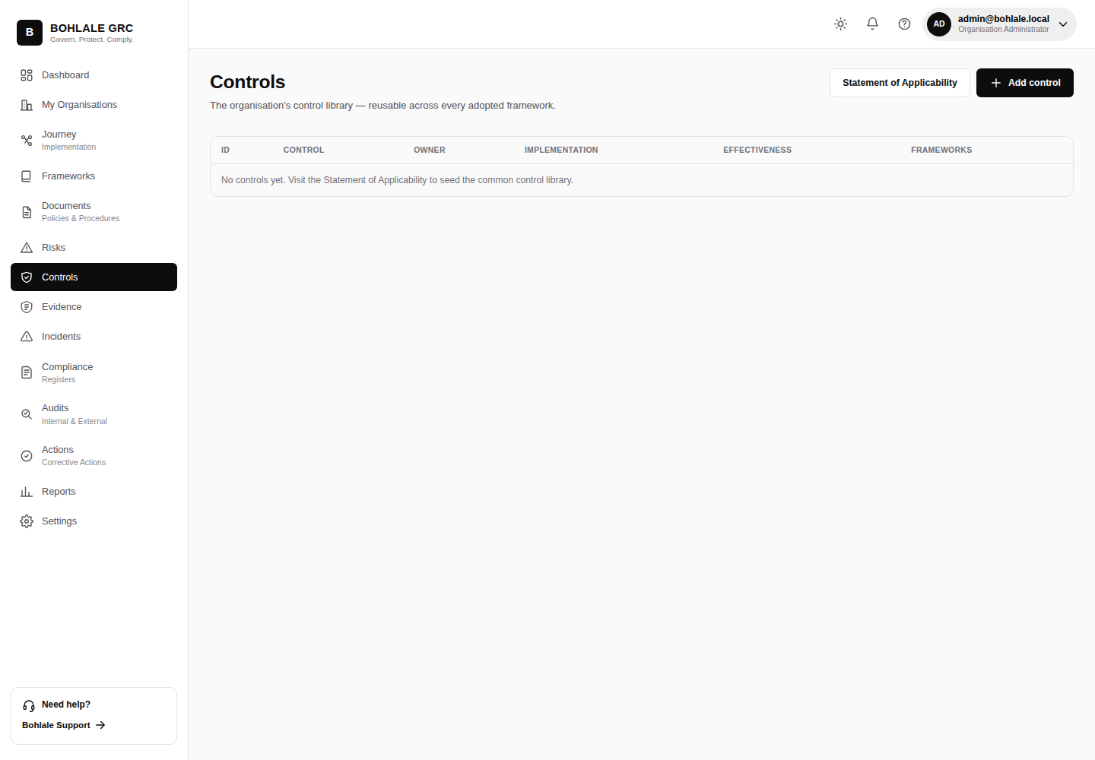
Figure 12 — Controls / SoA

10. Evidence
Evidence stores the artefacts — documents, screenshots, exports, sign-offs — that prove a control is actually operating. Evidence is linked directly to the control or requirement it supports, so an auditor (or your future self) can trace a claim straight back to its proof.
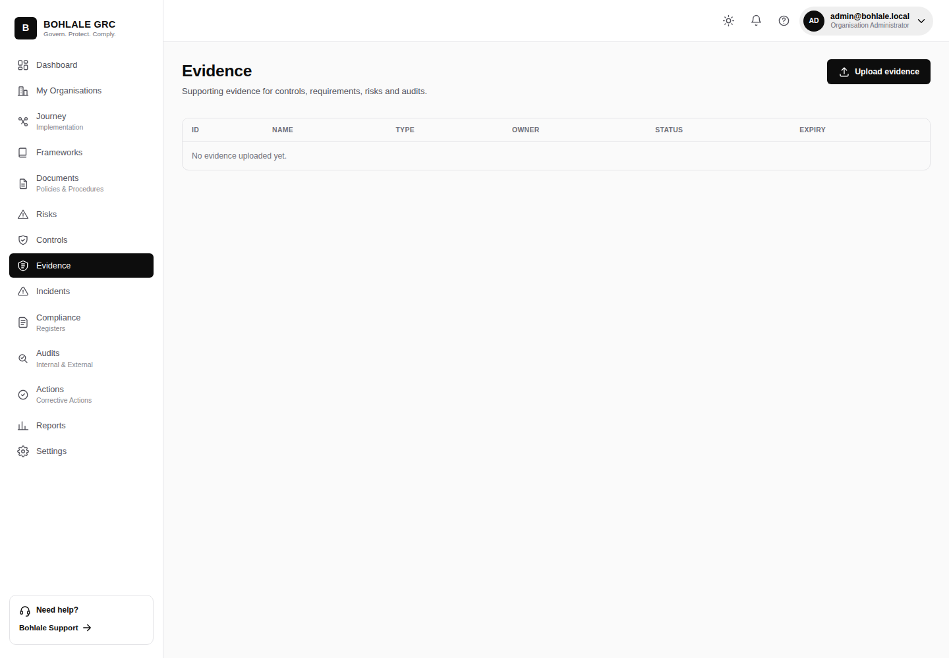
Figure 13 — Evidence

11. Assessments
Assessments run structured gap assessments and readiness scoring against a framework — useful both for an initial baseline and for periodic re-checks as your control environment matures.
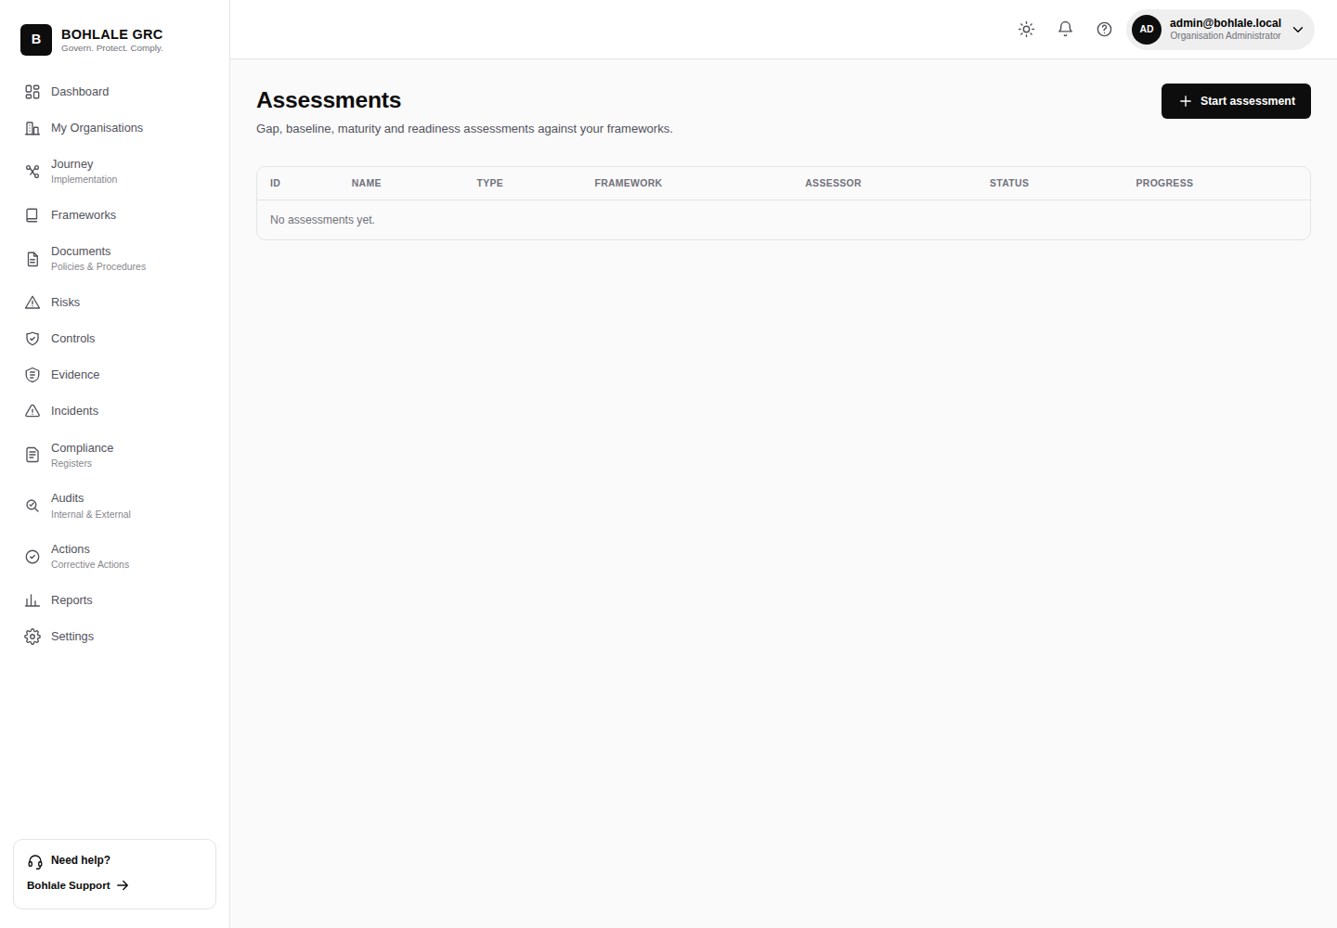
Figure 14 — Assessments

12. Assets & Suppliers
Assets is the inventory of systems, applications, and information assets in scope for your management system. Suppliers is the equivalent register for third parties, tracking the risk and due-diligence status of each.
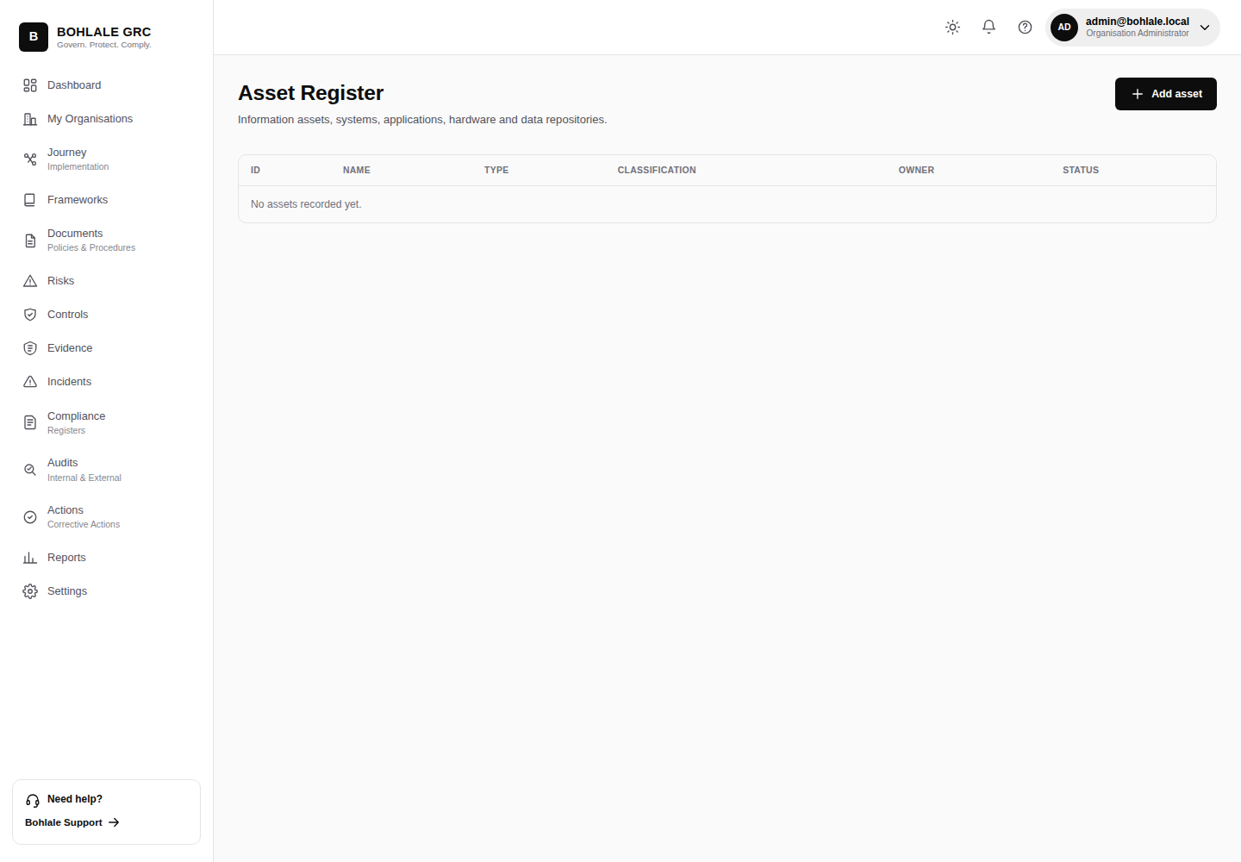
Figure 15 — Assets
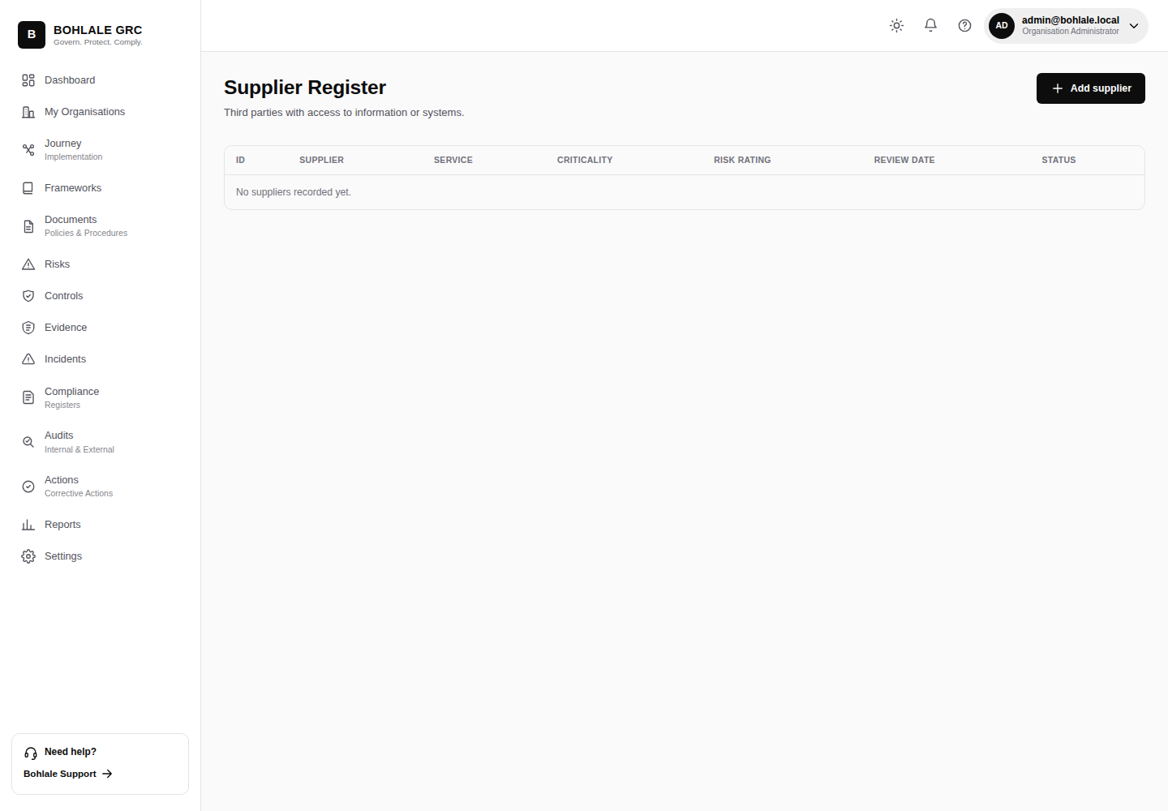
Figure 16 — Suppliers

13. Incidents
Incidents logs security and privacy incidents (and general change events), from initial report through investigation to closure — including the timelines POPIA requires for personal-information breaches.
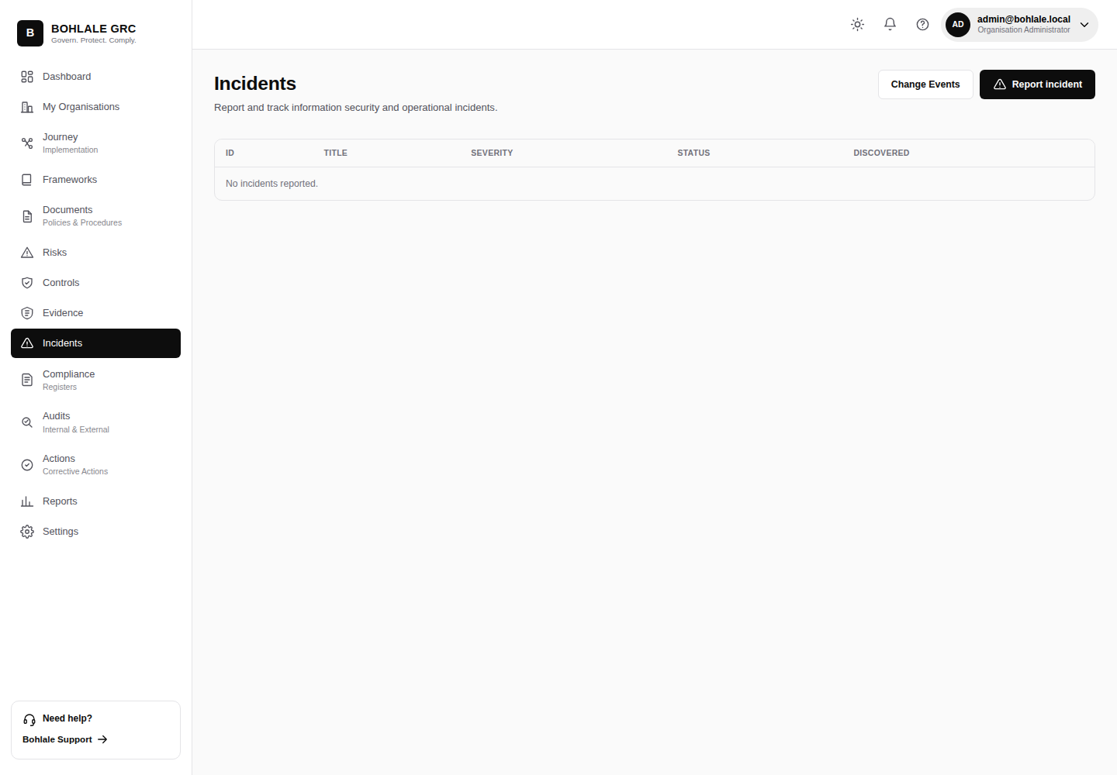
Figure 17 — Incidents

14. Registers
Registers is a single hub that surfaces every register-style module (risks, assets, suppliers, incidents, and more) in one place — useful when you want a cross-cutting view rather than working module by module.
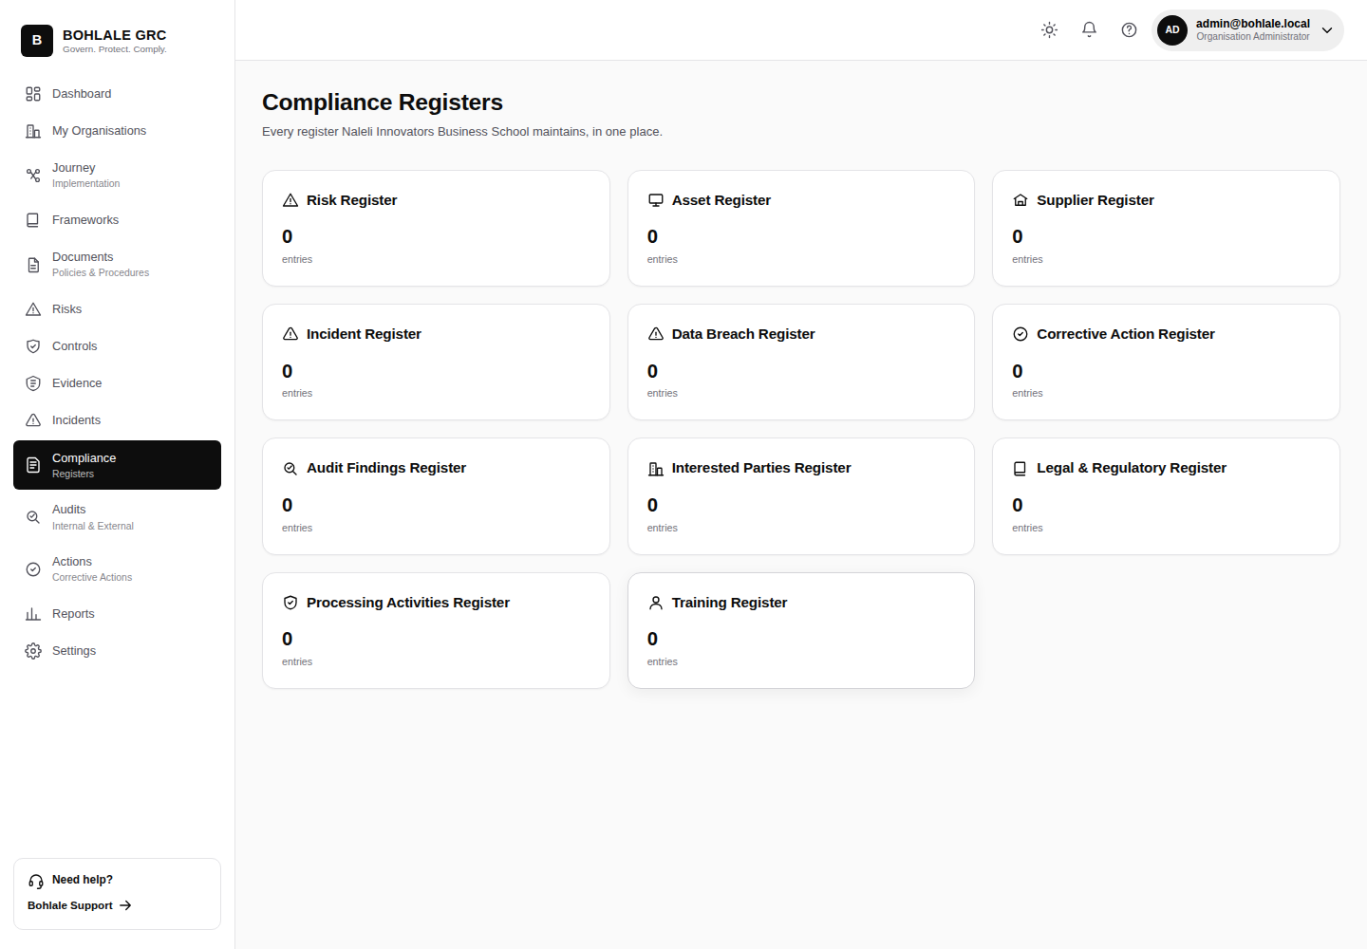
Figure 18 — Registers hub

15. Audits
Audits plans and records internal audits: scope, schedule, findings, and their resulting corrective actions.
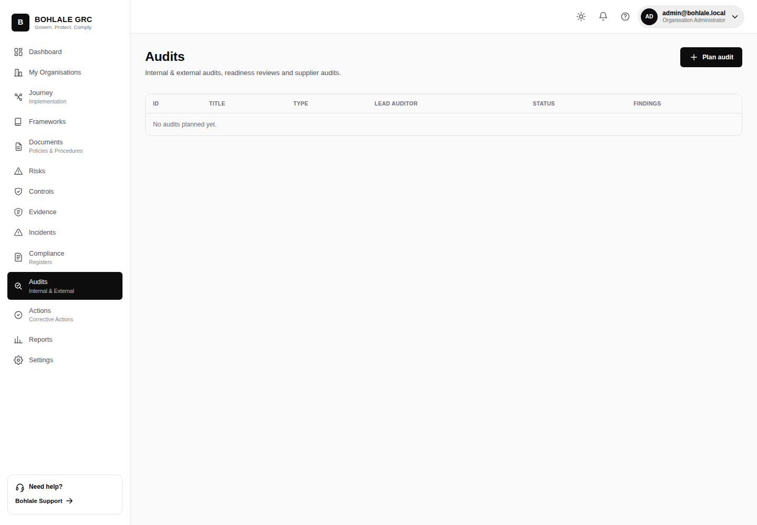
Figure 19 — Audits

16. Actions
Actions tracks corrective and preventive actions to completion, wherever they originated — an audit finding, an incident, a risk treatment, or a management review.
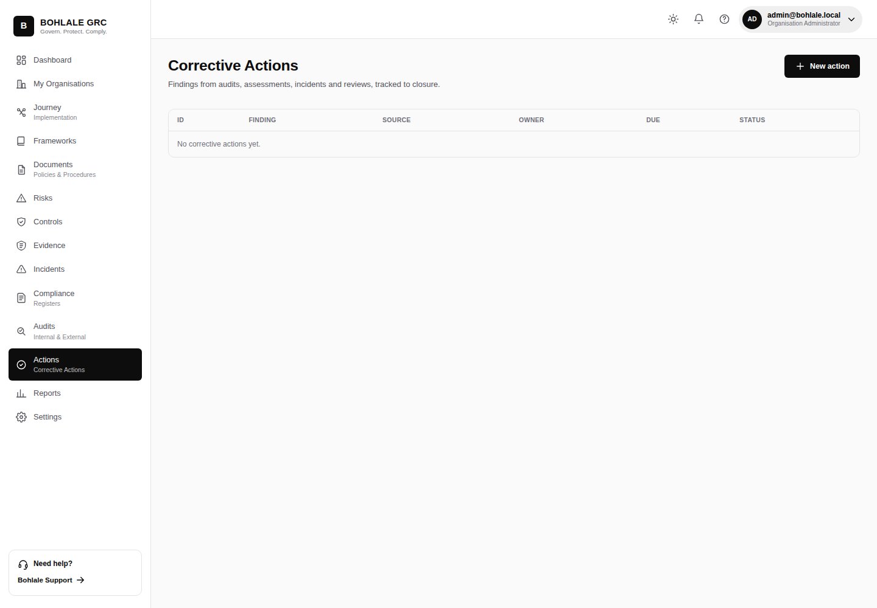
Figure 20 — Actions

17. Reviews
Reviews records formal management review meetings — the inputs considered, decisions made, and actions raised — as most management-system standards require at a defined cadence.
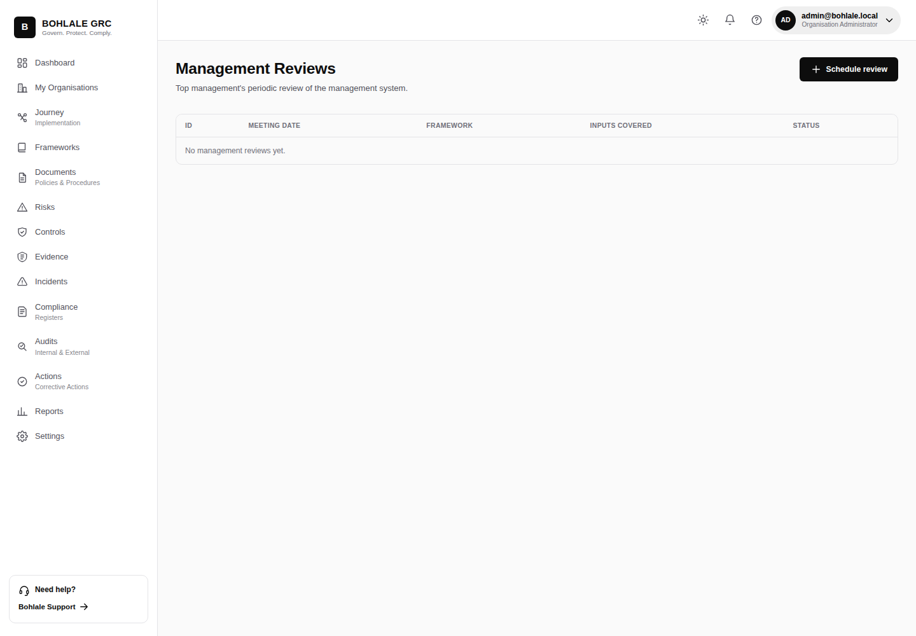
Figure 21 — Management review

18. Reports
Reports pulls data from every module into compliance and readiness reporting you can review internally or share with stakeholders and auditors.
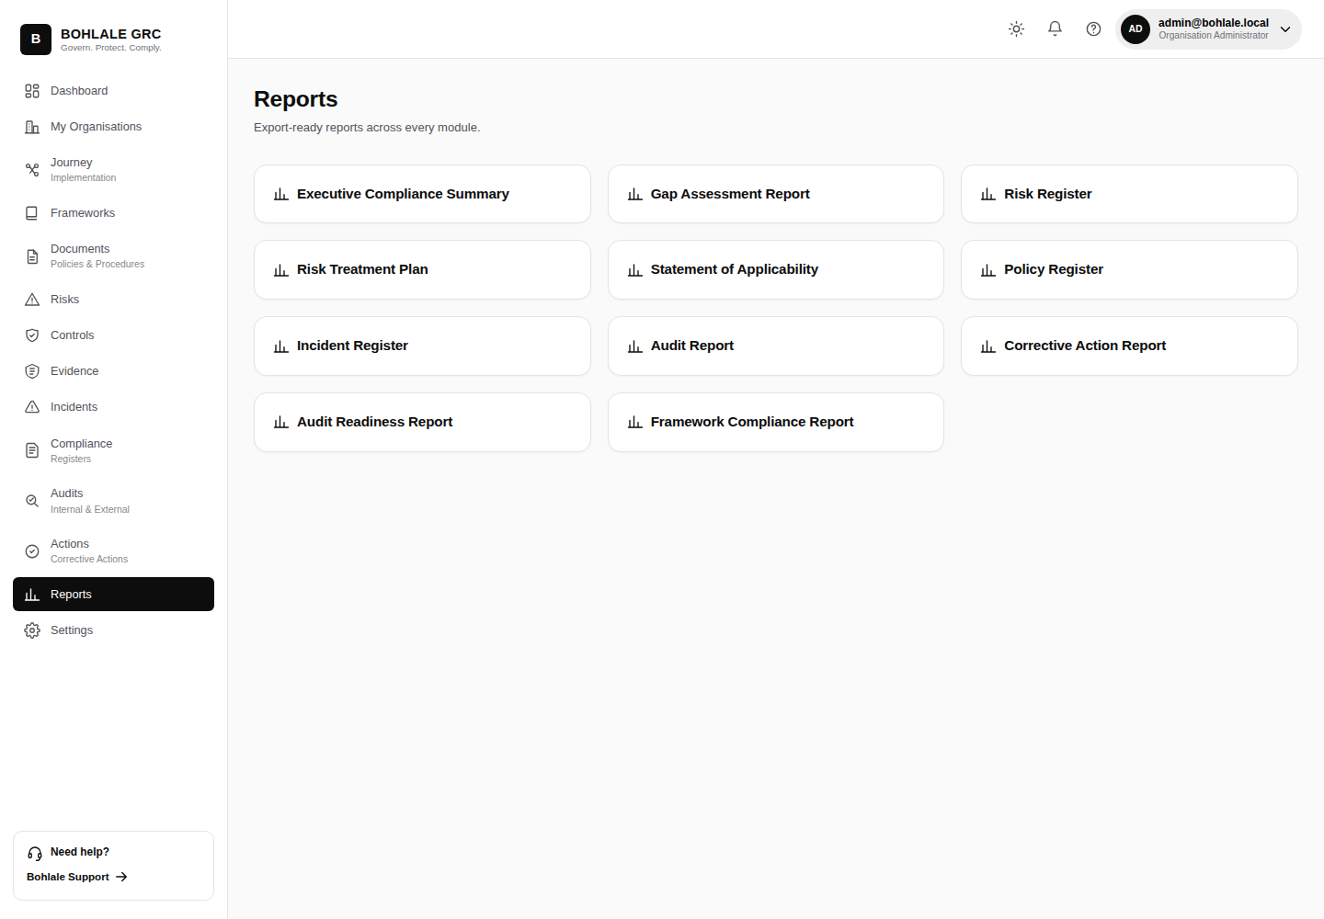
Figure 22 — Reports

19. Activity Log
Activity is the organisation-wide audit log — every create, update, and delete across every module is recorded here with who, what, and when, and it cannot be edited or deleted from within the app.
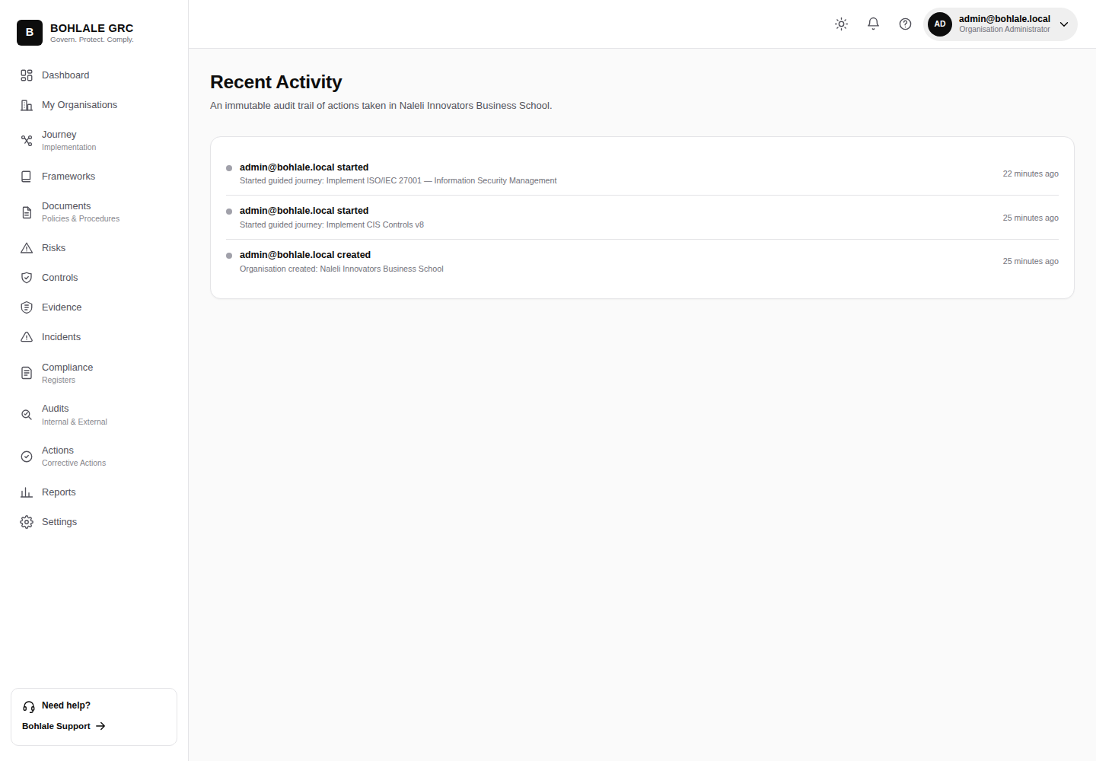
Figure 23 — Activity

20. Notifications
Notifications surfaces what needs your attention — new assignments, pending approvals, and approaching due dates — without having to check every module individually.
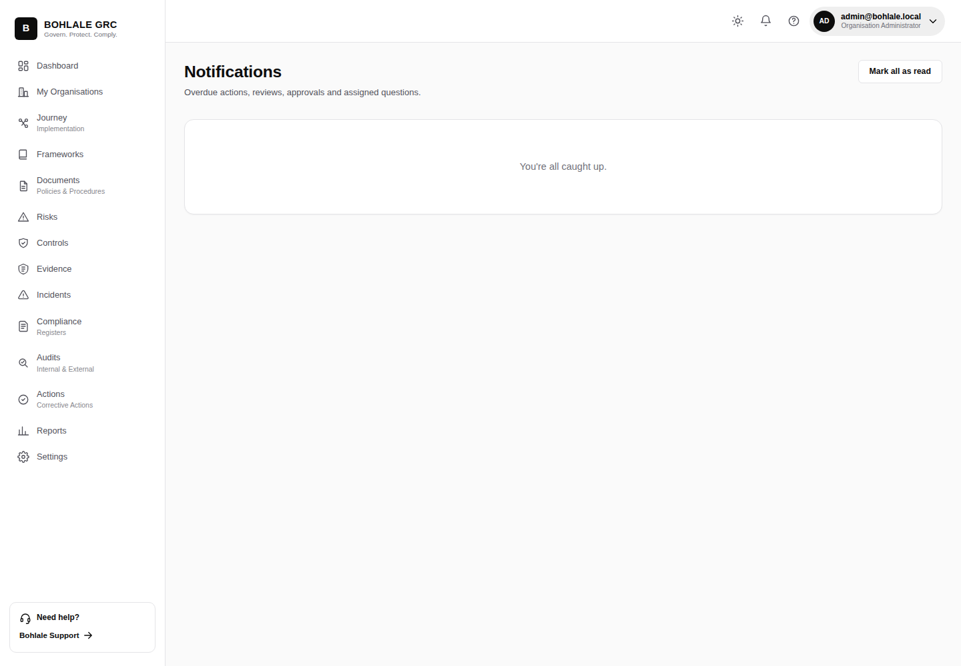
Figure 24 — Notifications

21. Glossary
- PDCA — Plan, Do, Check, Act: the continuous-improvement cycle the guided Journey is structured around.
- Framework — a structured set of domains and requirements, e.g. ISO/IEC 27001 or POPIA.
- Requirement — a single obligation within a framework, satisfied by one or more controls.
- Control — a safeguard your organisation has put in place; can satisfy requirements across multiple frameworks at once.
- SoA — Statement of Applicability: the formal record of which controls apply to your organisation, and why.
- Tenant / Organisation — the isolated workspace all your data belongs to; users only see data for organisations they're a member of.

