

>50 more



Ruby



PHP



C++



JS



C#



Java



Lua



C



Haskell



HTML



Python

.io

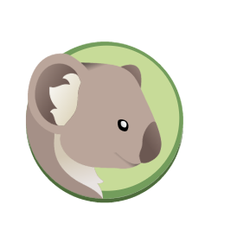

coala

browse the full analysis info at [coala.io](http://coala.io)

coala.io

linting and fixing code for all languages

install coala

$ pip3 install coala-bears

get started

$ echo "print( 'Hello World' )" > hello.py

$ coala --files hello.py --bears PEP8Bear

$ coala --files hello.py --bears PEP8Bear

languages supported

coala provides a unified command-line interface for linting and fixing all your code, regardless of the programming language you use.

With coala, users can create rules and standards to be followed in the source code. coala has a user-friendly interface that is completely customizable. It can be used in any environment and is completely modular.

about coala

what makes it special

coala is written with ease of extension in mind. That means: no big boilerplate, just write one small object with one routine, add the parameters you like and see how coala automates the organization of settings, user interaction and execution parallelization. You shouldn’t need to care about anything else than just writing your algorithm!

full tutorial

get in touch

[coala.io/tutorial](http://coala.io/tutorial)

.io



coala

[coala.io/chat](http://coala.io/chat)

documentation

[docs.coala.io](http://docs.coala.io)