

coala
_____________

COde AnaLysis Application
or
a modular way to brush up your code.
_____________

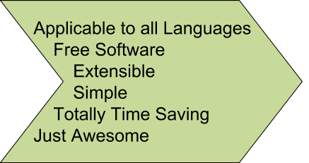

Getting Started
_____________

Get It!
sudo pip3 install coala --pre
_____________

Try It!
cd project && coala --files=\*\*/\*.py --bears=PEP8Bear --save
_____________

Commit It!
git add .coafile && git commit
-m "Add coala configuration"
_____________

Visit Us
https://gitter.im/coala-analyzer/coala

