Owl 4

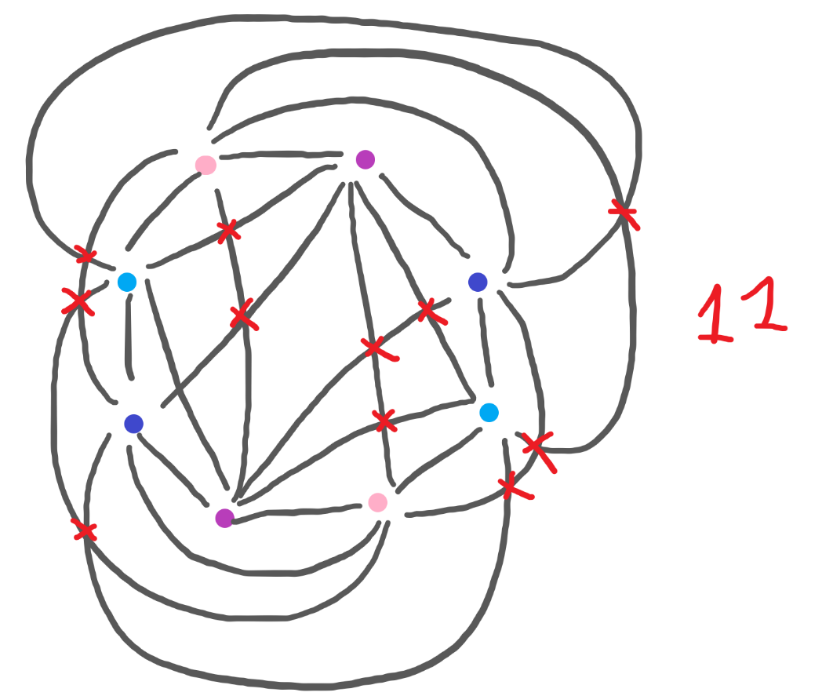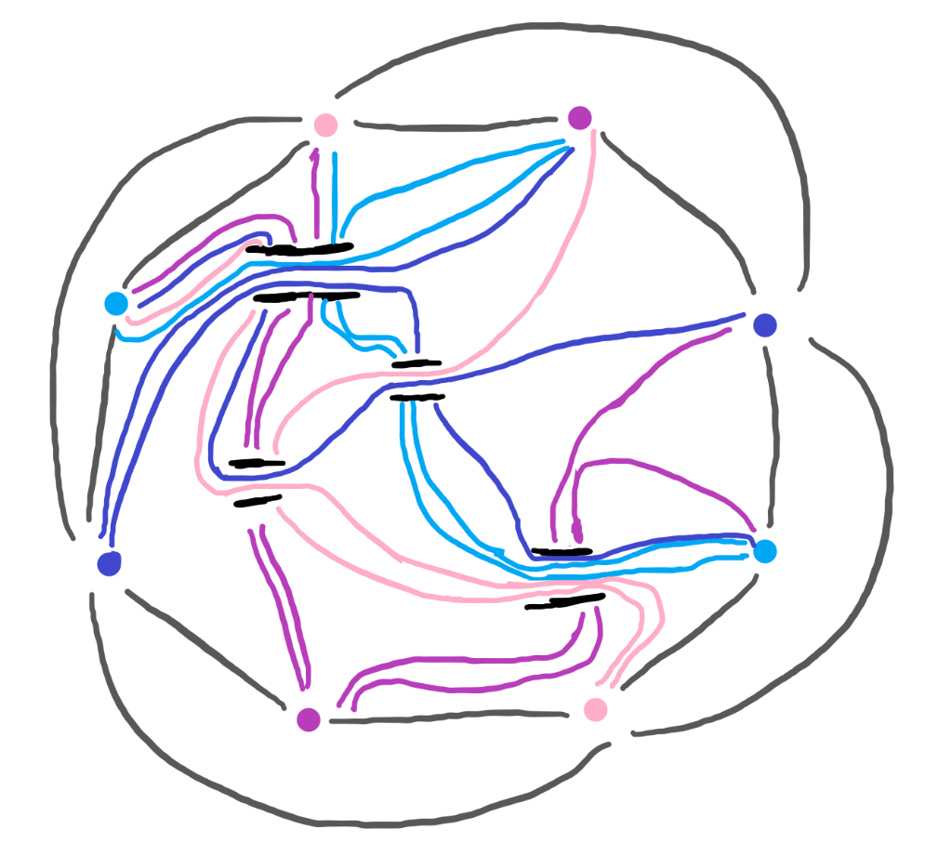

Reflection

I don’t think that I’ve found the minimum number of crossings nor am I sure that this is the minimum number of bridges needed. I can’t exactly give any good reasoning so I guess I’ll just explain my thought process. You’ll notice that instead of labeling the points, I just used colors to save myself time.

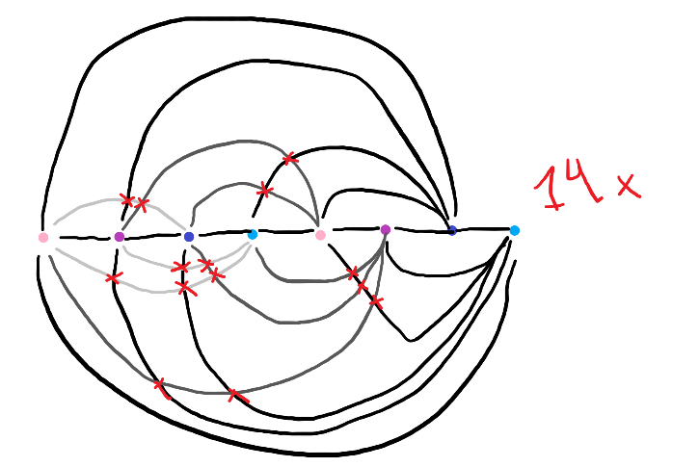At first, I tried lining them all up like this.

Honestly, my method of trying to figure out if I found the minimum was going to be if it “felt” right and looked symmetrical.

As you can see, this is not a pretty sight. I tried again with this straight line method but I wasn’t having much success. You could yank this graph into the shape of an octagon so technically it’s still the same thing, I guess, but this is visual so I ended up putting it back into an octagon. After coming up with my 11 crossings solution, I was annoyed with how unsymmetrical it looked.

None of my intuition for how to solve this worked at all, so I just tried doing the least intuitive connections after that. That proved to be about as bad as me planning out connections.

I thought maybe thinking about this as trying to make the fewest areas would help me optimize. After all, an area is just a space enclosed by either nodes or crossings. In the end, this is the best I was able to do. To do better, I think I’d have to look at it for like a day in the woods or something.

For the bridges, I didn’t have a strategy at all. I just connected until I couldn’t connect any more. I used bridges to avoid closing off areas, if that makes any sense. I only used a bridge when it was clear that an area was closed off and I needed to get into that area to connect a node.

I am truly lost with this owl work. Also it occurs to me that they’re called vertexes, not nodes.