The following two styles are in wide use, and are generally easier to create using drawing (e.g. Microsoft Visio) or CASE (e.g. Rational Rose) tools.
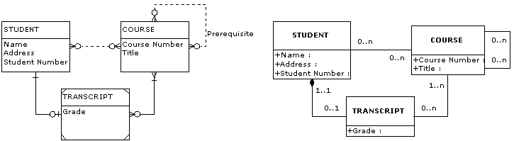
Crow's Foot Notation | Unified Modelling Language (UML) Notation
The elements making up both diagrams are as follows:
- STUDENT is a strong entity with the attributes: Name, Address, and Student Number.
- COURSE is a strong entity with the attributes: Course Number and Title.
- TRANSCRIPT is a weak entity with the attribute: Grade.
- A STUDENT may enroll in zero or more COURSEs. A COURSE may be attended by zero or more STUDENTs.
- A STUDENT either has been issued a TRANSCRIPT or has not. A TRANSCRIPT is assigned to a single STUDENT.
- A TRANSCRIPT must record at least one COURSE. A COURSE may appear on zero or many TRANSCRIPTs.
- A TRANSCRIPT is identified by both a STUDENT and one or more COURSEs.
- A COURSE may specify zero or more prerequisite COURSEs. A COURSE may be a prerequisite for zero or more COURSEs.

