**AP Calculus BC – Data Narrative**

Kyle Coapman

kyle.d.coapman@gmail.com

March 31, 2020

# Abstract

Table of Contents

Abstract 2

Teaching Context 4

Academic Data Analysis for All Students 5

Students’ learning, relative to the Proficient and Ambitious Goal: 5

All student’s academic achievement, displayed relative to the Proficient and Ambitious Goal: 5

Distribution of academic performance for all students: 5

My perspective on these whole-class results: 5

Academic Data Analysis for Subgroups of Students 6

Research Question #1: 6

Rational for selection of research question #1: 6

Analytics of research question #1: 6

Research Question #2: 6

Rational for selection of research question #2: 6

Analytics of research question #2: 6

Academic Data Analysis for One Student 7

Student Description: 7

Student’s academic achievement throughout the year: 7

Connection to additional data source: 7

Character Data Analysis 8

Character measure: 8

Character results analysis: 8

Character results storyline: 8

Next Steps from Analyses of Academic and Character Data 9

Action Step #1 (from academic analysis): 9

Action Step #2 (from character analysis): 9

# Teaching Context

I teach at North Star Academy Washington Park High School. My school is part of a greater network of schools in Newark (North Star Academy) and a greater network of schools in the north eastern United States (Uncommon Schools). Most North Star students attended the NSA middle schools starting in 5th grade, but we also have students who have transferred from different middle schools and high schools. *Add a blurb about demographics at NSA WPHS related to race and income.* Washington Park HS places a high emphasis on high expectations across all classrooms and cultivates a culture of success by routinely recognizing accomplishments through a morning forum of the entire school community.

This year, I had the honor of working with 30 students in their senior year of high school in the challenging course of AP Calculus BC. My sections were relatively small this year, so I decided to include all 30 students in my analysis throughout this year. Most of my students are part of the first elementary class at North Star Academy. This means that they have attended North Star Academy for their entire K12 experience. 17 of 30 students identify as African American, five as African, and seven as Latino/Latina.

The AP Calculus BC curriculum is aligned to that of a Calculus I and Calculus II course during the Freshman Year at a University. I have taught this course for the past five years and have had the challenge of creating and iterating on the curriculum over these years. In May, students have the opportunity to take a AP exam to earn college credit. At most institutions, if a student earns a four or five on the AP exam, they can receive credit for both courses. Success in the course is dependent on strong foundations in algebra.

Another unique aspect of this group is that 10 of 30 students took a Pre-AP Calculus course the previous year and 20 of 30 took AP Calculus AB the previous year. For the Pre-AP Calculus students, they have already covered Limits and Derivatives in their previous class. For the AP Calculus AB students, they have already covered Limits, Derivative, and Integrals. For the Pre-AP Calculus students, the first two quarters of materials will be completely new content. For the AP Calculus AB students, the first two quarters will be review of prior knowledge. My students are actively engaged in multiple extra curriculars and jobs while balancing a rigorous course load. Nathan, Paul, Nakeba, and Sade are heavily involved with the North Star Volleyball Program. Deja, Kayla, and Naím work in retail stores while Noah is an intern at Audible in Newark. Wilschnaida started the year with us but had to transfer to a school in Connecticut in February.

# Academic Data Analysis for All Students

## Students’ learning, relative to the Proficient and Ambitious Goal:

Throughout the 2019-2020 school year, I focused my curriculum and instruction on the AP Calculus Curriculum guide. This guide outlines a list of 38 standards across the major ideas of limits, derivatives, integrals, and series. These standards are assessed quarterly during interim assessments and within quarters through unit tests. Due to the COVID-19 pandemic, the number of standards was limited to only 29 of the original 38 standards. These 29 standards covered over 90% of the content within limits, derivatives, and integrals but fails to include any standards on series.

At the beginning of the school year, I set the following goals for my students’ academic performance:

**Proficient Goal:** On average, students will achieve an average standards mastery of 55% of the selected set of standards.

**Ambitious Goal:** On average, students will achieve an average standards mastery of 65% of the selected set of standards.

These two goals are aligned to the AP scores that have been given for previous AP Calculus BC exams. Historically, a score of 55% yields a 4 on the exam and a score of 65% yields a 5 on the exam. As mentioned previously, a score of a 4 or 5 can earn students college credit for Calculus I and Calculus II at most higher education institutions. Given these criteria, for college credit, these scores can be used as a proxy for measuring college readiness for college STEM courses.

## All student’s academic achievement, displayed relative to the Proficient and Ambitious Goal:

Throughout the school year, student mastery was recorded for each the 29 standards. For each student, the percent mastery for each standard was calculated based on the number of items administered. These *standard averages* were then averaged to calculate an overall standards mastery for each student. The visualization above shows the number of students performing below proficient, between proficient and ambitious, and above ambitious.

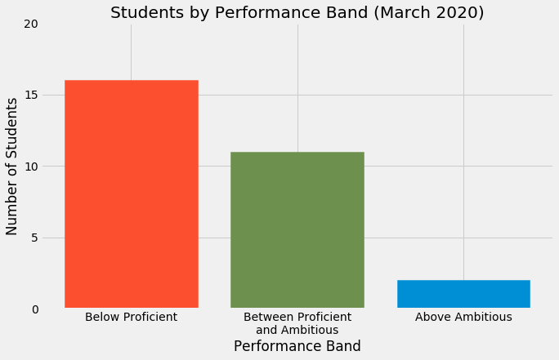

There are two students who attained a mastery above the ambitious goal of 65% mastery. 11 students surpassed the proficient goal but did not reach the ambitious goal. 16 students had not yet reached the proficient goal. Overall, this shows that approximately 45% of students achieved the Proficient Goal.

In the context of the AP exam, it is important to note that a score of a 3 is considered passing the exam. Historically, if a student achieves a percent score of 40% on the AP exam, this is sufficient for scoring a 3. From this perspective, 23 students are on track to score a 3 or higher on the AP exam in May. I believe it is important as a teacher to push for the 4 or 5 to maintain high expectations, but this in an interesting implication for students. Some colleges and universities will grant college credit for scores of a 3.

## Distribution of academic performance for all students:

The figure below shows the overall standards mastery for each student.

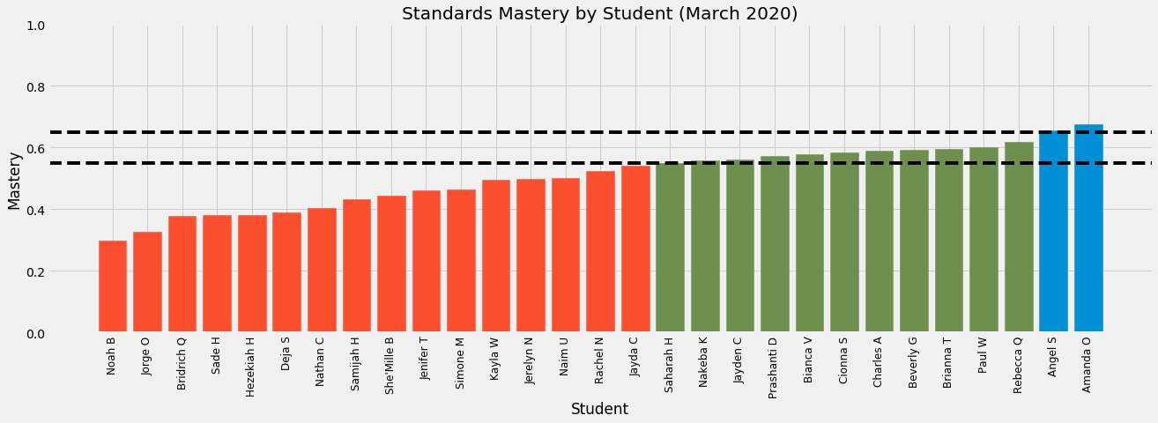

The upper dotted line represents the ambitious goal and the lower dotted line represents the proficient goal. We can see that Angel and Amanda had the highest overall standards mastery for the course. The range of scores for students that met the proficient goal is 12% between Saharah and Amanda. The range of scores for students that met the ambitious goal is 25 between Noah and Jayda. These observations show that there was a smaller spread of scores for students above the proficient goal than below the proficient goal.

## My perspective on these whole-class results:

The data above shows a wide range standards mastery for students. The highest mastery 67% while the lowest was 29% for a range of 38%. This accurately reflects the wide range of skill levels in mathematics that I expected at the start of the year. Some students have previously learned all the content assessed while others had only learned a fraction of it in their prior course.

I am very impressed by Angel and Amanda’s scores at the top of the class. Angel loves math and is always eager to get started and complete his homework right away. Amanda is a deep thinker and has deep conceptual knowledge of calculus. I am also impressed by Jayden who was already meeting the proficient goal at this point in the year. She was enrolled in Pre-AP Calculus last year, so she learned all the content this year for the first time.

I would have liked to see a higher number of students above the proficient goal at this point. I think student’s previous math course was a major determining factor (see research questions) when looking at the names that are listed as below proficient. In working with students, I think there are two factors leading to these below proficient scores: a) test anxiety/sophistication and b) need for scaffolding in mathematics. Hezekiah and Sade are always participating and understand the material in class but have difficulty synthesizing and applying their knowledge and skills during an exam. Noah and Deja have struggled with the calculus content throughout the year and would benefit from smaller group and one-on-one tutoring. Overall, it is my responsibility to own these results and intentionally chart a path forward to try to get all students to a proficient level.

# Academic Data Analysis for Subgroups of Students

## Research Question #1:

How does a student’s previous math course impact standards mastery?

## Rational for selection of research question #1:

This year’s cohort was unique in comparison to previous years. Historically, my students have all been enrolled in Pre-AP Calculus the previous year and then start AP Calculus BC with me. This year, about 33% of my students were coming from Pre-AP Calculus and 67% were coming from AP Calculus AB. The course is designed to continue where students finish in Pre-AP Calculus. The implication for AP Calculus AB students is that the first two quarters of material is teaching of prior content. I intentionally redesigned the lessons for this year so that they did not match exactly to what this group learned the previous year.

## Analysis of research question #1:

* Need two visuals (above/below PG by course and student broken down by course.
* Discussion of findings, reasoning, and implications

## Research Question #2:

What character trait indicators based on self-assessment have the strongest correlation with standards mastery?

## Rational for selection of research question #2:

We focus a ton on academic data in school because it is a tangible metric for measuring student outcomes on the way to college. I enjoyed developing character strengths this year. Through this second year at RELAY, I have gathered data across 8 indicators for the character traits of Curiosity, Grit, and Gratitude. I am curious to see if there are any links between individual indicators and standards mastery for my group of 29 students. I will be examining students’ scores for themselves as a proxy for measuring students self-perception and how it is related to academic performance.

## Analysis of research question #2:

* Need multiple visuals
  + GRAPH: 2x4 xy scatter for each indicator vs. mastery (maybe normalize these??)
  + TABLE: Correlation coefficients for indicator scores vs. standards mastery
* Discussion of findings, reasoning, and implications

# Academic Data Analysis for One Student

## Student Description:

* Describe the student (context, information, etc.)

## Student’s academic achievement throughout the year:

* Visualization of mastery over time relative to the rest of the class

## Connection to additional data source:

* Get some other information on this student that can be connected here. (books read, character data, some other metric like homework, etc.)

# Character Data Analysis

## Character measure:

During my second-year teaching in New Orleans (2014 – 2015), I audited the RELAY course, *Teaching Character and Creating Positive Classrooms.* I learned about these same eight-character strengths discussed in my second year at RELAY. At that time, I chose to focus on curiosity, grit, and gratitude for the following reasons:

* Curiosity – When one is curious about a subject, they are naturally more inclined to learn more and develop their skills in that subject. Curiosity is a muscle that can be developed for any subject and AP Calculus is a great content to work on developing this aspect of character because it can be initially uninteresting.
* Grit – College is tough! I want my students to develop their grit so they can succeed in future college STEM courses where they will have trouble. We have seen alumni switch out of STEM majors due to difficulty in the past. I want to disrupt this narrative with my students this year.
* Gratitude – Any strong community is based on appreciation for those around you. I want to give my students opportunities to develop this character strength so be thankful for others in the good and the bad times.

In my second year at RELAY, I wanted to tap back into these character strengths with my group of 29 seniors. At the beginning of the 2019-2020 school year, I thought that it would be important for my students to be involved in the character trait that we tracked for the school year. For my 12th grade students, I have found that involving students in instructional decisions improves investment. We started the year with a lesson designed to introduce curiosity, grit, and gratitude and then narrow down to one trait. Through a discussion, both classes decided to keep all three traits! In the words of Charles, “All of these traits are important so I think we should work on all of them this year.”

We decided to track all these character strengths throughout the year and I tried to promote each of these in *micro moments* throughout the course. The results for all three traits are captured in Appendix 1. As an instructor, I decided to focus specifically on developing curiosity. The analysis and discussion below are focused on curiosity.

## Character results analysis:

The figure below shows the average score of each curiosity indicator aggregated by the evaluator.

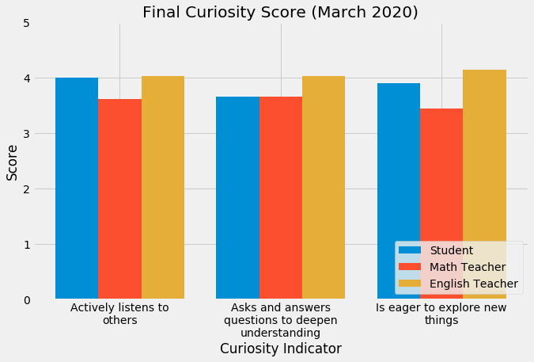

The students’ scores were students’ self-assessment of themselves on that indicator. The math teacher scores represent scores given by me and the English teacher scores given by each student’s respective English teacher. For all three indicators, the English teacher average is the highest for the class. This may imply that this group of students’ curiosities is stronger in English and/or Humanities classes than Math and/or STEM classes.

The figure below represents that final curiosity score by students where each students score is average across the three indicators and the three evaluators (Student, Math teacher, and English teacher).

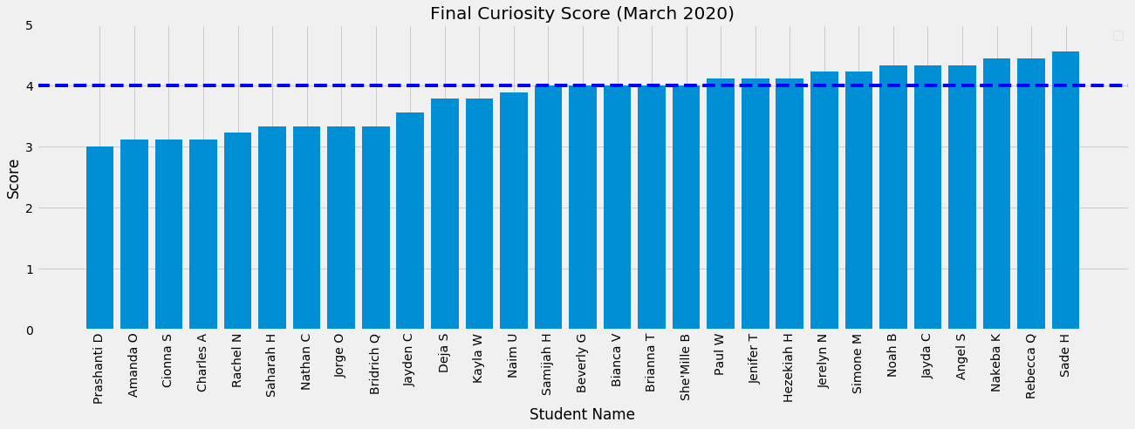

From the graph above, 16 of 29 (55%) students were at a score of 4 or higher for curiosity. There appears to be a subgroup of students who are at or below 3.5 for curiosity. When I step back and think about the course, I remember Sade, Jayda, and Angel asking questions throughout the course and this matches up with their high curiosity scores. When I think about the students towards the left end of the graph, they tend to be more reserved in class and do not ask as many questions.

The figure below shows the average growth for each curiosity indicator between quarter 1 and quarter 3.

The figure below shows the average growth for curiosity aggregated by student.

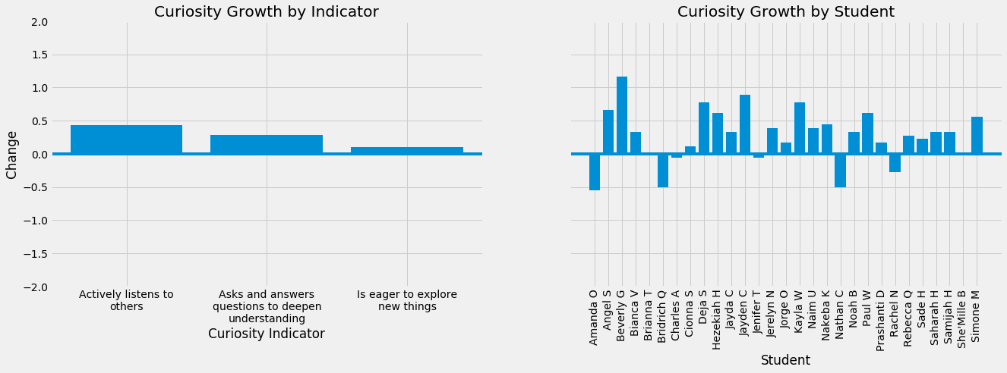

Average growth:

There was an increase in all three indicators from the start of the year, though at varying magnitudes. We can see the largest growth for the class occurred for the indicator *actively listens to others* and there was minimal average growth for *is eager to explore new things.*

Student growth:

From this visual we can see individual trends by students. Beverly, Jayden, Kayla, and Deja showed the greatest increase in curiosity over the course of the year. Amanda, Bridrich, and Nathan all showed a decrease in their curiosity scores throughout the year.

## Character results storyline:

* How did you build this strength?
* Are the results reflective of your work teacher actions?

# Next Steps from Analyses of Academic and Character Data

## Action Step #1 (from academic analysis):

## Action Step #2 (from character analysis):

# Appendix 1: Character Data for Curiosity, Grit, and Gratitude

