Last Information for French German adsorption Meeting – ECPM

The main entrance of the campus is on 23 rue du Loess, 67000 Strasbourg. You have to be registered to the meeting to get in the campus.

Then a signposting will give you information to get to ECPM (building n°100) for pedestrians and cars.

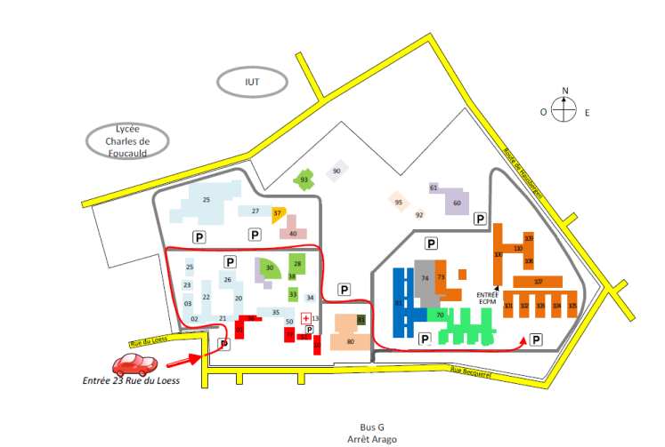

The meeting will start at 13:30 on Tuesday October 24th and end at Thursday October 26th at 12:10 pm. A lunch box will be supplied (please bring a totebag to get it).

The bus line is G (departure from the main railway station – direction “Espace Européen des Entreprises and stop “Arago”) and the trip is 10 – 15 min long.

For exhibitors: it will be possible to enter the room from 10:00 pm on Tuesday. Follow the above map. The local coordinator is Cécile Vallières : vallieres@unistra.fr