Bamazon Supervisor Workflow

- Supervisor options

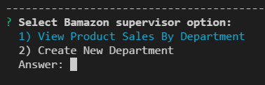
- View product sales by dept
Note: ID's 6 and 7 represent departments without any products
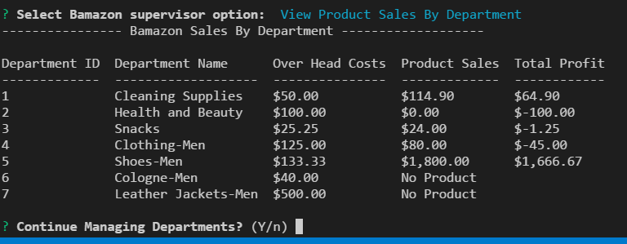

- Create new department
  - department table before update

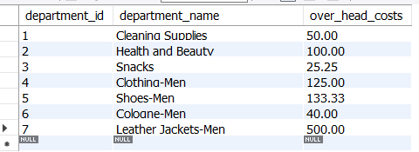

  - New department entries and confirmation
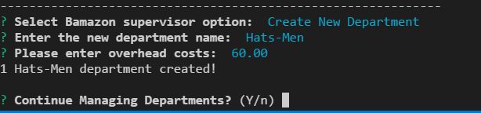
  - Table and supervisor view option after update
Note new dept of 'Hats-Men'

