EXAM 2

George Coates Roberts (gcr422)

6/26/2020

## R Markdown

This is an R Markdown document. Markdown is a simple formatting syntax for authoring HTML, PDF, and MS Word documents. For more details on using R Markdown see <http://rmarkdown.rstudio.com>.

When you click the **Knit** button a document will be generated that includes both content as well as the output of any embedded R code chunks within the document. You can embed an R code chunk like this:

summary(cars)

## speed dist   
## Min. : 4.0 Min. : 2.00   
## 1st Qu.:12.0 1st Qu.: 26.00   
## Median :15.0 Median : 36.00   
## Mean :15.4 Mean : 42.98   
## 3rd Qu.:19.0 3rd Qu.: 56.00   
## Max. :25.0 Max. :120.00

## Including Plots

You can also embed plots, for example:

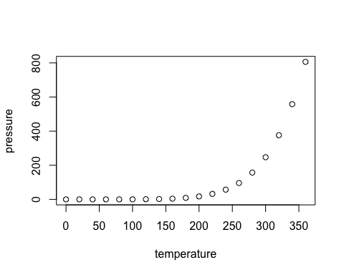

Note that the echo = FALSE parameter was added to the code chunk to prevent printing of the R code that generated the plot. # clear the envirnoment rm(list=ls(all=TRUE)) #load the inequality dataset library(rio) inequality_data = import(“inequality.xlsx”, which = 1) # This is a cross-sectional dataset, this is a snapshot of year 2015 head(inequality_data) # Use subset command to provide inequality_gini scores for Denmark and Sweden library(countrycode) inequality_data $country_{c}ode=countrycode(sourcevar=inequality_{d}ata$ country, origin = “country.name”, destination = “iso3c”, warn = TRUE) giniscores <- subset(inequality_data,inequality_gini, c(“Denmark”, “Sweden”) # Inequality Gini scores, Denmark= 28.2, Sweden = 29.2 # Show inequality_gini score for Brazil giniscorebrazil <- subset(inequality_data, inequality_gini, c(“Brazil”) # Inequality Gini score Brazil= 51.9 # It is better to have a low inequality_gini score # Use head command to quick peak at the data frame head(inequality_data) # Remove accent on Belarus, run head command again accent.remove <- function(s) {

#1 character substitutions old1 <- “ú” new1 <- “u” s <- chartr(old1,new1,s) } head(inequality_data) # Sort data by countries with lowest inequality_gini inequality_data = inequality_data[order(inequality_data$inequality_gini),] head(inequality_data) # The mean inequality score = 36.81375 mean(inequality_data$inequality_gini,na.rm=TRUE) # Use ifelse command to create 2 dummy variables