Software Development Life Cycle and Roles

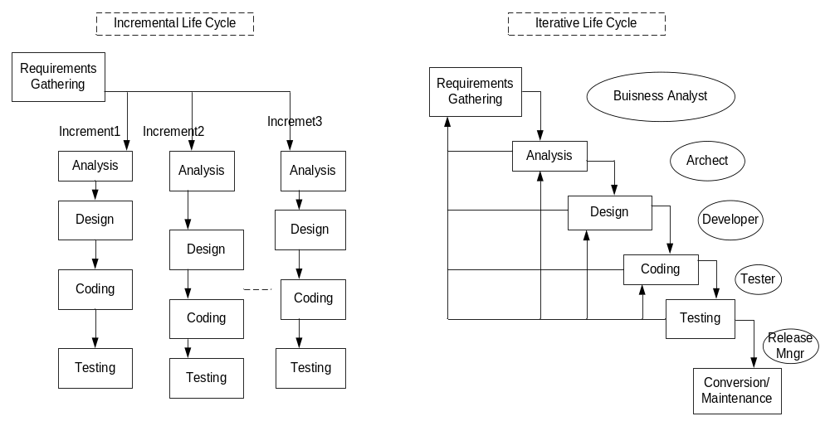

A Waterfall: The model that describes (first requirements followed by design, coding, testing and release) is the Waterfall model. This model is useful only if the requirements are absolutely clear and never change during the project. Pros: Each phase is independent…useful when reqs will not change over time, project is small. Cons: cannot handle changes very well, users only involved in the end.
An incremental: requiring that the system be developed in succinct pieces. Each increment (after the first) can reuse assets that were developed in earlier increments. The most common requirements falling in the first and the least last. (Pros: issues raised in previous increments can be addressed in current, More frequent releases can be done, everything in each phase does not have to be completed in order to move forward, different teams can work on different increments independently. Cons: Problems raised in a phase can not be addresses until future increment, Requires planning to determine which requirements will be addresses in which increment.
Useful when not all functionality is necessary in order for the project to be useful. Not all requirements are specified(or known) at the beginning of the project. Project is large scale.

An iterative: requiring that issues/errors identified and handled immediately in the
Appropriate phase. Objects allow this easy flow between phases because the language used is always objects. Characterized by the ability to move up the waterfall. (Pros: issues not put off—addressed immediately(in appropriate phase, changes made in later phase do not contradict what was documented in earlier phase, all phases up-to-date, deliver system will have documentation in current state. Issues are resolved in the appropriate phase & changes are cascaded down. Cons: difficult to gauge where the project is according to plan. Difficult to project manage where different group/people in different phase).
Useful when Documents needs to match system in production. A single team working on the project. Flexibility is feasible on development team.

A combination of iterative and incremental life cycle fits our development process.

Based on the above SDLC: The different roles could be defined as..

Project Manager: This would include
- Tracking the project progress, address issues.
- Supporting PDD
- Estimation Schedule
- Researching Risk Mgnt, Cust. Relation Mgnt
Business Analyst: This would include
- Requirements Gathering
- Gap Analysis with existing system or process
- Identify Actors, Use cases
- Work flow, Sequence diagram
- Screen Design
- Facilitate UAT

Architect: includes
- Workflow analysis: focus on specification of the system
- Architectural analysis - objects (use case realization)
Requirement and Use case analysis (Analyze class model)
- Object diagram, Sequence diagram
- Class Diagram
- Moving analysis to implementation
- Database Design

Developer: includes
- Analyze Database Design
- Coding and unit testing on Local host

Tester/QA : includes
- Functional/Integrated Testing (not developer)

Release Manager: includes
- Code review, Build war file, deploy to various environments

