**CSC13009 – Mobile Application Development**

**FINAL REPORT**

1. **Information**

Group ID**: 16**

Members**:**

|  |  |  |  |
| --- | --- | --- | --- |
| **ID** | **Student ID** | **Full name** | **Tasks (%)** |
| 1 | 20120195 | Trần Hoài Thiện | 7% |
| 2 | 20120206 | Nguyễn Ngọc Thùy | 20% |
| 3 | 20120231 | Phan Huy Trường | 33% |
| 4 | 20120581 | Nguyễn Thị Ngọc Thành | 20% |
| 5 | 20120589 | Nguyễn Hạnh Thư | 20% |

1. **Expected Point: 10/10**
2. **Video links (Youtube)**

* Link video demo: <https://youtu.be/aqc4MrdfrlI>

1. **Source code (Google drive links)**

* Project: https://drive.google.com/file/d/1lh4amaRkKe3sgFsdnRiIJc_1GEuAZwt9/view?usp=sharing

1. **Screenshots**
2. Đối với album Album

* Lưu ảnh vào album name khi nhấn done

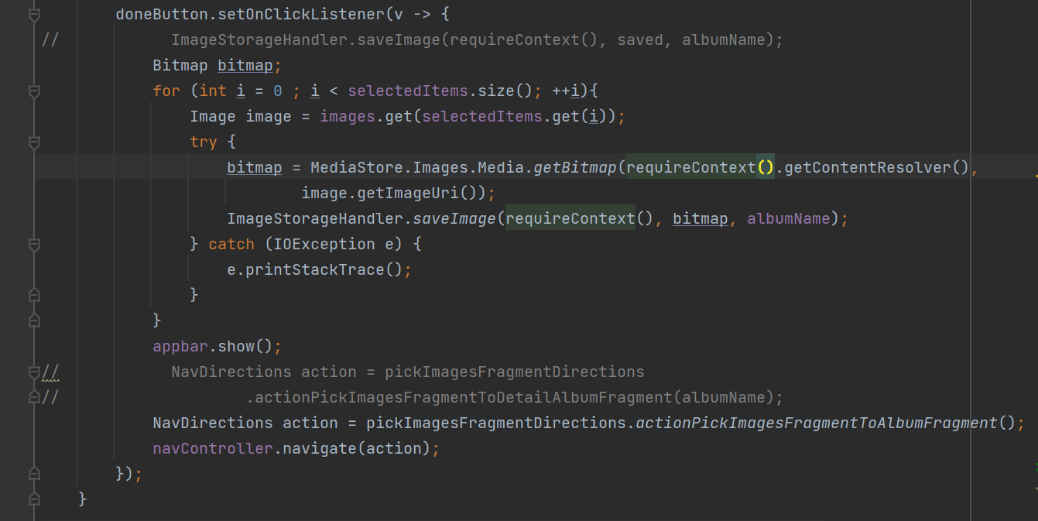

* Xử lí sự kiện click khi chọn vào Album

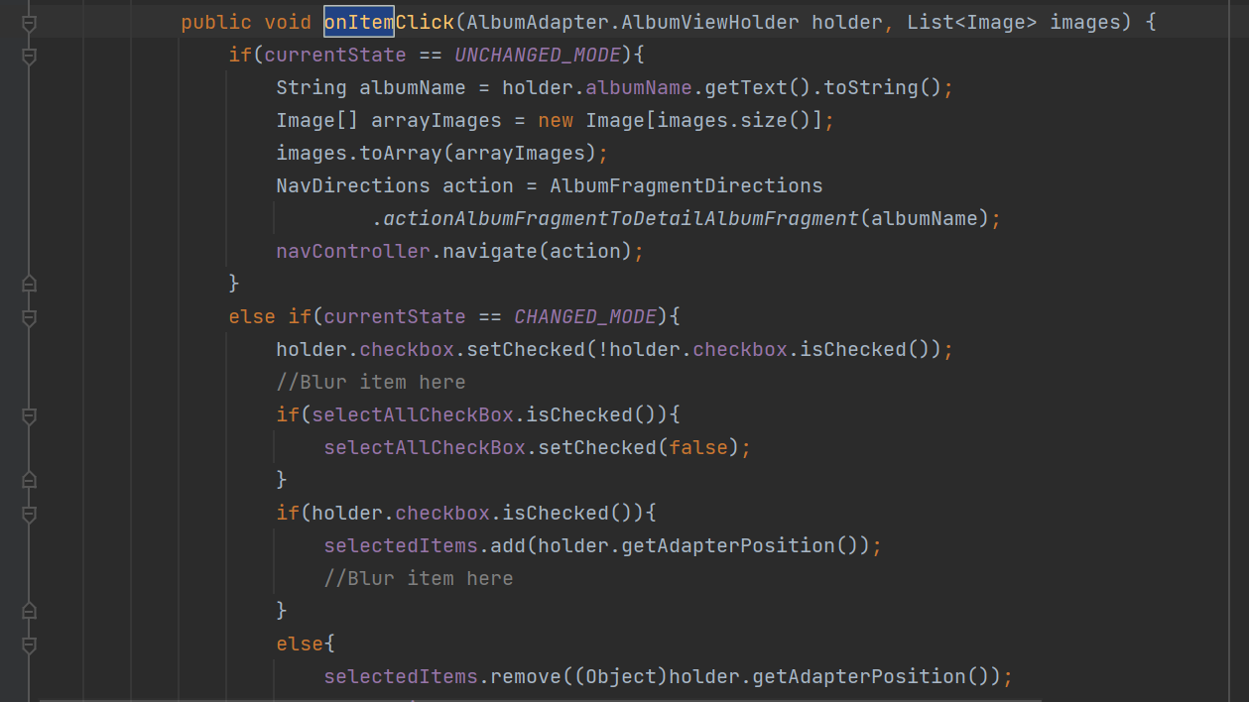

1. Đối với ảnh

* Hàm saveImage

* Hàm xóa ảnh

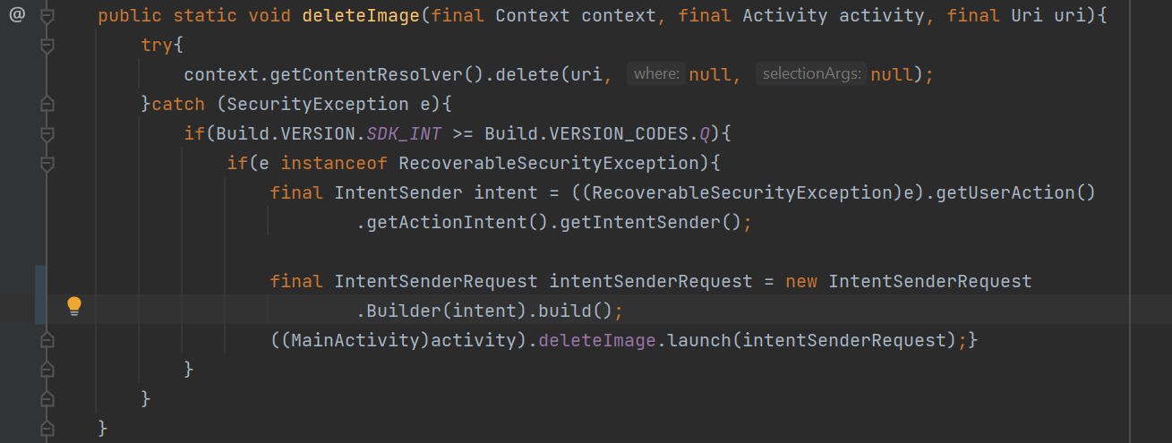

* Hàm để add filter cho ảnh

* chức năng hiển thị thông tin + thêm mô tả ảnh

* Lưu ảnh từ máy vào app

1. **Spicific techniques (optional)**
2. Jetpack Compose Navigation
3. LiveData with ViewModel
4. **References**
5. Cắt ảnh: <https://github.com/Yalantis/uCrop>
6. Hiển thị thông tin, thêm mô tả cho ảnh + đổi tên ảnh:

* <https://developer.android.com/reference/android/app/AlertDialog.Builder>
* https://stackoverflow.com/questions/18225365/show-error-on-the-tip-of-the-edit-text-android

1. Quay ảnh: <https://stackoverflow.com/questions/9015372/how-to-rotate-a-bitmap-90-degrees>
2. Lật ảnh: <https://stackoverflow.com/questions/36493977/flip-a-bitmap-image-horizontally-or-vertically>
3. Chuyển ngôn ngữ (Anh <-> Việt):

* <https://www.youtube.com/watch?v=OprxdkVKEcc>
* https://developer.android.com/training/data-storage/shared-preferences

1. Data: <https://medium.com/@jmcassis/android-livedata-and-content-provider-updates-5f8fd3b2b3a4>
2. Zoom ảnh:[https://stackoverflow.com/a/17649895](https://stackoverflow.com/a/17649895?fbclid=IwAR2qwiUSZD5PcxuTZstDewCAJB5aJEaL_id9CwcEFIdZAqpxaA5KY2qvyUo)
3. Filter: <https://xjaphx.wordpress.com/learning/tutorials/>
4. Paint: <https://stackoverflow.com/questions/26209532/draw-on-picture-in-android>