# Windows Tray Application

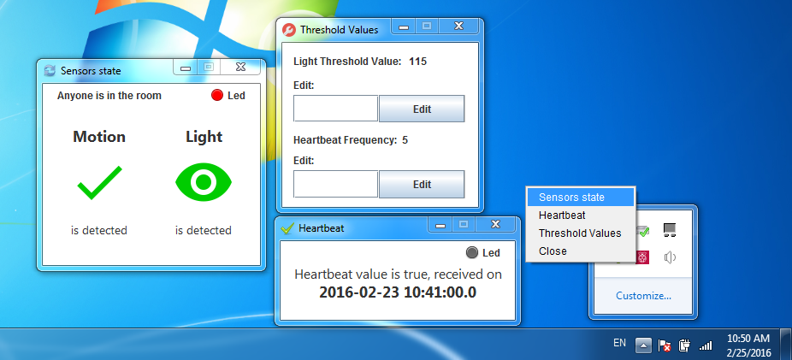

Screenshot-ul de mai sus reprezenta aplicația client Windows Tray Application. Este o aplicatie simpla formata din trei ferestre:

* Sensors state – afiseaza starea curenta a senzorilor;
* Threshold Values – seteaza valorea de prag a luminii si frecventa mesajului de heartbeat;
* Heartbeat – afiseaza ultimul mesaj de heartbeat si timpul de receptionare a acestuia.

Aplicatia face cereri la Server la fiecare 2 secunde si afiseaza modificarile. Acest lucru se observa indeosebi la fereastra *Sensors State* unde in cazul modificarilor de stare a senzorilor se schimba iconitele si deasemenea si textul ceea ce creeaza un efect dinamic placut.

Ledul din partea de sus serveste drept indicator de stare. Daca exista o conexiune activa dintre bordul Arduino si Server ledul va fi de culoare verde iar daca nu atunci acesta va deveni rosu.

The screenshot represents the Windows Tray Application. It’s a simple application consists of three windows:

* Sensors state - display the sensors current state;
* Threshold Values - sets the threshold light value and frequency of heartbeat message;
* Heartbeat - displays the last heartbeat message and its reception time.

This application makes requests to the server every two seconds and displays the changes. This is observed in the window Sensors State, where if the sensors state is changed, is changing also the icons and text, that create a nice dynamic effect.

The LED at the top serves as a status indicator. If there is an active connection between the Arduino board and Server LED will be green and if not then it will become red.