PART 1 — Install SQLite

Windows installation:
Add a screenshot of your output below if you are using windows:
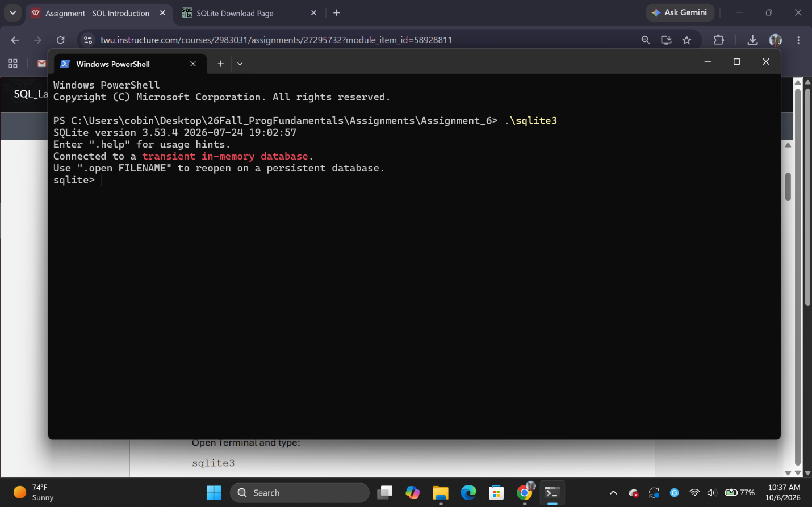

Install SQLite Extension in VS Code
Add a screenshot showing the extension installed
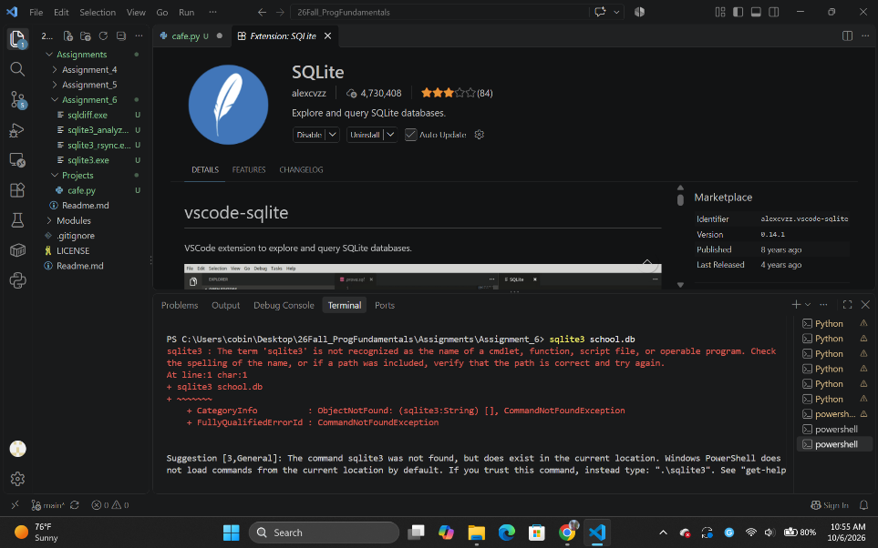
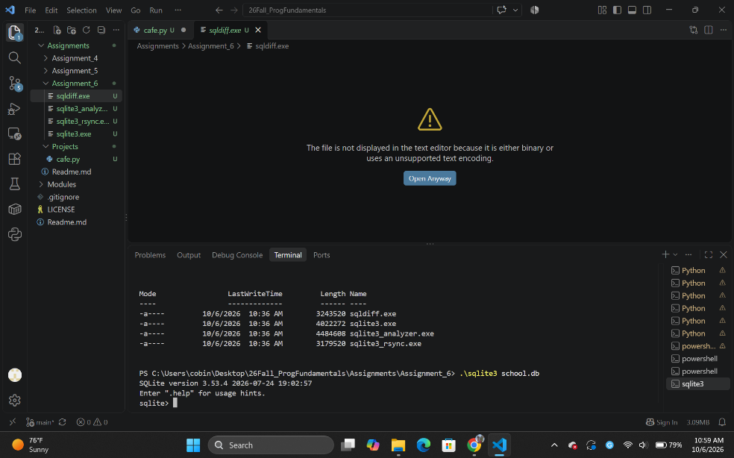

Create Your First Database
Add a screenshot of your folders section. You will see a database file in the left side pane:

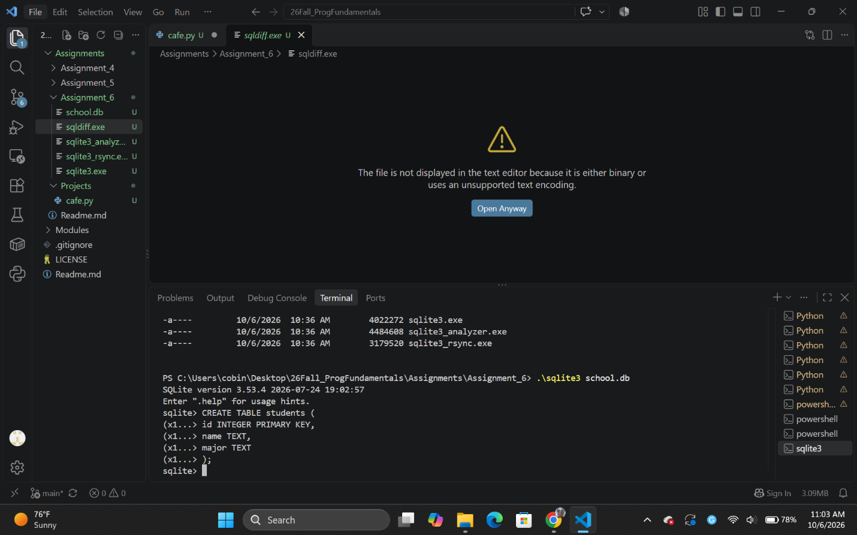

Add a screenshot of your terminal output:

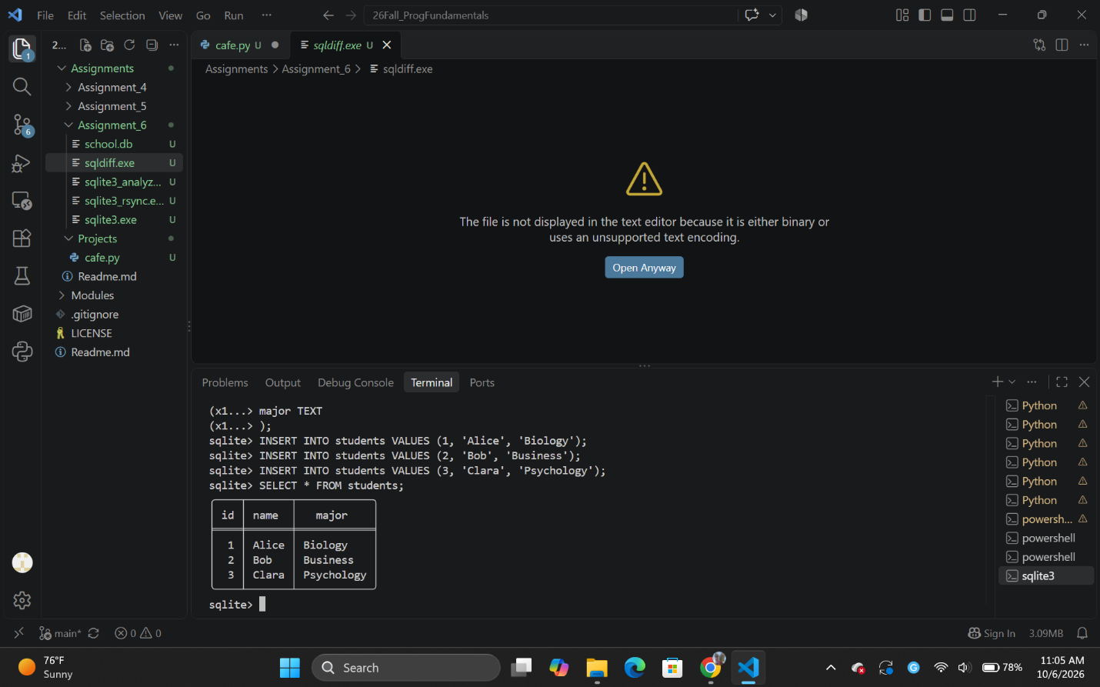

Add a screenshot of your outputs (There will be 3 screenshots for 3 queries):
