Python Cafe (Part 1)

Output in the screenshot below shows the program running and asks for the customer's name after greeting the customer.

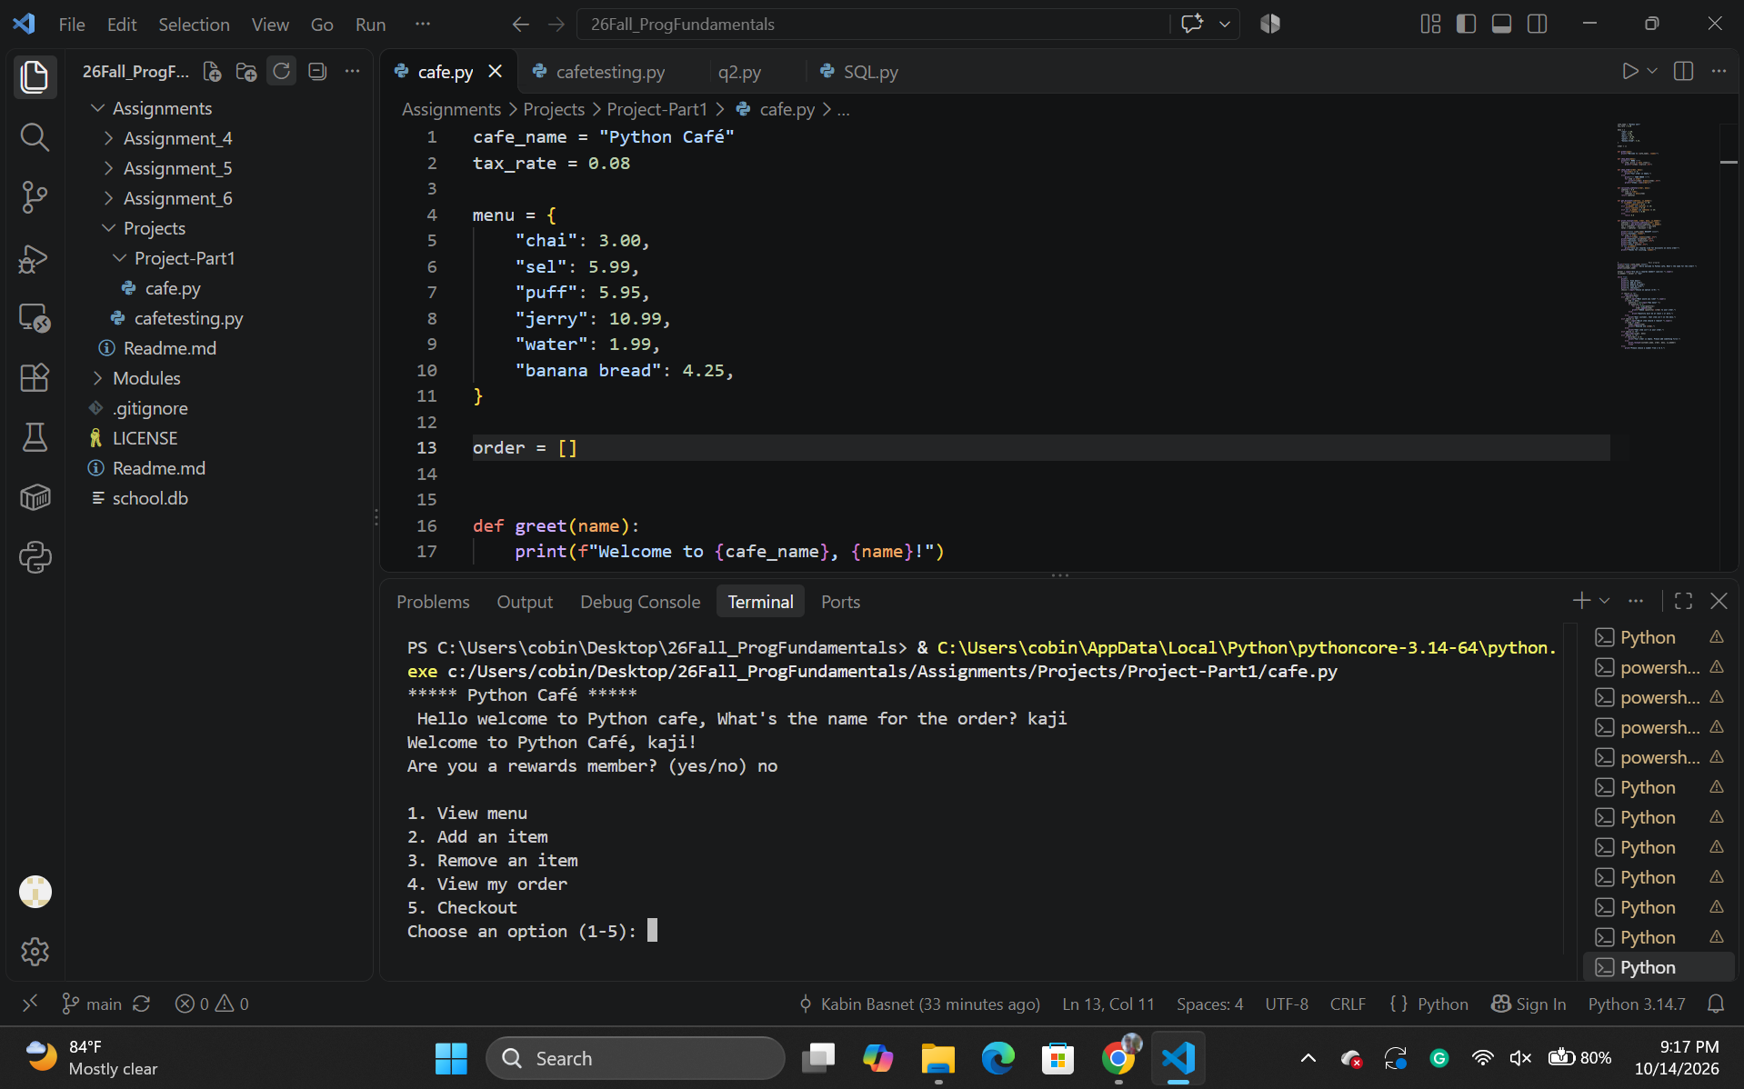

Screenshot below shows the menu option after the customer chose option 1 / (View menu).

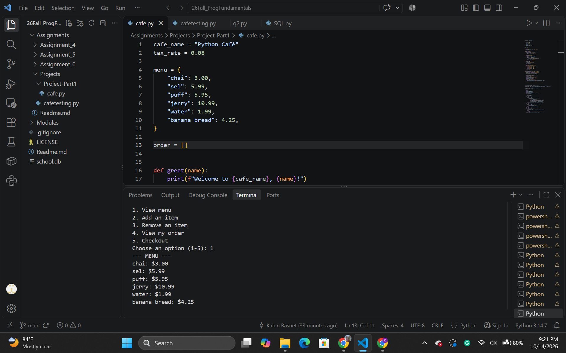

Below I chose option 2 to add an item which was “Jerry” and it asked “ How many” where I chose 5 and after doing so it again took me to the main menu option where I can choose to either view, add, remove, or check out.

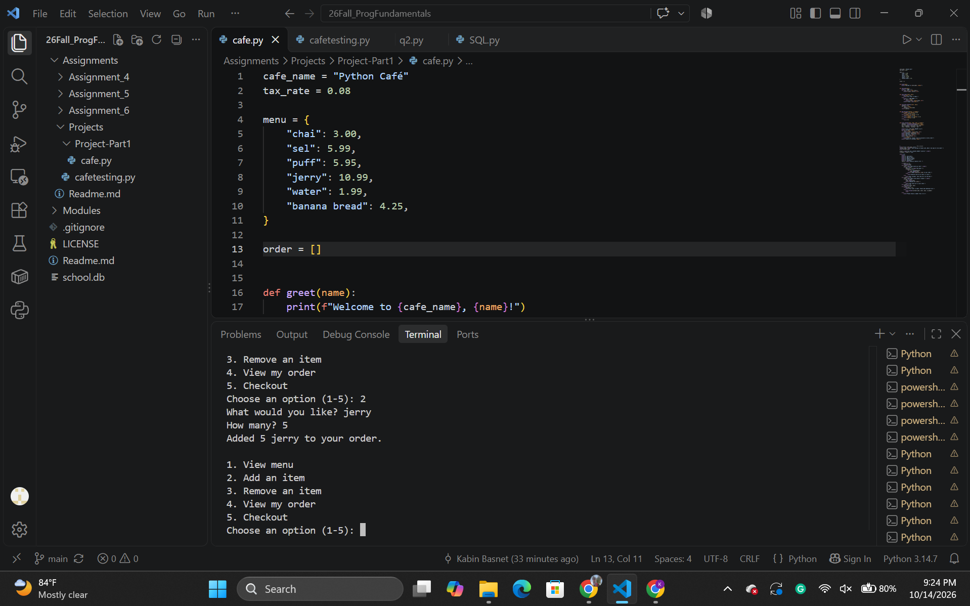

Here, I chose option 3 and removed 1 jerry from the cart. And after doing so, it took me to the menu again where i can choose to either add, remove or check out.

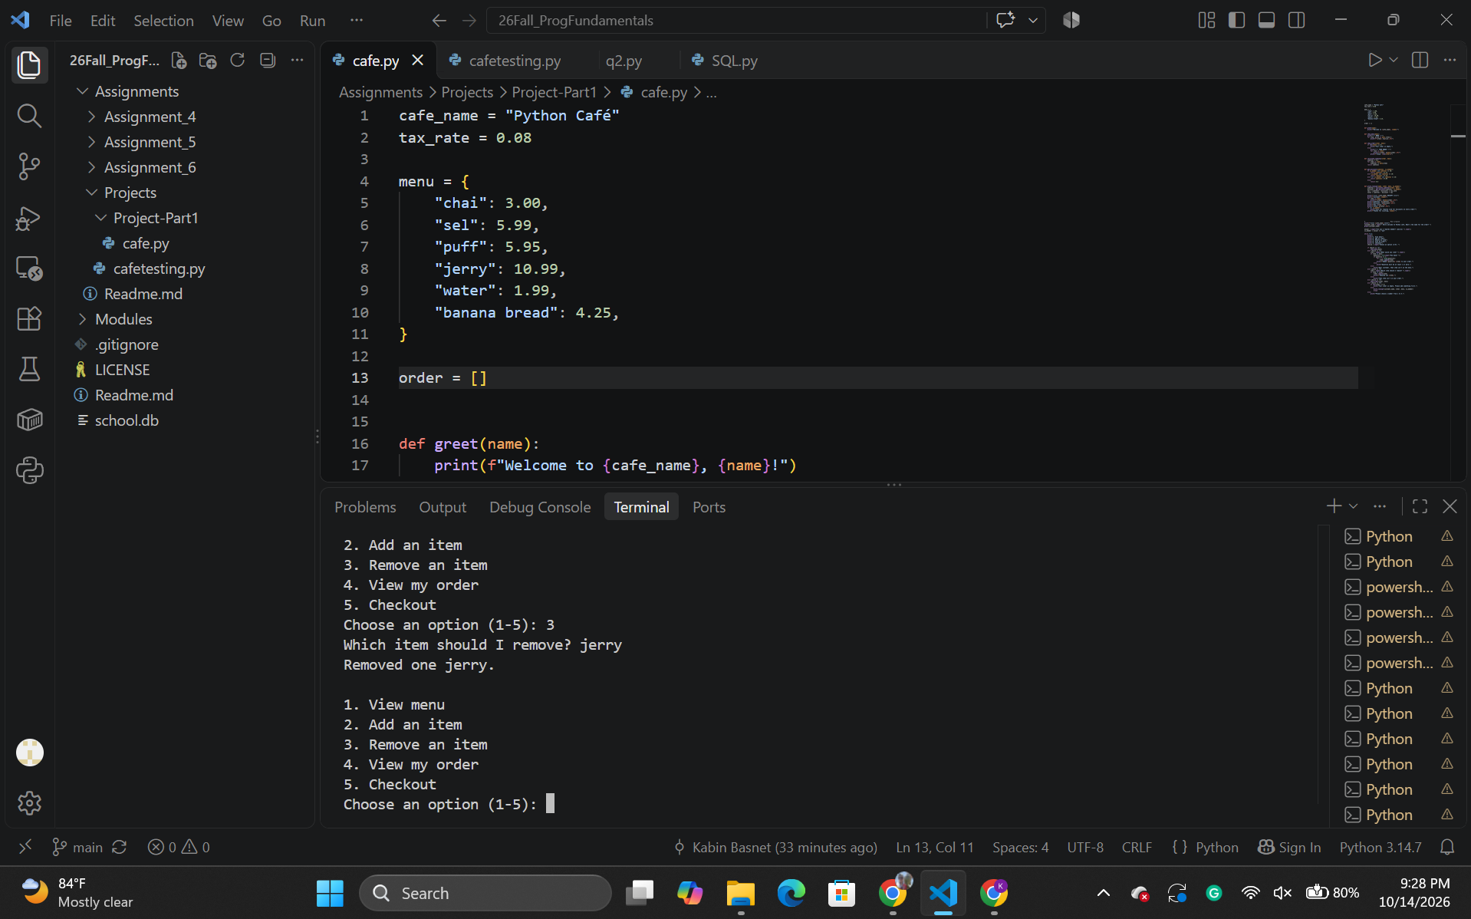

Here I chose option 4 to view my orders and there are only 4 Jerry which I initially added 5 and later removed one of them.

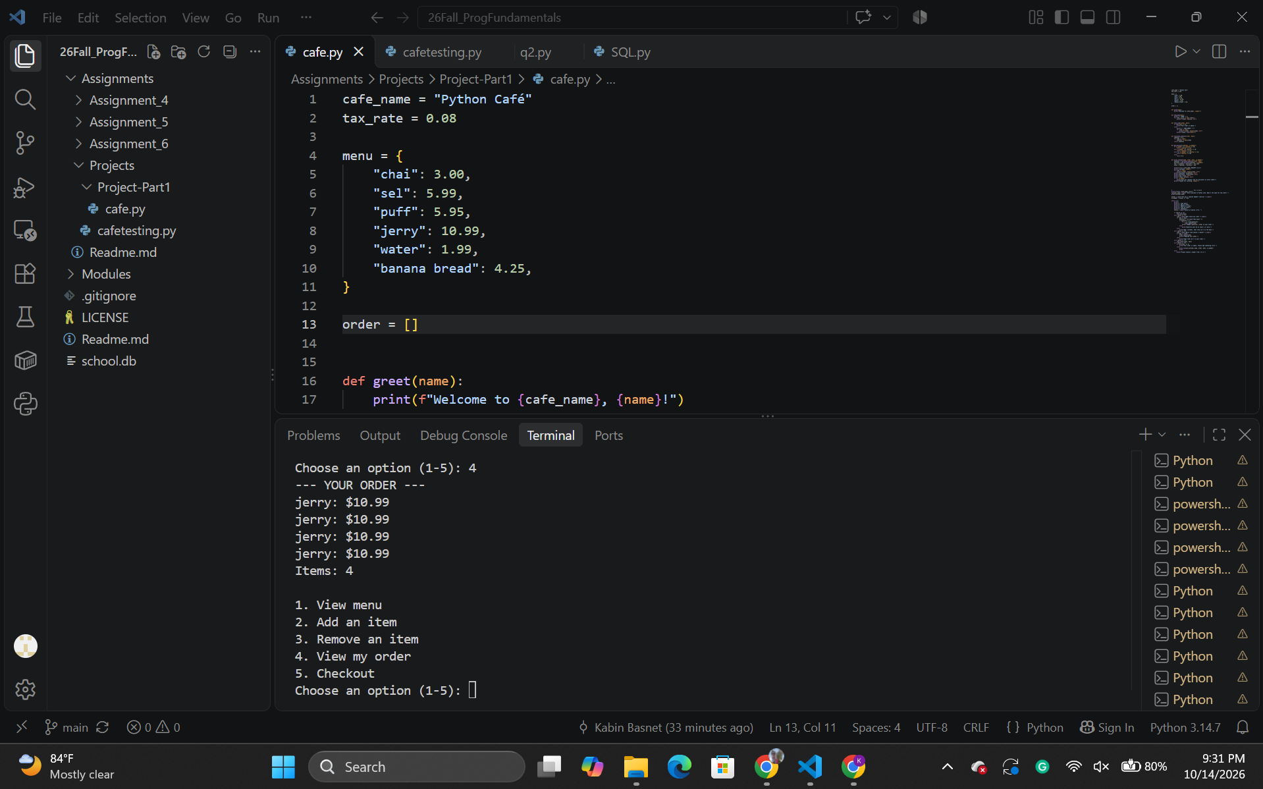

Finally, here is the checkout option at number 5 which prints the receipt and as I chose option “No” for the rewards member, It asks me to join the reward club for discounts at the receipt.

