**DATABASE DML DDL COMMANDS AND SCREENSHOTS OF TESTING**

**CREATE COMMANDS**

Activity Table:

CREATE TABLE `activity` (  
 `activityid` int(11) NOT NULL AUTO_INCREMENT,  
 `description` varchar(100) NOT NULL,  
 PRIMARY KEY (`activityid`)  
);

Package:

CREATE TABLE `package` (  
 `packageid` int(11) NOT NULL AUTO_INCREMENT,  
 `description` varchar(100) NOT NULL,  
 `noofnights` int(11) NOT NULL,  
 `cost` double NOT NULL,  
 PRIMARY KEY (`packageid`)  
) ;

Reservation Yurt:

CREATE TABLE `reservationyurt` (  
 `resid` int(11) NOT NULL AUTO_INCREMENT,  
 `arrivalDate` date NOT NULL,  
 `noofnights` int(11) NOT NULL,  
 `packageid` int(11) NOT NULL,  
 PRIMARY KEY (`resid`),  
 KEY `packageid` (`packageid`),  
 CONSTRAINT `reservationyurt_ibfk_1` FOREIGN KEY (`packageid`) REFERENCES `package` (`packageid`)  
) ;

Client:

CREATE TABLE `client` (  
 `clientid` int(11) NOT NULL AUTO_INCREMENT,  
 `fname` varchar(50) NOT NULL,  
 `lname` varchar(50) NOT NULL,  
 `address` varchar(100) NOT NULL,  
 `phone` varchar(10) NOT NULL,  
 `email` varchar(100) NOT NULL,  
 `resid` int(11) NOT NULL,  
 `activityid` int(11) NOT NULL,  
 PRIMARY KEY (`clientid`),  
 KEY `activityid` (`activityid`),  
 CONSTRAINT `client_ibfk_1` FOREIGN KEY (`activityid`) REFERENCES `activity` (`activityid`)  
) ;

When:

CREATE TABLE `whenres` (  
 `id` int(11) NOT NULL AUTO_INCREMENT,  
 `date` date NOT NULL,  
 `activityid` int(11) NOT NULL,  
 `clientid` int(11) NOT NULL,  
 PRIMARY KEY (`id`),  
 KEY `activityid` (`activityid`),  
 KEY `clientid` (`clientid`),  
 CONSTRAINT `whenres_ibfk_1` FOREIGN KEY (`activityid`) REFERENCES `activity` (`activityid`),  
 CONSTRAINT `whenres_ibfk_2` FOREIGN KEY (`clientid`) REFERENCES `client` (`clientid`)  
) ;

Temp:

CREATE TABLE `temp` (  
 `quantity` int(11) NOT NULL,  
 `cost` double NOT NULL,  
 `description` varchar(50) NOT NULL,  
 PRIMARY KEY (`description`)  
);

Order:

CREATE TABLE `ordertable` (  
 `name` varchar(100) NOT NULL,  
 `email` varchar(100) NOT NULL,  
 `address` varchar(100) NOT NULL,  
 `city` varchar(100) NOT NULL,  
 `state` varchar(100) NOT NULL,  
 `zip` varchar(100) NOT NULL,  
 `cc` int(100) NOT NULL,  
 `month` varchar(100) NOT NULL,  
 `year` varchar(100) NOT NULL,  
 `orderid` int(100) NOT NULL AUTO_INCREMENT,  
 `cost` double NOT NULL,  
 PRIMARY KEY (`orderid`)  
) ;

**SELECT COMMANDS:**

[SELECT](http://localhost/phpmyadmin/url.php?url=https://dev.mysql.com/doc/refman/5.5/en/select.html) * FROM `activity`

[SELECT](http://localhost/phpmyadmin/url.php?url=https://dev.mysql.com/doc/refman/5.5/en/select.html) * FROM `client`

[SELECT](http://localhost/phpmyadmin/url.php?url=https://dev.mysql.com/doc/refman/5.5/en/select.html) * FROM `ordertable`

[SELECT](http://localhost/phpmyadmin/url.php?url=https://dev.mysql.com/doc/refman/5.5/en/select.html) * FROM `package`

[SELECT](http://localhost/phpmyadmin/url.php?url=https://dev.mysql.com/doc/refman/5.5/en/select.html) * FROM `reservationyurt

[SELECT](http://localhost/phpmyadmin/url.php?url=https://dev.mysql.com/doc/refman/5.5/en/select.html) * FROM `temp`

[SELECT](http://localhost/phpmyadmin/url.php?url=https://dev.mysql.com/doc/refman/5.5/en/select.html) * FROM `ordertable`

**DELETE COMMANDS**

DELETE FROM `package` WHERE `package`.`packageid` = 1";

DELETE FROM `activity` WHERE `activity`.`activityid` = 2";

DELETE FROM `client` WHERE `client`.`clientid` = 25";

DELETE FROM `ordertable` WHERE `ordertable`.`orderid` = 1;

DELETE FROM `reservationyurt` WHERE `reservationyurt`.`resid` = 28";

**UPDATE COMMANDS**

UPDATE `reservationyurt` SET `resid`=[value-1],`arrivalDate`=[value-2],`noofnights`=[value-3],`packageid`=[value-4] WHERE `resid`=[value-1],’;

UPDATE `activity` SET `activityid`=[value-1],`description`=[value-2] WHERE ‘activityid`=[value-1]’

UPDATE `client` SET `clientid`=[value-1],`fname`=[value-2],`lname`=[value-3],`address`=[value-4],`phone`=[value-5],`email`=[value-6],`resid`=[value-7],`activityid`=[value-8] WHERE `clientid`=[value-1];

UPDATE `ordertable` SET `name`=[value-1],`email`=[value-2],`address`=[value-3],`city`=[value-4],`state`=[value-5],`zip`=[value-6],`cc`=[value-7],`month`=[value-8],`year`=[value-9],`orderid`=[value-10],`cost`=[value-11] WHERE `name`=[value-1];

UPDATE `package` SET `description`=[value-2],`noofnights`=[value-3],`cost`=[value-4] WHERE `packageid`=[value-1];

**INSERT COMMANDS:**

INSERT INTO `reservationyurt`(`resid`, `arrivalDate`, `noofnights`, `packageid`) VALUES ([value-1],[value-2],[value-3],[value-4])

INSERT INTO `activity`(`activityid`, `description`) VALUES ([value-1],[value-2])

INSERT INTO `order`(`name`, `email`, `address`, `city`, `state`, `zip`, `cc`, `month`, `year`, `orderid`) VALUES ([value-1],[value-2],[value-3],[value-4],[value-5],[value-6],[value-7],[value-8],[value-9],[value-10])

INSERT INTO `client`(`clientid`, `fname`, `lname`, `address`, `phone`, `email`, `resid`, `activityid`) VALUES ([value-1],[value-2],[value-3],[value-4],[value-5],[value-6],[value-7],[value-8])

INSERT INTO `package`(`packageid`, `description`, `noofnights`) VALUES ([value-1],[value-2],[value-3],[value-4]);

**DATABASE CONTENT**

ACTIVITY:

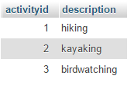

CLIENT:

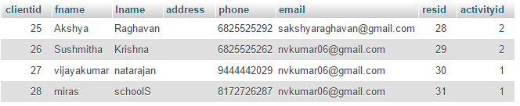

RESERVATION YURT:

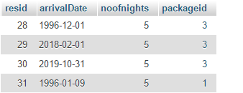

ORDER TABLE:

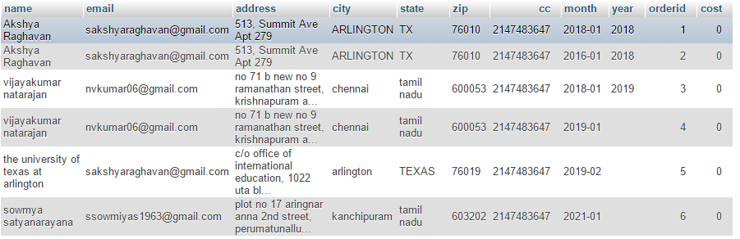

PACKAGE:

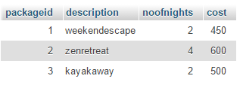

**SCREENSHOTS OF TESTING:**

