Chapter 6 Draft - Stage 1 Results and Feasibility Decision
Draft generated: 2026-03-05 22:43
Scope: measurement feasibility, scan efficiency, and decision thresholds only.

6.1 Processing Validation - Baseline PEGDA (No SiNP)
Baseline validation still depends on the topo-only PEGDA rerun for a direct false-positive bound. For this draft, the workflow credibility argument rests on the completed method-validation work and the consistency of the completed Stage 1 outputs.
Figure 6.1 gives an early orienting summary so the chapter does not open without a figure.
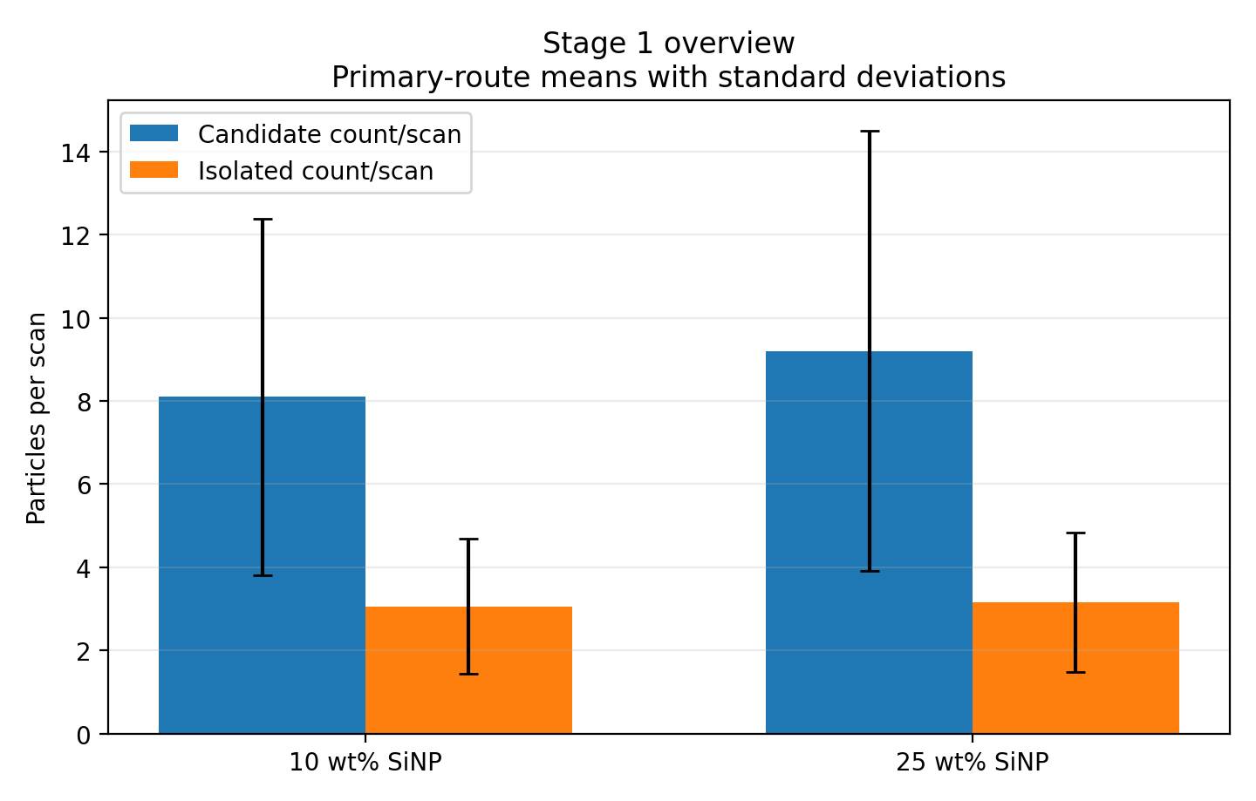
Figure 6.1 - Stage 1 overview for PEGDA, 1 wt% TPO, no coating, comparing 10 wt% and 25 wt% SiNP. Bars show mean candidate and isolated counts per scan with standard deviations.
Source: docs\Thesis\generated_assets\chapter6_stage1_overview.png

6.2 Stage 1 - Particle Presence in PEGDA-SiNP

6.2.1 Scan Inventory
Table 6.1 - Scan inventory used for the current Stage 1 analysis
System | Sample sets | Scans analyzed | Scan size (um x um) | Pixel grid | Resolution (nm/pixel) | Nominal map grid
10 wt% SiNP | 4 | 386 | 5 x 5 | 512 x 512 | 9.77 | 21 x 21
25 wt% SiNP | 5 | 404 | 5 x 5 | 512 x 512 | 9.77 | 21 x 21
10 wt% SiNP contributed 386 scans across 4 sample sets. 25 wt% SiNP contributed 404 scans across 5 sample sets. Each scan is a 5 um x 5 um AFM image on a nominal 21 x 21 survey grid with 512 x 512 pixels.

6.2.2 Particle Count Per Scan
Under the primary route (particle_forward_medianbg_mean), retained candidate counts averaged 8.10 +/- 4.29 particles per scan for 10 wt% SiNP and 9.20 +/- 5.30 particles per scan for 25 wt% SiNP. Zero-count scans were rare in both sets (0.8% and 0.7%).
The 25 wt% SiNP set showed a modest increase in candidate density relative to 10 wt% SiNP (1.14x), but this stage still describes candidate features, not fully validated true particles.
Table 6.2 - Primary-method candidate count summary
System | Mean count/scan | Std | Min | Max | Zero-count rate
10 wt% SiNP | 8.10 | 4.29 | 0 | 23 | 0.8%
25 wt% SiNP | 9.20 | 5.30 | 0 | 30 | 0.7%
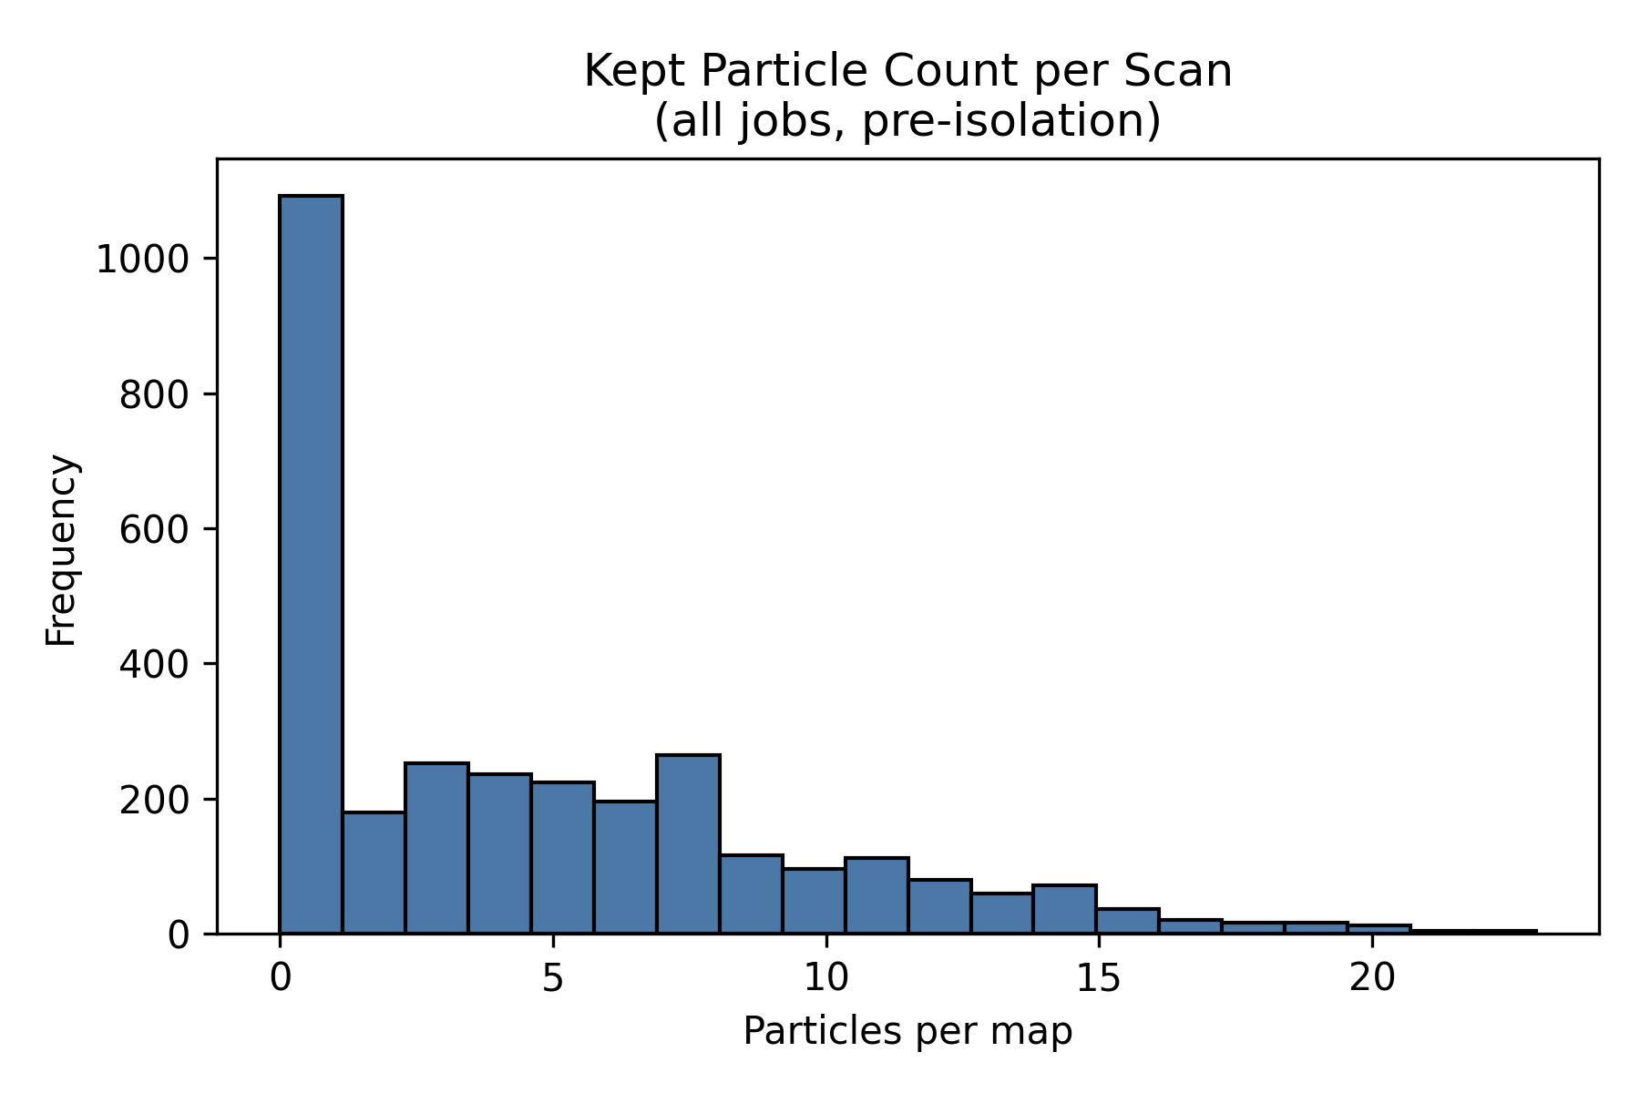
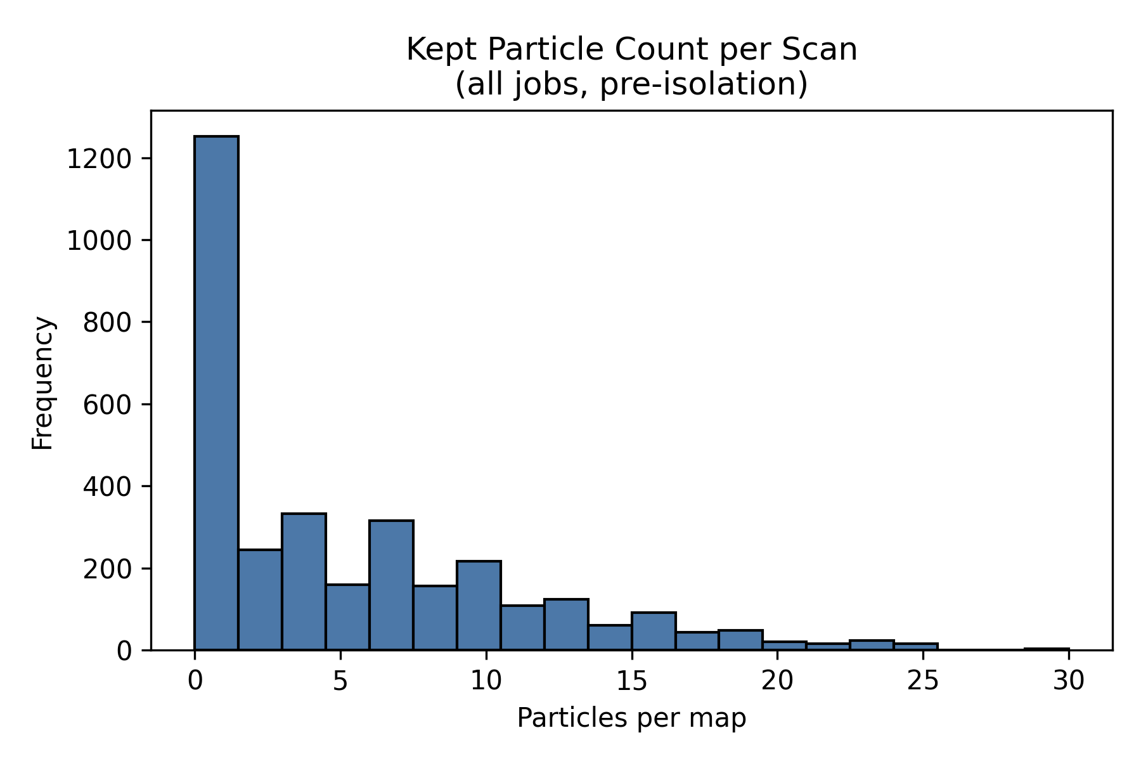
Figure 6.2 - Particle-count histograms for PEGDA, 1 wt% TPO, no coating, with 10 wt% and 25 wt% SiNP under the primary route.
Source: C:\Users\Conor O'Brien\Dropbox\03_AML\00 IN-BOX\AFM Topo Particle processing OUT\run_grains_full_wt10_20260304_145519\fig_particle_count_hist.png
Source: C:\Users\Conor O'Brien\Dropbox\03_AML\00 IN-BOX\AFM Topo Particle processing OUT\run_grains_full_wt25_20260304_145519\fig_particle_count_hist.png
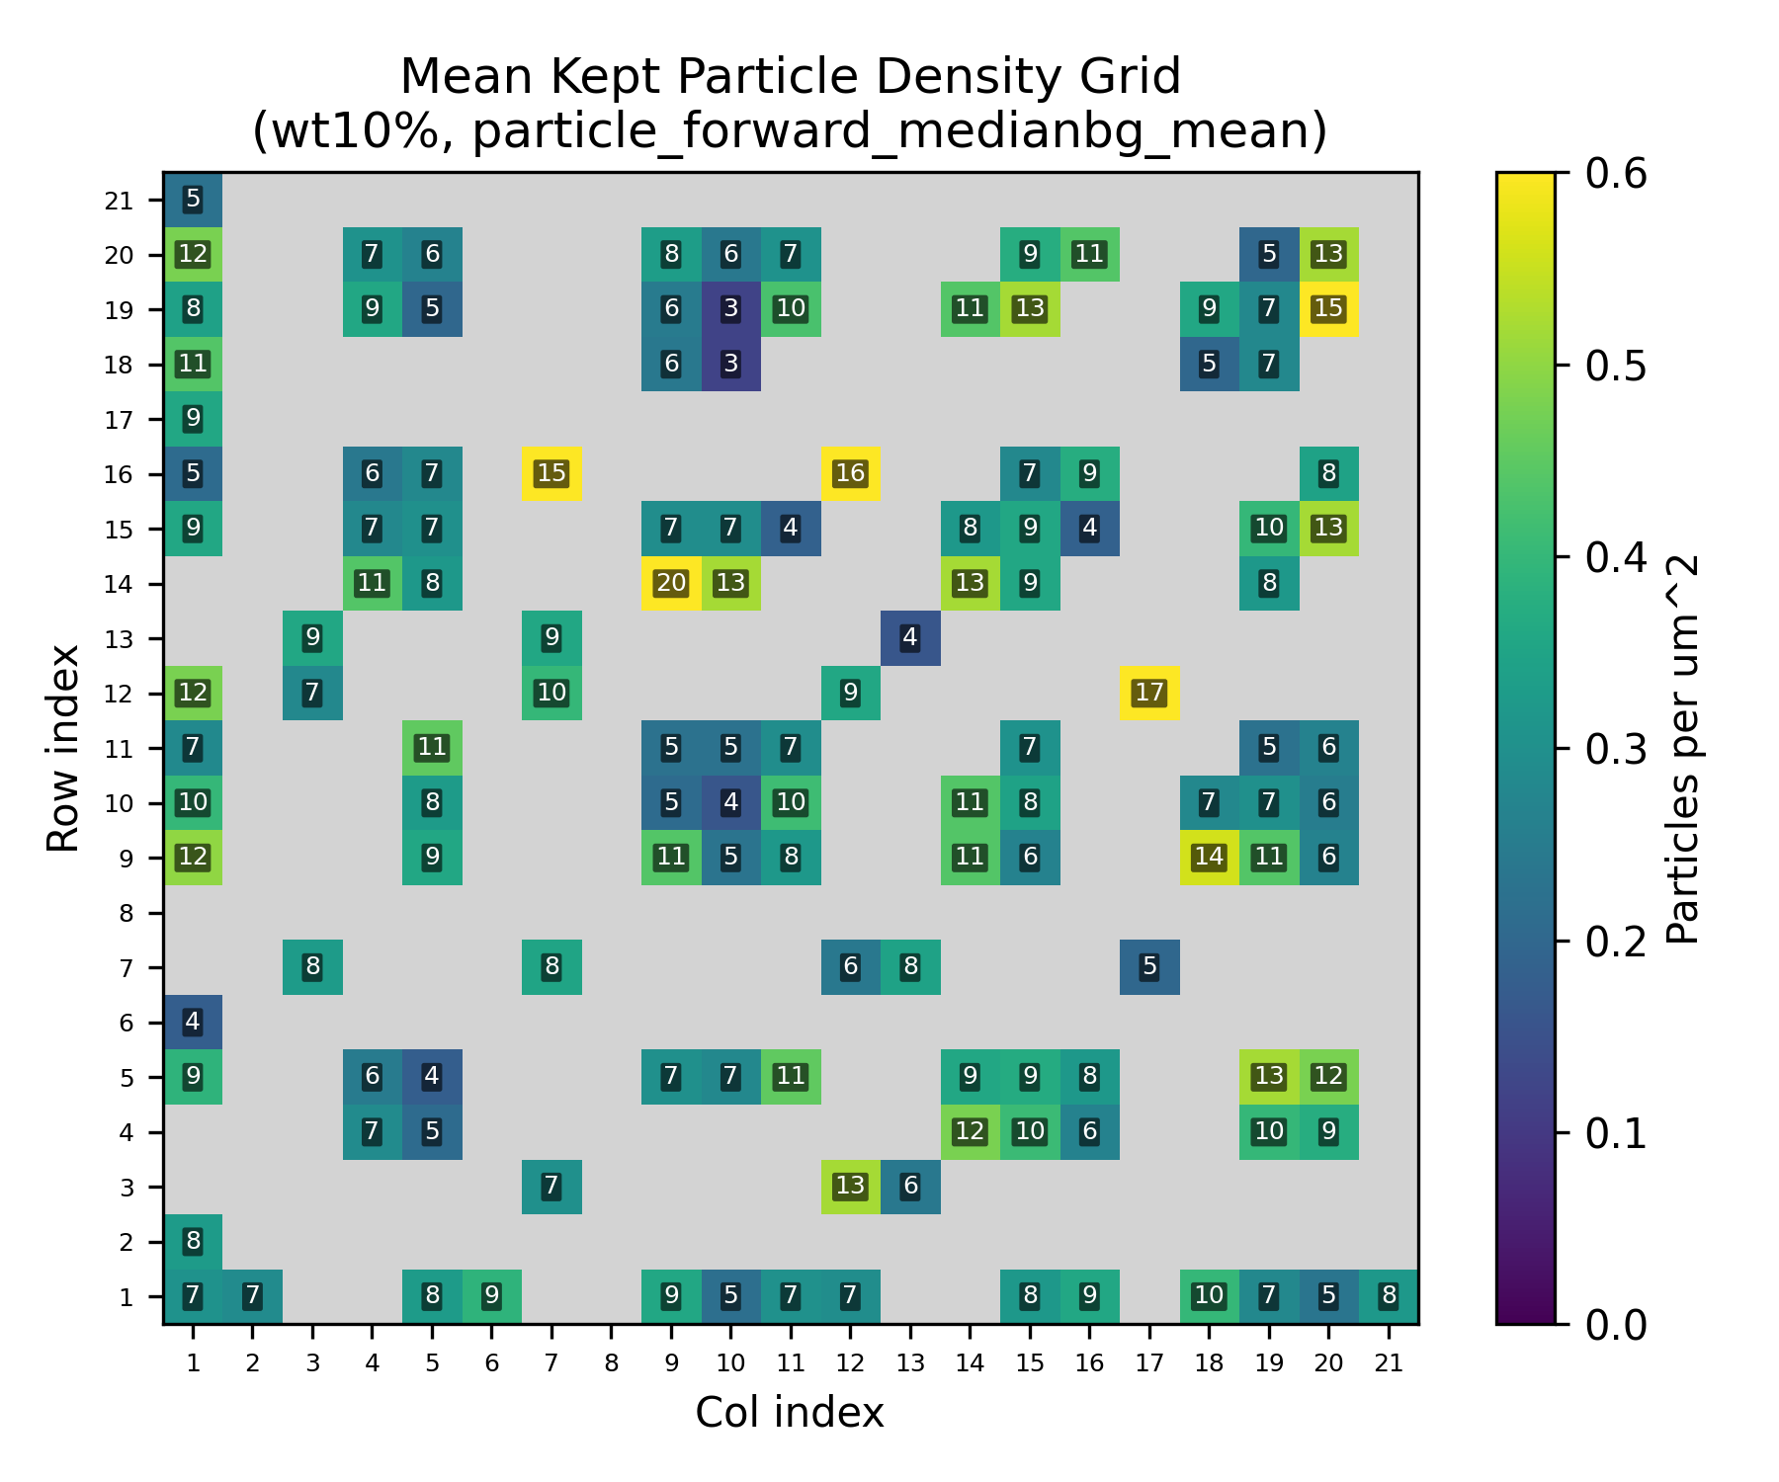
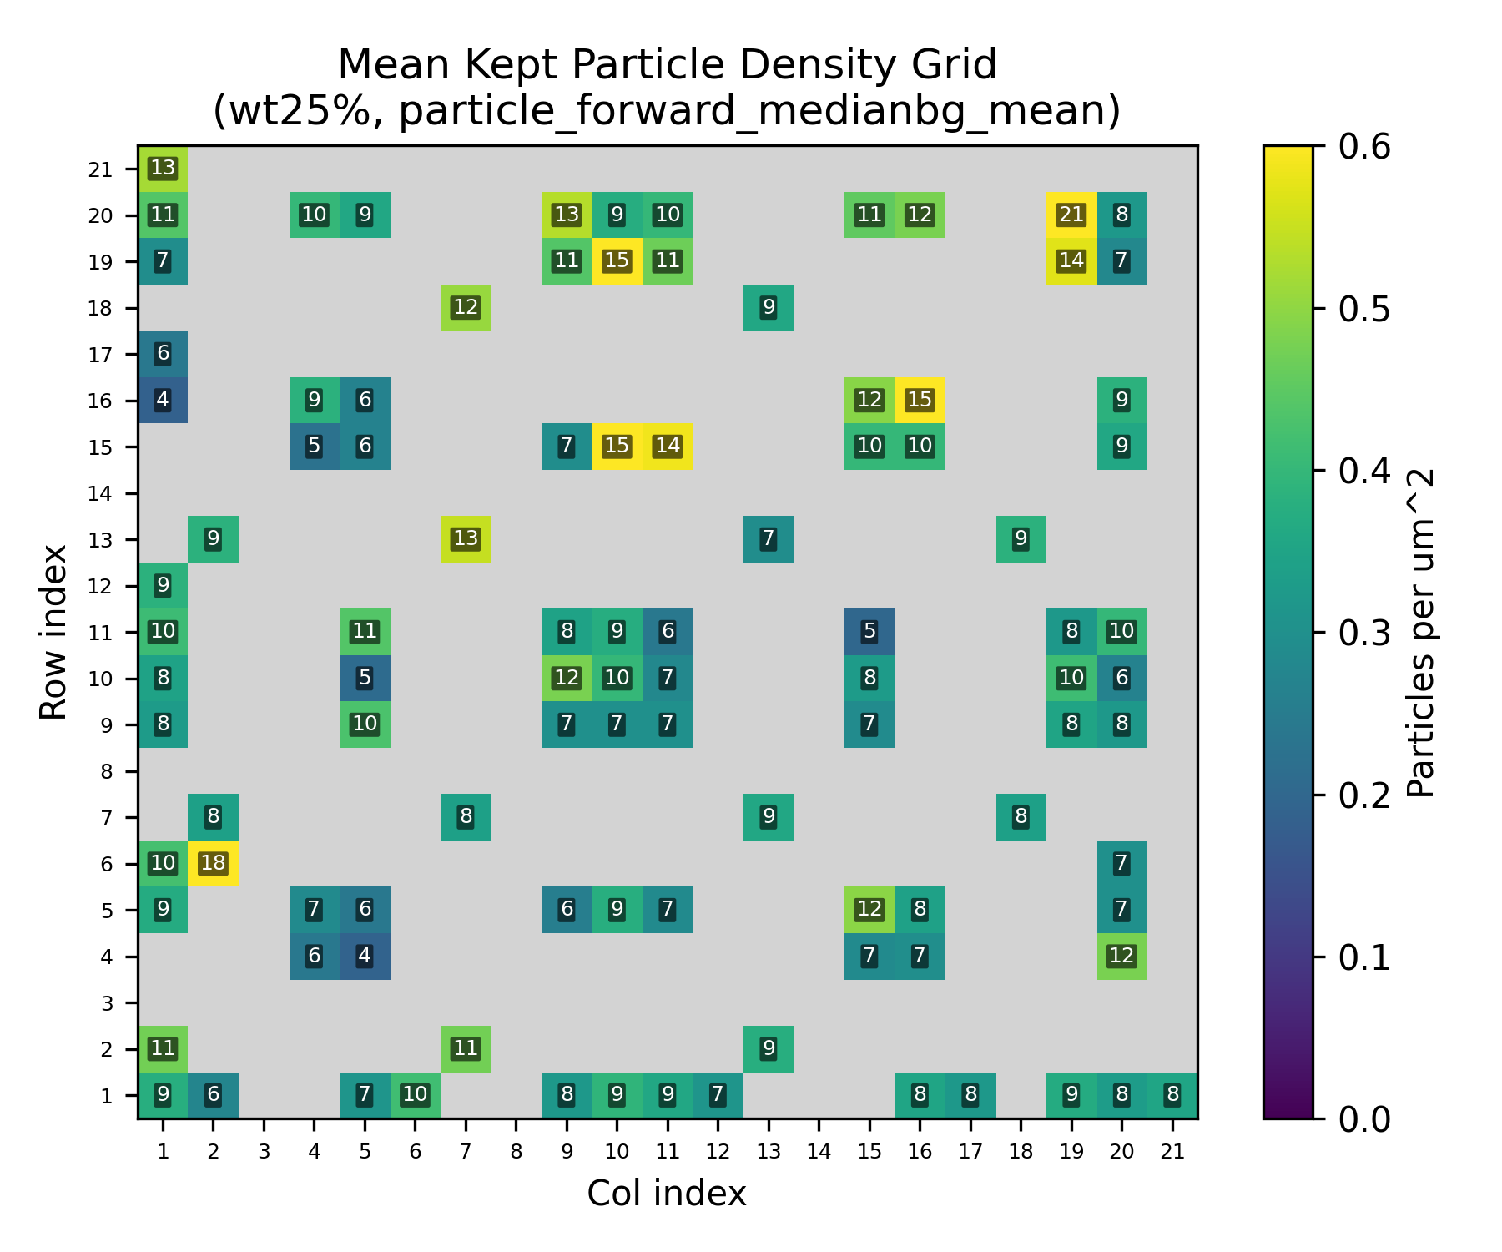
Figure 6.3 - Particle-count grid heatmaps for the primary route, separated by SiNP loading.
Source: C:\Users\Conor O'Brien\Dropbox\03_AML\00 IN-BOX\AFM Topo Particle processing OUT\run_grains_full_wt10_20260304_145519\summary_outputs\combined\fig_particle_count_grid_wt10_particle_forward_medianbg_mean.png
Source: C:\Users\Conor O'Brien\Dropbox\03_AML\00 IN-BOX\AFM Topo Particle processing OUT\run_grains_full_wt25_20260304_145519\summary_outputs\combined\fig_particle_count_grid_wt25_particle_forward_medianbg_mean.png

6.2.3 Particle Diameter Distribution
After applying the configured 350-550 nm filter, retained particle diameter averaged 432.91 +/- 56.66 nm for 10 wt% SiNP and 442.23 +/- 57.60 nm for 25 wt% SiNP. The retained means remain centered on the expected SiNP size band.
Table 6.3 - Retained particle diameter summary
System | Filter band (nm) | Mean diameter (nm) | Std diameter (nm)
10 wt% SiNP | 350-550 | 432.91 | 56.66
25 wt% SiNP | 350-550 | 442.23 | 57.60
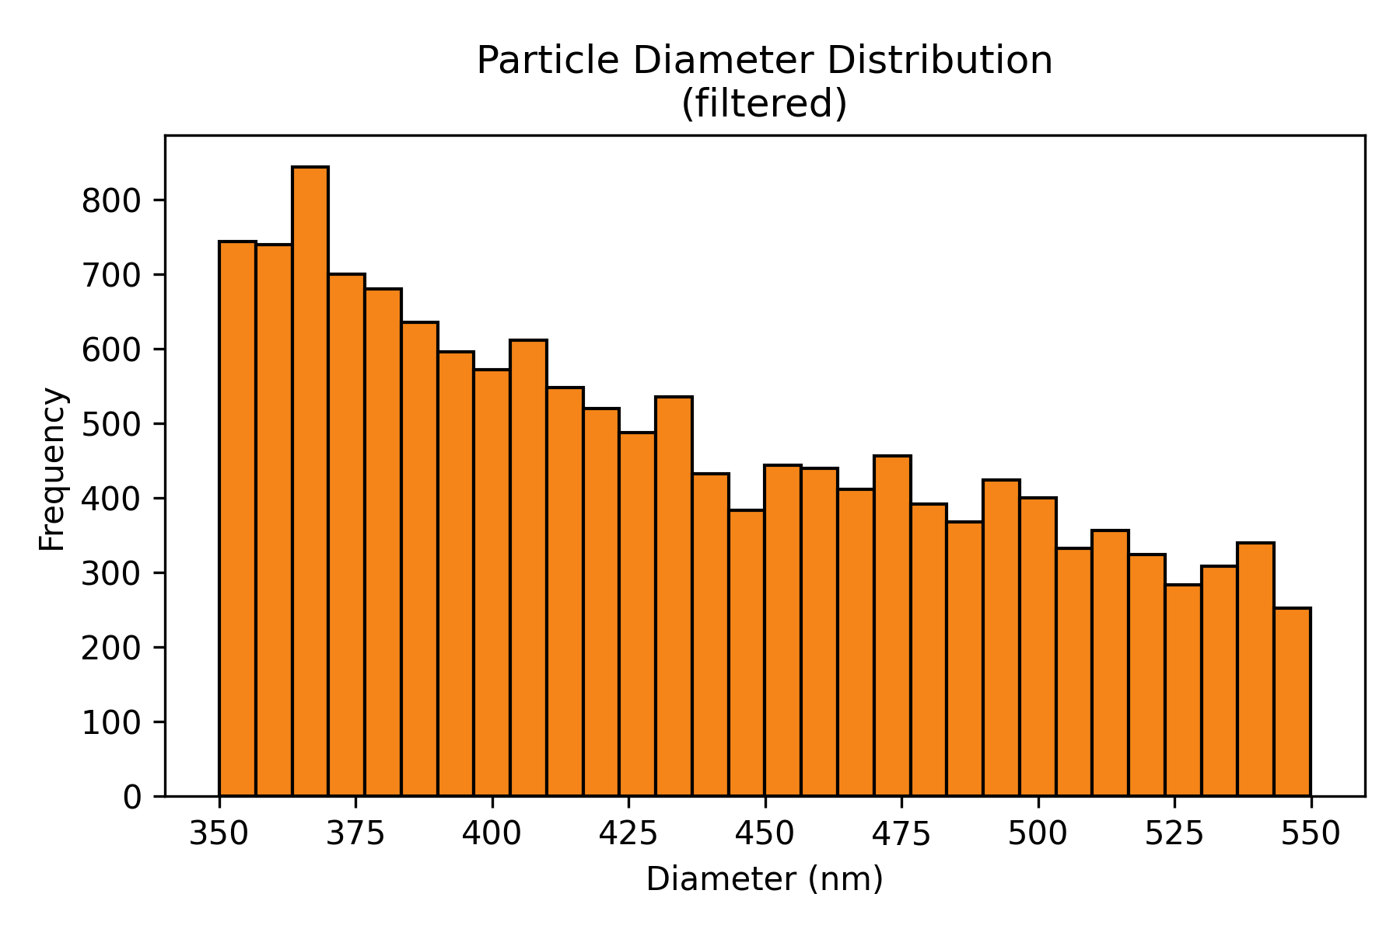
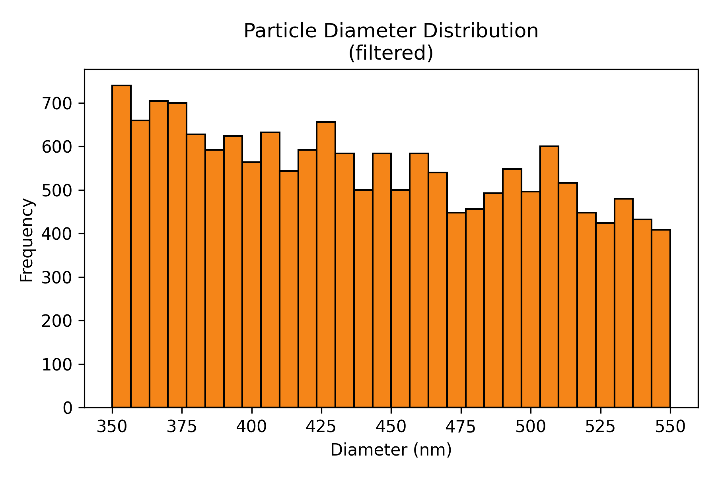
Figure 6.4 - Retained particle-diameter histograms for PEGDA, 1 wt% TPO, no coating, comparing 10 wt% and 25 wt% SiNP after filtering.
Source: C:\Users\Conor O'Brien\Dropbox\03_AML\00 IN-BOX\AFM Topo Particle processing OUT\run_grains_full_wt10_20260304_145519\fig_particle_diameter_hist.png
Source: C:\Users\Conor O'Brien\Dropbox\03_AML\00 IN-BOX\AFM Topo Particle processing OUT\run_grains_full_wt25_20260304_145519\fig_particle_diameter_hist.png

6.3 Isolation Analysis

6.3.1 Isolation Count Per Scan
Isolation is the controlling Stage 1 feasibility metric because only spatially separated targets are usable for Stage 2. In the current workflow, isolation is defined by a minimum center-to-center spacing of 900 nm.
Primary-route isolated counts averaged 3.05 +/- 1.62 per scan for 10 wt% SiNP and 3.16 +/- 1.68 per scan for 25 wt% SiNP. Scans with at least one isolated particle accounted for 95.6% and 95.5% of the two datasets, respectively.
The key result is that the higher-loading dataset did not produce a proportionally larger isolated-particle yield. Mean isolated counts remained close (3.05 versus 3.16 isolated particles per scan) even though candidate density increased.
Table 6.4 - Sample-level isolated-particle yield under the primary route
System | Sample set | Scans | Mean isolated/scan | Std | % scans with >=1 isolated
10 wt% SiNP | PEGDA1TPO10SiNP Sa1 Si1- | 88 | 3.31 | - | 96.6%
10 wt% SiNP | PEGDA1TPO10SiNP Sa1 Si2 | 99 | 3.12 | - | 97.0%
10 wt% SiNP | PEGDA1TPO10SiNP Sam02 S1 | 100 | 3.17 | - | 97.0%
10 wt% SiNP | PEGDA1TPO10SiNP Sam02 S2 | 99 | 2.65 | - | 91.9%
25 wt% SiNP | PEGDA1TPO25SiNP Sam01 S2 | 55 | 3.11 | - | 96.4%
25 wt% SiNP | PEGDA1TPO25SiNP Sam02 S1 | 105 | 3.10 | - | 95.2%
25 wt% SiNP | PEGDA1TPO25SiNP Sam02 S2 | 34 | 3.71 | - | 100.0%
25 wt% SiNP | PEGDA1TPO25SiNP Sam03 S1 | 105 | 3.31 | - | 97.1%
25 wt% SiNP | PEGDA1TPO25SiNP Sam03 S2 | 105 | 2.90 | - | 92.4%
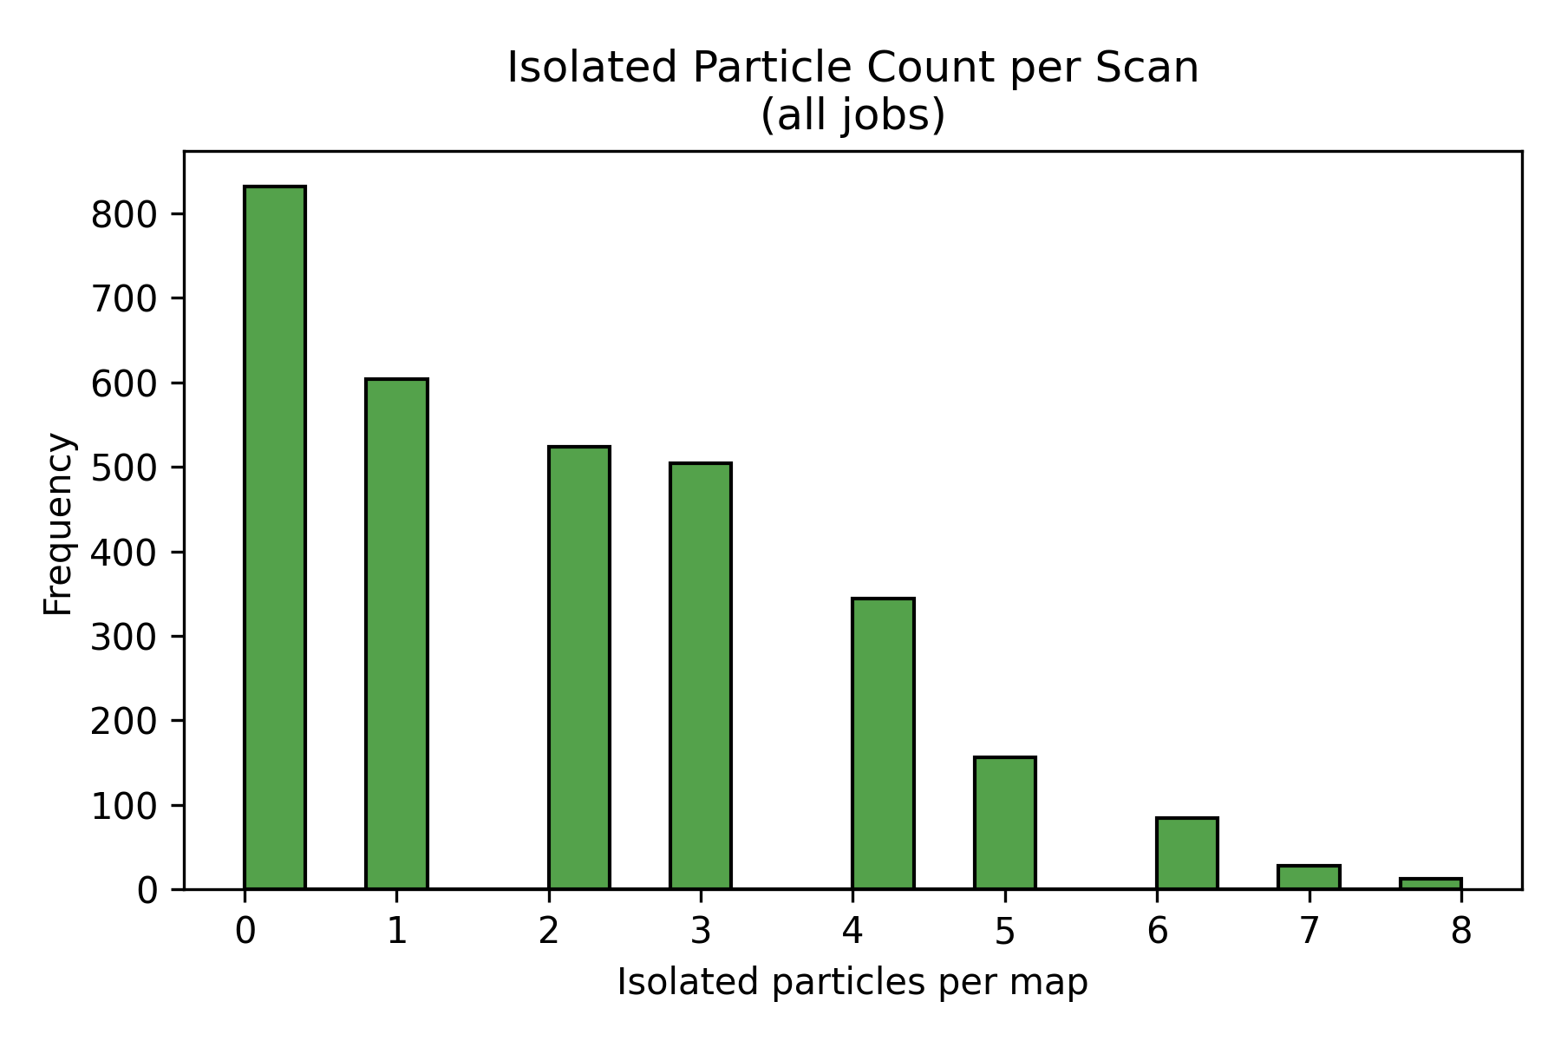
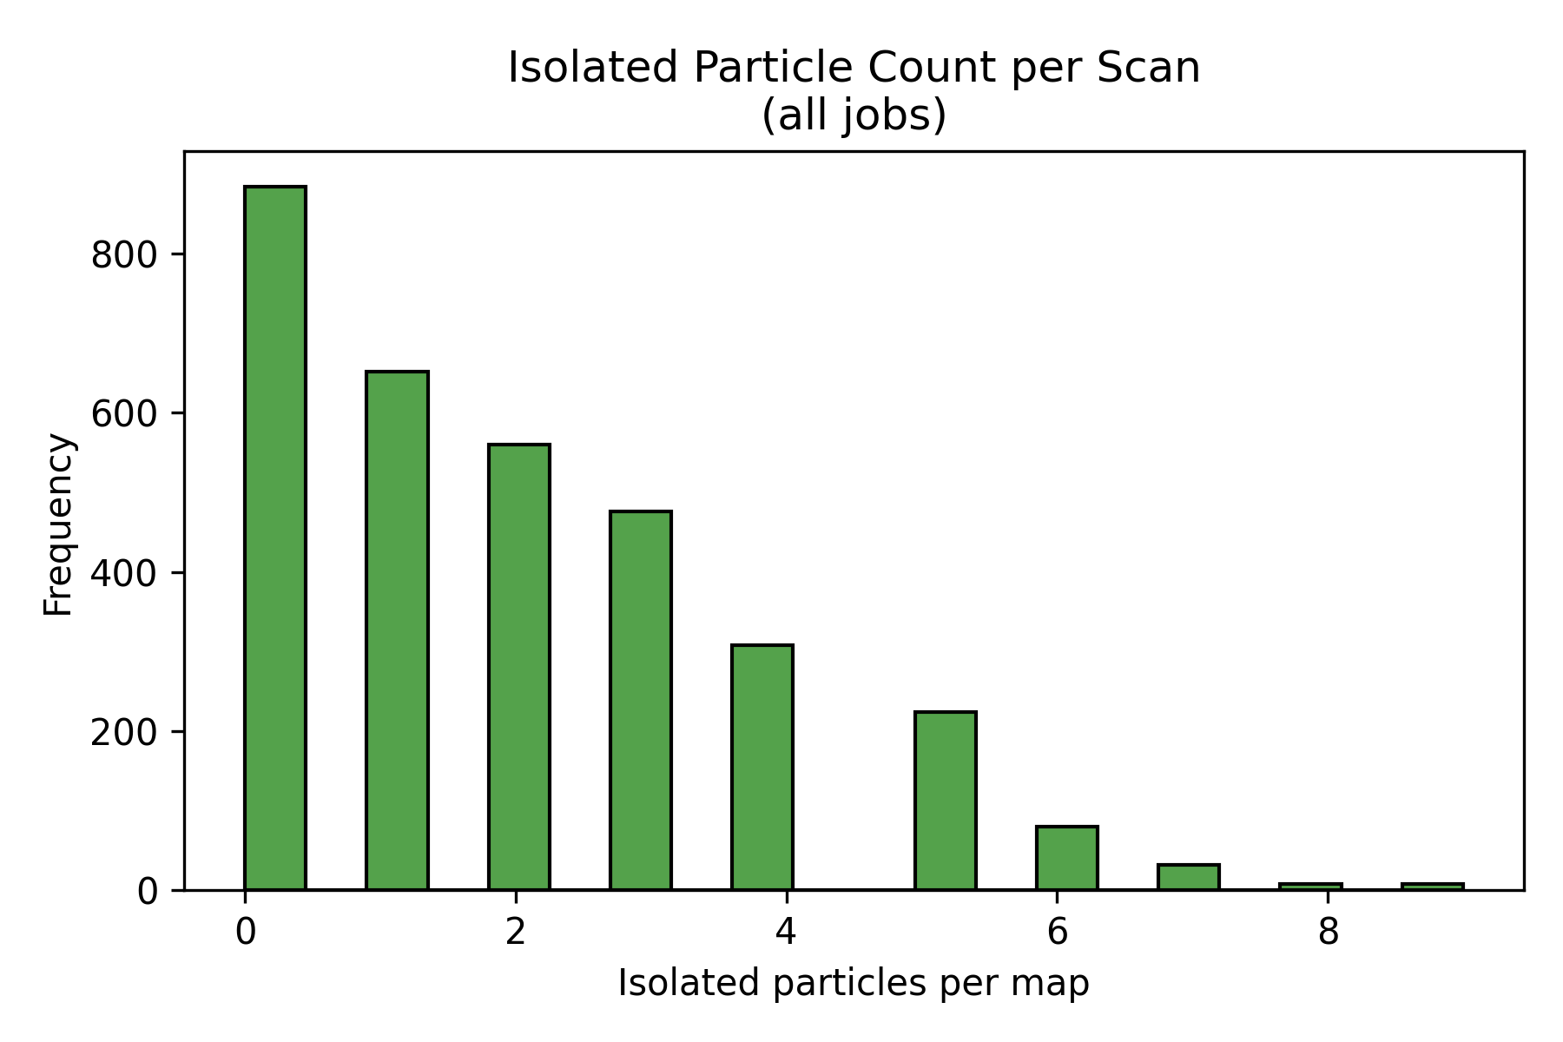
Figure 6.5 - Histograms of isolated-particle counts per scan for the primary route, separated by 10 wt% and 25 wt% SiNP.
Source: C:\Users\Conor O'Brien\Dropbox\03_AML\00 IN-BOX\AFM Topo Particle processing OUT\run_grains_full_wt10_20260304_145519\fig_isolated_count_hist.png
Source: C:\Users\Conor O'Brien\Dropbox\03_AML\00 IN-BOX\AFM Topo Particle processing OUT\run_grains_full_wt25_20260304_145519\fig_isolated_count_hist.png
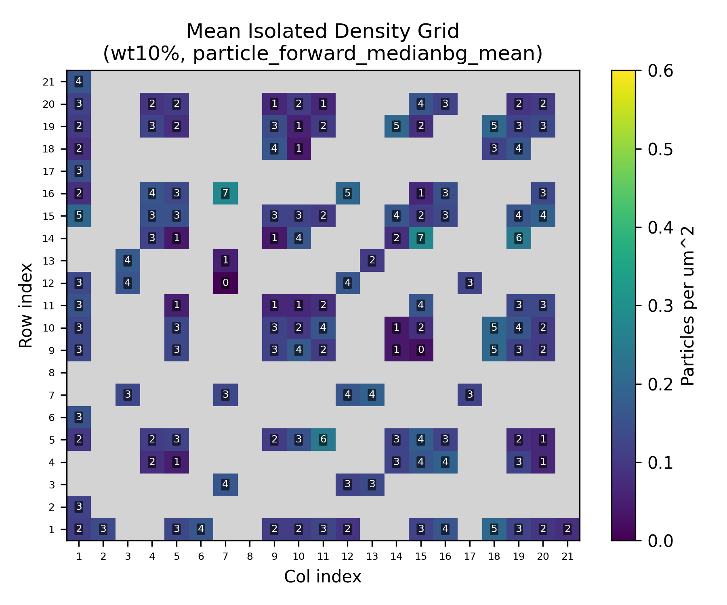
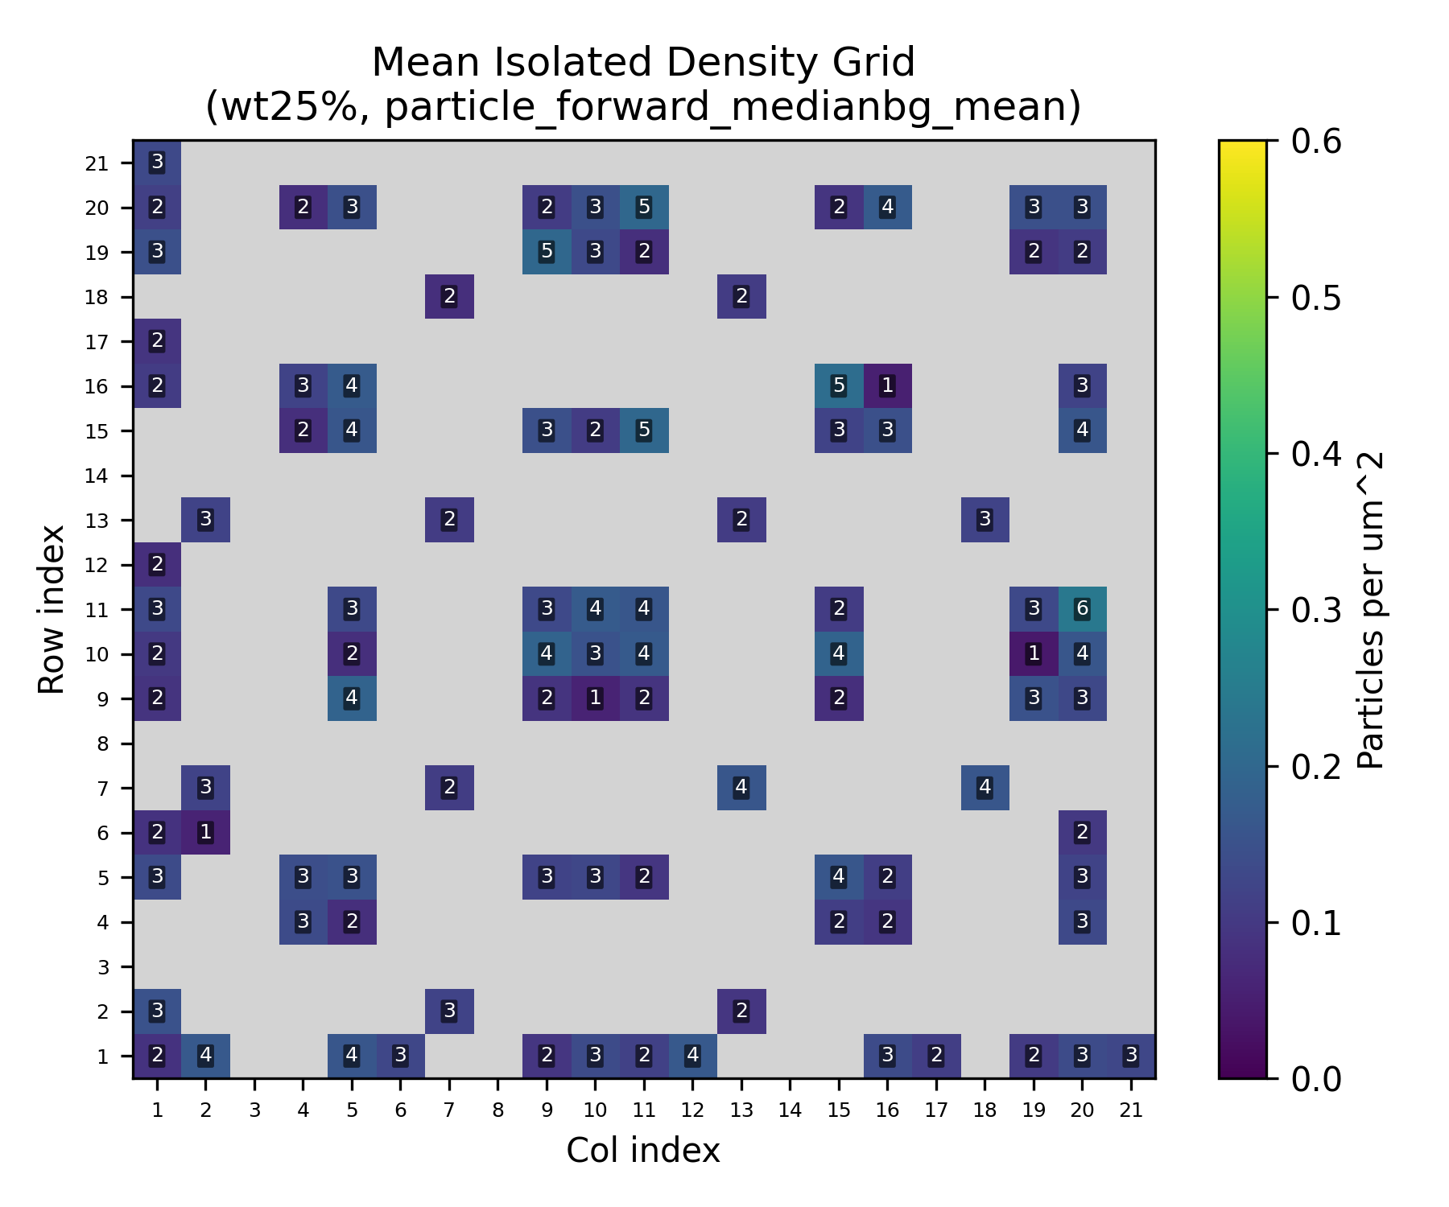
Figure 6.6 - Isolated-particle grid heatmaps for the primary route, separated by SiNP loading.
Source: C:\Users\Conor O'Brien\Dropbox\03_AML\00 IN-BOX\AFM Topo Particle processing OUT\run_grains_full_wt10_20260304_145519\summary_outputs\combined\fig_isolated_count_grid_wt10_particle_forward_medianbg_mean.png
Source: C:\Users\Conor O'Brien\Dropbox\03_AML\00 IN-BOX\AFM Topo Particle processing OUT\run_grains_full_wt25_20260304_145519\summary_outputs\combined\fig_isolated_count_grid_wt25_particle_forward_medianbg_mean.png

6.3.2 Required Scans for 95% Confidence
Using the Poisson baseline fit, a target of 30 isolated particles, and 95% confidence, the primary route required 13 scans for 10 wt% SiNP and 13 scans for 25 wt% SiNP. Both analyzed inventories greatly exceed those requirements.
Table 6.5 - Required scans for isolated-particle sufficiency under the primary route
System | Primary lambda | Observed zero-isolated rate | Required scans (95%) | Available scans
10 wt% SiNP | 3.054 | 4.4% | 13 | 386
25 wt% SiNP | 3.156 | 4.5% | 13 | 404

6.4 Grain Metrics
Grain exports are now available for the full method matrix. These do not replace particle or isolation statistics, but they strengthen the segmentation-quality discussion and provide an additional diameter-based consistency check.
Table 6.6 - Grain summary across the full method matrix
System | Method | Grain total | Grain kept | Grain isolated | Kept diameter mean +/- std | Isolated diameter mean +/- std
10 wt% SiNP | Median BG + mean threshold | 395902 | 3125 | 1179 | 433.69 +/- 56.73 nm | 433.11 +/- 57.25 nm
10 wt% SiNP | Median BG + fixed 0 | 395902 | 3125 | 1179 | 433.69 +/- 56.73 nm | 433.11 +/- 57.25 nm
10 wt% SiNP | Median BG + p95 threshold | 395902 | 3125 | 1179 | 433.69 +/- 56.73 nm | 433.11 +/- 57.25 nm
10 wt% SiNP | Median BG + fixed 0 + p95 | 395902 | 3125 | 1179 | 433.69 +/- 56.73 nm | 433.11 +/- 57.25 nm
10 wt% SiNP | Flatten + mean threshold | 263884 | 516 | 350 | 428.23 +/- 56.06 nm | 428.92 +/- 54.61 nm
10 wt% SiNP | Flatten + fixed 0 | 263884 | 516 | 350 | 428.23 +/- 56.06 nm | 428.92 +/- 54.61 nm
10 wt% SiNP | Flatten + p95 threshold | 263884 | 516 | 350 | 428.23 +/- 56.06 nm | 428.92 +/- 54.61 nm
10 wt% SiNP | Flatten + fixed 0 + p95 | 263884 | 516 | 350 | 428.23 +/- 56.06 nm | 428.92 +/- 54.61 nm
25 wt% SiNP | Median BG + mean threshold | 236342 | 3718 | 1275 | 443.21 +/- 57.61 nm | 439.50 +/- 57.35 nm
25 wt% SiNP | Median BG + fixed 0 | 236342 | 3718 | 1275 | 443.21 +/- 57.61 nm | 439.50 +/- 57.35 nm
25 wt% SiNP | Median BG + p95 threshold | 236342 | 3718 | 1275 | 443.21 +/- 57.61 nm | 439.50 +/- 57.35 nm
25 wt% SiNP | Median BG + fixed 0 + p95 | 236342 | 3718 | 1275 | 443.21 +/- 57.61 nm | 439.50 +/- 57.35 nm
25 wt% SiNP | Flatten + mean threshold | 82805 | 451 | 323 | 434.11 +/- 56.86 nm | 435.48 +/- 57.26 nm
25 wt% SiNP | Flatten + fixed 0 | 82805 | 451 | 323 | 434.11 +/- 56.86 nm | 435.48 +/- 57.26 nm
25 wt% SiNP | Flatten + p95 threshold | 82805 | 451 | 323 | 434.11 +/- 56.86 nm | 435.48 +/- 57.26 nm
25 wt% SiNP | Flatten + fixed 0 + p95 | 82805 | 451 | 323 | 434.11 +/- 56.86 nm | 435.48 +/- 57.26 nm
[MISSING FIGURE] Figure 6.7 - Grain diameter summaries by method for PEGDA, 1 wt% TPO, no coating, separated by 10 wt% and 25 wt% SiNP.

6.5 Processing Route Sensitivity
Relative to the primary route, the comparison route (particle_forward_flatten_mean) reduced mean isolated yield from 3.05 +/- 1.62 to 0.91 +/- 1.16 per scan in 10 wt% SiNP and from 3.16 +/- 1.68 to 0.80 +/- 1.00 per scan in 25 wt% SiNP. The corresponding 95% scan requirements increased from 13 to 44 scans and from 13 to 50 scans.
The full method table shows that the dominant split is preprocessing family rather than threshold variant. In the current data, methods within a family collapse onto the same statistical behavior, so the feasibility verdict is robust even though the magnitude of the gain is method-sensitive.
Table 6.7 - All-method comparison with loading-normalized isolation yield
System | Method | Job/profile | Mean isolated/scan | Std | Zero-isolated rate | Req. scans (95%) | Relative to primary | Isolated/scan/wt%
10 wt% SiNP | Median BG + mean threshold | particle_forward_medianbg_mean | 3.05 | 1.62 | 4.4% | 13 | 1.00x | 0.305
10 wt% SiNP | Median BG + fixed 0 | particle_forward_medianbg_fixed0 | 3.05 | 1.62 | 4.4% | 13 | 1.00x | 0.305
10 wt% SiNP | Median BG + p95 threshold | particle_forward_medianbg_p95 | 3.05 | 1.62 | 4.4% | 13 | 1.00x | 0.305
10 wt% SiNP | Median BG + fixed 0 + p95 | particle_forward_medianbg_max_fixed0_p95 | 3.05 | 1.62 | 4.4% | 13 | 1.00x | 0.305
10 wt% SiNP | Flatten + mean threshold | particle_forward_flatten_mean | 0.91 | 1.16 | 49.5% | 44 | 0.30x | 0.091
10 wt% SiNP | Flatten + fixed 0 | particle_forward_flatten_fixed0 | 0.91 | 1.16 | 49.5% | 44 | 0.30x | 0.091
10 wt% SiNP | Flatten + p95 threshold | particle_forward_flatten_p95 | 0.91 | 1.16 | 49.5% | 44 | 0.30x | 0.091
10 wt% SiNP | Flatten + fixed 0 + p95 | particle_forward_flatten_max_fixed0_p95 | 0.91 | 1.16 | 49.5% | 44 | 0.30x | 0.091
25 wt% SiNP | Median BG + mean threshold | particle_forward_medianbg_mean | 3.16 | 1.68 | 4.5% | 13 | 1.00x | 0.126
25 wt% SiNP | Median BG + fixed 0 | particle_forward_medianbg_fixed0 | 3.16 | 1.68 | 4.5% | 13 | 1.00x | 0.126
25 wt% SiNP | Median BG + p95 threshold | particle_forward_medianbg_p95 | 3.16 | 1.68 | 4.5% | 13 | 1.00x | 0.126
25 wt% SiNP | Median BG + fixed 0 + p95 | particle_forward_medianbg_max_fixed0_p95 | 3.16 | 1.68 | 4.5% | 13 | 1.00x | 0.126
25 wt% SiNP | Flatten + mean threshold | particle_forward_flatten_mean | 0.80 | 1.00 | 50.2% | 50 | 0.25x | 0.032
25 wt% SiNP | Flatten + fixed 0 | particle_forward_flatten_fixed0 | 0.80 | 1.00 | 50.2% | 50 | 0.25x | 0.032
25 wt% SiNP | Flatten + p95 threshold | particle_forward_flatten_p95 | 0.80 | 1.00 | 50.2% | 50 | 0.25x | 0.032
25 wt% SiNP | Flatten + fixed 0 + p95 | particle_forward_flatten_max_fixed0_p95 | 0.80 | 1.00 | 50.2% | 50 | 0.25x | 0.032
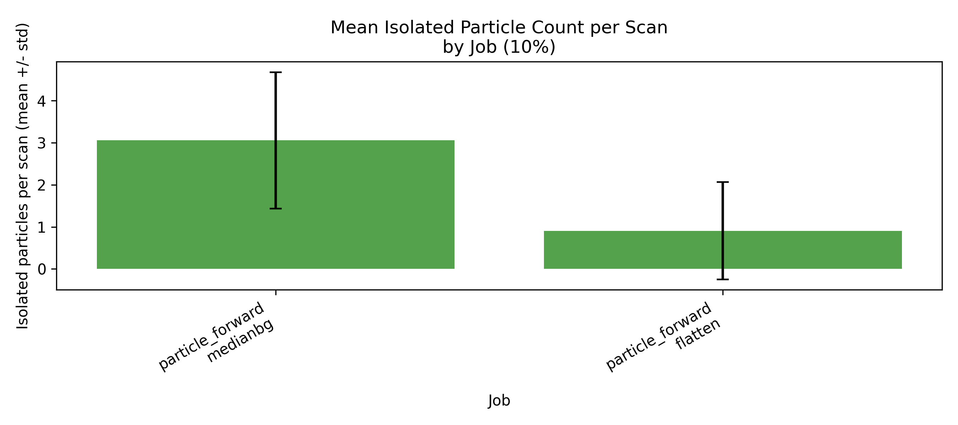
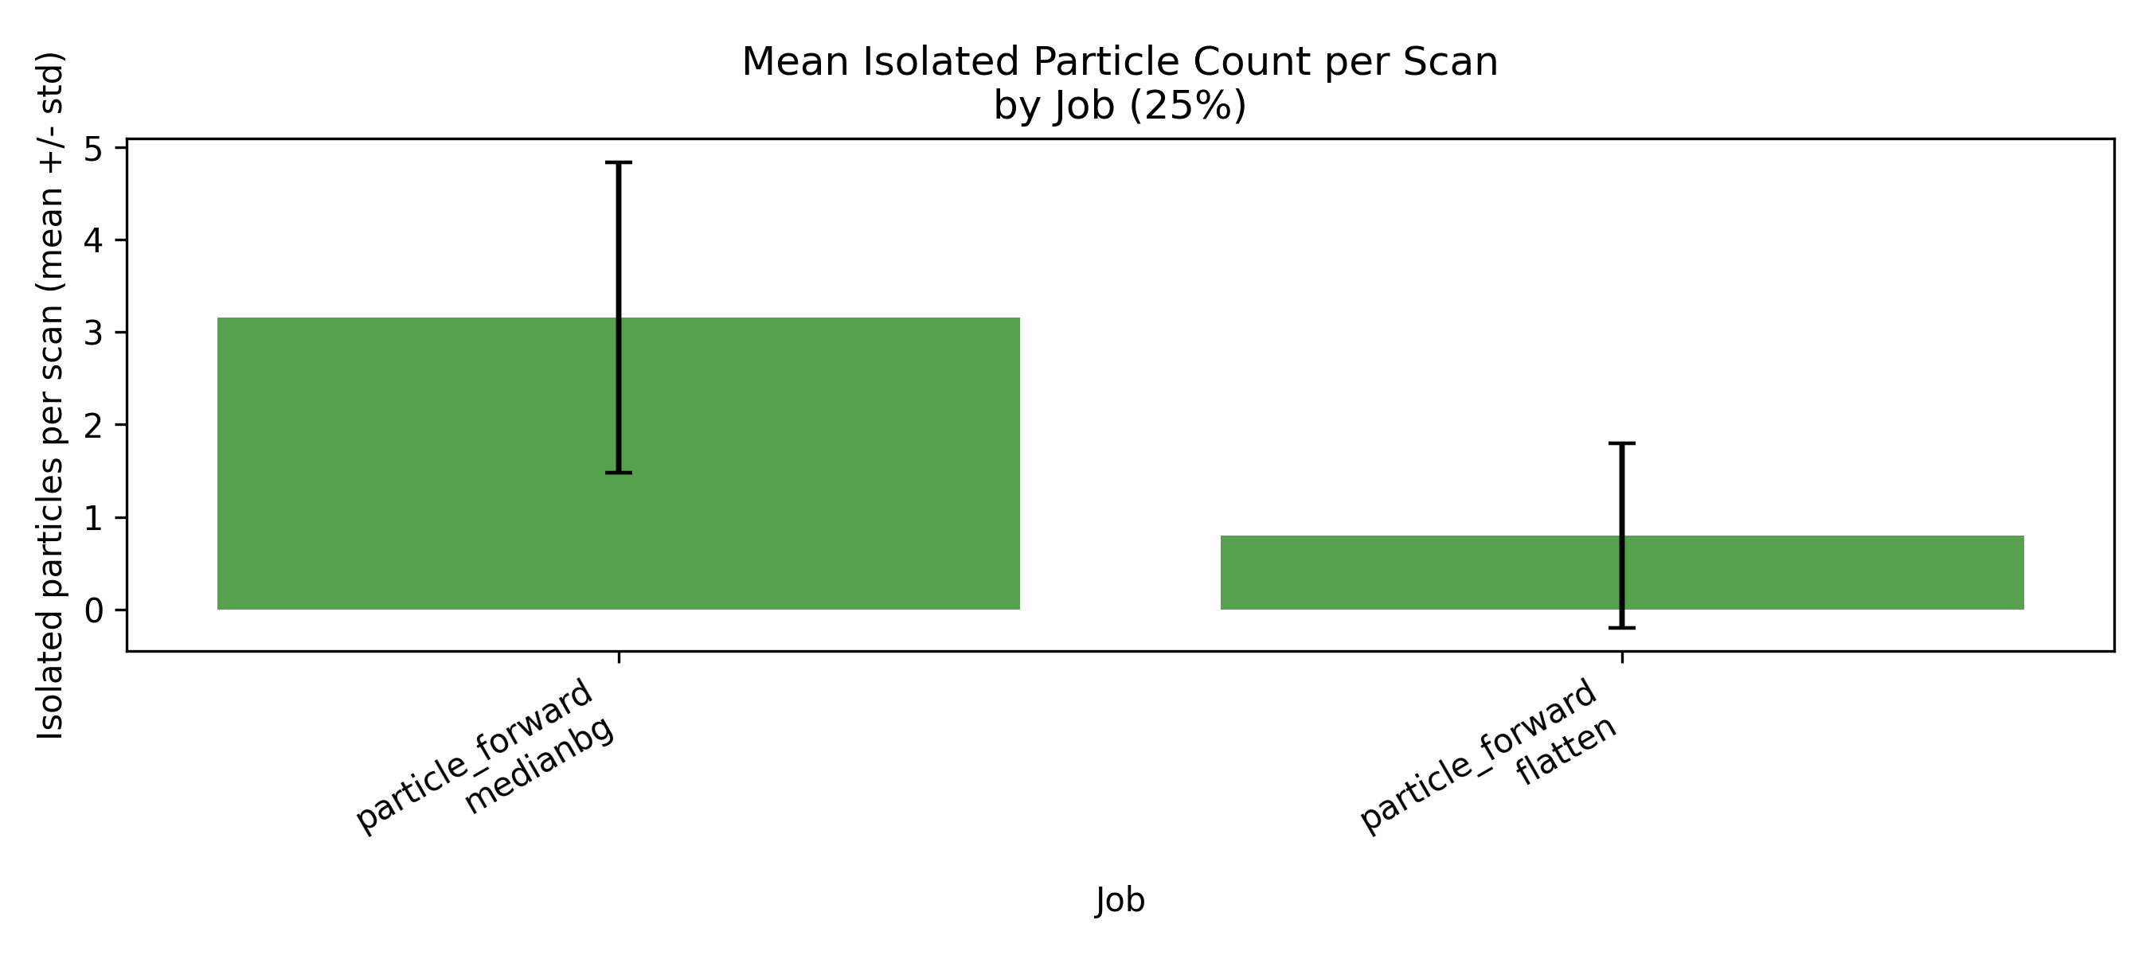
Figure 6.8 - Method-comparison mean isolated-particle yield by job and SiNP loading for PEGDA, 1 wt% TPO, no coating.
Source: C:\Users\Conor O'Brien\Dropbox\03_AML\00 IN-BOX\AFM Topo Particle processing OUT\run_grains_full_wt10_20260304_145519\summary_outputs\compare_by_wt\fig_isolated_count_mean_by_job_10pct.png
Source: C:\Users\Conor O'Brien\Dropbox\03_AML\00 IN-BOX\AFM Topo Particle processing OUT\run_grains_full_wt25_20260304_145519\summary_outputs\compare_by_wt\fig_isolated_count_mean_by_job_25pct.png
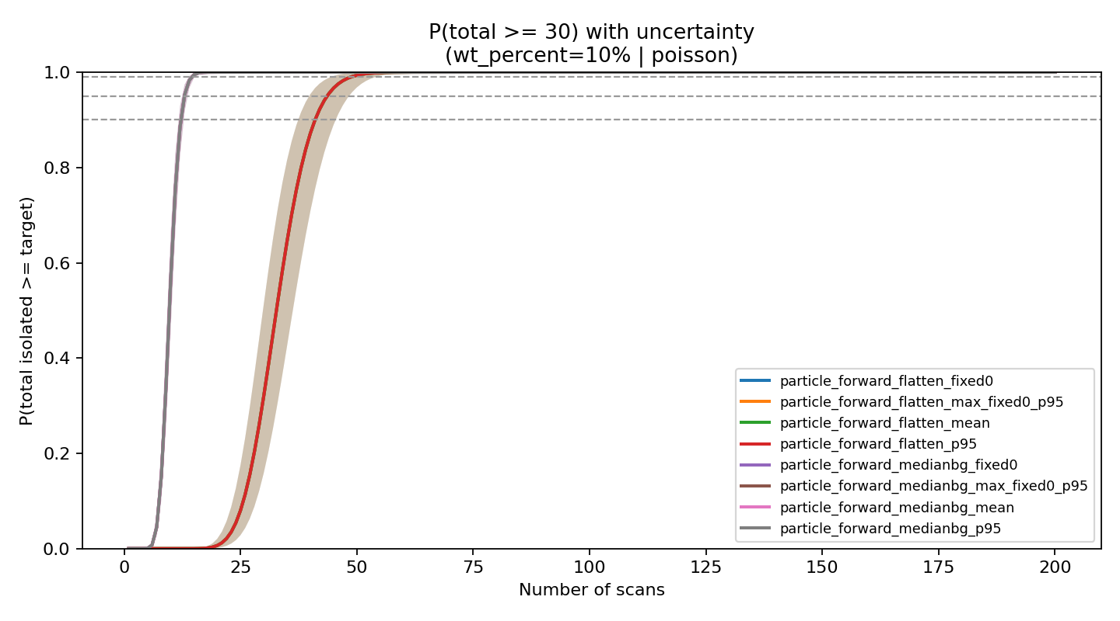
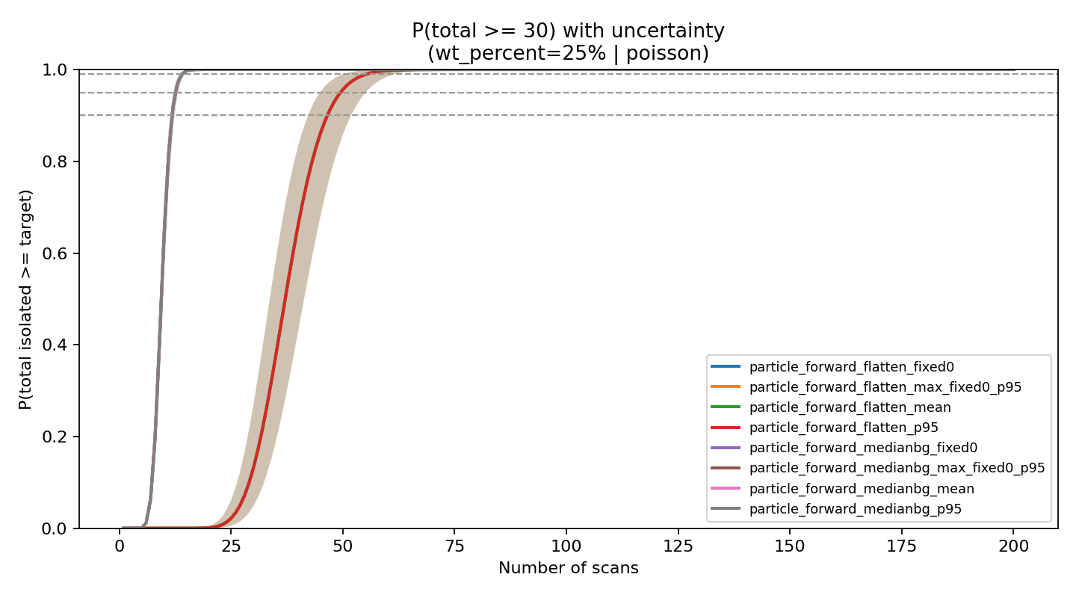
Figure 6.9 - Aggregate Poisson success-probability curves for all methods, separated by 10 wt% and 25 wt% SiNP. Overlapping traces indicate methods that collapse to the same statistical behavior.
Source: C:\Users\Conor O'Brien\Dropbox\03_AML\00 IN-BOX\AFM Topo Particle processing OUT\run_grains_full_wt10_20260304_145519\summary_outputs\fits\risk_aggregate_wt_percent_10_poisson.png
Source: C:\Users\Conor O'Brien\Dropbox\03_AML\00 IN-BOX\AFM Topo Particle processing OUT\run_grains_full_wt25_20260304_145519\summary_outputs\fits\risk_aggregate_wt_percent_25_poisson.png

6.6 Stage 2 Trigger / Crossover Decision
The Stage 2 trigger is expressed as a sensitivity study in confirmation probability p. The question is how far the confirmation rate could drop before the current Stage 1 scan pool would no longer meet the 30-particle, 95%-confidence target.
Table 6.8 - Current Stage 2 availability crossover summary
System | Primary lambda | Available scans | Approx. availability crossover p
10 wt% SiNP | 3.054 | 386 | ~0.034
25 wt% SiNP | 3.156 | 404 | ~0.032
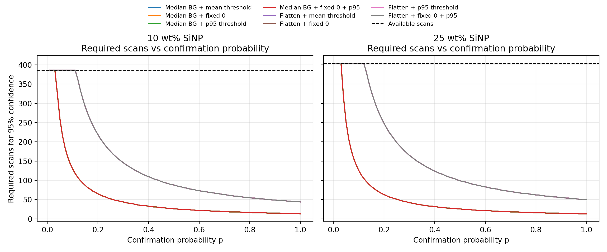
Figure 6.10 - Required scan count versus confirmation probability p across the full method matrix, with available scans shown as a horizontal reference. PEGDA, 1 wt% TPO, no coating, separated by 10 wt% and 25 wt% SiNP.
Source: docs\Thesis\generated_assets\chapter6_crossover_by_method.png

6.7 Stage 1 Decision
For 10 wt% SiNP, candidate particle presence was confirmed, the retained diameter distribution remained consistent with the configured 350-550 nm size window, isolated particles occurred in 95.6% of scans under the primary route, and the analyzed inventory of 386 scans greatly exceeded the 13-scan requirement.
For 25 wt% SiNP, candidate particle presence was likewise confirmed, the retained diameter distribution remained acceptable, isolated particles occurred in 95.5% of scans under the primary route, and the analyzed inventory of 404 scans greatly exceeded the corresponding 13-scan requirement.
Stage 2 high-resolution interrogation is therefore justified for both loadings under the current Stage 1 interpretation. The comparative result is that higher loading increased candidate density modestly, but did not materially improve isolated-particle availability enough to change the decision.

6.8 Discussion (Controlled)
Discussion is appropriate here so long as it remains tied to measurement feasibility. The chapter now supports three bounded claims: isolated particles are available in sufficient number, the scan-efficiency conclusion is robust to the completed method matrix, and higher loading does not automatically produce a higher yield of usable isolated targets.
The remaining uncertainty is not whether isolated candidates exist, but what fraction of those candidates will be confirmed as true particles once Stage 2 multi-channel validation is performed. That is why the crossover figure belongs in this chapter: it converts Stage 2 from a vague next step into a quantitative decision threshold.

