Chapter 4 Draft — AFM Acquisition Protocol (Stage 1 Focused)
Draft generated: 2026-03-05 13:22
Status: working draft scaffold. Replace placeholders with prose, tables, and figures.
Purpose: define AFM configuration, Stage 1 survey scan parameters, particle identification criteria, and acquisition stopping logic.

4.1 AFM Configuration
[PLACEHOLDER] Instrument, probe type, calibration approach, environment, imaging mode details.

4.2 Stage 1 Survey Design (Grid Scans)
[PLACEHOLDER] 50 um x 50 um region, 21 x 21 grid, overlap %, and per-scan size/pixels.
Table 4.1 — Stage 1 Scan Parameters
Scan size (um) | Pixels | nm/px | Grid | Overlap | Channels

4.3 Particle Identification Criteria (Stage 1)
[PLACEHOLDER] Diameter filter and isolation definition references (point to Ch.5 for the statistical framework).

4.4 Acquisition Stopping Logic
[PLACEHOLDER] Define what triggers stopping Stage 1 vs proceeding to Stage 2 (ties to crossover).

4.5 Data Organization + Traceability
[PLACEHOLDER] File naming conventions, manifests, and how runs are reproducible from config.

Representative Acquisition Support Images
Probe vision image for fractured PEGDA with 10 wt% SiNP.
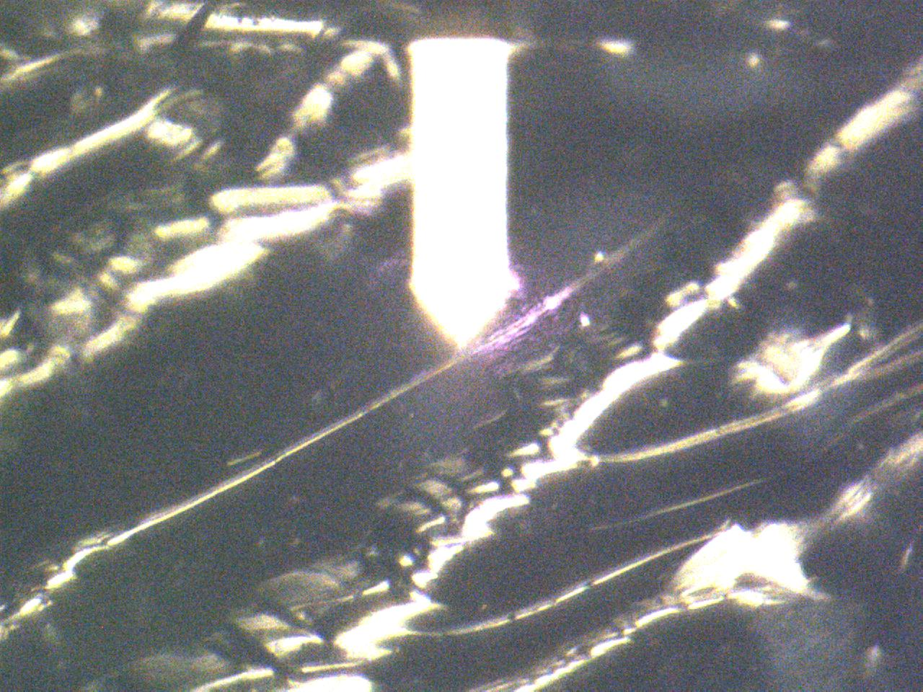
Representative probe-vision image associated with fractured PEGDA containing 10 wt% SiNP. This figure is included as acquisition-context support material rather than a quantitative analysis image.
Source: C:\Users\Conor O'Brien\Dropbox\03_AML\00 IN-BOX\AFM Topo Particle processing OUT\Particle Images for Thesis Figures\raw\PEGDA01TPO10SiNPSam01_S2_P__GrID018_LOC_RC004014--Vision_-250929-CRO.jpg
Silicon lithography calibration image.
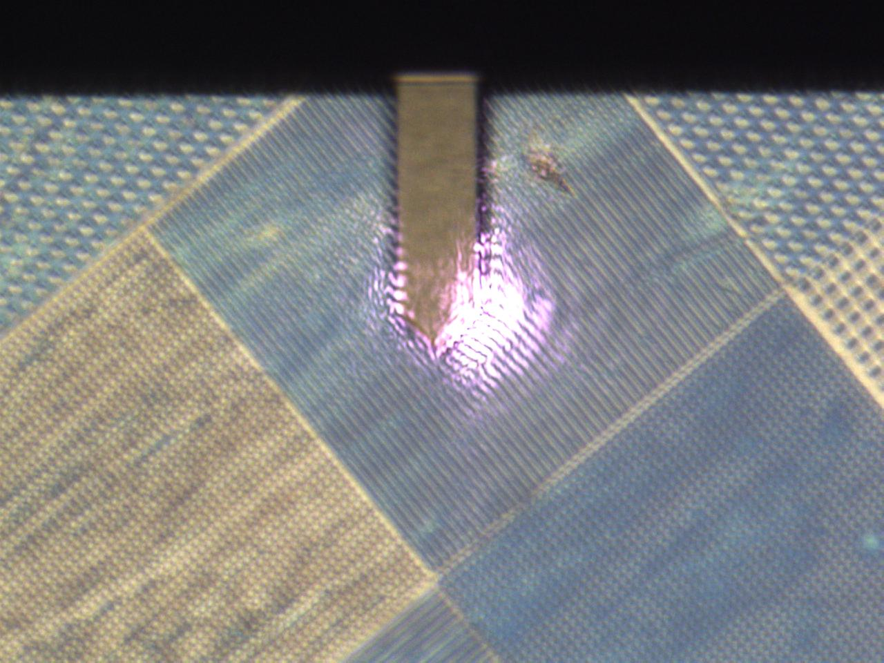
Silicon lithography image used for calibration support. This figure is useful for documenting the instrument/calibration context of the AFM workflow.
Source: C:\Users\Conor O'Brien\Dropbox\03_AML\00 IN-BOX\AFM Topo Particle processing OUT\Particle Images for Thesis Figures\raw\HS100MG-PPP-NCM_250925_ChNameDirVision__ScanSize_GrID001_LocationOfScanRC-CRO.jpg

