Chapter 6 Draft - Stage 1 Results and Feasibility Decision
Draft generated: 2026-03-06 21:11
Scope: measurement feasibility, scan efficiency, and decision thresholds only.

6.1 Processing Validation - Baseline PEGDA (No SiNP)
Baseline PEGDA validation in this chapter is carried primarily by the modulus method-comparison study. That study was used to evaluate forward/backward agreement, route consistency, and the practical effect of pixel loss before extending the Stage 1 logic to the particle-count workflow.
The modulus baseline artifact is limited in scope: it was performed on one PEGDA sample and one fracture-surface side, so it should be interpreted as method-validation evidence rather than a population-level PEGDA modulus study. Even with that scope limit, the paired forward/backward comparison and the route-consistency summaries provide the direct baseline-validation evidence requested in the thesis outline.
Unit provenance should be stated explicitly for this section. In this workflow, Gwyddion-derived outputs inherit the physical unit attached to the active data field when that unit is actually present in the imported field metadata. A direct one-file verification run on the current PEGDA modulus TIFFs showed that pygwy did not detect an embedded modulus z-unit for that file, so the current modulus source summaries carrying units = kPa should be treated as a workflow-level fallback/default assignment rather than fully verified source metadata truth. That same one-file verification run also produced a negative modulus export, so the absolute modulus value path should be treated as provisional pending targeted re-validation of the TIFF unit/processing chain. By contrast, the Stage 1 particle-count outputs are count-based summaries and therefore do not inherit a physical z-unit, while particle and grain diameter summaries are derived geometric metrics reported in nm.
Table 6.1 - Paired forward/backward modulus baseline summary by method
Method | Paired scans | Median B/F ratio | Mean B/F ratio | Median delta avg (GPa-equiv.) | Mean delta avg (GPa-equiv.) | Mean delta n_valid
Baseline Gwyddion stats | 99 | 1.000 | 2.181 | -0.005 | -800.432 | -4318.7
Gwyddion preprocess + Python stats | 99 | 1.001 | 1.418 | 0.037 | 4.562 | -4318.7
Raw export + min/max filter | 99 | 1.001 | 1.418 | 0.037 | 4.562 | -4318.7
Raw export + Chauvenet | 91 | 1.000 | 1.419 | -0.006 | -4.069 | -8176.5
Raw export + 3-sigma | 88 | 1.001 | 1.424 | 0.018 | 2.604 | -11256.0
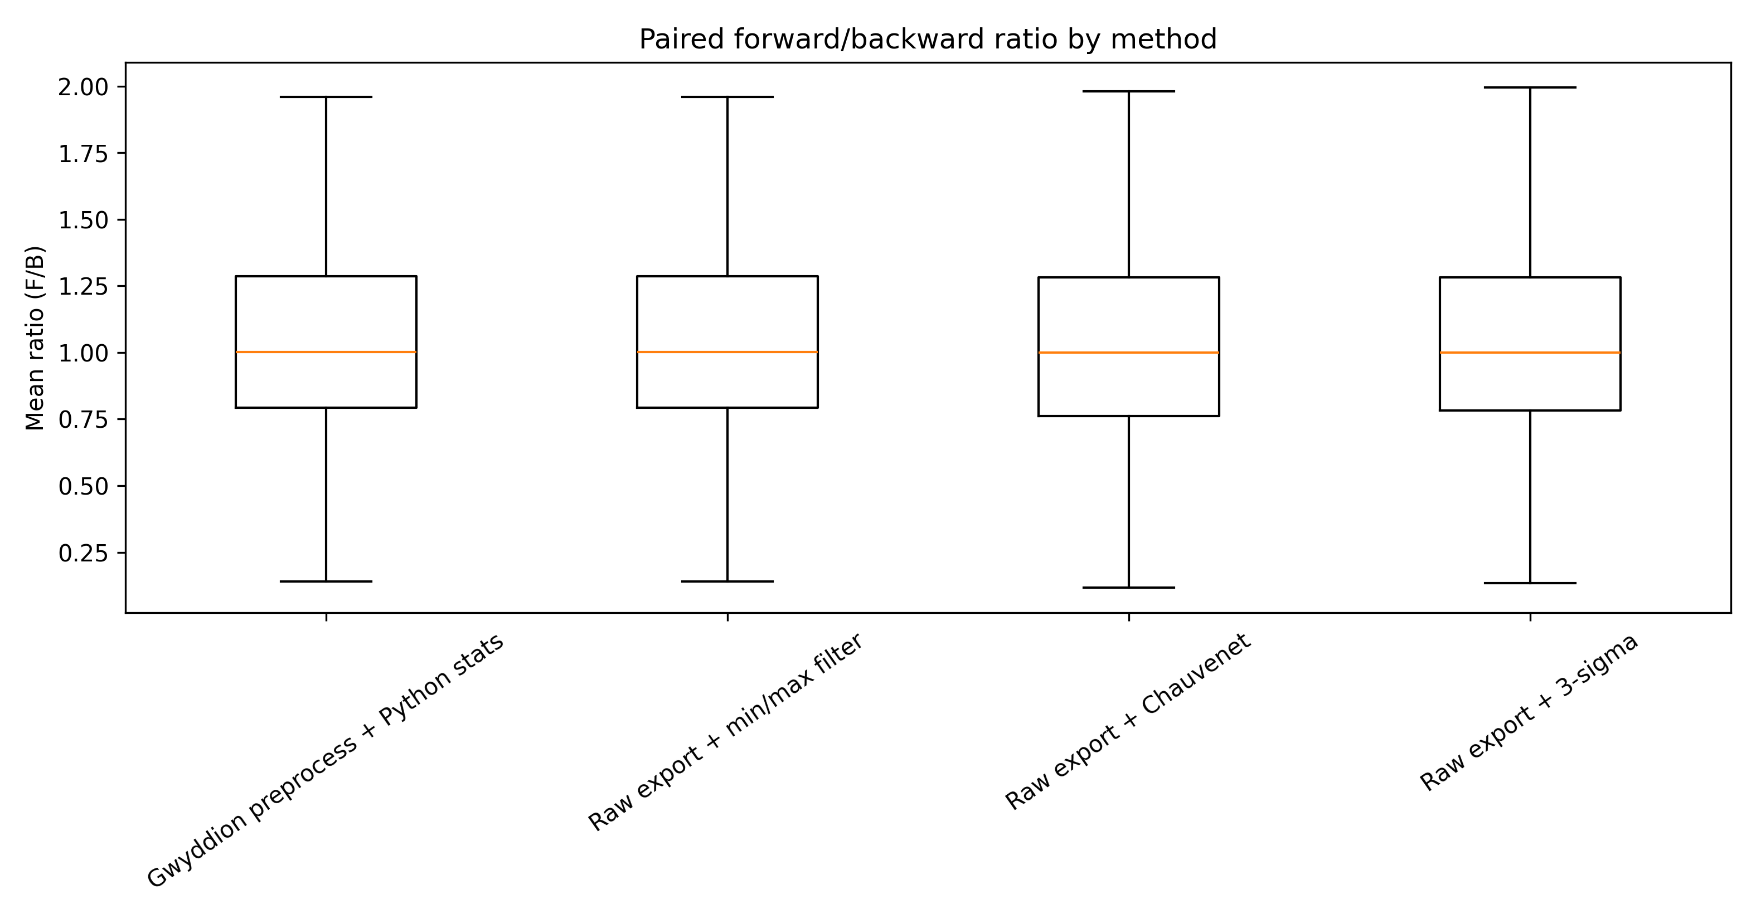
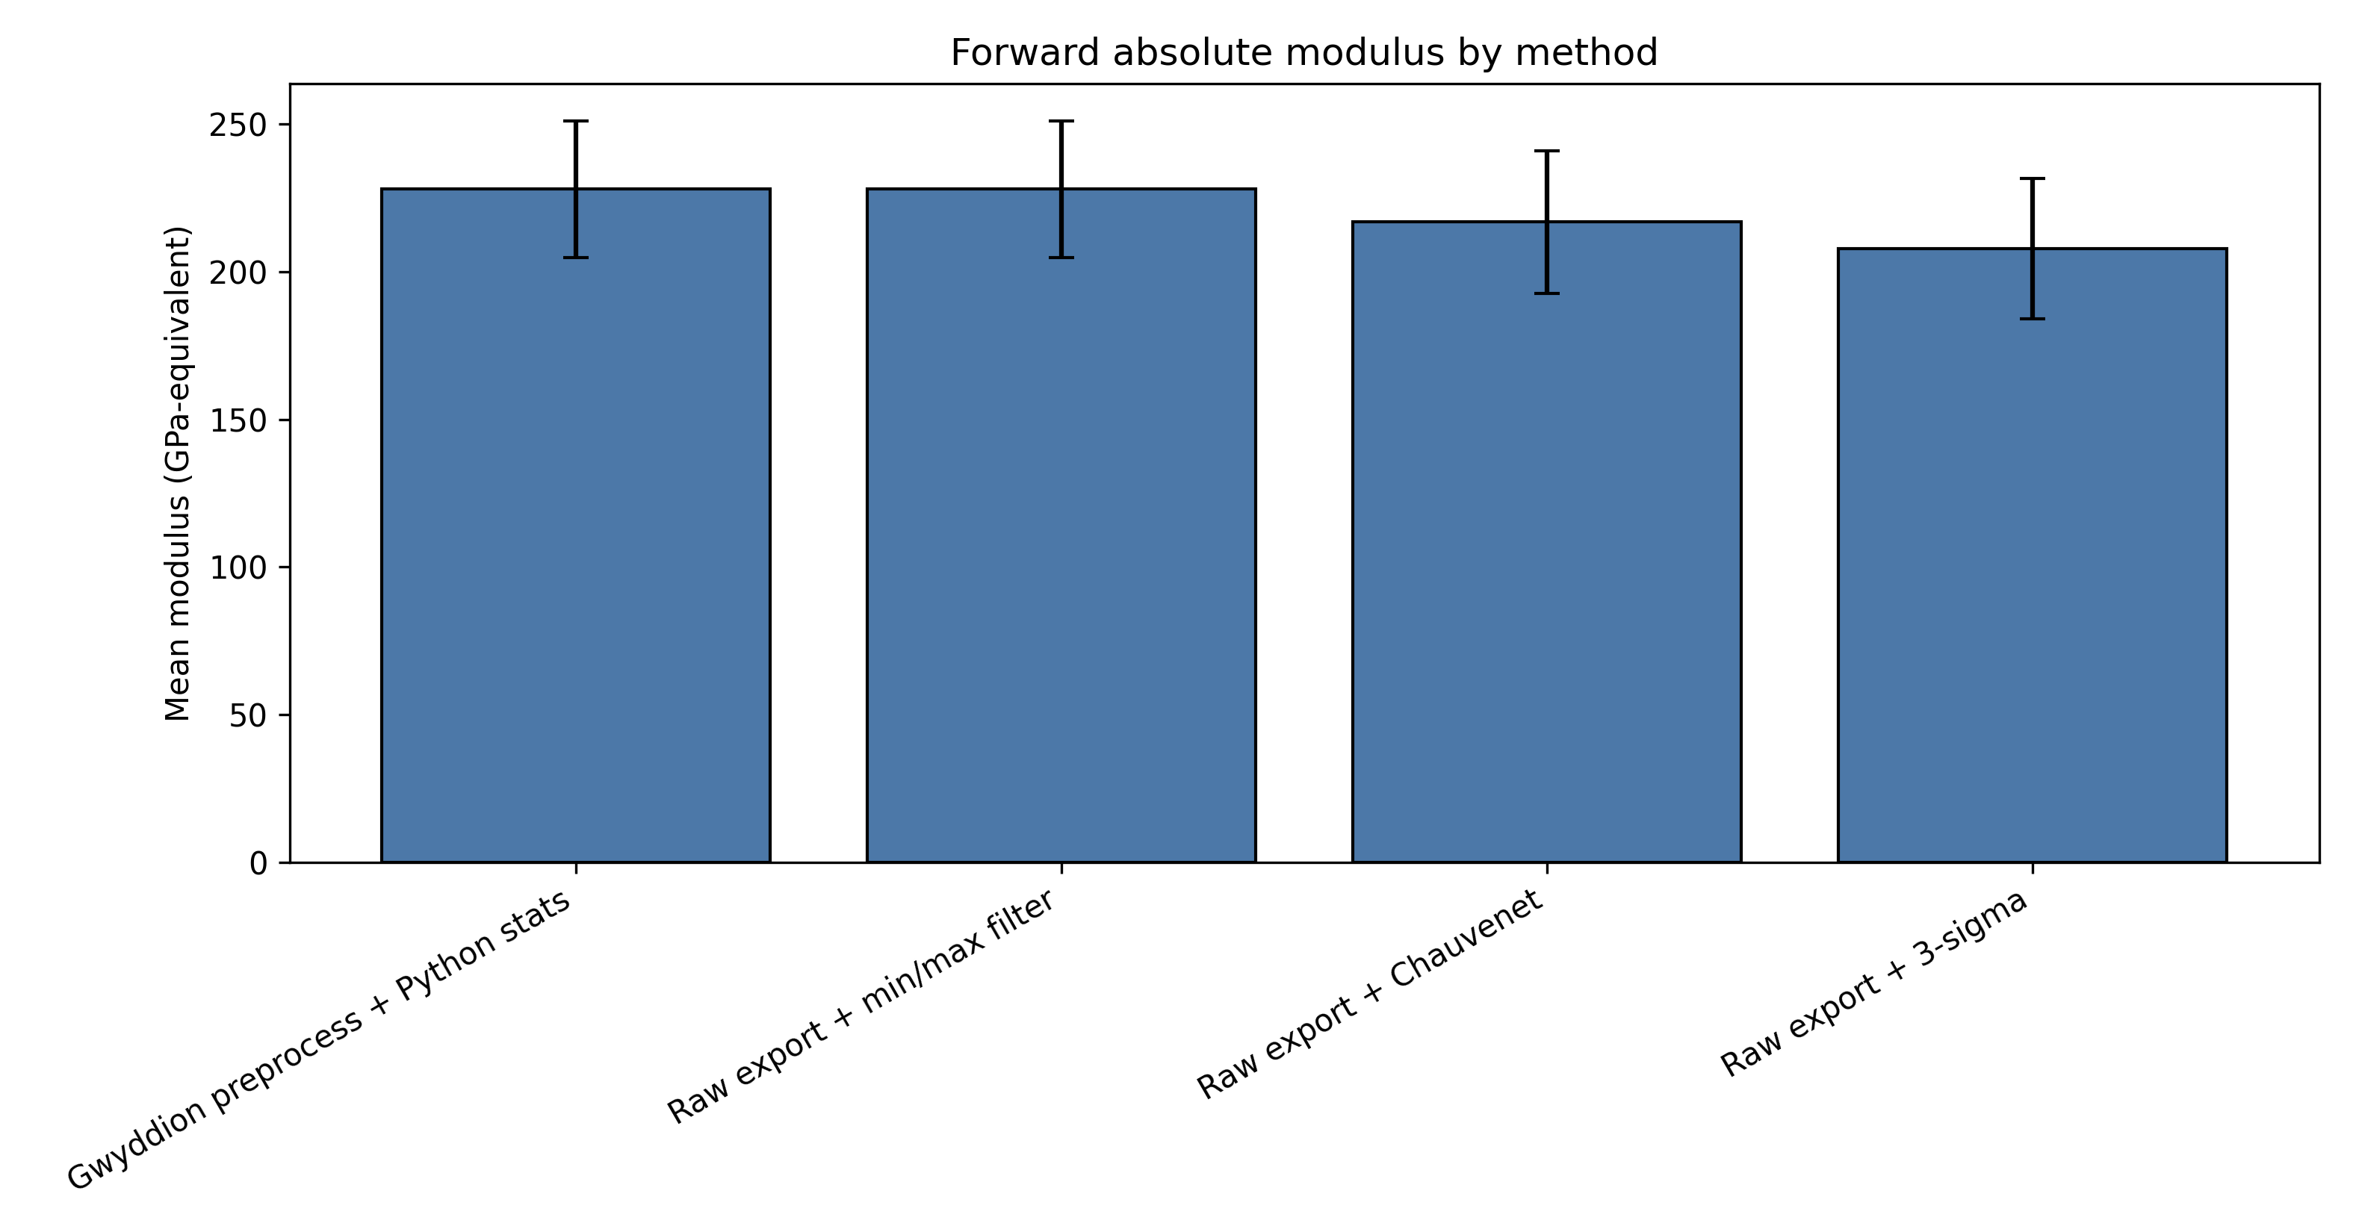
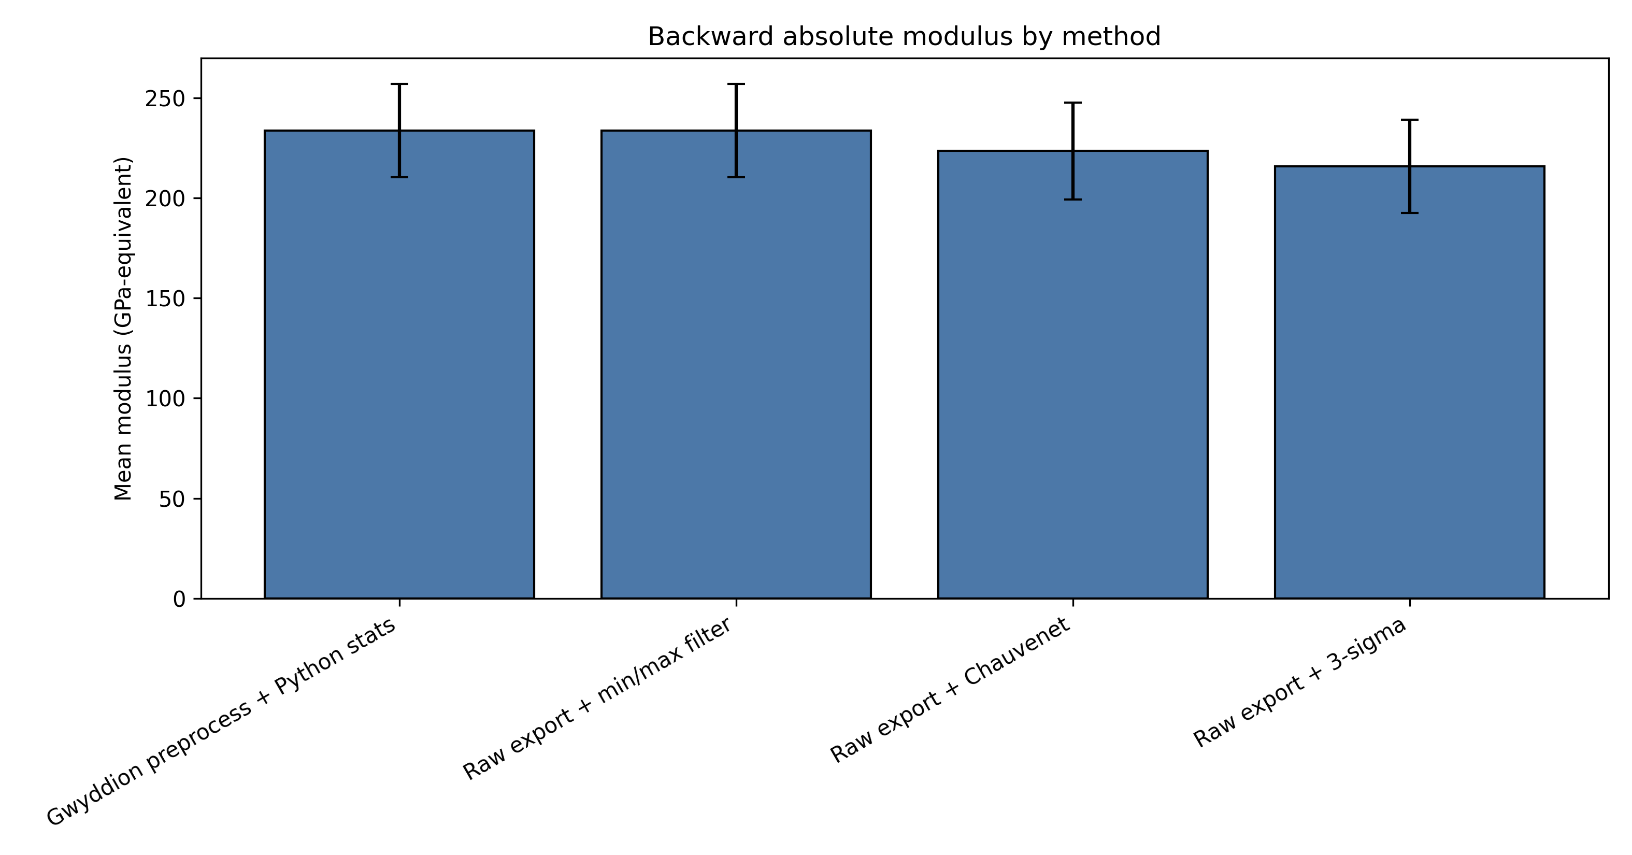
Figure 6.1 - Baseline PEGDA modulus validation figures. The paired-ratio box plot summarizes forward/backward agreement by method, while the absolute-modulus bars show method-level forward and backward modulus summaries with standard-error bars. These figures support route consistency and the forward-only selection used later in the Stage 1 topography workflow.
Source: C:\Users\Conor O'Brien\Dropbox\03_AML\00 IN-BOX\AFM Topo Particle processing OUT\modulus_baseline_assets\paired_ratio_boxplot.png
Source: C:\Users\Conor O'Brien\Dropbox\03_AML\00 IN-BOX\AFM Topo Particle processing OUT\modulus_baseline_assets\forward_absolute_modulus_bar.png
Source: C:\Users\Conor O'Brien\Dropbox\03_AML\00 IN-BOX\AFM Topo Particle processing OUT\modulus_baseline_assets\backward_absolute_modulus_bar.png
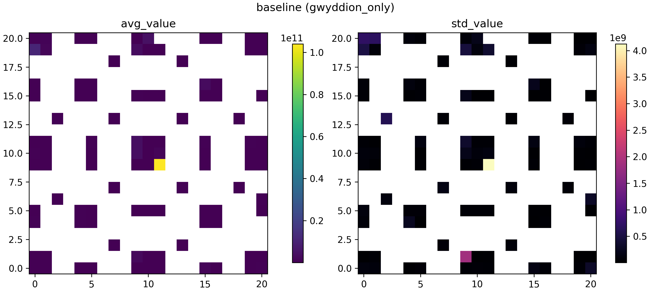
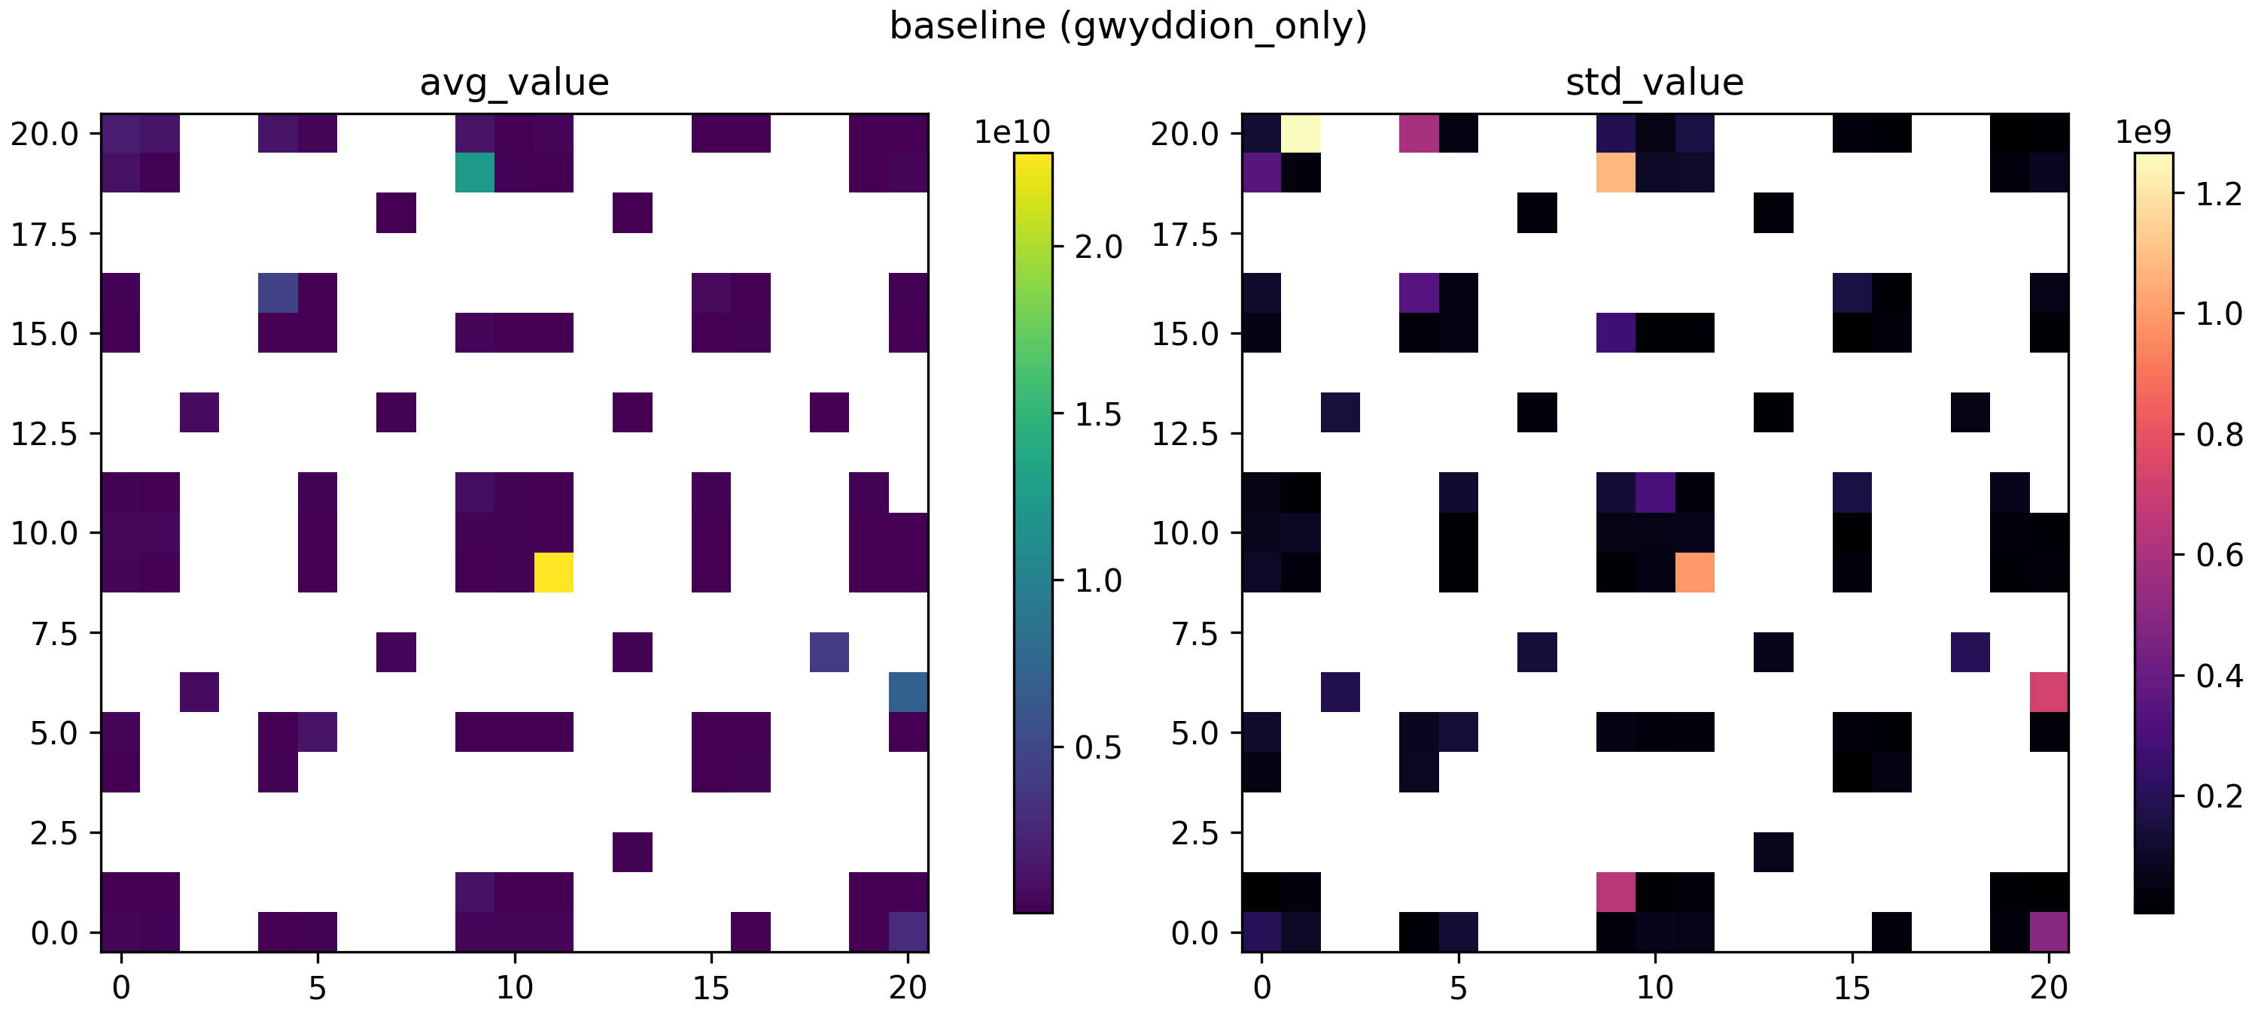
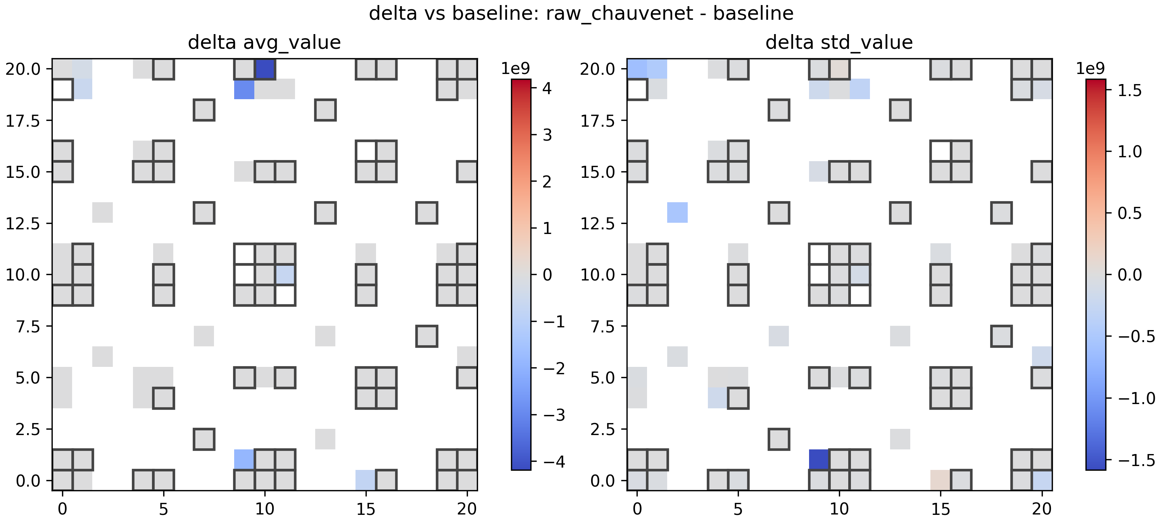
Figure 6.1b - Forward and backward baseline PEGDA modulus heatmaps plus one representative delta-versus-baseline comparison heatmap. These plots show the spatial baseline field for each scan direction and one example of how a comparison route shifts the baseline modulus pattern.
Source: out\method_compare\compare_20260306_180402\plots\heatmap_two_panel__baseline.png
Source: out\method_compare\compare_20260306_180452\plots\heatmap_two_panel__baseline.png
Source: out\method_compare\compare_20260306_180402\plots\heatmap_two_panel__delta_vs_baseline__raw_chauvenet.png
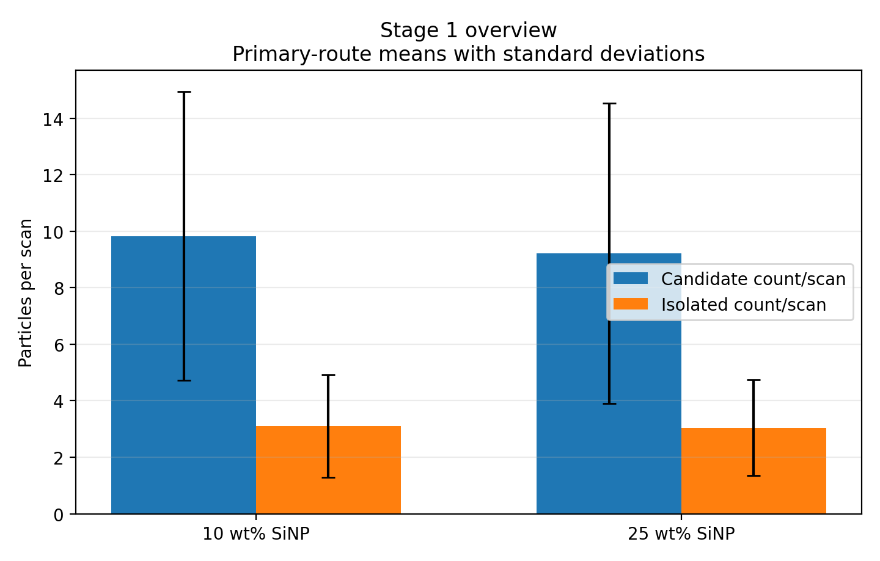
Figure 6.1c - Stage 1 overview for PEGDA, 1 wt% TPO, no coating, comparing 10 wt% and 25 wt% SiNP. Bars show mean candidate and isolated counts per scan with standard deviations.
Source: docs\Thesis\generated_assets\chapter6_stage1_overview.png

6.2 Stage 1 - Particle Presence in PEGDA-SiNP

6.2.1 Scan Inventory
Table 6.2 - Scan inventory used for the current Stage 1 analysis
System | Sample sets | Scans analyzed | Scan size (um x um) | Pixel grid | Resolution (nm/pixel) | Nominal map grid
10 wt% SiNP | 4 | 386 | 5 x 5 | 512 x 512 | 9.77 | 21 x 21
25 wt% SiNP | 5 | 404 | 5 x 5 | 512 x 512 | 9.77 | 21 x 21
10 wt% SiNP contributed 386 scans across 4 sample sets. 25 wt% SiNP contributed 404 scans across 5 sample sets. Each scan is a 5 um x 5 um AFM image on a nominal 21 x 21 survey grid with 512 x 512 pixels.
The nominal survey layout was 21 x 21 scans, but the analyzed inventories reflect only scans that were actually collected and retained in the grouped dataset. Some 25 wt% grouped sample sets were therefore incomplete relative to the nominal grid, even though the total analyzed inventory remained well above the later scan-sufficiency threshold.

6.2.2 Particle Count Per Scan
Under the primary route (particle_forward_medianbg_mean), retained candidate counts averaged 9.83 +/- 5.12 particles per scan for 10 wt% SiNP and 9.22 +/- 5.31 particles per scan for 25 wt% SiNP. Zero-count scans were rare in both sets (3.1% and 2.0%).
The 25 wt% SiNP set showed a modest increase in candidate density relative to 10 wt% SiNP (0.94x), but this stage still describes candidate features, not fully validated true particles.
Figures 6.2A and 6.2B show histograms of retained candidate-particle count per scan. In these plots, frequency is the number of scans falling at each retained-count value. For both loadings, the highest frequencies occur at low retained counts, indicating that most scans contain only a small number of retained candidate particles rather than large multi-particle populations.
Figures 6.3A and 6.3B are mean count maps across the grouped sample sets for each loading. They show that retained candidate particles are distributed across the surveyed grid rather than concentrated at a single localized region. These maps summarize mean count only; they do not show per-position standard deviation, which should be treated as a separate variability layer if spatial uncertainty is discussed in detail.
Table 6.3 - Primary-method candidate count summary
System | Mean count/scan | Std | Min | Max | Zero-count rate
10 wt% SiNP | 9.83 | 5.12 | 0 | 28 | 3.1%
25 wt% SiNP | 9.22 | 5.31 | 0 | 25 | 2.0%
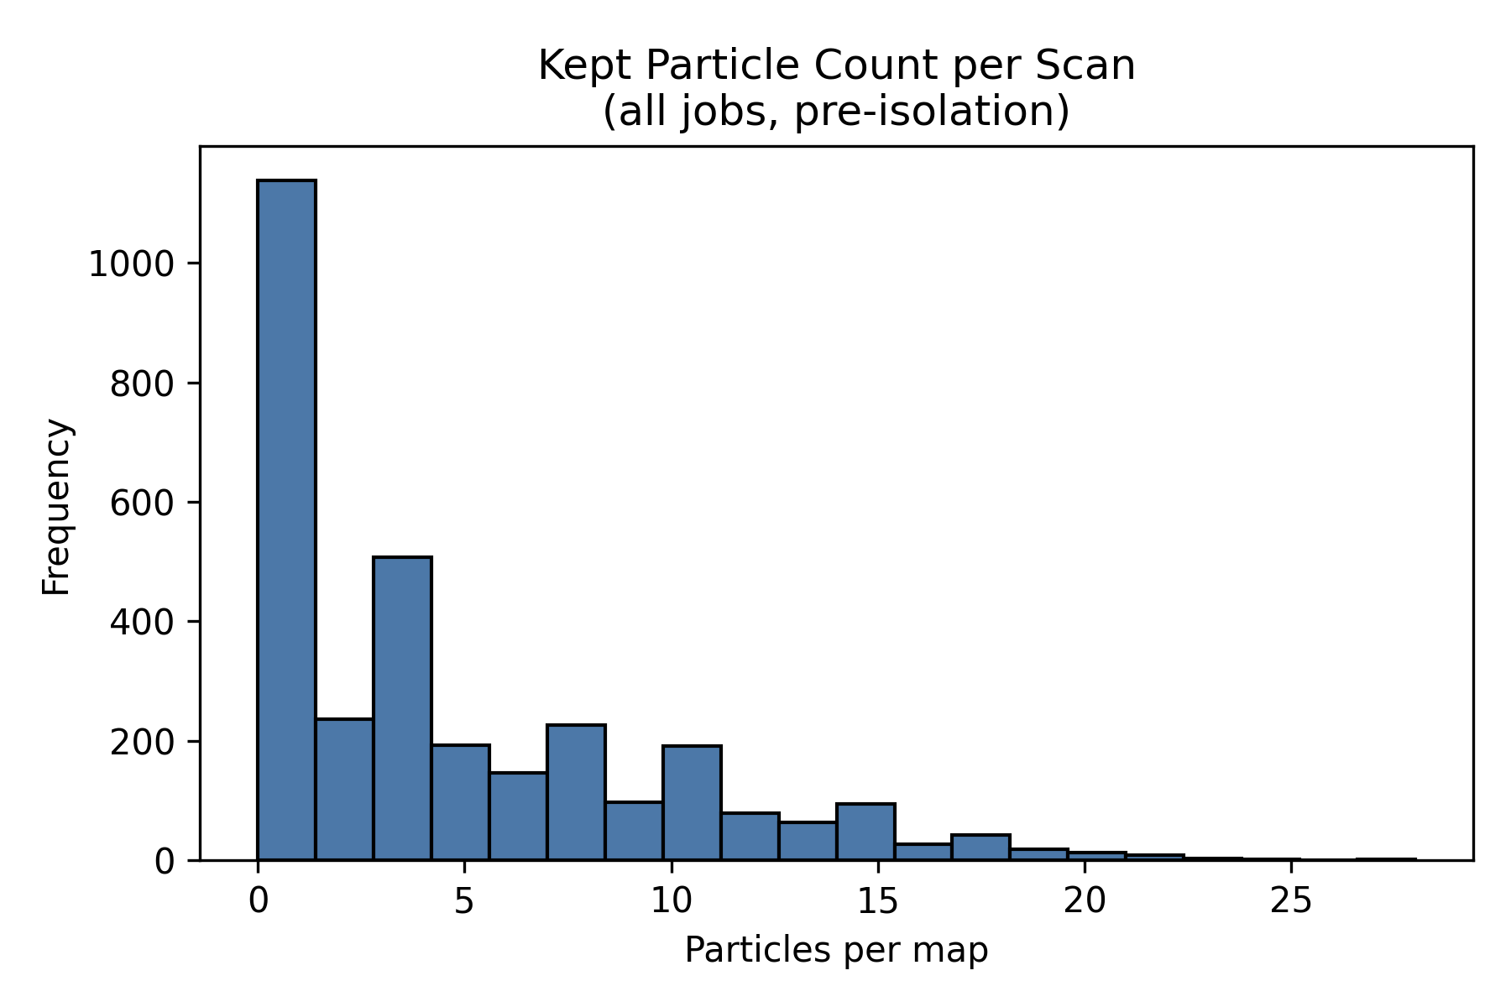
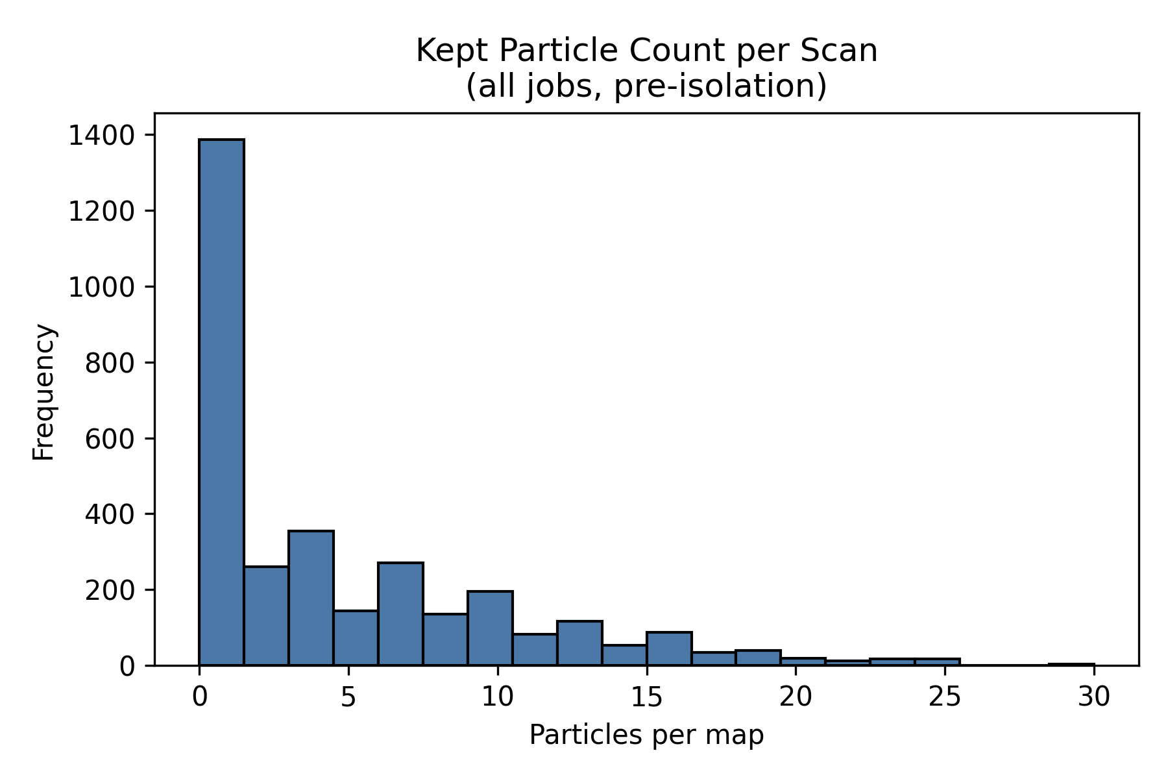
Figure 6.2 - Particle-count histograms for PEGDA, 1 wt% TPO, no coating, with 10 wt% and 25 wt% SiNP under the primary route.
Source: C:\Users\Conor O'Brien\Dropbox\03_AML\00 IN-BOX\AFM Topo Particle processing OUT\run_grains_full_wt10_20260304_145519\fig_particle_count_hist.png
Source: C:\Users\Conor O'Brien\Dropbox\03_AML\00 IN-BOX\AFM Topo Particle processing OUT\run_grains_full_wt25_20260304_145519\fig_particle_count_hist.png
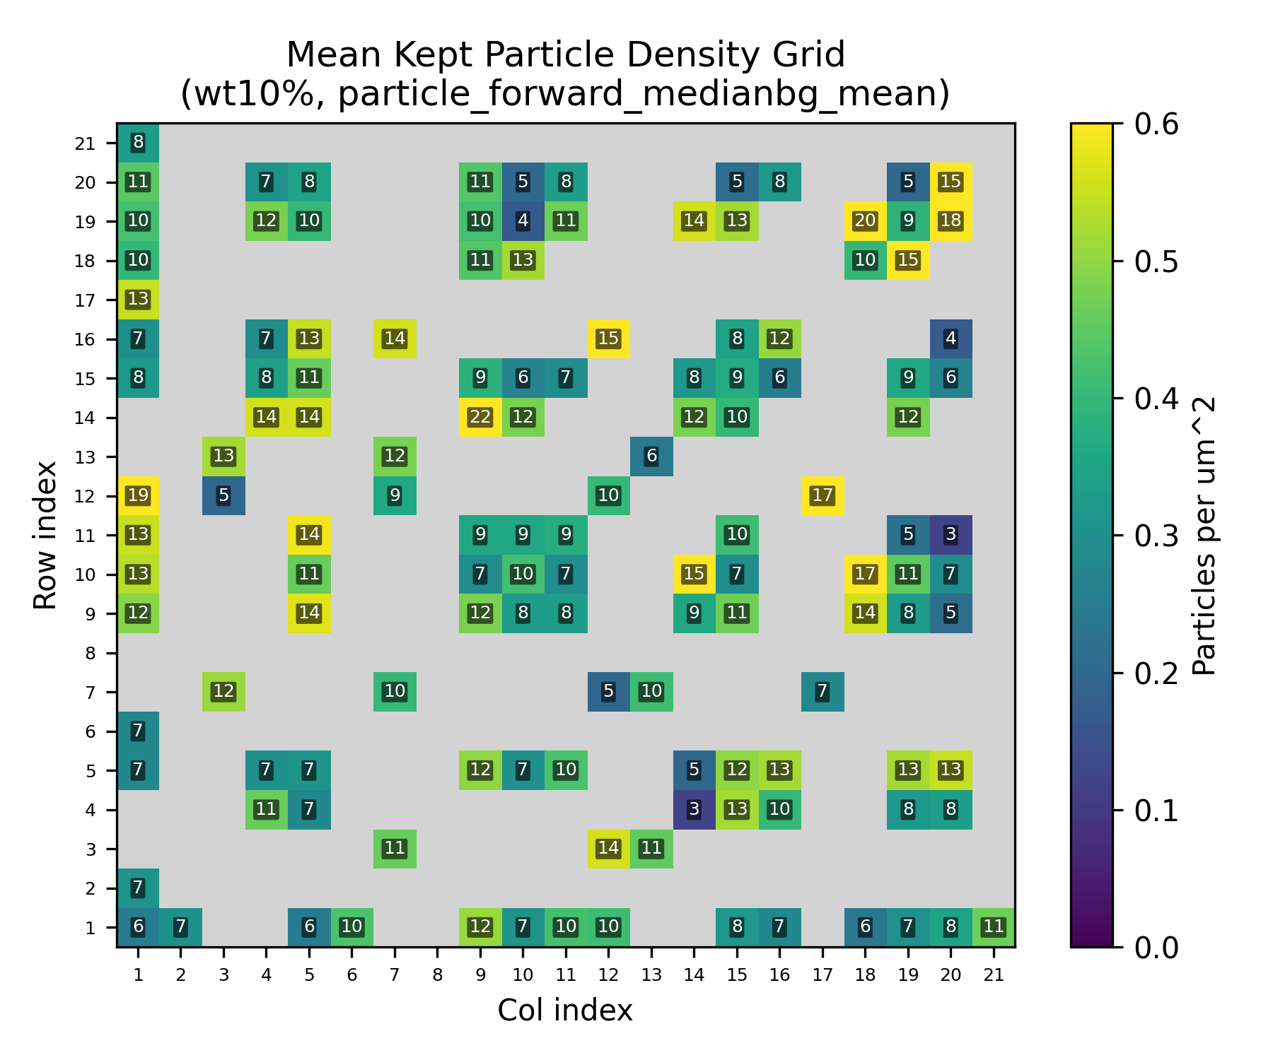
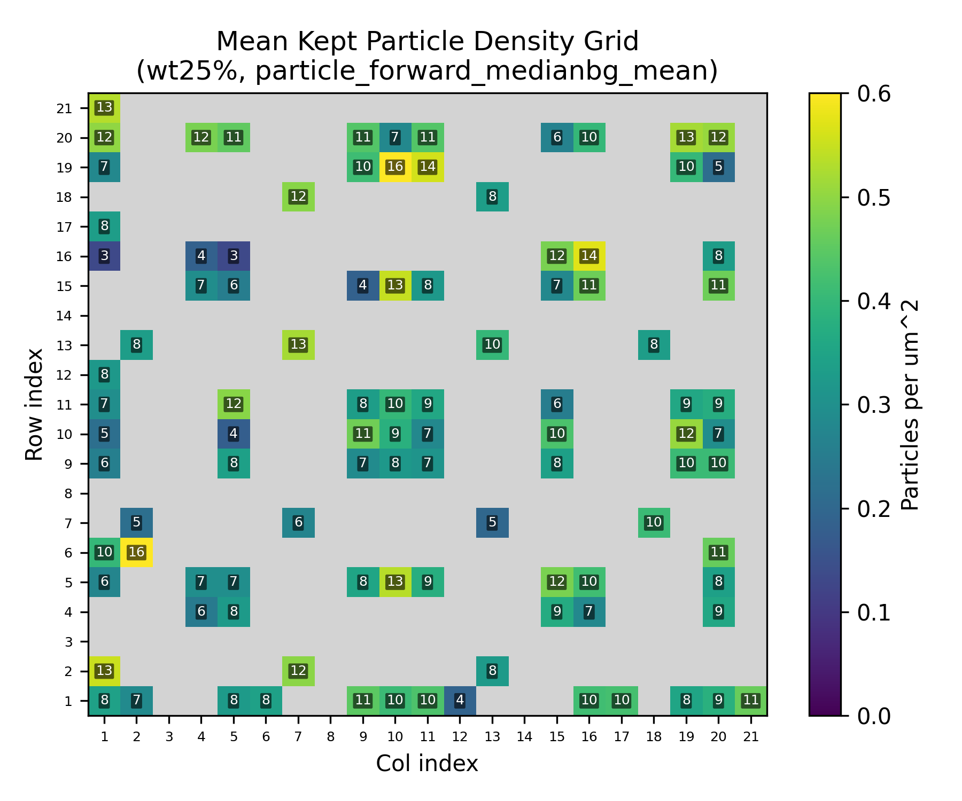
Figure 6.3 - Particle-count grid heatmaps for the primary route, separated by SiNP loading.
Source: C:\Users\Conor O'Brien\Dropbox\03_AML\00 IN-BOX\AFM Topo Particle processing OUT\run_grains_full_wt10_20260304_145519\summary_outputs\combined\fig_particle_count_grid_wt10_particle_forward_medianbg_mean.png
Source: C:\Users\Conor O'Brien\Dropbox\03_AML\00 IN-BOX\AFM Topo Particle processing OUT\run_grains_full_wt25_20260304_145519\summary_outputs\combined\fig_particle_count_grid_wt25_particle_forward_medianbg_mean.png
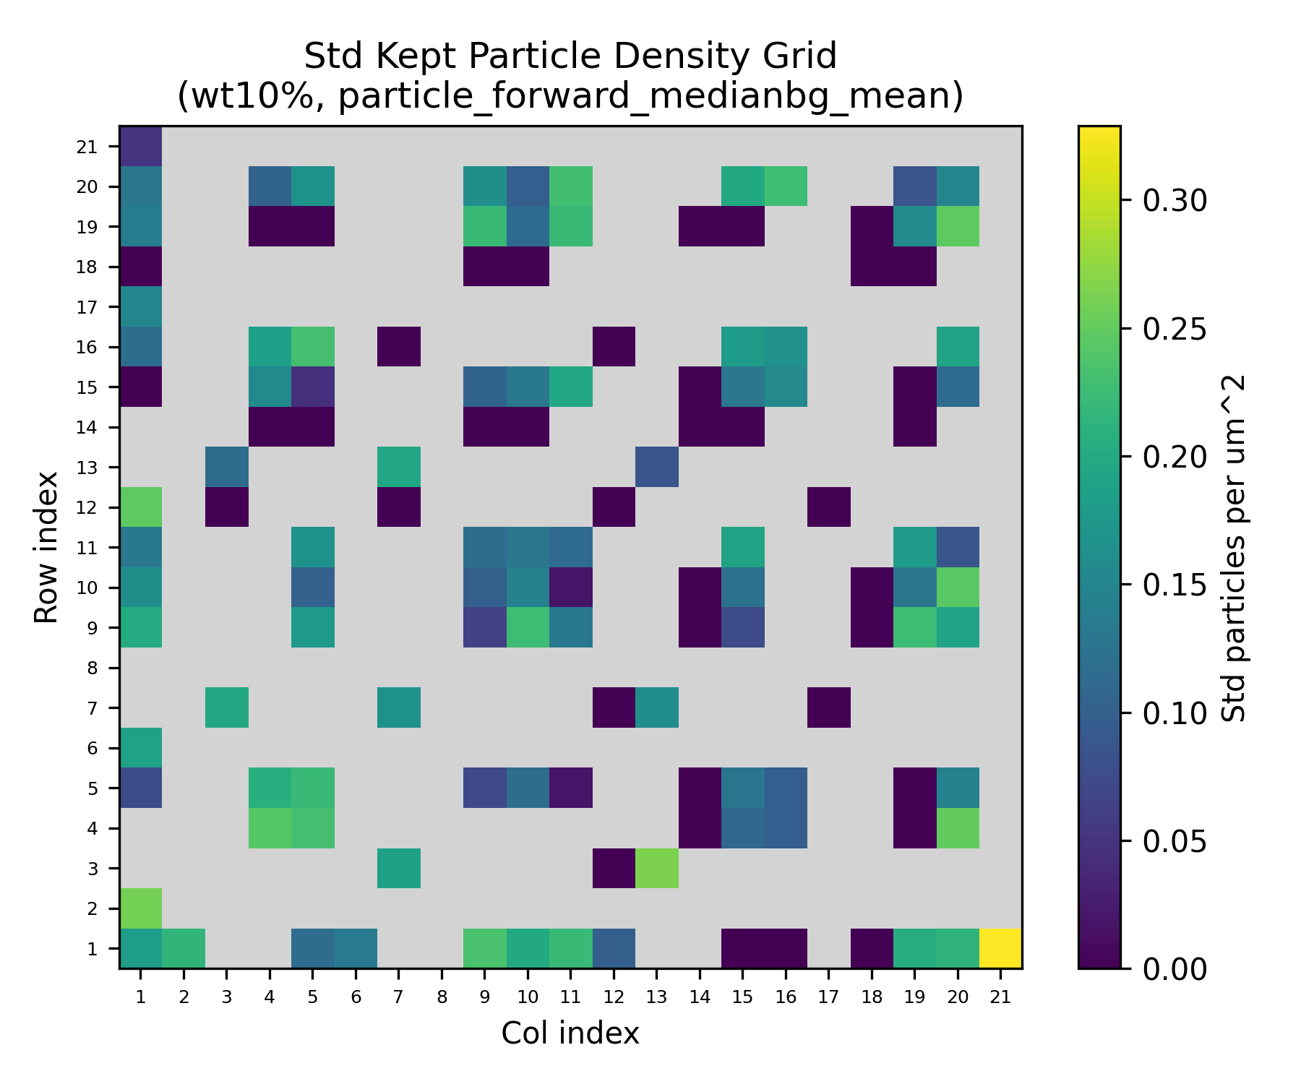
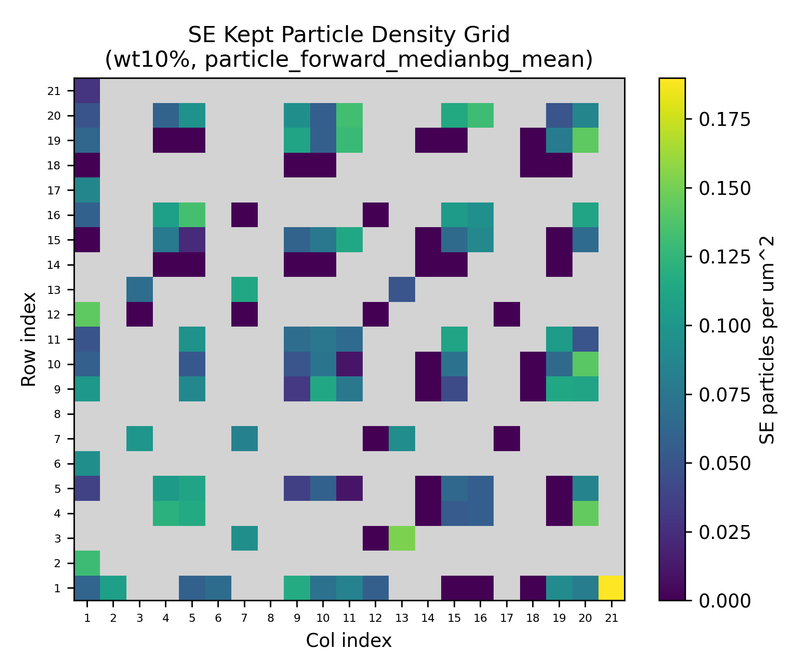
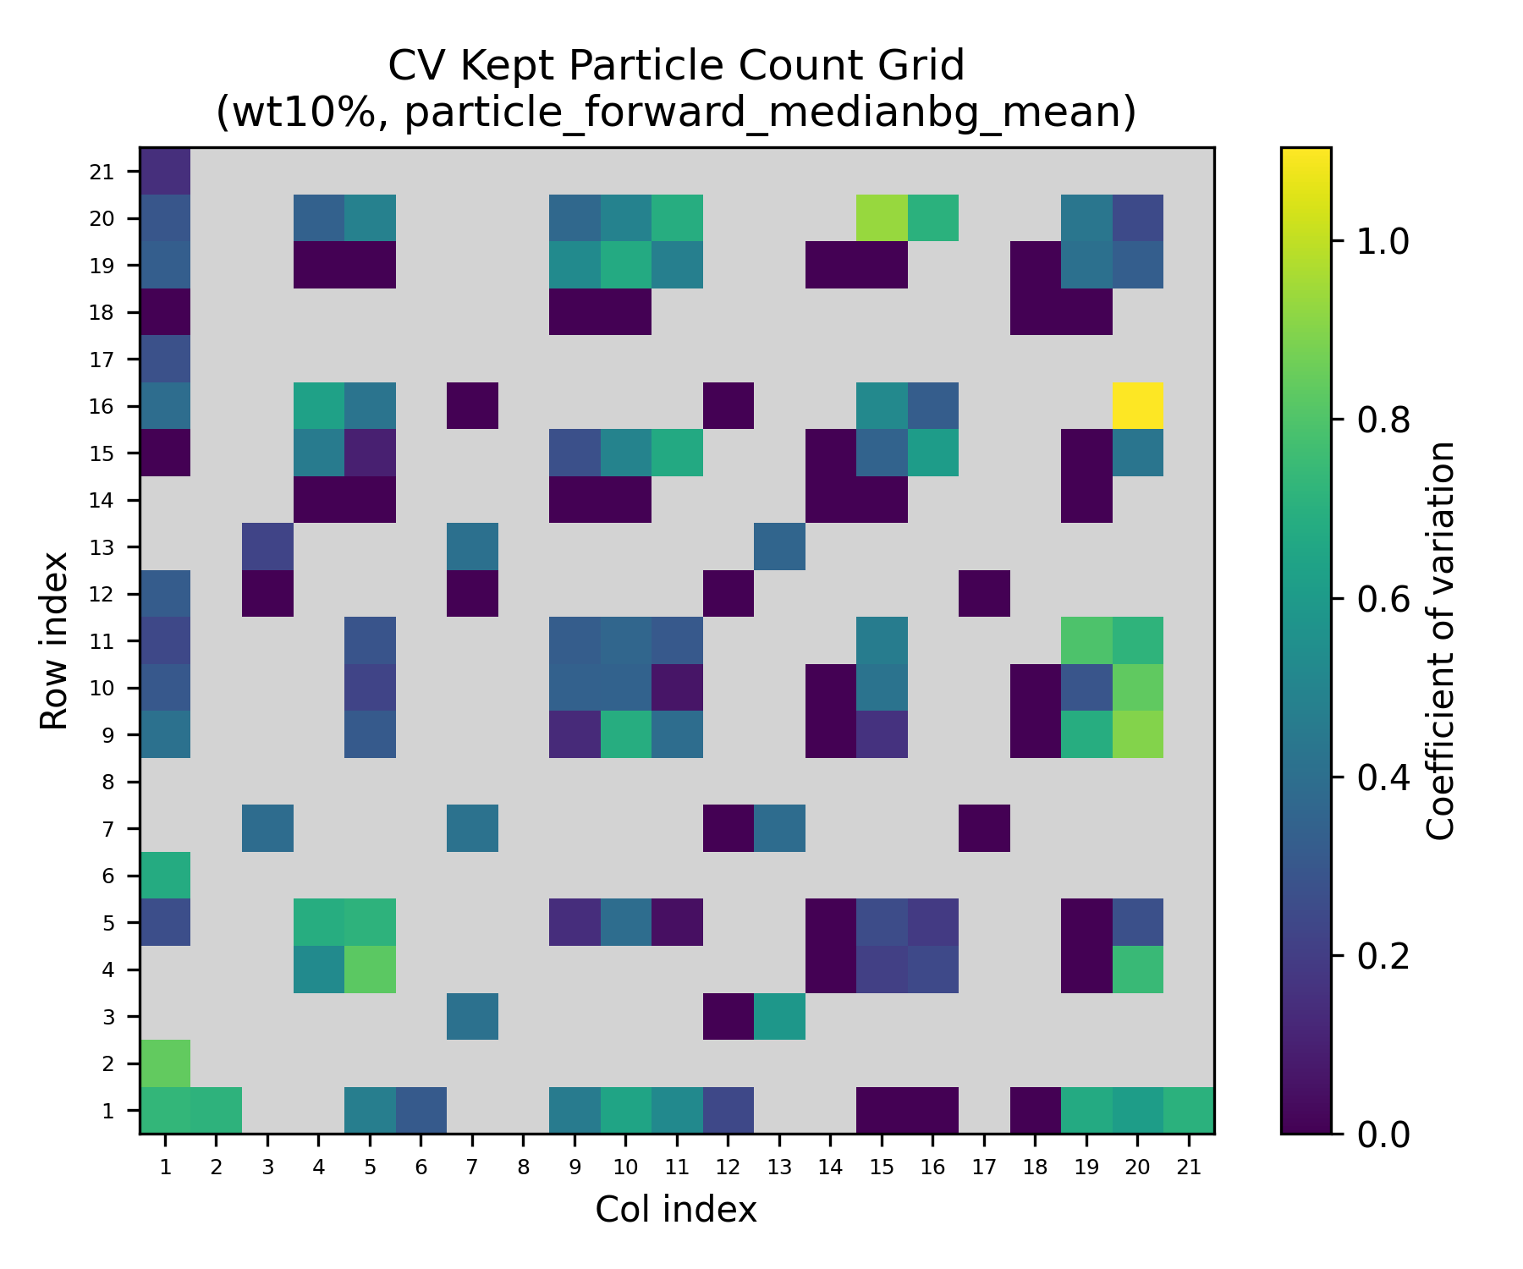
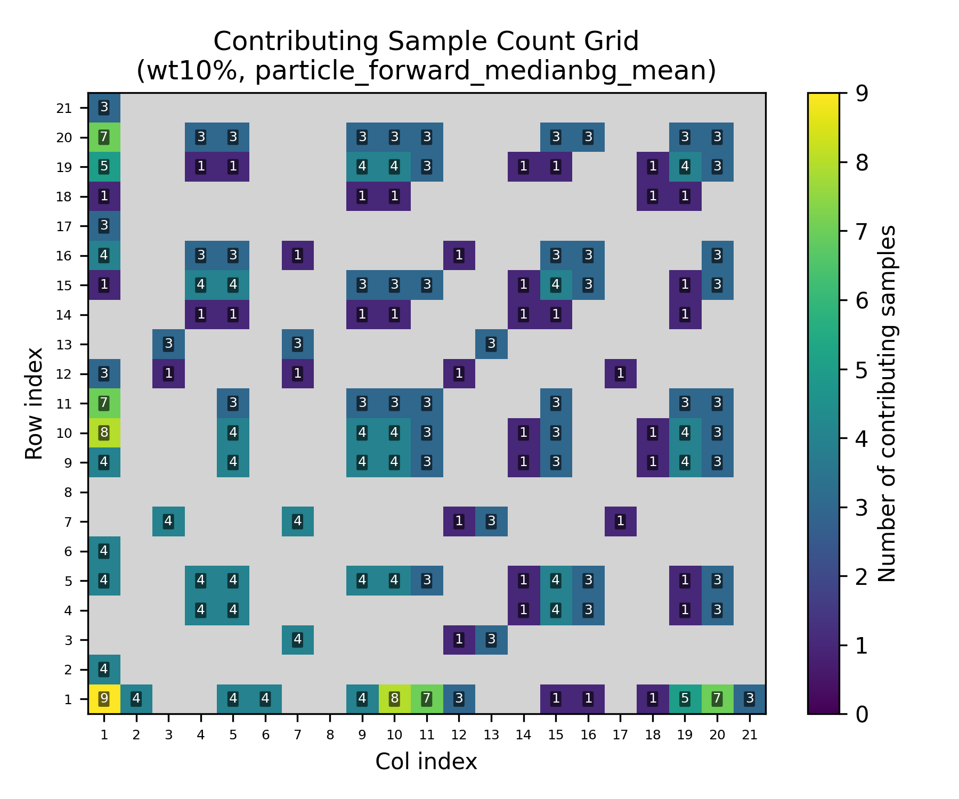
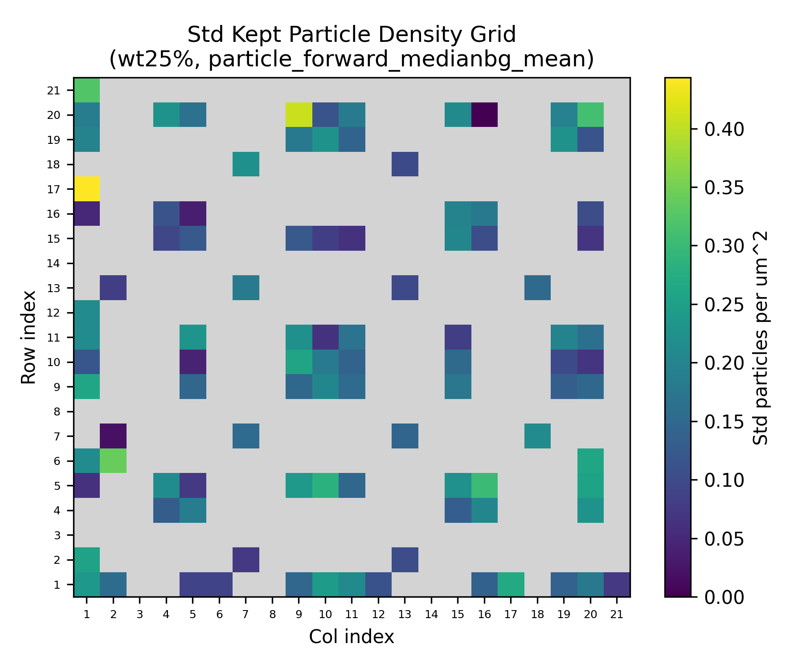
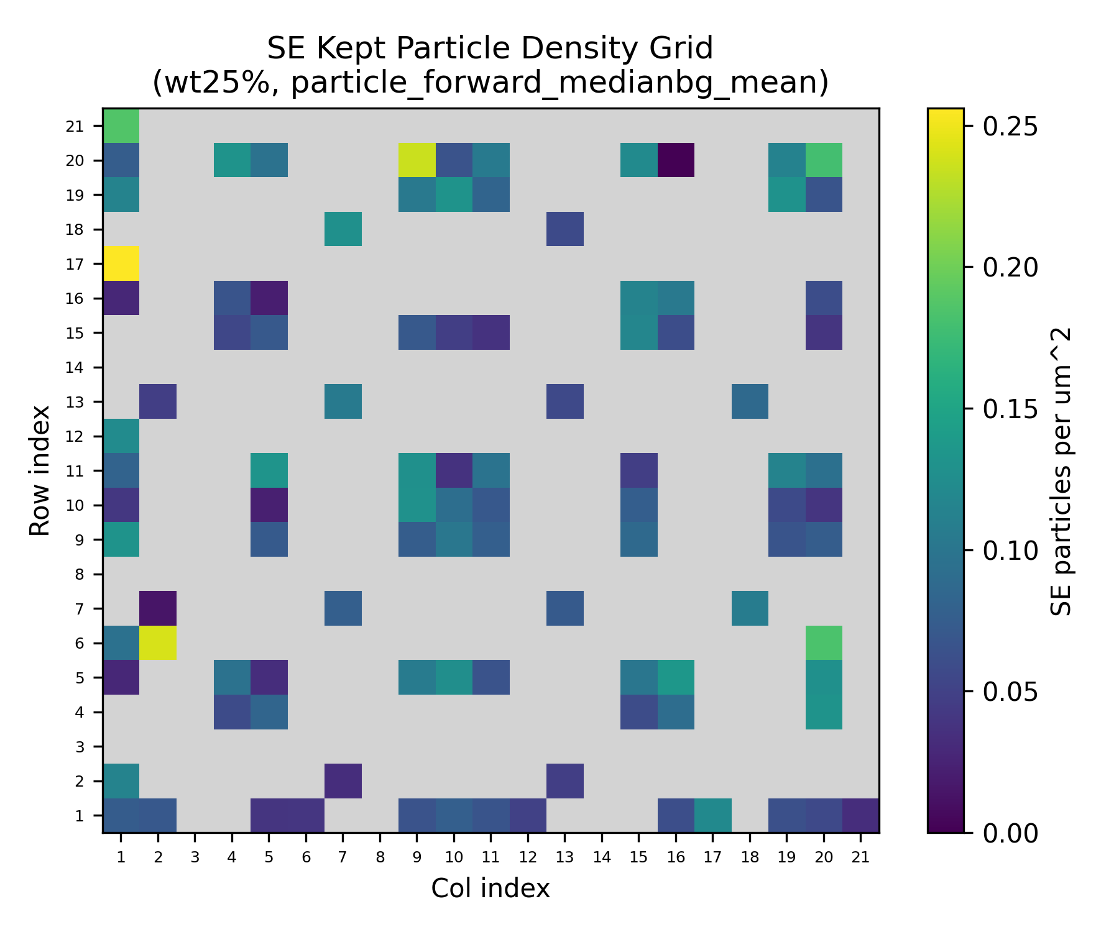
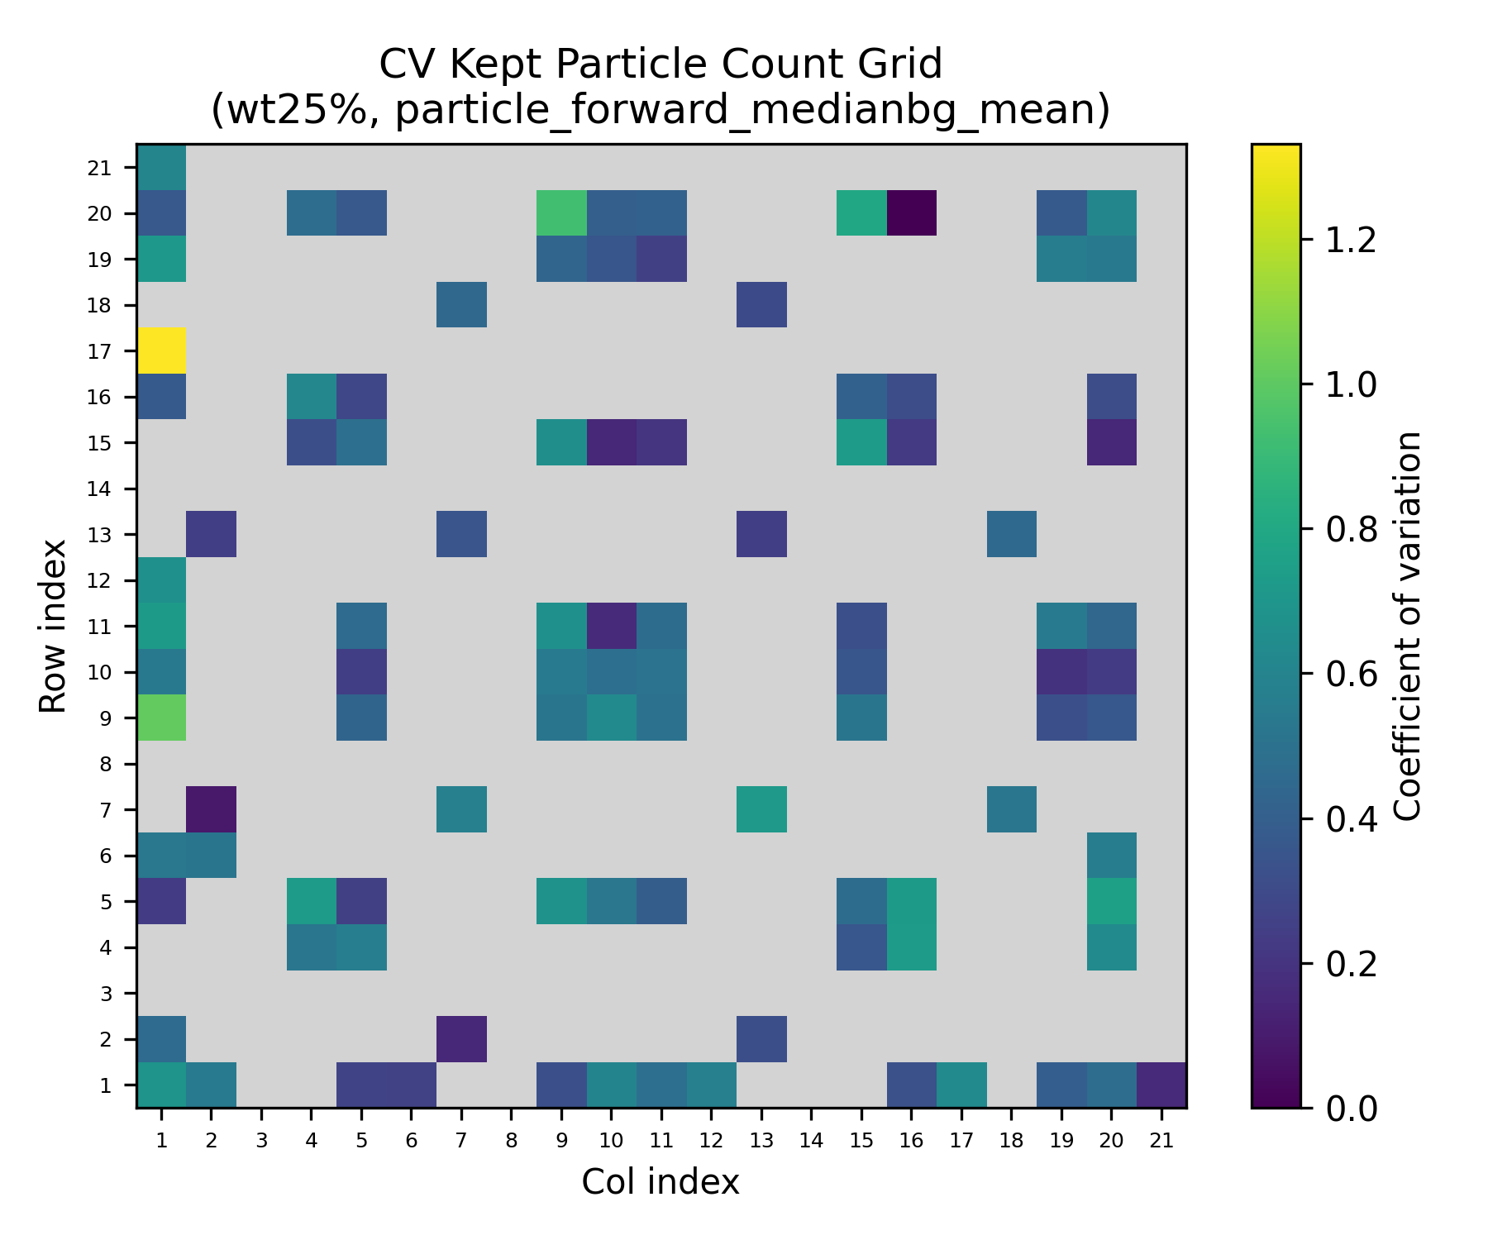
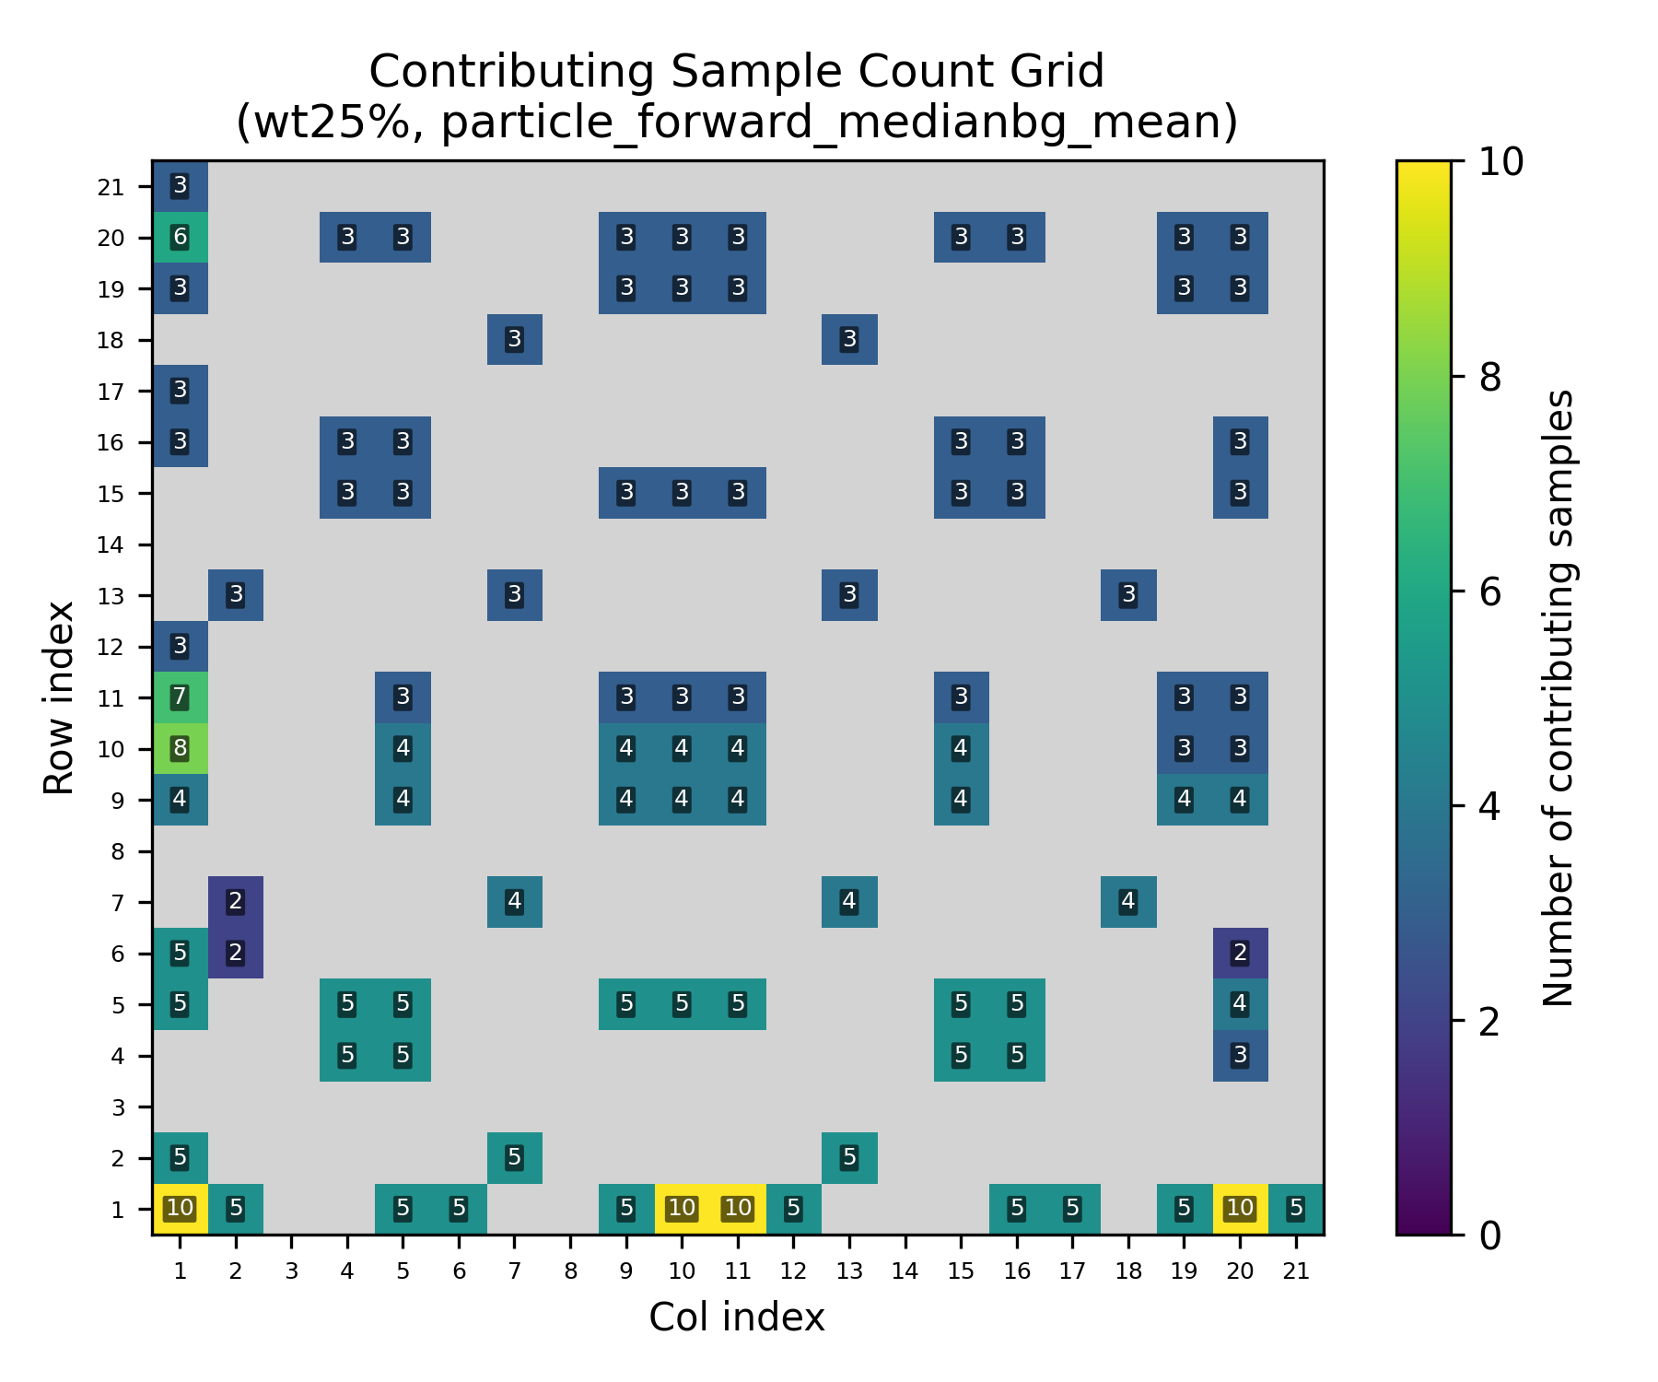
Figure 6.3b - Empirical uncertainty companions for the mean kept-particle heatmaps under the primary route. Standard-deviation maps show between-sample spread, standard-error maps show uncertainty in the estimated mean, coefficient-of-variation maps normalize variability by the local mean, and n-maps show the number of contributing sample sets at each scan position.
Source: C:\Users\Conor O'Brien\Dropbox\03_AML\00 IN-BOX\AFM Topo Particle processing OUT\run_grains_full_wt10_20260304_145519\summary_outputs\combined\fig_particle_count_grid_std_wt10_particle_forward_medianbg_mean.png
Source: C:\Users\Conor O'Brien\Dropbox\03_AML\00 IN-BOX\AFM Topo Particle processing OUT\run_grains_full_wt10_20260304_145519\summary_outputs\combined\fig_particle_count_grid_se_wt10_particle_forward_medianbg_mean.png
Source: C:\Users\Conor O'Brien\Dropbox\03_AML\00 IN-BOX\AFM Topo Particle processing OUT\run_grains_full_wt10_20260304_145519\summary_outputs\combined\fig_particle_count_grid_cv_wt10_particle_forward_medianbg_mean.png
Source: C:\Users\Conor O'Brien\Dropbox\03_AML\00 IN-BOX\AFM Topo Particle processing OUT\run_grains_full_wt10_20260304_145519\summary_outputs\combined\fig_particle_count_grid_n_wt10_particle_forward_medianbg_mean.png
Source: C:\Users\Conor O'Brien\Dropbox\03_AML\00 IN-BOX\AFM Topo Particle processing OUT\run_grains_full_wt25_20260304_145519\summary_outputs\combined\fig_particle_count_grid_std_wt25_particle_forward_medianbg_mean.png
Source: C:\Users\Conor O'Brien\Dropbox\03_AML\00 IN-BOX\AFM Topo Particle processing OUT\run_grains_full_wt25_20260304_145519\summary_outputs\combined\fig_particle_count_grid_se_wt25_particle_forward_medianbg_mean.png
Source: C:\Users\Conor O'Brien\Dropbox\03_AML\00 IN-BOX\AFM Topo Particle processing OUT\run_grains_full_wt25_20260304_145519\summary_outputs\combined\fig_particle_count_grid_cv_wt25_particle_forward_medianbg_mean.png
Source: C:\Users\Conor O'Brien\Dropbox\03_AML\00 IN-BOX\AFM Topo Particle processing OUT\run_grains_full_wt25_20260304_145519\summary_outputs\combined\fig_particle_count_grid_n_wt25_particle_forward_medianbg_mean.png

6.2.3 Particle Diameter Distribution
After applying the configured 350-550 nm filter, retained particle diameter averaged 432.37 +/- 56.57 nm for 10 wt% SiNP and 441.50 +/- 57.70 nm for 25 wt% SiNP. The retained means remain centered on the expected SiNP size band.
Table 6.4 - Retained particle diameter summary
System | Filter band (nm) | Mean diameter (nm) | Std diameter (nm)
10 wt% SiNP | 350-550 | 432.37 | 56.57
25 wt% SiNP | 350-550 | 441.50 | 57.70
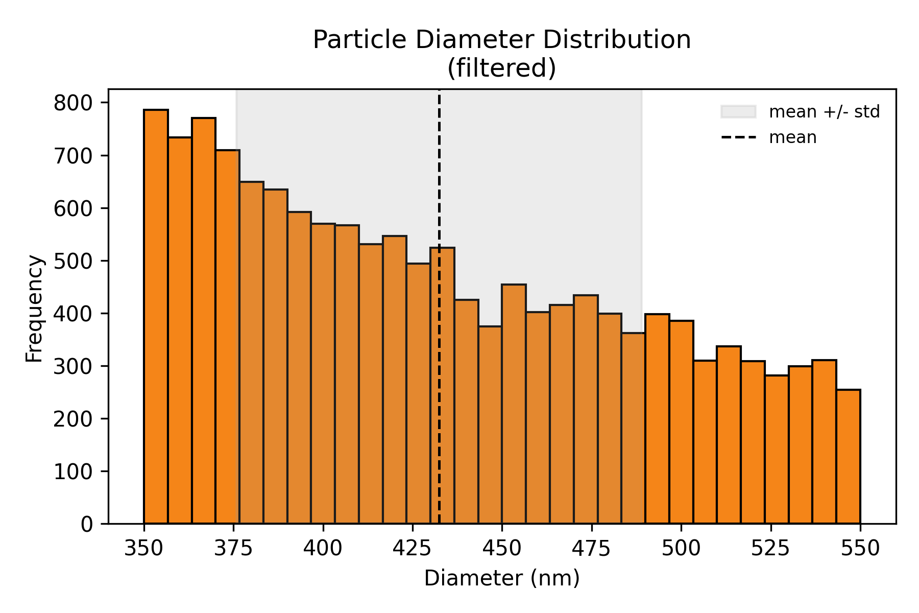
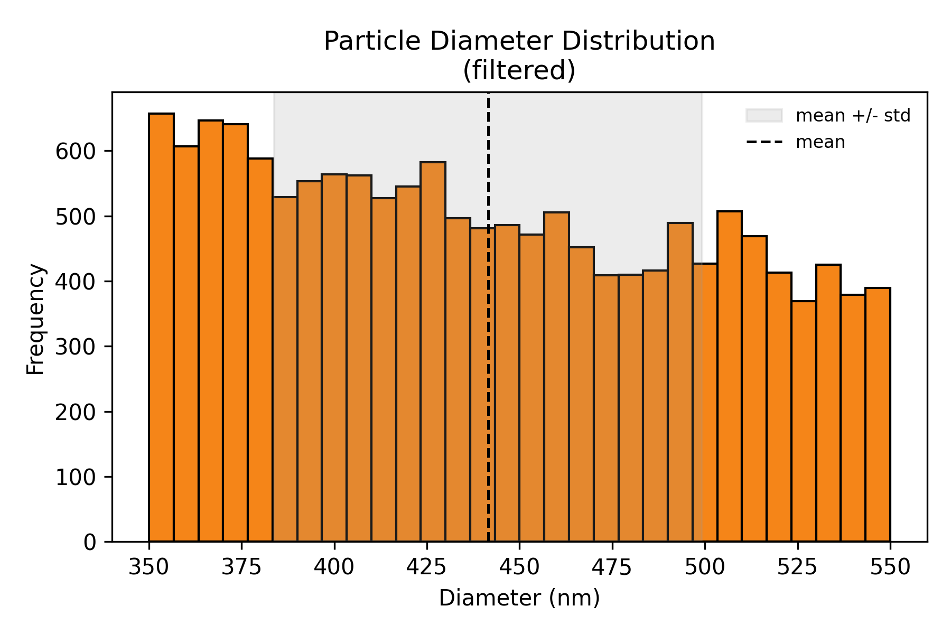
Figure 6.4 - Retained particle-diameter histograms for PEGDA, 1 wt% TPO, no coating, comparing 10 wt% and 25 wt% SiNP after filtering.
Source: C:\Users\Conor O'Brien\Dropbox\03_AML\00 IN-BOX\AFM Topo Particle processing OUT\run_grains_full_wt10_20260304_145519\fig_particle_diameter_hist.png
Source: C:\Users\Conor O'Brien\Dropbox\03_AML\00 IN-BOX\AFM Topo Particle processing OUT\run_grains_full_wt25_20260304_145519\fig_particle_diameter_hist.png

6.3 Isolation Analysis

6.3.1 Isolation Count Per Scan
Isolation is the controlling Stage 1 feasibility metric because only spatially separated targets are usable for Stage 2. In the current workflow, isolation is defined by a minimum center-to-center spacing of 900 nm.
Primary-route isolated counts averaged 3.10 +/- 1.82 per scan for 10 wt% SiNP and 3.04 +/- 1.70 per scan for 25 wt% SiNP. Scans with at least one isolated particle accounted for 92.0% and 93.6% of the two datasets, respectively.
The key result is that the higher-loading dataset did not produce a proportionally larger isolated-particle yield. Mean isolated counts remained close (3.10 versus 3.04 isolated particles per scan) even though candidate density increased.
As in the retained-count maps, the isolated-count heatmaps summarize mean isolated-particle count at each scan position across the grouped sample sets. They are therefore useful for showing spatial distribution, but not for showing the full between-sample spread at each position.
Table 6.5 - Sample-level isolated-particle yield under the primary route
System | Sample set | Scans | Mean isolated/scan | Std | % scans with >=1 isolated
10 wt% SiNP | PEGDA1TPO10SiNP Sa1 Si1- | 88 | 3.41 | 1.69 | 93.2%
10 wt% SiNP | PEGDA1TPO10SiNP Sa1 Si2 | 99 | 3.02 | 1.98 | 86.9%
10 wt% SiNP | PEGDA1TPO10SiNP Sam02 S1 | 100 | 3.26 | 1.67 | 95.0%
10 wt% SiNP | PEGDA1TPO10SiNP Sam02 S2 | 99 | 2.76 | 1.87 | 92.9%
25 wt% SiNP | PEGDA1TPO25SiNP Sam01 S2 | 55 | 3.51 | 1.80 | 94.5%
25 wt% SiNP | PEGDA1TPO25SiNP Sam02 S1 | 105 | 3.01 | 1.64 | 97.1%
25 wt% SiNP | PEGDA1TPO25SiNP Sam02 S2 | 34 | 3.71 | 1.64 | 100.0%
25 wt% SiNP | PEGDA1TPO25SiNP Sam03 S1 | 105 | 2.92 | 1.81 | 88.6%
25 wt% SiNP | PEGDA1TPO25SiNP Sam03 S2 | 105 | 2.74 | 1.53 | 92.4%
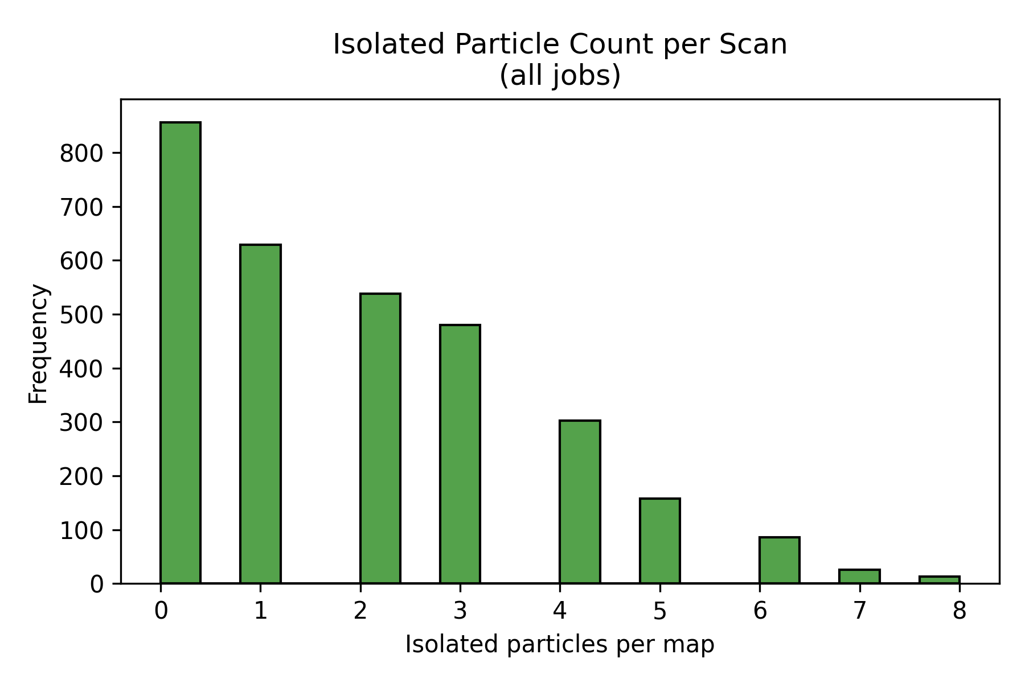
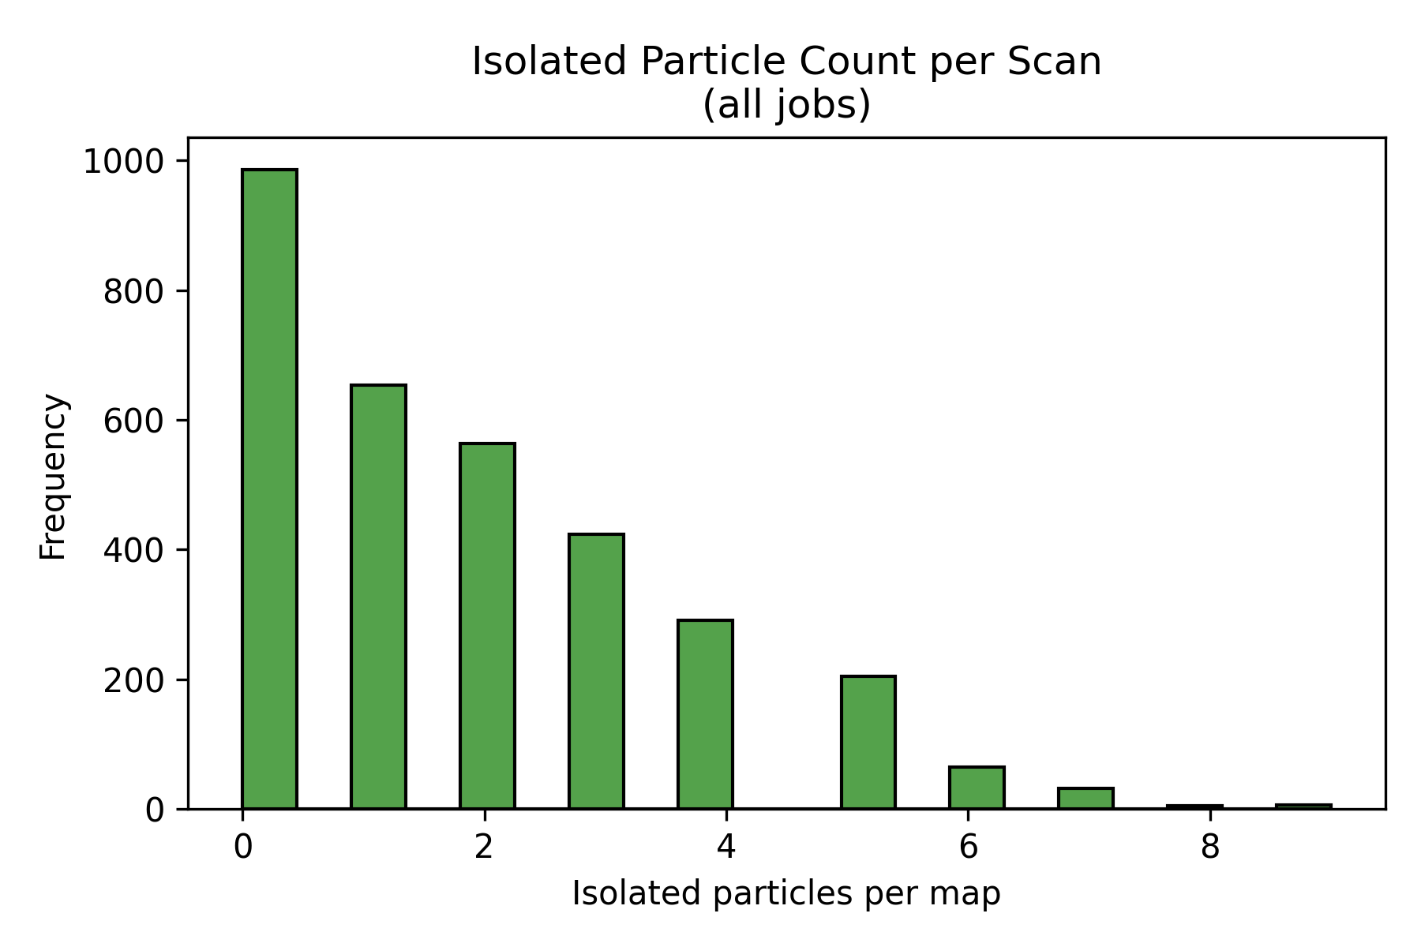
Figure 6.5 - Histograms of isolated-particle counts per scan for the primary route, separated by 10 wt% and 25 wt% SiNP.
Source: C:\Users\Conor O'Brien\Dropbox\03_AML\00 IN-BOX\AFM Topo Particle processing OUT\run_grains_full_wt10_20260304_145519\fig_isolated_count_hist.png
Source: C:\Users\Conor O'Brien\Dropbox\03_AML\00 IN-BOX\AFM Topo Particle processing OUT\run_grains_full_wt25_20260304_145519\fig_isolated_count_hist.png
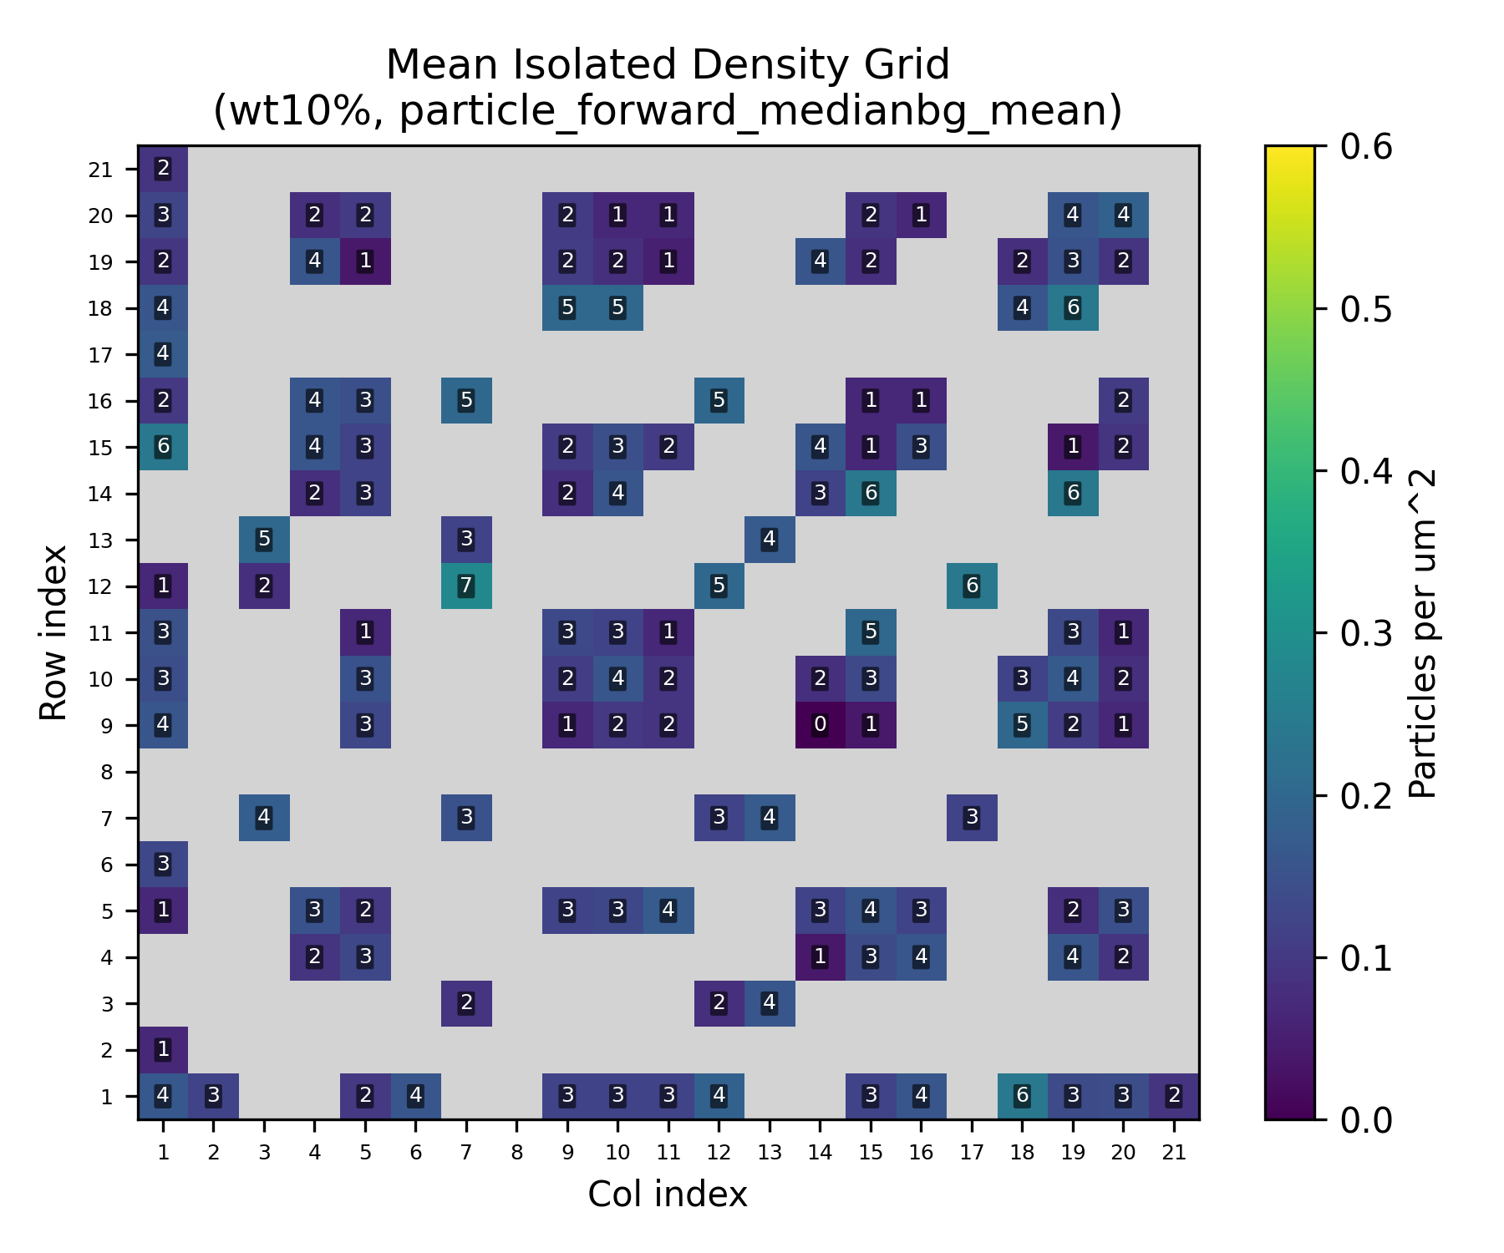
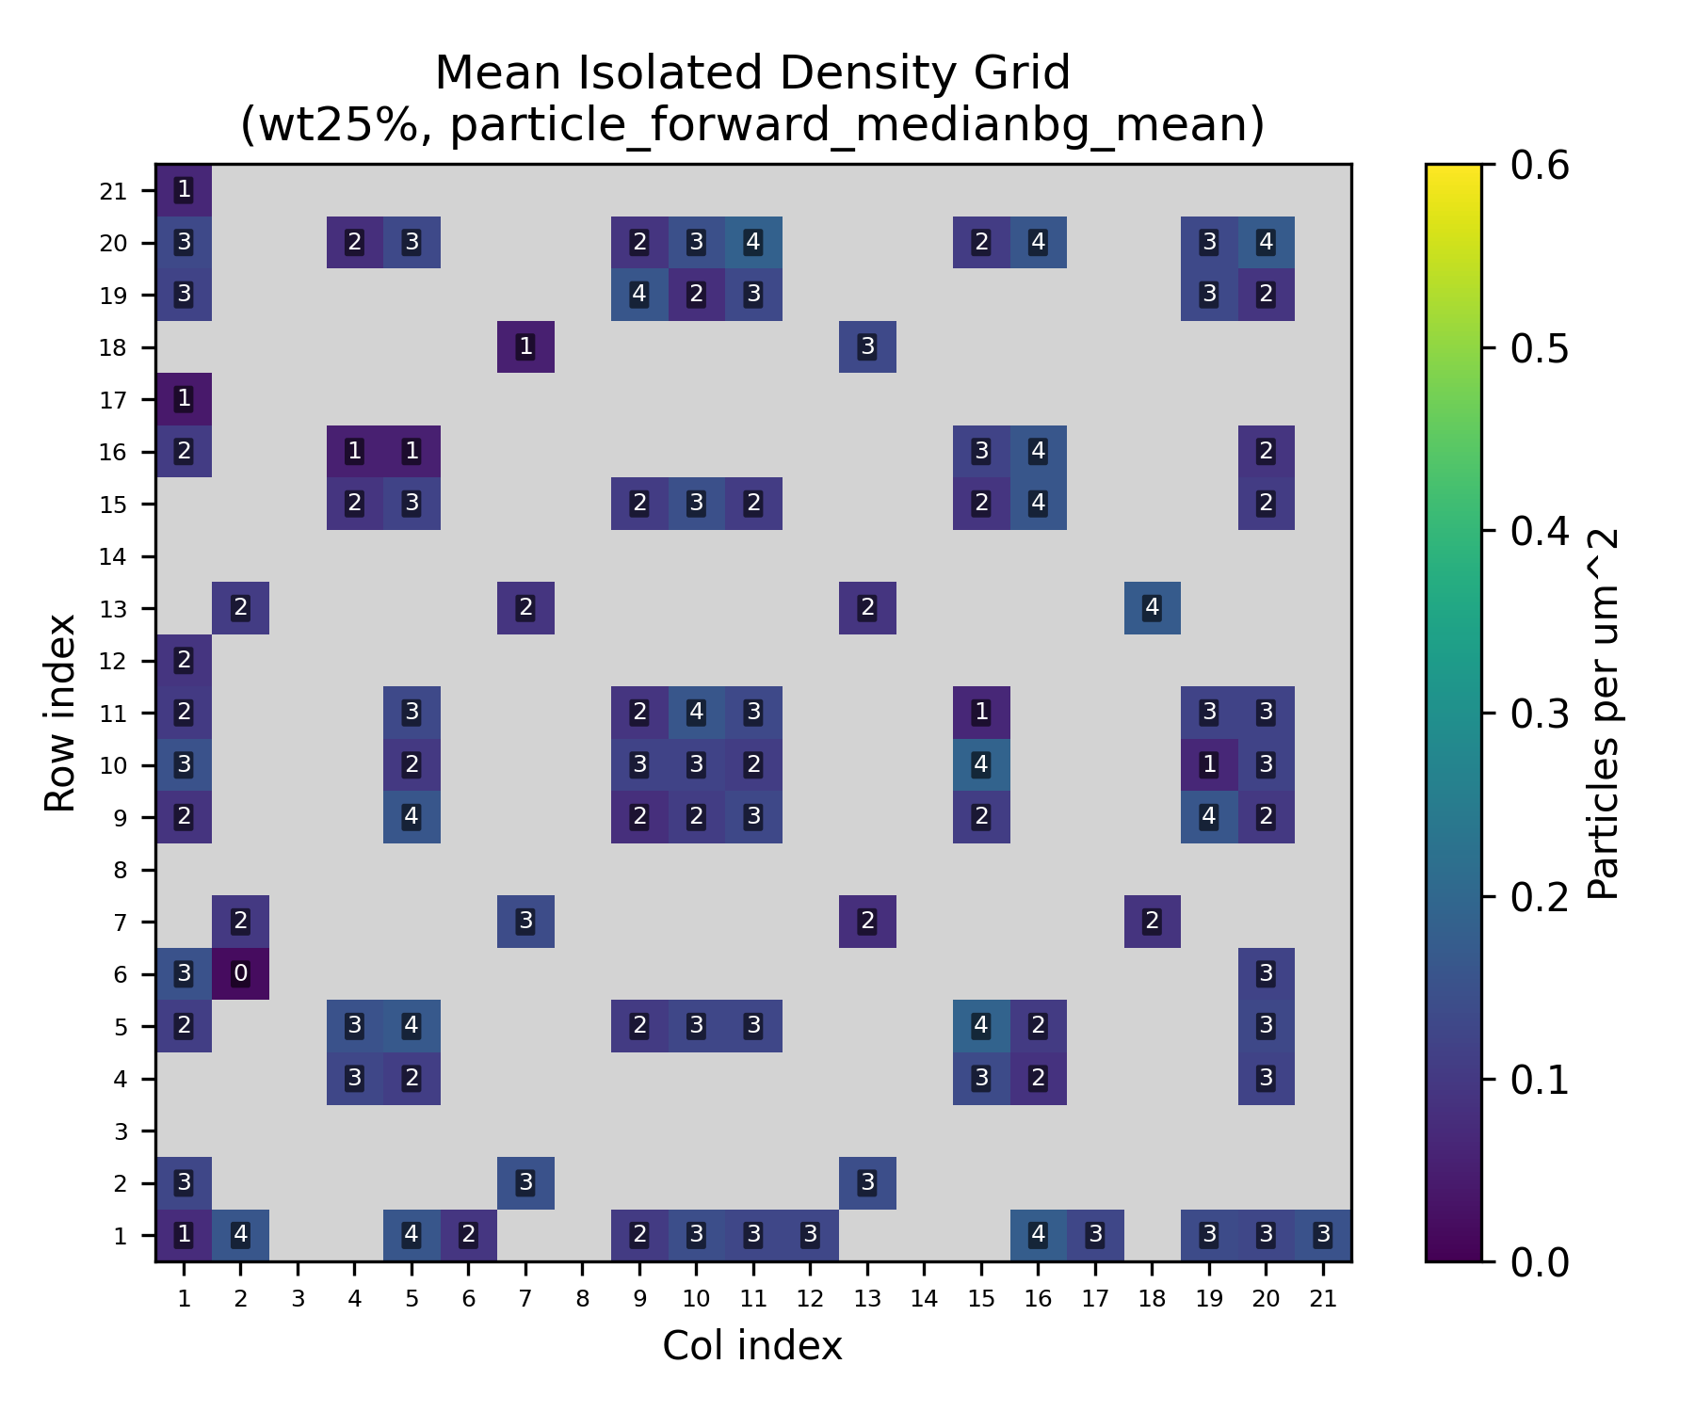
Figure 6.6 - Isolated-particle grid heatmaps for the primary route, separated by SiNP loading.
Source: C:\Users\Conor O'Brien\Dropbox\03_AML\00 IN-BOX\AFM Topo Particle processing OUT\run_grains_full_wt10_20260304_145519\summary_outputs\combined\fig_isolated_count_grid_wt10_particle_forward_medianbg_mean.png
Source: C:\Users\Conor O'Brien\Dropbox\03_AML\00 IN-BOX\AFM Topo Particle processing OUT\run_grains_full_wt25_20260304_145519\summary_outputs\combined\fig_isolated_count_grid_wt25_particle_forward_medianbg_mean.png
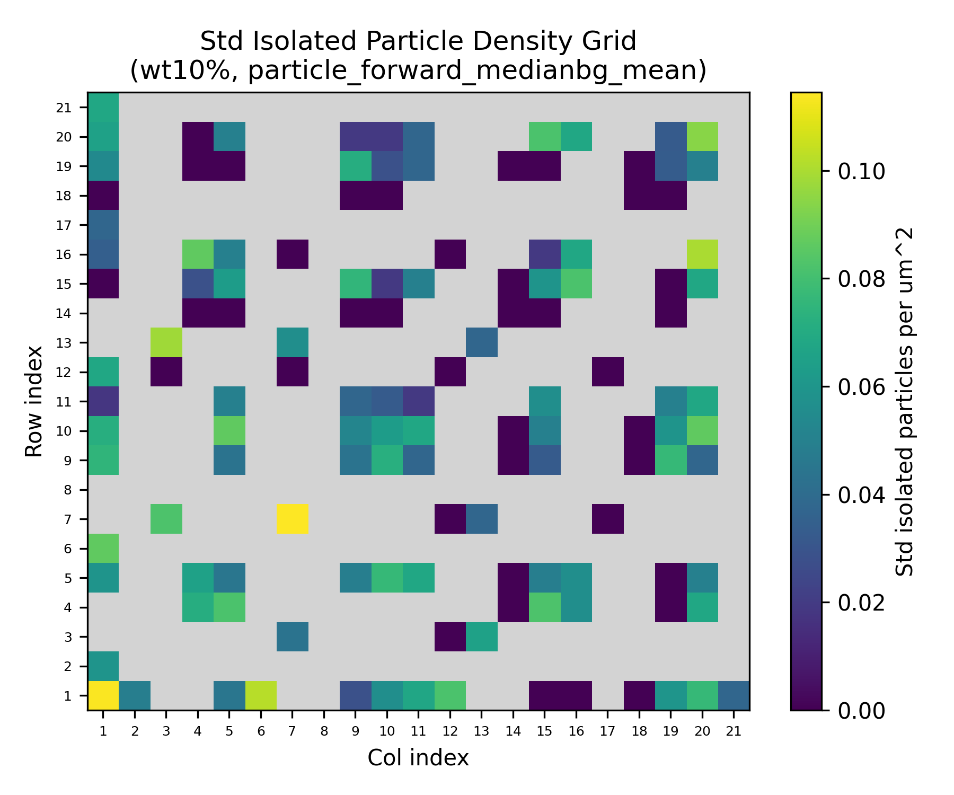
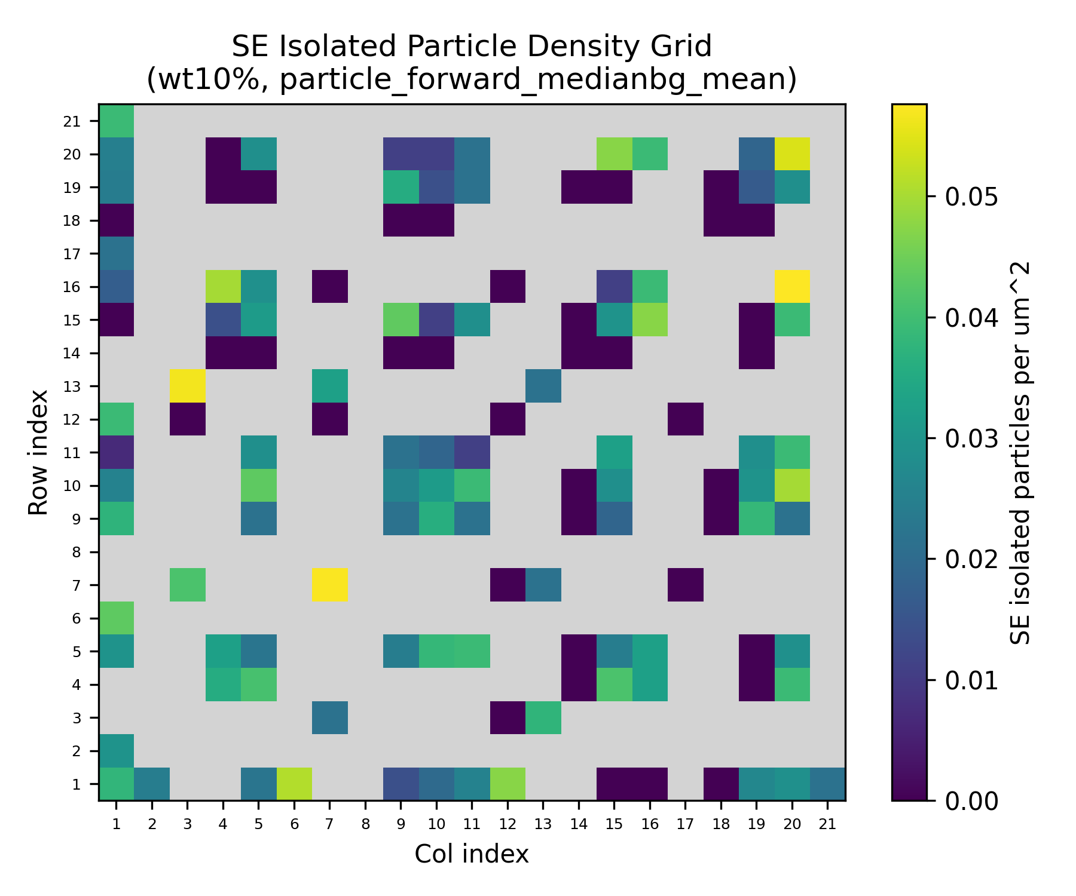
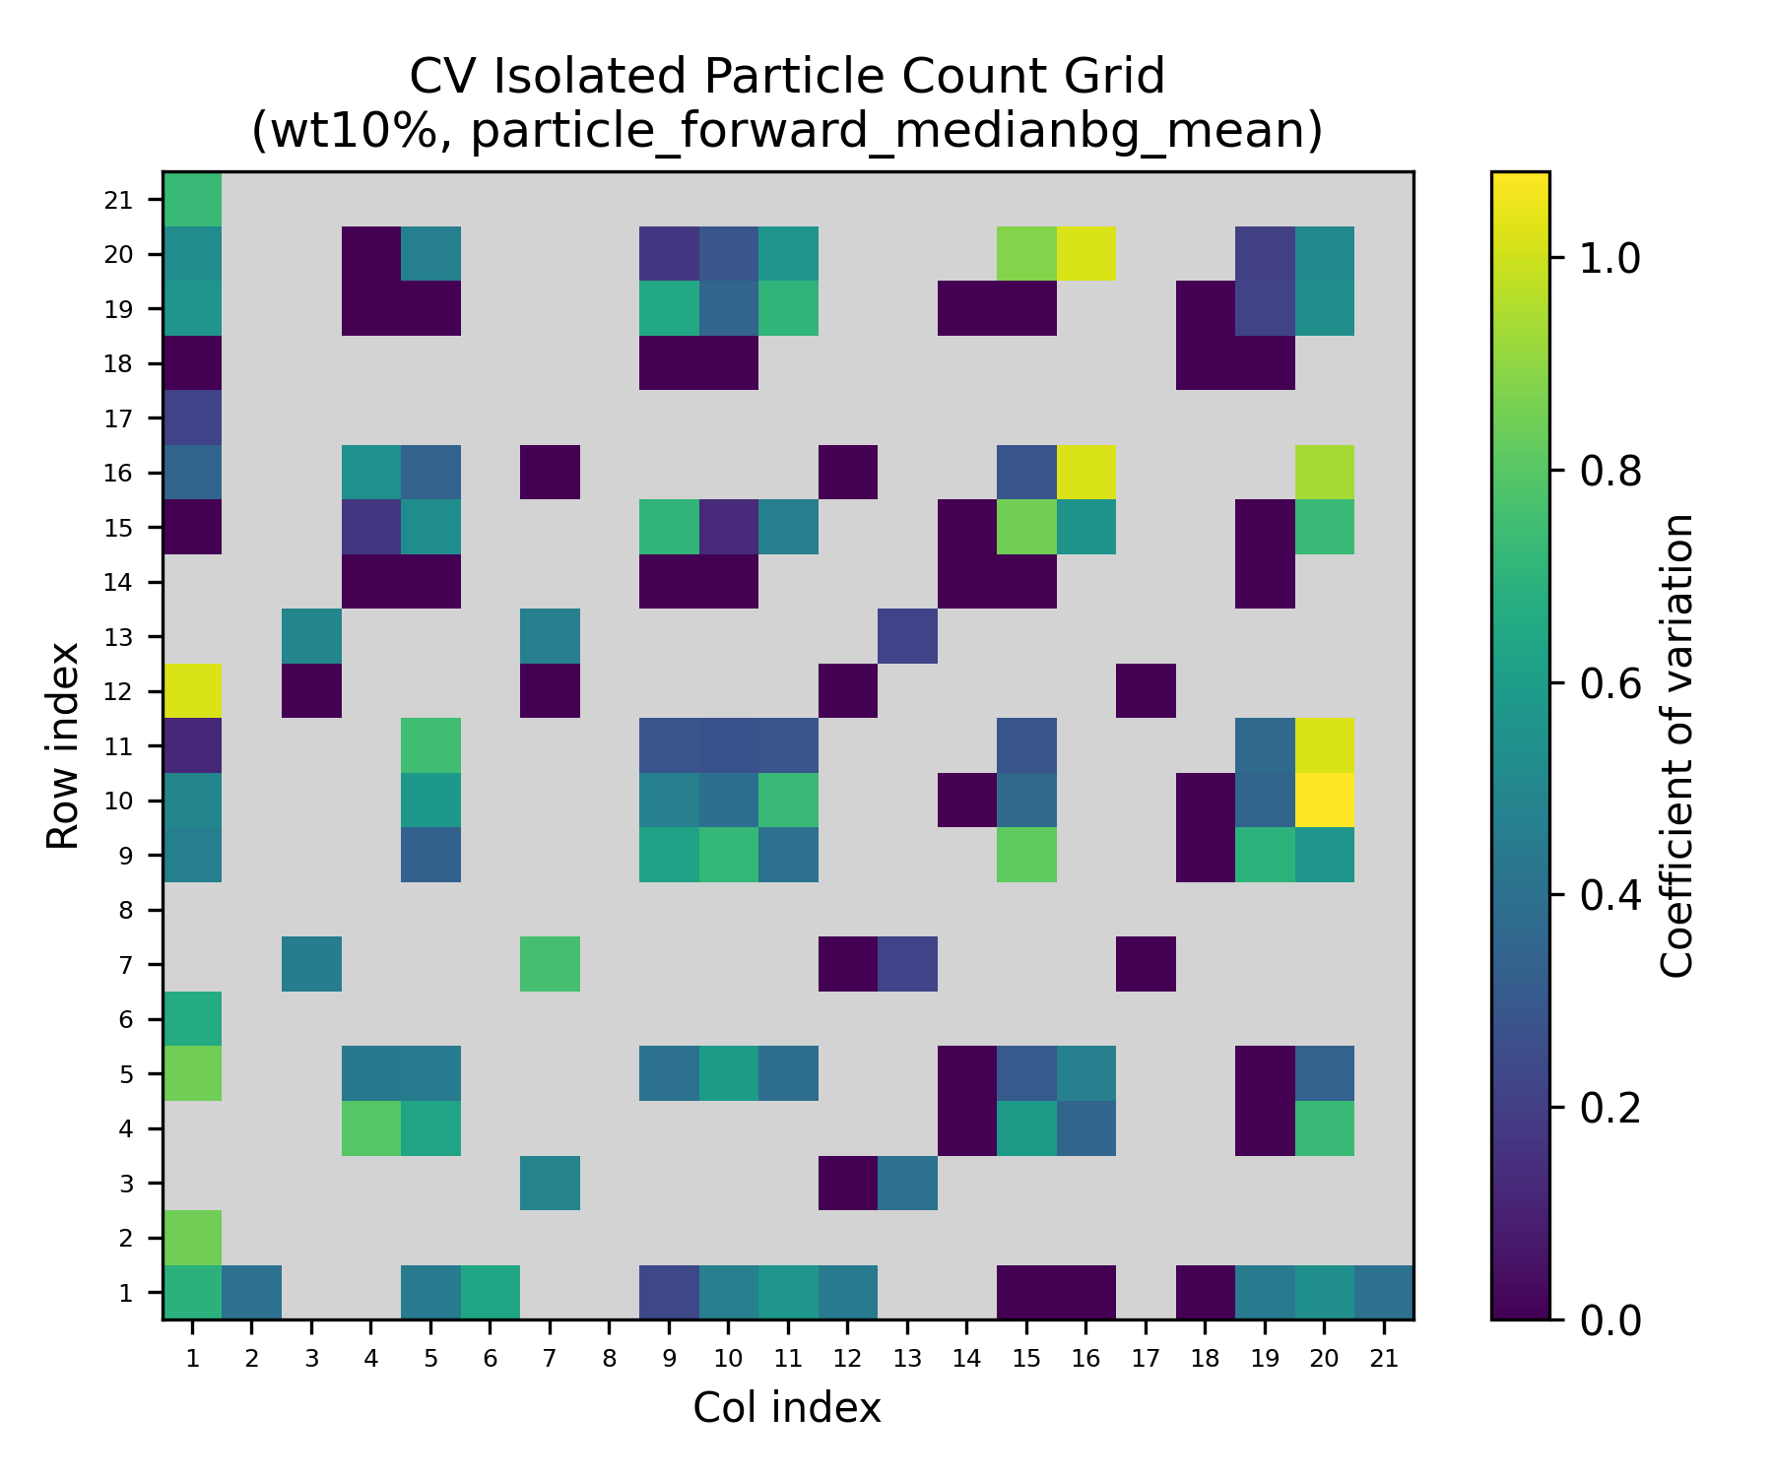

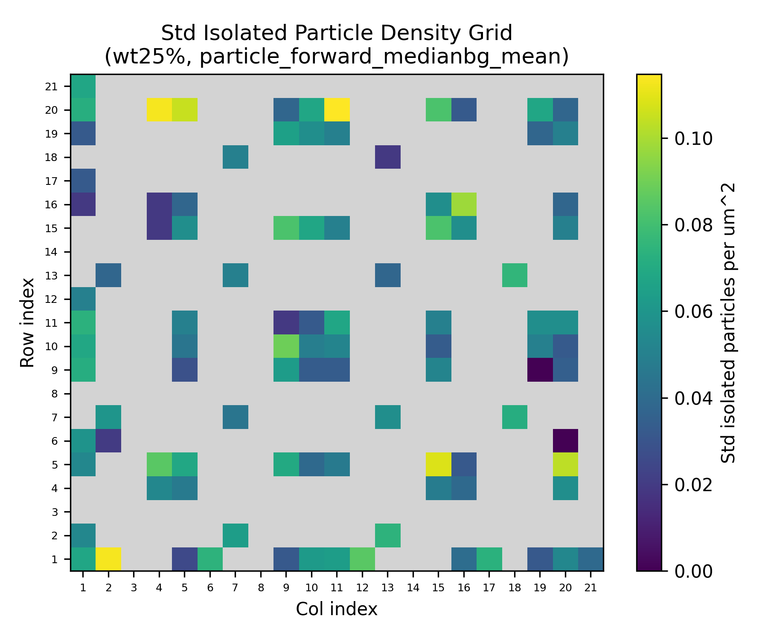
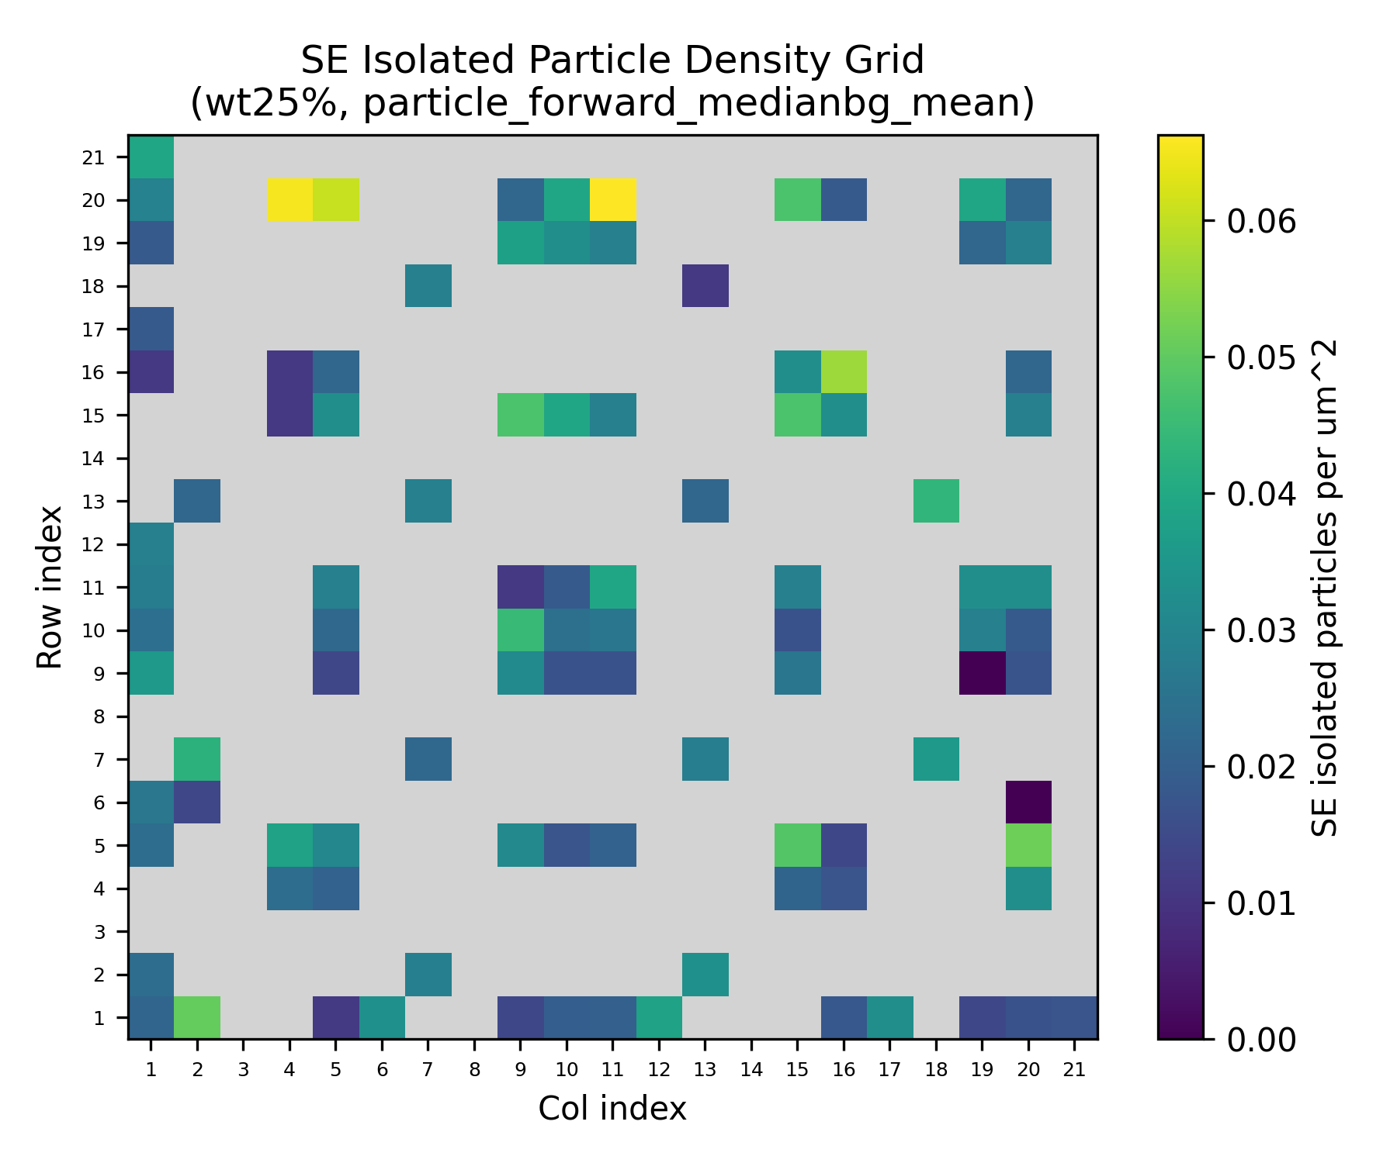
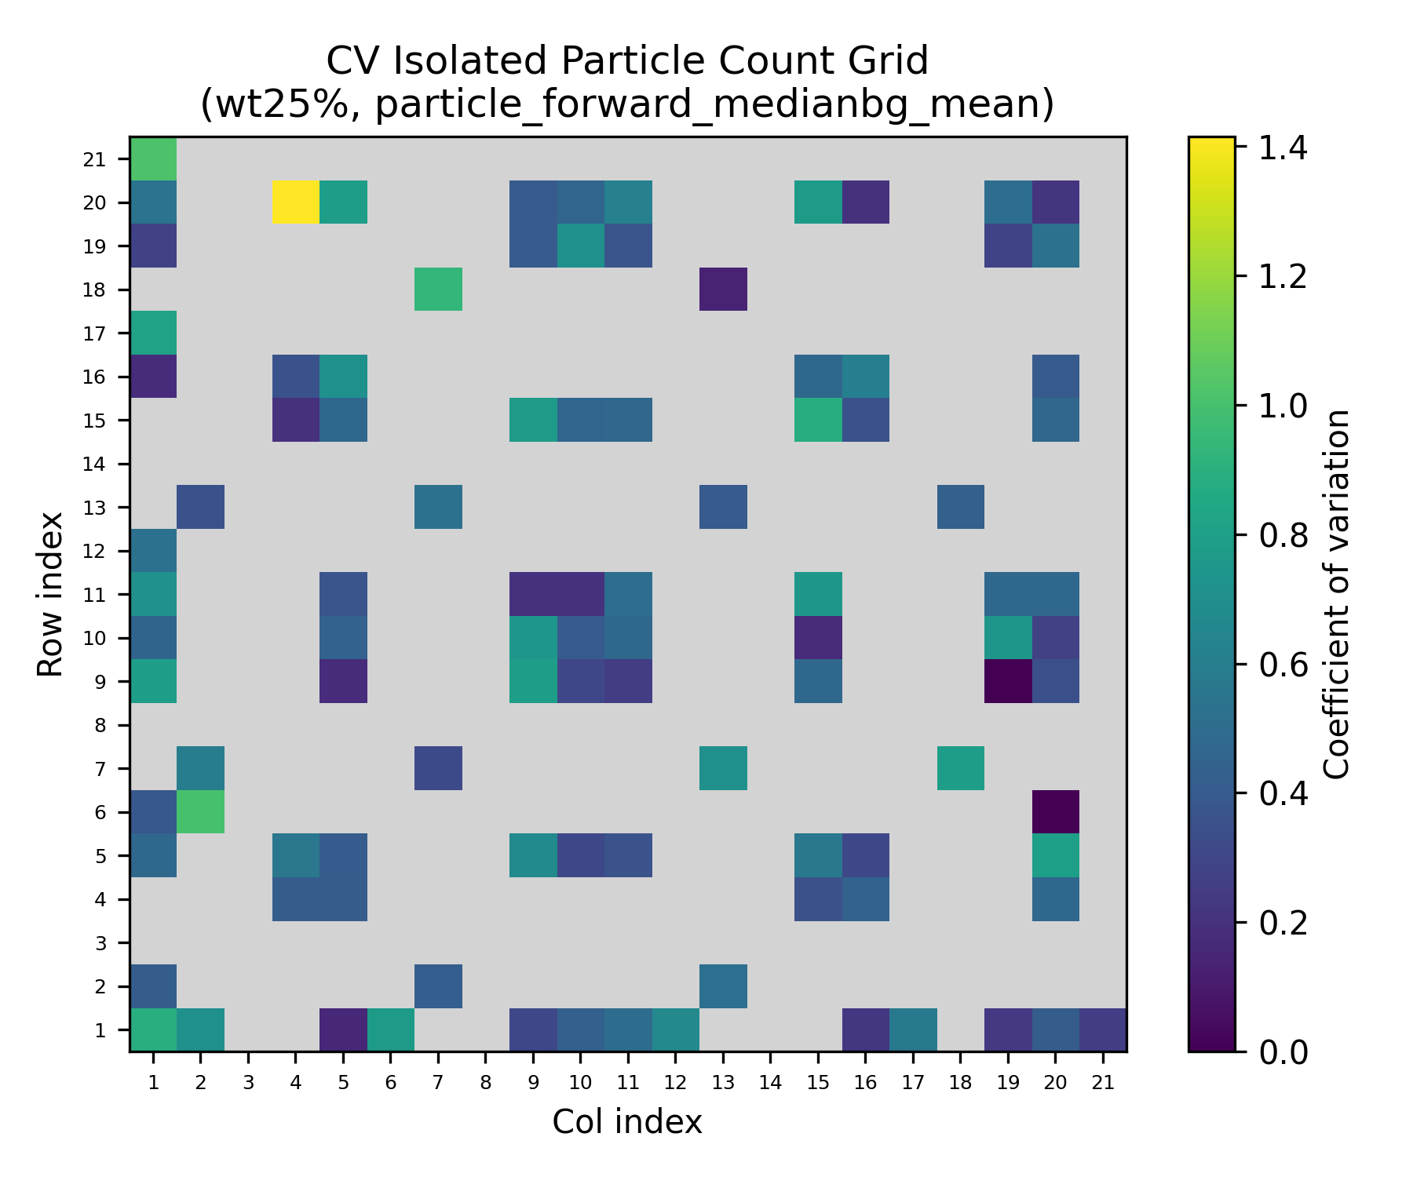

Figure 6.6b - Empirical uncertainty companions for the mean isolated-particle heatmaps under the primary route. These maps separate between-sample spread (std), uncertainty in the mean estimate (SE), normalized variability (CV), and spatial coverage (n contributing sample sets).
Source: C:\Users\Conor O'Brien\Dropbox\03_AML\00 IN-BOX\AFM Topo Particle processing OUT\run_grains_full_wt10_20260304_145519\summary_outputs\combined\fig_isolated_count_grid_std_wt10_particle_forward_medianbg_mean.png
Source: C:\Users\Conor O'Brien\Dropbox\03_AML\00 IN-BOX\AFM Topo Particle processing OUT\run_grains_full_wt10_20260304_145519\summary_outputs\combined\fig_isolated_count_grid_se_wt10_particle_forward_medianbg_mean.png
Source: C:\Users\Conor O'Brien\Dropbox\03_AML\00 IN-BOX\AFM Topo Particle processing OUT\run_grains_full_wt10_20260304_145519\summary_outputs\combined\fig_isolated_count_grid_cv_wt10_particle_forward_medianbg_mean.png
Source: C:\Users\Conor O'Brien\Dropbox\03_AML\00 IN-BOX\AFM Topo Particle processing OUT\run_grains_full_wt10_20260304_145519\summary_outputs\combined\fig_particle_count_grid_n_wt10_particle_forward_medianbg_mean.png
Source: C:\Users\Conor O'Brien\Dropbox\03_AML\00 IN-BOX\AFM Topo Particle processing OUT\run_grains_full_wt25_20260304_145519\summary_outputs\combined\fig_isolated_count_grid_std_wt25_particle_forward_medianbg_mean.png
Source: C:\Users\Conor O'Brien\Dropbox\03_AML\00 IN-BOX\AFM Topo Particle processing OUT\run_grains_full_wt25_20260304_145519\summary_outputs\combined\fig_isolated_count_grid_se_wt25_particle_forward_medianbg_mean.png
Source: C:\Users\Conor O'Brien\Dropbox\03_AML\00 IN-BOX\AFM Topo Particle processing OUT\run_grains_full_wt25_20260304_145519\summary_outputs\combined\fig_isolated_count_grid_cv_wt25_particle_forward_medianbg_mean.png
Source: C:\Users\Conor O'Brien\Dropbox\03_AML\00 IN-BOX\AFM Topo Particle processing OUT\run_grains_full_wt25_20260304_145519\summary_outputs\combined\fig_particle_count_grid_n_wt25_particle_forward_medianbg_mean.png

6.3.2 Required Scans for 95% Confidence
Using the Poisson baseline fit, a target of 30 isolated particles, and 95% confidence, the primary route required 13 scans for 10 wt% SiNP and 13 scans for 25 wt% SiNP. Both analyzed inventories greatly exceed those requirements.
In Table 6.5, primary lambda is the mean isolated-particle count per scan under the primary route. The observed zero-isolated rate is the empirical fraction of scans with zero isolated particles. The required-scan value is the smallest number of scans for which the modeled probability of obtaining at least 30 isolated particles reaches 95%.
Table 6.6 - Required scans for isolated-particle sufficiency under the primary route
System | Primary lambda | Observed zero-isolated rate | Required scans (95%) | Available scans
10 wt% SiNP | 3.203 | 10.2% | 13 | 386
25 wt% SiNP | 3.181 | 3.8% | 13 | 404

6.4 Grain Metrics
Grain exports are now available for the full method matrix. These do not replace particle or isolation statistics, but they strengthen the segmentation-quality discussion and provide an additional diameter-based consistency check.
Table 6.7 - Grain summary across the full method matrix
System | Method | Grain total | Grain kept | Grain isolated | Kept diameter mean +/- std | Isolated diameter mean +/- std
10 wt% SiNP | Median BG + mean threshold | 430288 | 3796 | 1198 | 433.36 +/- 56.48 nm | 432.64 +/- 57.56 nm
10 wt% SiNP | Median BG + fixed 0 | 395902 | 3125 | 1179 | 433.69 +/- 56.73 nm | 433.11 +/- 57.25 nm
10 wt% SiNP | Median BG + p95 threshold | 373604 | 2586 | 1051 | 432.23 +/- 56.61 nm | 428.74 +/- 56.29 nm
10 wt% SiNP | Median BG + fixed 0 + p95 | 373604 | 2586 | 1051 | 432.23 +/- 56.61 nm | 428.74 +/- 56.29 nm
10 wt% SiNP | Flatten + mean threshold | 261027 | 553 | 377 | 428.71 +/- 55.48 nm | 429.11 +/- 54.22 nm
10 wt% SiNP | Flatten + fixed 0 | 263884 | 516 | 350 | 428.23 +/- 56.06 nm | 428.92 +/- 54.61 nm
10 wt% SiNP | Flatten + p95 threshold | 259300 | 548 | 370 | 429.71 +/- 56.80 nm | 431.05 +/- 55.80 nm
10 wt% SiNP | Flatten + fixed 0 + p95 | 259283 | 547 | 369 | 429.52 +/- 56.68 nm | 430.77 +/- 55.61 nm
25 wt% SiNP | Median BG + mean threshold | 246321 | 3724 | 1230 | 440.77 +/- 57.48 nm | 438.06 +/- 57.67 nm
25 wt% SiNP | Median BG + fixed 0 | 236342 | 3718 | 1275 | 443.21 +/- 57.61 nm | 439.50 +/- 57.35 nm
25 wt% SiNP | Median BG + p95 threshold | 230737 | 2852 | 1053 | 443.69 +/- 58.19 nm | 438.44 +/- 57.55 nm
25 wt% SiNP | Median BG + fixed 0 + p95 | 230737 | 2852 | 1053 | 443.69 +/- 58.19 nm | 438.44 +/- 57.55 nm
25 wt% SiNP | Flatten + mean threshold | 81650 | 469 | 335 | 433.49 +/- 56.27 nm | 435.98 +/- 57.46 nm
25 wt% SiNP | Flatten + fixed 0 | 82805 | 451 | 323 | 434.11 +/- 56.86 nm | 435.48 +/- 57.26 nm
25 wt% SiNP | Flatten + p95 threshold | 76038 | 465 | 342 | 431.87 +/- 55.25 nm | 433.57 +/- 55.61 nm
25 wt% SiNP | Flatten + fixed 0 + p95 | 76009 | 463 | 340 | 431.80 +/- 55.35 nm | 433.48 +/- 55.76 nm
[MISSING FIGURE] Figure 6.7 - Full-method grain diameter summaries for PEGDA, 1 wt% TPO, no coating, separated by 10 wt% and 25 wt% SiNP. Bar plots show method-wise mean +/- standard deviation; box plots show the corresponding diameter distributions.

6.5 Processing Route Sensitivity
The practical sensitivity question is not whether the processing routes produce visually different maps, but whether they materially change isolated-particle yield and therefore the number of scans needed for Stage 1 sufficiency. Relative to the primary route, the comparison route (particle_forward_flatten_mean) reduced mean isolated yield from 3.10 +/- 1.82 to 0.98 +/- 1.17 per scan in 10 wt% SiNP and from 3.04 +/- 1.70 to 0.83 +/- 1.05 per scan in 25 wt% SiNP. The corresponding 95% scan requirements increased from 13 to 28 scans and from 13 to 46 scans.
The full method table should be interpreted provisionally. A targeted post-generation verification identified a mask write-back issue in the thresholded particle-analysis path, so the full all-method matrix must be regenerated after that fix before any final claim is made about whether threshold variants truly collapse within a preprocessing family.
Table 6.8 - All-method comparison with loading-normalized isolation yield
System | Method | Job/profile | Mean isolated/scan | Std | Zero-isolated rate | Req. scans (95%) | Relative to primary | Isolated/scan/wt%
10 wt% SiNP | Median BG + mean threshold | particle_forward_medianbg_mean | 3.10 | 1.82 | 8.0% | 13 | 1.00x | 0.310
10 wt% SiNP | Median BG + fixed 0 | particle_forward_medianbg_fixed0 | 3.05 | 1.62 | 4.4% | 13 | 0.98x | 0.305
10 wt% SiNP | Median BG + p95 threshold | particle_forward_medianbg_p95 | 2.72 | 1.71 | 9.3% | 13 | 0.88x | 0.272
10 wt% SiNP | Median BG + fixed 0 + p95 | particle_forward_medianbg_max_fixed0_p95 | 2.72 | 1.71 | 9.3% | 13 | 0.88x | 0.272
10 wt% SiNP | Flatten + mean threshold | particle_forward_flatten_mean | 0.98 | 1.17 | 46.1% | 28 | 0.31x | 0.098
10 wt% SiNP | Flatten + fixed 0 | particle_forward_flatten_fixed0 | 0.91 | 1.16 | 49.5% | 28 | 0.29x | 0.091
10 wt% SiNP | Flatten + p95 threshold | particle_forward_flatten_p95 | 0.96 | 1.17 | 47.4% | 28 | 0.31x | 0.096
10 wt% SiNP | Flatten + fixed 0 + p95 | particle_forward_flatten_max_fixed0_p95 | 0.96 | 1.17 | 47.7% | 28 | 0.31x | 0.096
25 wt% SiNP | Median BG + mean threshold | particle_forward_medianbg_mean | 3.04 | 1.70 | 6.4% | 13 | 1.00x | 0.122
25 wt% SiNP | Median BG + fixed 0 | particle_forward_medianbg_fixed0 | 3.16 | 1.68 | 4.5% | 13 | 1.04x | 0.126
25 wt% SiNP | Median BG + p95 threshold | particle_forward_medianbg_p95 | 2.61 | 1.83 | 14.6% | 13 | 0.86x | 0.104
25 wt% SiNP | Median BG + fixed 0 + p95 | particle_forward_medianbg_max_fixed0_p95 | 2.61 | 1.83 | 14.6% | 13 | 0.86x | 0.104
25 wt% SiNP | Flatten + mean threshold | particle_forward_flatten_mean | 0.83 | 1.05 | 50.5% | 46 | 0.27x | 0.033
25 wt% SiNP | Flatten + fixed 0 | particle_forward_flatten_fixed0 | 0.80 | 1.00 | 50.2% | 46 | 0.26x | 0.032
25 wt% SiNP | Flatten + p95 threshold | particle_forward_flatten_p95 | 0.85 | 1.11 | 51.5% | 46 | 0.28x | 0.034
25 wt% SiNP | Flatten + fixed 0 + p95 | particle_forward_flatten_max_fixed0_p95 | 0.84 | 1.11 | 51.7% | 46 | 0.28x | 0.034
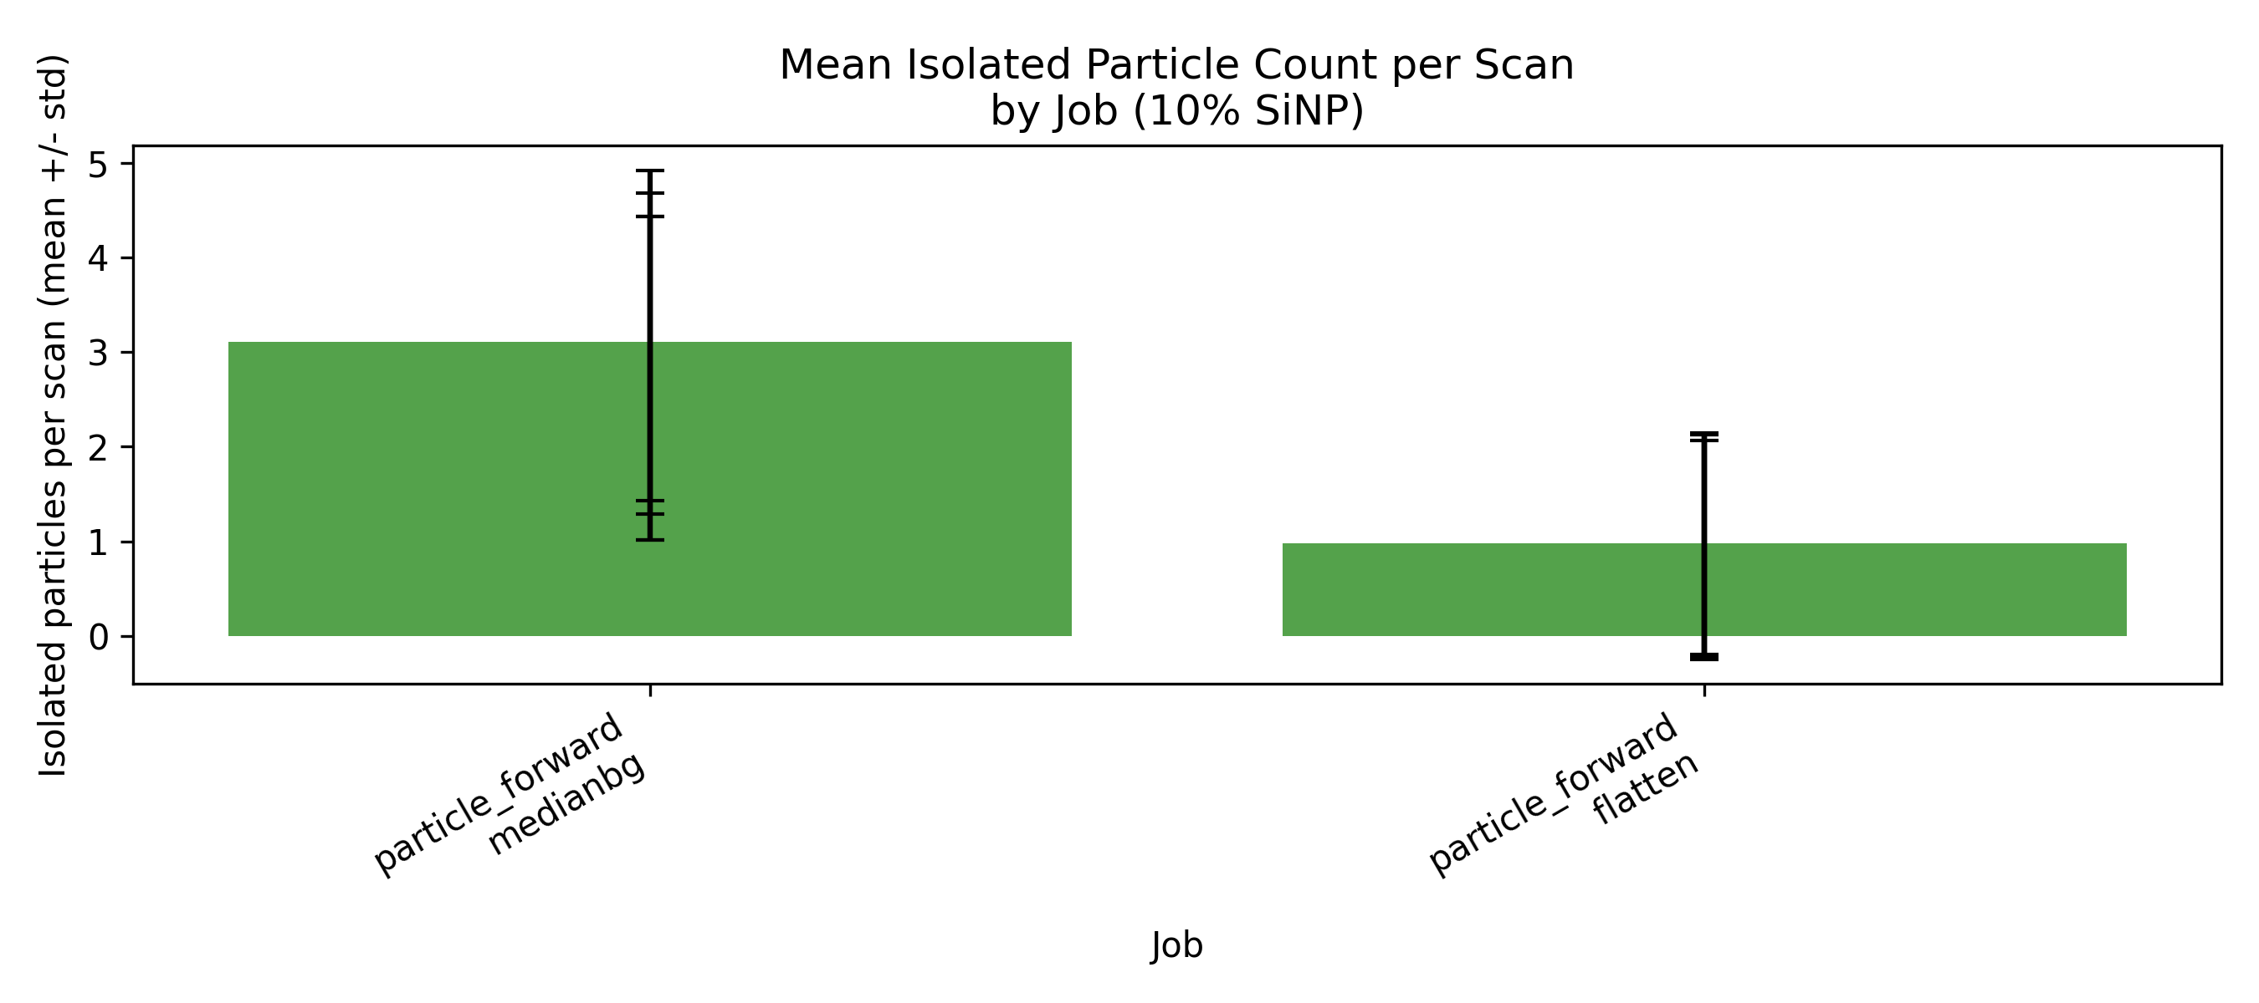
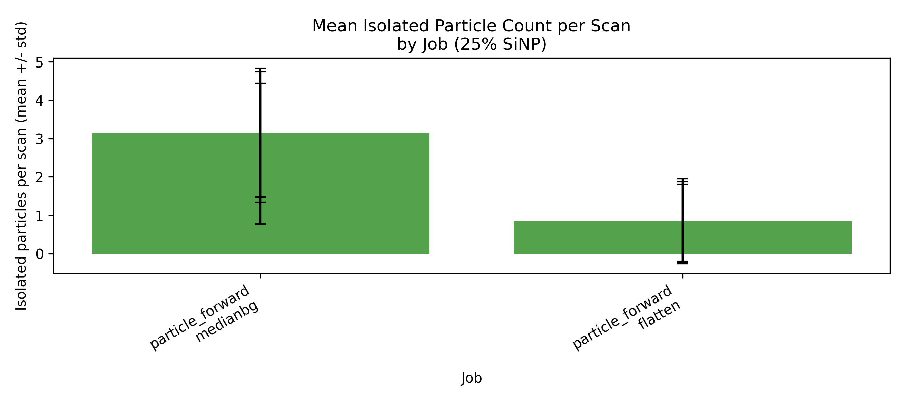
Figure 6.8 - Full-method comparison of mean isolated-particle yield by job and SiNP loading for PEGDA, 1 wt% TPO, no coating. These plots summarize how preprocessing and threshold choices affect isolated-particle yield.
Source: C:\Users\Conor O'Brien\Dropbox\03_AML\00 IN-BOX\AFM Topo Particle processing OUT\run_grains_full_wt10_20260304_145519\summary_outputs\compare_by_wt\fig_isolated_count_mean_by_job_10pct.png
Source: C:\Users\Conor O'Brien\Dropbox\03_AML\00 IN-BOX\AFM Topo Particle processing OUT\run_grains_full_wt25_20260304_145519\summary_outputs\compare_by_wt\fig_isolated_count_mean_by_job_25pct.png
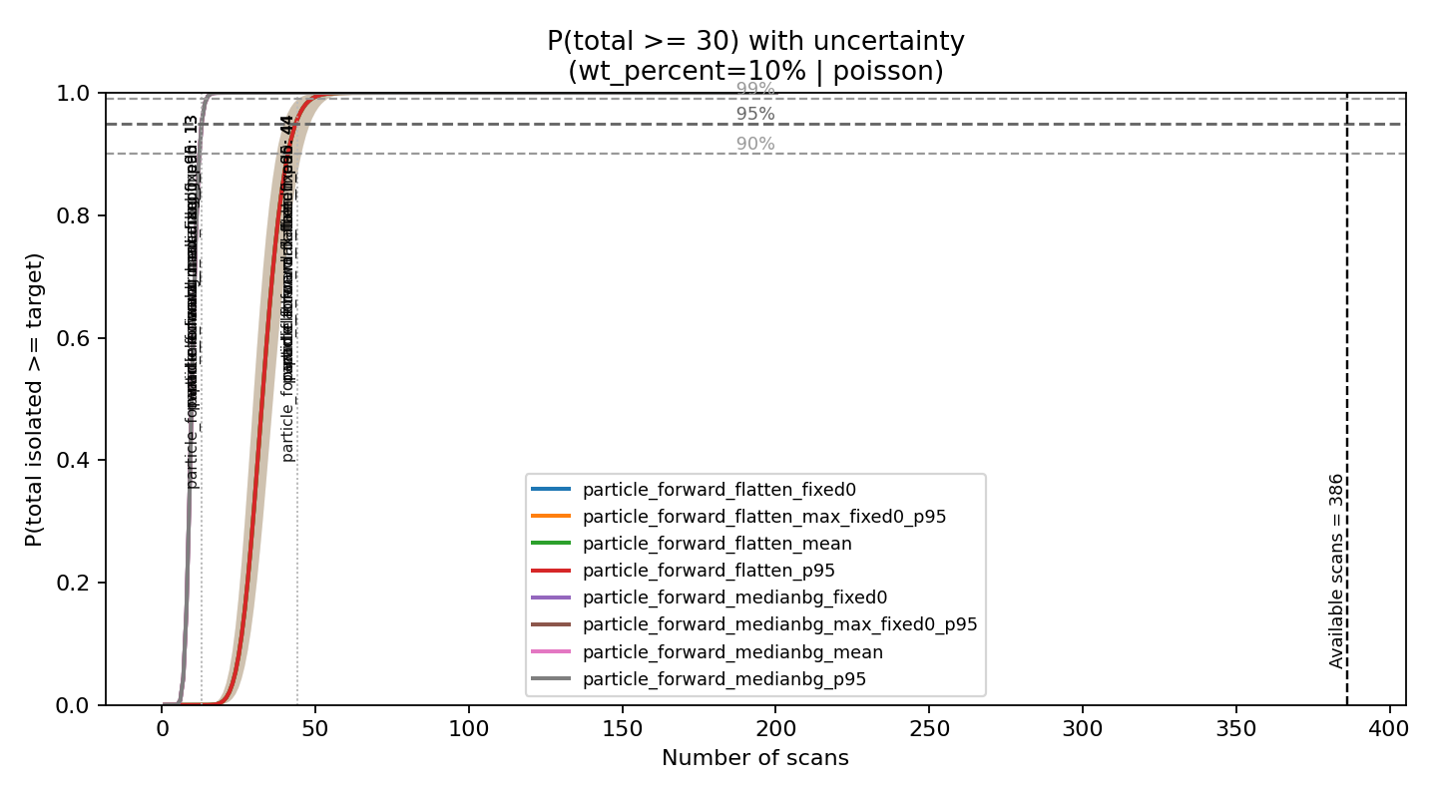
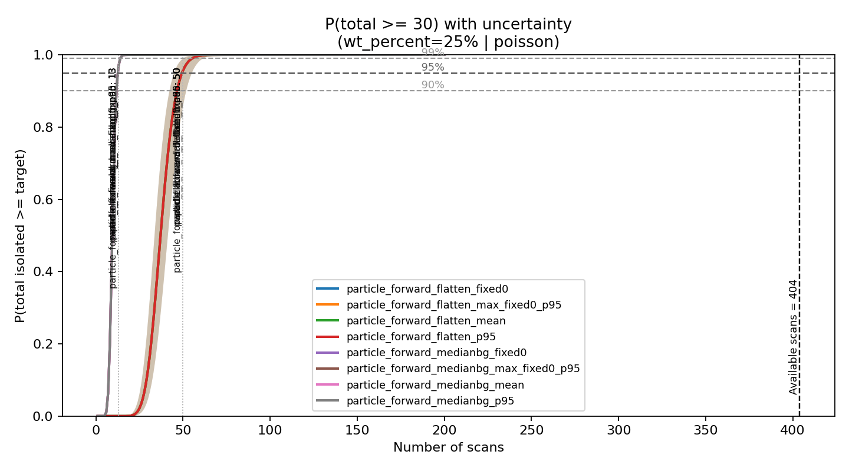
Figure 6.9 - Aggregate Poisson success-probability curves for all methods, separated by 10 wt% and 25 wt% SiNP. Horizontal dashed lines mark the 90%, 95%, and 99% success thresholds; vertical markers show the 95%-requirement scan count for each method.
Source: C:\Users\Conor O'Brien\Dropbox\03_AML\00 IN-BOX\AFM Topo Particle processing OUT\run_grains_full_wt10_20260304_145519\summary_outputs\fits\risk_aggregate_wt_percent_10_poisson.png
Source: C:\Users\Conor O'Brien\Dropbox\03_AML\00 IN-BOX\AFM Topo Particle processing OUT\run_grains_full_wt25_20260304_145519\summary_outputs\fits\risk_aggregate_wt_percent_25_poisson.png

6.6 Stage 2 Trigger / Crossover Decision
The Stage 2 trigger is expressed as a sensitivity study in confirmation probability p. The question is how far the confirmation rate could drop before the current Stage 1 scan pool would no longer meet the 30-particle, 95%-confidence target.
Figure 6.10 should be read as follows: the x-axis is the assumed fraction of Stage 1 isolated candidates that would later be confirmed as true particles in Stage 2, and the y-axis is the number of scans required to still achieve the Stage 2 target. The horizontal reference line is the number of scans already available. The crossover value p* is therefore the minimum confirmation fraction required for the currently available inventory to remain sufficient; it is not the probability that a crossover event occurs.
Table 6.9 - Minimum confirmation fraction p* required for the current scan inventory to remain sufficient
System | Primary lambda | Available scans | Minimum confirmation fraction p*
10 wt% SiNP | 3.203 | 386 | 0.032
25 wt% SiNP | 3.181 | 404 | 0.031
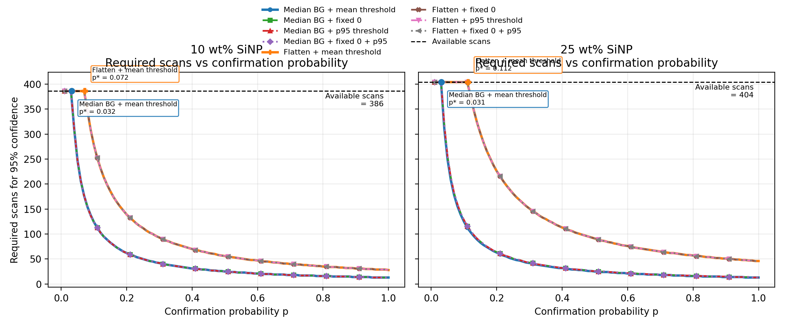
Figure 6.10 - Required scan count versus confirmation probability p across the full method matrix, with the available-scan inventory shown as a horizontal reference and labeled crossover points for the primary and comparison routes. PEGDA, 1 wt% TPO, no coating, separated by 10 wt% and 25 wt% SiNP.
Source: docs\Thesis\generated_assets\chapter6_crossover_by_method.png

6.7 Stage 1 Decision
For 10 wt% SiNP, candidate particle presence was confirmed, the retained diameter distribution remained consistent with the configured 350-550 nm size window, isolated particles occurred in 92.0% of scans under the primary route, and the analyzed inventory of 386 scans greatly exceeded the 13-scan requirement.
For 25 wt% SiNP, candidate particle presence was likewise confirmed, the retained diameter distribution remained acceptable, isolated particles occurred in 93.6% of scans under the primary route, and the analyzed inventory of 404 scans greatly exceeded the corresponding 13-scan requirement.
Stage 2 high-resolution interrogation is therefore justified for both loadings under the current Stage 1 interpretation. The comparative result is that higher loading increased candidate density modestly, but did not materially improve isolated-particle availability enough to change the decision.

6.8 Discussion and Limits
Discussion is appropriate here so long as it remains tied to measurement feasibility. At present the chapter supports two firm claims and one provisional claim. The firm claims are that isolated particles are available in sufficient number under the primary route and that higher loading does not automatically produce a higher yield of usable isolated targets. The provisional claim is the detailed threshold-variant comparison, which must be regenerated after the threshold-mask fix is propagated through the full dataset.
The remaining uncertainty is not whether isolated candidates exist, but what fraction of those candidates will be confirmed as true particles once Stage 2 multi-channel validation is performed. That is why the crossover figure belongs in this chapter: it converts Stage 2 from a vague next step into a quantitative decision threshold while keeping Stage 2 itself as a neutral unknown to be investigated rather than assumed.
A second discussion point is model justification. The current datasets are large enough that both 10 wt% and 25 wt% inventories substantially exceed the scan requirement for the immediate Stage 1 feasibility claim, even though the two loadings do not contain equal numbers of scans. That does not by itself prove that Poisson is the only appropriate count model; rather, it shows that the present inventories are comfortably above the threshold needed to estimate the isolated-particle rate for this decision problem.

