Modulus Baseline Validation Report
Generated: 2026-03-06 16:59
This report summarizes the baseline PEGDA modulus method-comparison results used to support Chapter 6, Section 6.1 (Baseline PEGDA Validation). Its purpose is to document forward/backward agreement, route consistency, and the practical basis for restricting the Stage 1 topography workflow to forward scans.
Table M1 - Baseline dataset context
Dataset | Baseline method | Scans | Units | Compare directory
Forward modulus baseline | modulus_gwy_stats | 107 | kPa | out\method_compare\compare_20260223_173256
Backward modulus baseline | modulus_gwy_stats | 107 | kPa | out\method_compare\compare_20260223_173335
Paired forward/backward summary | paired row/col matches | 5 |  | out\method_compare\fwd_bwd_20260223_173826
Table M2 - Forward method comparison summary
Method | Scans | Mean ratio vs baseline | Median ratio vs baseline | Mean delta avg | Mean delta n_valid
Gwyddion preprocess + Python stats | 105 | 0.910 | 0.996 | -1.284e+09 | 0.000e+00
Raw export + min/max filter | 105 | 0.910 | 0.996 | -1.284e+09 | 0.000e+00
Raw export + Chauvenet | 100 | 0.944 | 0.984 | -1.155e+08 | -4.901e+02
Raw export + 3-sigma | 98 | 0.950 | 0.975 | -6.602e+07 | -1.189e+03
Table M3 - Backward method comparison summary
Method | Scans | Mean ratio vs baseline | Median ratio vs baseline | Mean delta avg | Mean delta n_valid
Gwyddion preprocess + Python stats | 103 | 0.913 | 0.997 | -5.277e+08 | 0.000e+00
Raw export + min/max filter | 103 | 0.913 | 0.997 | -5.277e+08 | 0.000e+00
Raw export + Chauvenet | 99 | 0.936 | 0.984 | -1.543e+08 | -4.669e+02
Raw export + 3-sigma | 98 | 0.938 | 0.976 | -1.208e+08 | -1.142e+03
Table M4 - Paired forward/backward method agreement summary
Method | Pairs | Mean ratio (F/B) | Median ratio (F/B) | Mean delta avg (F-B) | Mean delta n_valid (F-B)
Forward/backward paired baseline | 99 | 2.181 | 1.000 | -8.004e+08 | -4.319e+03
Gwyddion preprocess + Python stats | 99 | 1.418 | 1.001 | 4.562e+06 | -4.319e+03
Raw export + min/max filter | 99 | 1.418 | 1.001 | 4.562e+06 | -4.319e+03
Raw export + Chauvenet | 91 | 1.419 | 1.000 | -4.069e+06 | -8.176e+03
Raw export + 3-sigma | 88 | 1.424 | 1.001 | 2.604e+06 | -1.126e+04
Interpretive note: the paired forward/backward table is the most direct basis for the forward-only selection used in the Stage 1 topography workflow. Values with median ratio near 1.0 indicate close directional agreement when matching scans by grid position.
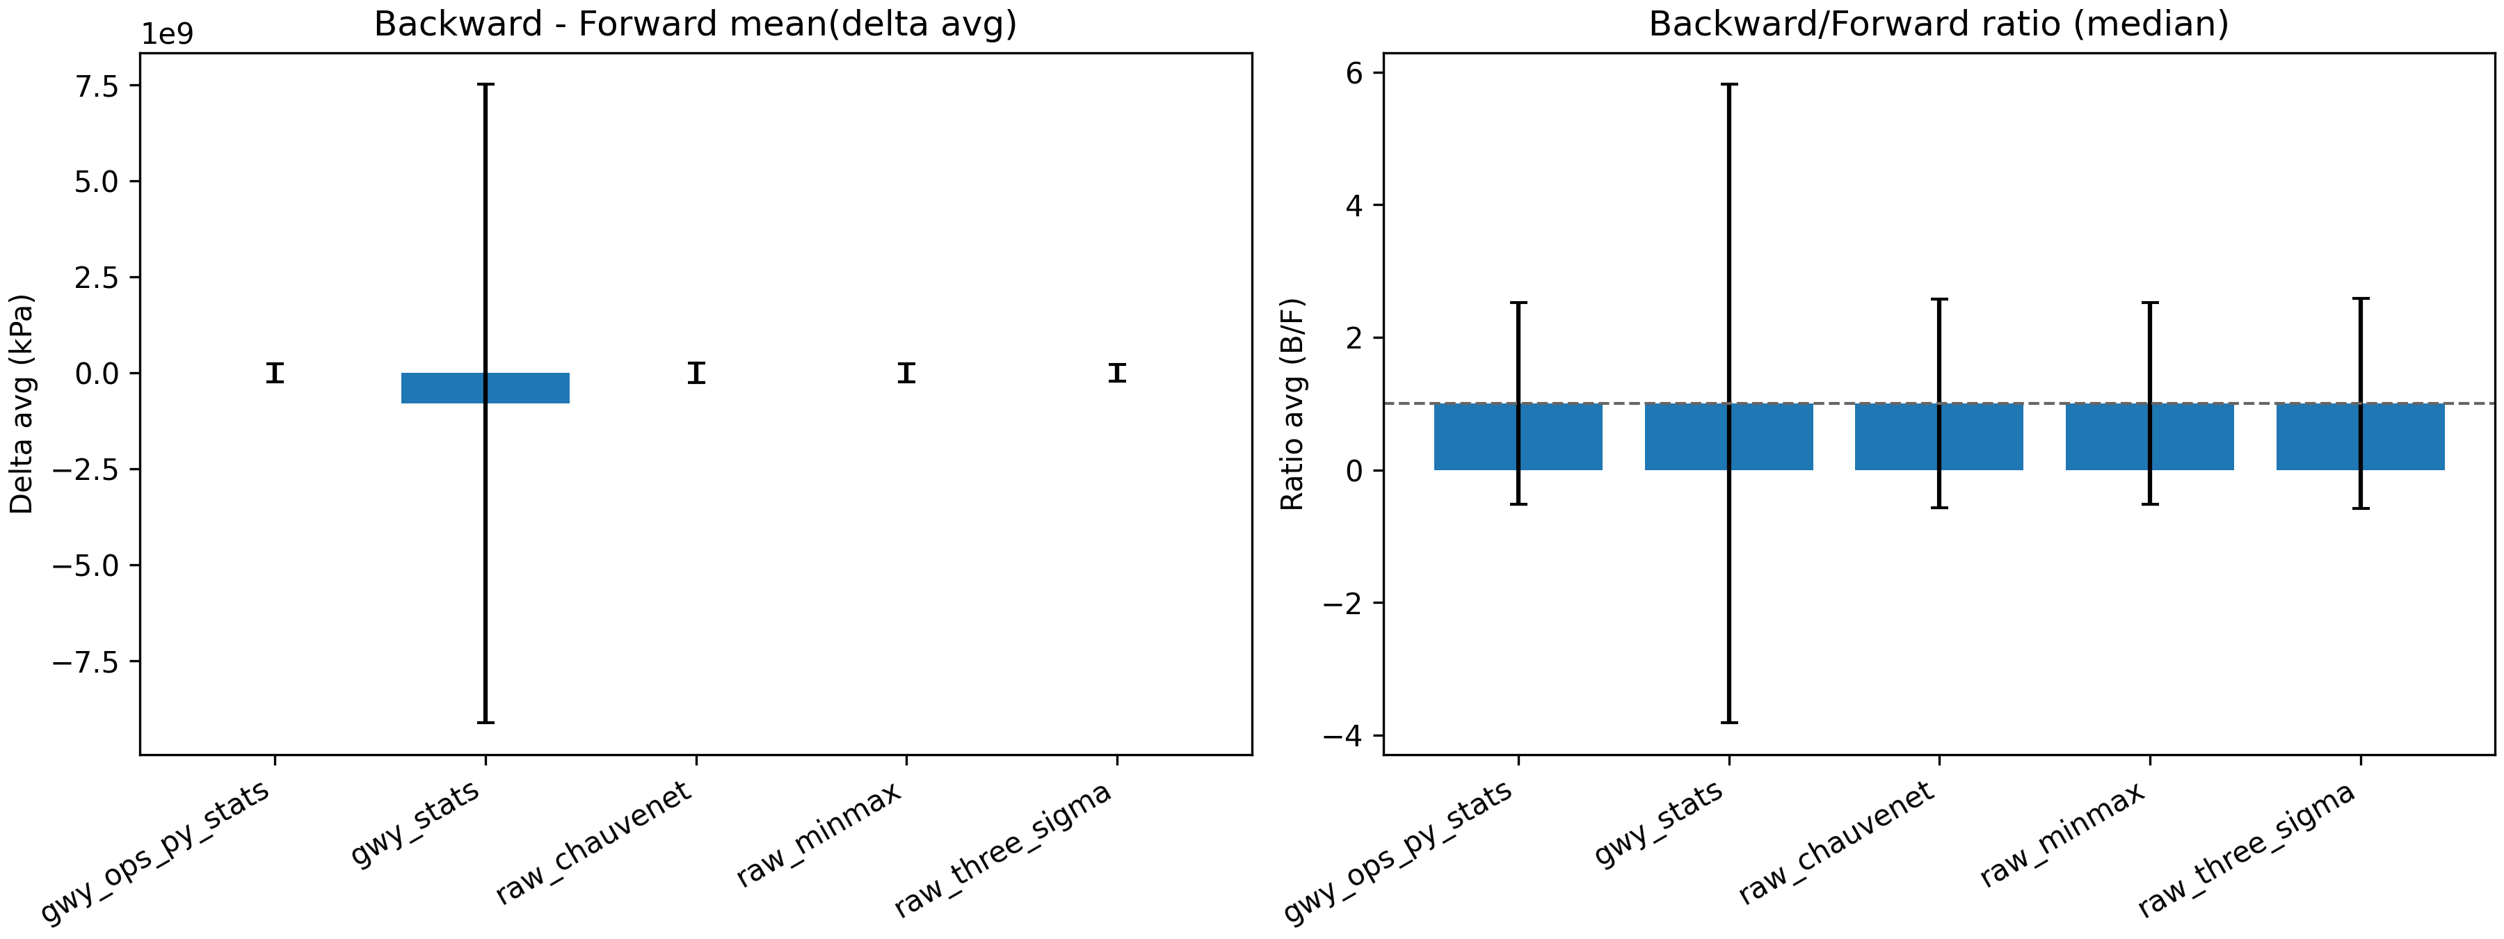
Figure M1 - Paired forward/backward modulus summary.
Source: out\method_compare\fwd_bwd_20260223_173826\plots\fwd_bwd_summary.png
Figure M2 - Forward modulus method comparison (grouped bar plot).
Source: out\method_compare\compare_20260223_173256\plots\avg_grouped_bar.png
Figure M3 - Backward modulus method comparison (grouped bar plot).
Source: out\method_compare\compare_20260223_173335\plots\avg_grouped_bar.png
Use in Chapter 6: this report supports the baseline PEGDA validation section by showing that the modulus workflow was internally consistent across route variants and that forward/backward directional differences were small enough to justify restricting the present Stage 1 topography workflow to forward scans.

