**Mill**

**Estate** submitted FFB to Mill. Our trial is in BINE (Bukit Intant Estate)

1 estate has several Division, e.g. BINE1, BINE2 ... 5

1 division has several Block, e.g. M25, M26 -> Alphabet + Number (matrix coord)

At 1 day, harvest area -> kadvel, several blocks in a division

Restan -> left over, in the morning, from yesterday not picked up yet

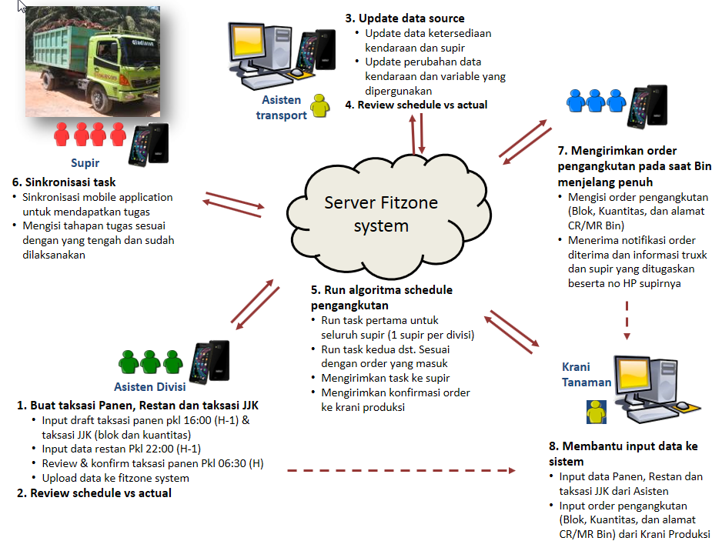

In db:

Job (fbJob)

Task (fbTask2)

1 job has 2 tasks:

1. Pick: Go from POOL / Mill to kadvel / blocks
2. Deliver: Go from kadvel / block to Mill

|  |  |
| --- | --- |
| User | Tech |
| Login jsp | Already exist |
| Main/main.jsp  Order | Web/ffbv3/main/main.jsp |
| Order jsp  Div: dropdown (BINE1 .. BINE5)  Location: between block [...] and [....]  Estm Bin Ready: [...]  [Order] | Web/ffbv3/order/order.jsp  Run(com.fz.ffbv3.service.order.OrderLogic)  Insert to fbJob,  doneStatus = ‘NEW’ |
|  |  |
|  |  |
|  |  |
|  |  |