DEVELOPER PORTFOLIO
Project Documentation

Building and Deploying a Laravel Portfolio Website
with Documented AI-Assisted Development

Russel Tristan L. Marzo
BS in Information Technology
Data Center College of the Philippines - Bangued

Integrative Programming
Instructor: Adrian D. Baruela
College of Information Technology Education
September 2026

1. Project Overview
This project is a personal developer portfolio website built with the Laravel PHP framework. It presents the professional profile of Russel Tristan L. Marzo, an Information Technology student at Data Center College of the Philippines - Bangued. The site displays the student's background, education, technical skills, certifications, and contact information in a clean, responsive single-page layout.
The project was developed as an individual activity for the Integrative Programming course under the direction of Instructor Adrian D. Baruela. Development followed a responsible AI-collaboration workflow: the Laravel project was scaffolded, coded, styled, debugged, and version-controlled with the help of an AI coding assistant (opencode model big-pickle), and every AI interaction was logged in PROMPT_LOG.md in the repository root, as required by the activity.
The final output is a working portfolio site deployed to live hosting, meeting the activity objectives of building a Laravel application, practicing incremental version control, documenting AI collaboration, deploying to public hosting, and producing professional documentation.
2. Features
The portfolio site includes the following sections:
- Hero section with profile introduction and status title
- About section with a short personal background
- Education section showing program, school, campus, and enrollment status
- Technical skills section with skill cards, progress bars, and level badges
- Certifications and eligibility display with status indicators (earned / processing)
- Contact section with clickable email, phone, and GitHub links
- Responsive navigation bar with smooth scroll-to-section links
- Fully responsive design across desktop and mobile viewports
- Custom CSS styling using design tokens (CSS custom properties)
3. Technology Stack
Technology | Role / Use
Laravel 13 (PHP) | Backend framework; MVC structure, routing, Blade templating
Blade Templates | Server-side rendering of the portfolio view
HTML5 / CSS3 | Page structure and custom styling
JavaScript | Interactive behaviors (progress bars, navigation)
MySQL | Sessions/cache on production hosting
XAMPP | Local development environment (Apache, PHP, MySQL)
Git & GitHub | Version control and repository hosting
InfinityFree | Live PHP/MySQL hosting for deployment
Composer | PHP dependency management

4. Laravel Implementation (MVC)
The application follows Laravel's Model-View-Controller architecture:
- Route (routes/web.php): The root URI "/" is registered and mapped to the index method of PortfolioController.
- Controller (app/Http/Controllers/PortfolioController.php): Holds all profile data - personal details, education, skills, and certifications - as PHP arrays, then returns the portfolio view with the data compacted.
- View (resources/views/portfolio.blade.php): A single Blade template that renders the hero, about, education, skills, certifications, and contact sections, styled with embedded CSS.

Data flows one way: the controller prepares the data arrays, passes them to the view with compact(), and the Blade template echoes them using Blade interpolation. The code runs without errors on PHP 8.5 and Laravel 13 locally and on shared hosting.
5. Git & GitHub Version Control
A git repository was initialized at the start of the project, and work was committed incrementally by feature, as required. No single "final upload" commit was made. The repository is hosted publicly at https://github.com/cobyRuss/portfolio.

Commit | Date | Description
Initial commit | 2026-09-04 | Initial repository seed
Set up Laravel project with default scaffolding | 2026-09-04 | Laravel framework scaffolded via Composer
Add PortfolioController with profile data and web route | 2026-09-04 | Controller data arrays and root route
Add portfolio Blade view | 2026-09-04 | Full portfolio view: hero, about, skills, certifications, contact
Add remaining Laravel app structure | 2026-09-04 | Views, tests, and asset scaffolding
Add AI assistant configuration files | 2026-09-04 | AGENTS.md / CLAUDE.md collaboration config
Add AI prompt log documenting development | 2026-09-04 | PROMPT_LOG.md with all AI interactions
Add root .htaccess and README | 2026-09-04 | InfinityFree routing rule and project README
Add console routes file | 2026-09-05 | routes/console.php for artisan commands
Update prompt log with SQLite debugging session | 2026-09-05 | Documented the database error fix

6. AI Collaboration Summary
The site was built in collaboration with an AI coding assistant (opencode, model big-pickle). Every prompt that shaped the project was recorded in PROMPT_LOG.md in the repository root, together with what the AI returned and what was done with the output. The following table summarizes the eight logged interactions, including one that required follow-up debugging - demonstrating an honest, iterative process.

Prompt | What the AI Produced | Outcome
1. Read the activity PDF | Extracted requirements and asked clarifying questions | Accepted
2. Provided personal info | Confirmed data and started project planning | Accepted
3. Set up Laravel project | Scaffolded project via composer (109 packages) | Accepted
4. Create portfolio controller | PortfolioController with profile/education/skills/certifications arrays | Accepted
5. Create routes | Root route mapped to PortfolioController@index | Accepted
6. Build portfolio view | Responsive Blade view with all five required sections and CSS | Accepted
7. Set up git | Initialized repo and made 5 incremental commits | Accepted
8. Debug SQLite error | Diagnosed missing database file; switched session/cache drivers | Accepted

All generated code was reviewed by the student and accepted as-is because the data structure matched the personal information provided, the code followed Laravel best practices, the design was clean and professional, and the git history was properly incremental. The final prompt is a real example of a debugging follow-up: the AI identified the missing SQLite database file and resolved it by creating the file and switching to file-based session/cache drivers.

7. Local Development Setup
- Clone the repository: git clone https://github.com/cobyRuss/portfolio.git
- Install PHP dependencies: composer install
- Create environment file: copy .env.example to .env
- Generate the application key: php artisan key:generate
- Start the development server: php artisan serve
- Open the printed URL (e.g., http://127.0.0.1:8000) in a browser

Note: During development the default database session driver caused an error because no SQLite file existed. The .env was updated to SESSION_DRIVER=file, QUEUE_CONNECTION=sync, and CACHE_STORE=file, which resolved the error. No database is required for the portfolio itself; MySQL is used only for sessions and cache in production.
8. Deployment to InfinityFree
- Create an InfinityFree account and set up a PHP hosting account.
- Upload all project files EXCEPT vendor/ and node_modules/ to the htdocs/ directory.
- Create a MySQL database through the InfinityFree control panel.
- Update .env with the production database credentials and the live APP_URL.
- Set APP_KEY (run php artisan key:generate on the server or set it manually).
- Ensure the root .htaccess routes requests to the public/ directory.
- Visit the assigned live URL to confirm the site loads without errors.

The live site matches the latest commit on the GitHub repository, so the deployment remains in sync with the committed source code.

9. Screenshots
Desktop (full page):
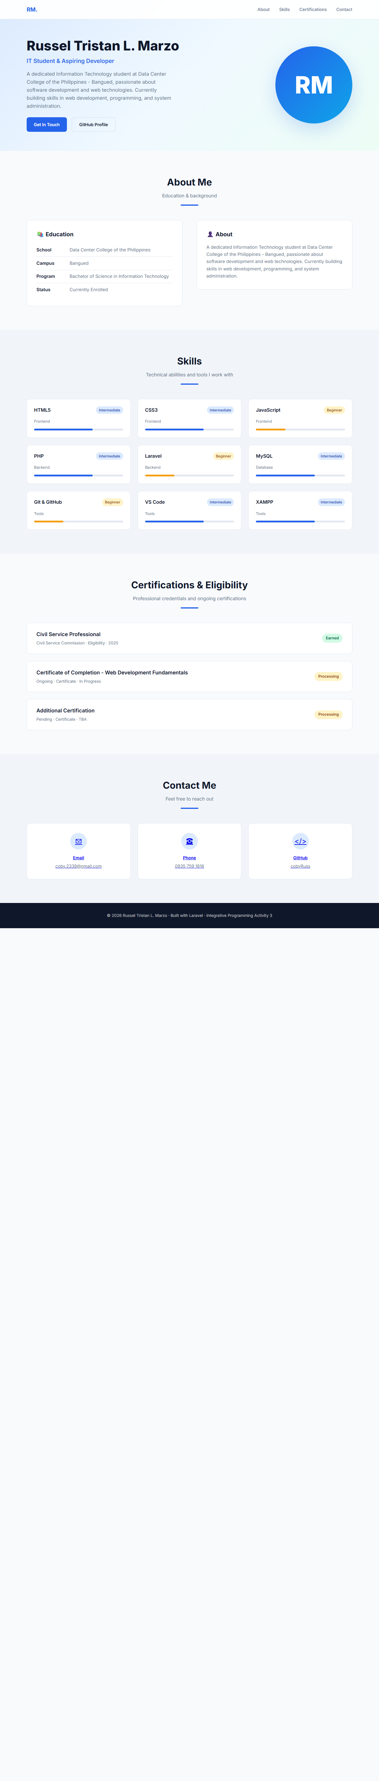

Mobile (responsive viewport):
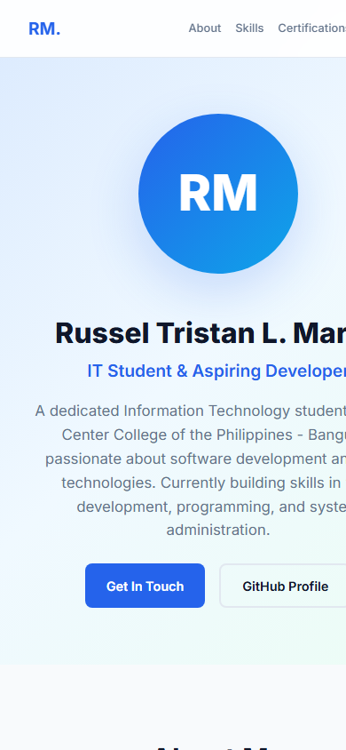

10. Conclusion
This activity produced a complete, working developer portfolio using the Laravel framework. The project satisfies all content requirements - profile picture/avatar, contact details, school and education, and skills and certifications - presented in a clean responsive design.
Beyond the website itself, the activity reinforced professional development practices: small and meaningful git commits with matching diffs, transparent documentation of AI-assisted work in PROMPT_LOG.md, and deployment to publicly reachable hosting. The experience demonstrated how an AI coding assistant can be used responsibly - as a planning, coding, and debugging partner whose contributions are documented, reviewed, and accepted or rejected by the student at each step.

---
Prepared by: Russel Tristan L. Marzo
Data Center College of the Philippines - Bangued

