2016

**Julia Coccia**

**CIS 512 Project**

**12/13/2016**

Tourism Industry of Florida

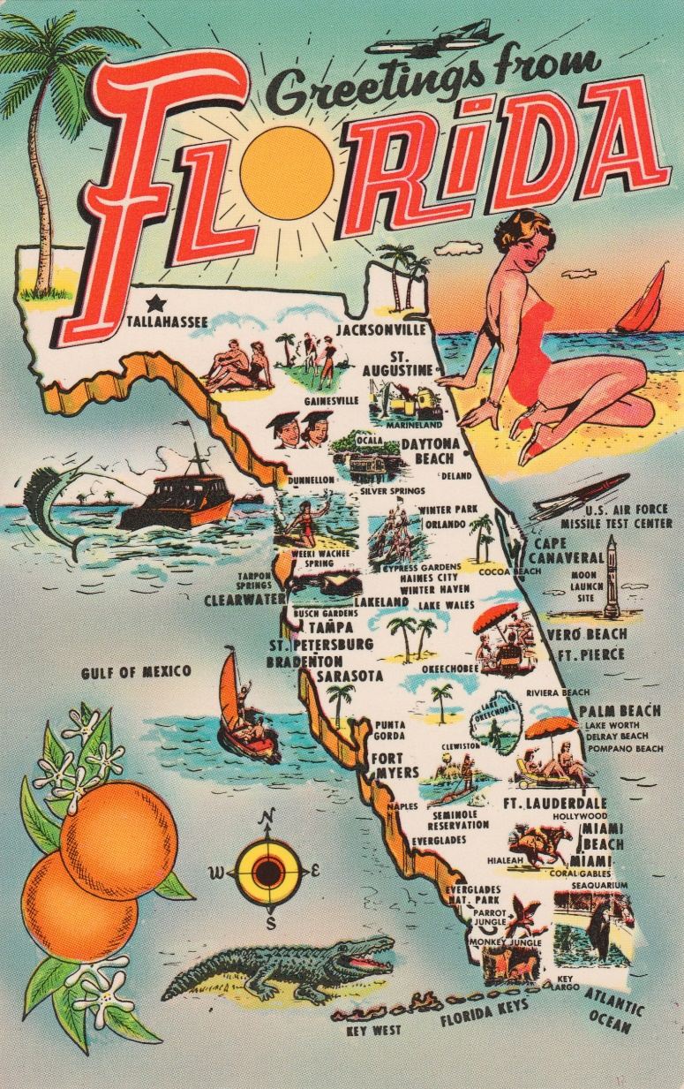

Abstract

Have you ever been to Florida? Have you ever wondered how many people visit per year? With so many places to visit in Florida it would be a surprise if you haven’t. This project will look at how the tourism industry impacts the state of Florida. This project was motivated by curiosity in the industry. Tourism is the number one provider of jobs for Floridians. It is also a major provider of tax revenue for cities, counties and the state of Florida. The tourism industry also has been on the rise, and has been one of the only industries in Florida that was not severely impacted by the recession in 2008. This Project will look at the comparison in GDP, employment, Visitors and many other factors that relate to the tourism industry. And Show how investing 10 million into the industry will benefit the state.

Introduction and topic selection

For this project I have decided to look at the state of Florida and in their hospitality and tourism industry. I started by looking at the top industries in the country as a whole. I found that from 1990-2013 the top industry in the United States went from manufacturing to health care across the country. This was interesting and in another project I may look into the rise of the health care industry or the decline of manufacturing, but since there is limited time and we are limiting to one state I continued to look at top industries by state. I looked at states I have lived, States I would like to visit and state I know nothing about. I looked Florida because I lived there last year while doing an internship at Walt Disney World. I found out that the top industries were international trade, Tourism, The Space industry, Agriculture, and Construction. I decided to narrow the search down to Tourism. I found that in 2011 Florida had 87.3 million visitors and tourism industry had an economic impact of $67 billion on Florida. I thought it might be interesting to investigate the different tourist destinations, see where the most impact is, as well as what might affect the industry. I planned to find tourism data to Florida. I selected this topic because I have an interest in working in this industry so knowing what drives it and what impact it has on the economy is interesting to me. What does Florida offer tourists? In Florida there are many tourist attractions, We can start with the beaches there are: Daytona Beach, Cocoa Beach, Miami Beach, West Palm Beach, Key West the list goes on. Then there is the major theme parks, starting with Walt Disney World, Universal, Busch Gardens, SeaWorld, Lego land and many other. Want to slow down a bit Florida offers 1,120 golf courses more than any other state, with the PGA tour plays at about 6 of those courses. On the Subject of the PGA Florida also has many sports teams from NCAA to Professional. There are 3 NFL teams (Miami, Tampa Bay, Jacksonville) , Two NHL teams ( Florida Panthers and Tampa Bay lightning, one MLS team in Orlando, two NBA teams (Miami Heat and Orlando magic), as well as two MBL teams ( Miami and Tampa bay) and don’t forget about Spring training that really brings in visitors. There are world renowned events that attract tourists, in Tampa Gasprilla attracts around 300,000 guests for a pirates party, the Bike week in Daytona beach that brings in 500,000 for a weekend.

Summary of the analyst workflow and results

I started by grabbing a lot of data that I thought would be useful. I began by looking at Employment in the tourism industry in Florida, then looking at visitors.

My first model was with gdp.

GDP= -4.64659E^10 + $62,411(tourism employment) +$274.34338 (visitors)-$43193(foreign visitors) -#-$41,727(domestic visitors) +$44,626(air arrivals) +$40,157(non air arrivals)

This models variables are not significant and therefore we may need to look at another model

But we do have a good R2 at.9916 or 99% of the model accounts for the variance in GDP

In 2015 toursim in florida employed 1,130,867 emplyoees

Conclusion and Discussion

Appendix

Link to github data

https://github.com/cocciajm01/cis512.git

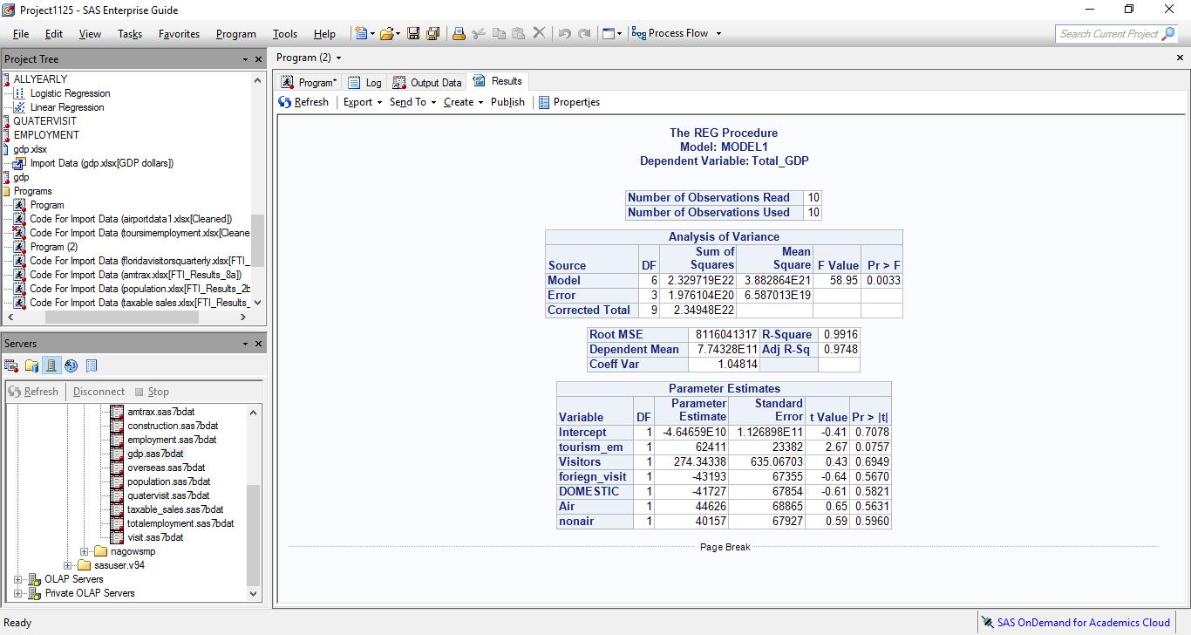Regression model 1



GDP vs Employment (tourism) 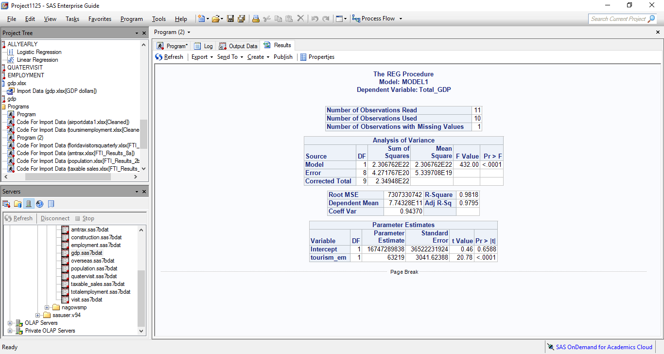

GDP vs Visitors

Emplyment by industry

