

Malware Case Study

Alejandro Panigada
CMP416: Advanced Digital Forensics
2025/26

Contents
1 Contents 3
2 Executive summary 6
3 Investigation plan 7
3.1 Methodology 7
3.2 Legal and Procedural Compliance 7
3.2.1 Chain of custody 8
3.3 Evidence Source Identification 8
3.3.1 Network Packet Capture 8
3.3.2 Memory Dumps for individual hosts 8
3.3.3 Firewall syslog dump 9
3.3.4 Malware files 9
3.3.5 Browser History for each host. 9
3.3.6 Prefetch files for each host 9
3.3.7 Registry Files for each host 9
3.3.8 Log files for each host 9
3.4 Investigation Workflow 9
3.4.1 Evidence Preparation 9
3.4.2 Initial Observations 9
3.4.3 Network Analysis 9
3.4.4 Memory Dump Analysis 10
3.4.5 Evidence Correlation and Final synthesis 10
3.4.6 Final reporting and documentation 10
4 Evidences and Analysis 11
4.1 Evidence Preservation 11
4.2 Network Forensics evidence 11
4.3 memory Forensics Evidence 11
4.4 Log Analysis 12
4.5 Browser History Analysis 13
4.6 System Logs 13
4.7 Registry 14
5 Findings and Conclusion 15
5.1 Timeline Reconstruction 15
5.2 Infection Vector 15
5.3 Malware Behavior 16
5.4 Indicators of Compromise 16
5.5 MITRE ATT&CK Framework Mapping 16
5.6 Impact Assessment 17
6 Analysis Limitations and Future work 19
7 Recommendations 20
8 References 21
9 Appendices 23
9.1 Appendix A - Screenshots 23
9.2 Appendix B – Scripts, code and Programs used 29

Executive summary
The IT Security team at Abertay University has detected unusual outbound network traffic from a staff workstation. The traffic appears to be communicating with multiple external IP addresses associated with known malware command-and-control (C2) servers.
The task to perform consisted in analyzing:
- A packet capture file from the affected host's network.
- A memory image from the university’s workstations.
- System logs from the university's perimeter firewall.
- A browser history export from the university’s workstations.

After analysis it was found out the presence of several indicators of compromise.
The first machine to be analyzed was a workstation machine of the company which clearly was infected by a credential harvester malware.
The damage to the company done is already high. Several credentials both belonging to the company and external to it were harvested including the public and private key which allows to read encrypted traffic or even impersonate the company itself.
Additionally, while there was no correlation, it was found out in network analysis the presence of high volume of traffic going towards a host located outside the network.
While there were 3 suspicious addresses, only 2 of them proved to be unreliable. One of them instead proved to be an update server from Microsoft with domain wdcp.microsoft.com. This information was found by inspecting the DNS records provided by the DNS servers.
The remaining addresses not found to be legitimate are:
- 4.250.18.209
- 2.20.12.70
Machines communicating with these addresses are the initially compromised WORKSTATION-768 host with address 192.168.4.10 and a corporate laptop, LAPTOP-142 with address 192.168.4.12.

Investigation plan

Methodology
The investigation adheres the methodology outlined in NIST special Special Publication “Guide to Integrating Forensic Techniques into Incident Response”.

The methodology consists of these steps:
- Preparation
Consisting of setting up initial workspace
- Identification
Consisting in initial identification of gathered evidence
- Preservation
Consisting in ensuring integrity of gathered evidence files
- Collection
Consisting in examination of how data was gathered
- Examination
Usage of forensics tools and knowledge to extract relevant data from evidence
- Analysis
Analysis of data to identify attacker/malware activity
- Presentation
Reporting of findings to stakeholders

Legal and Procedural Compliance
The investigation adheres to the ACPO principles found in the “Good Practice Guide for Digital Evidence(ACPO,2012).

The guide includes 4 key principles:
- No action should change data on a computer or storage media
- Where access to original data is necessary, that person must be competent
- An audit trail must be created and preserved
- The person in charge of the investigation has overall responsibility
Compliance was achieved by:
- Preserving original data in read only mode
- Hashing all original evidence using SHA-256 hashes
- Maintaining a log of all interactions done with the data
- Maintain a working copy rather than working on the originals
- Tools used and interactions made with them recorded
- Chain of custody

Chain of custody
Date/Time | Evidence Item | Action | Performed By | Location
November 23,2025 9:02 PM | Evidence Package | Uploaded | Sean Sturley | Online
November 24, 2025 2:41 PM | Evidence Download | Downloaded package | Alejandro | Online
December 2, 2025, 12:08 PM | Evidence unpacked | Extracted evidence from package | Alejandro | Locally on investigator Personal Computer
December 3, 2025, 3:00 PM | Evidence copied | Created a working copy and temporary working folder for temporary artifacts | Alejandro | Locally on investigator Personal Computer

Evidence Source Identification

Network Packet Capture
Among the evidence provided, the Network_capture.pcap file contains a general capture of the network to be analysed.

Memory Dumps for individual hosts
Each host comes with a memory dump saved in the memory folder as memory.bin

Firewall syslog dump
A firewall dump of the syslog service, containing all the incoming and outgoing traffic from the network, is provided alongside the other evidence.

Malware files
Extracted malware related files from each host

Browser History for each host.
All the browser history files from Edge browser are provided for each host.

Prefetch files for each host
Windows prefetch files are included as well, allowing for additional data recovery if needed regarding executable files.

Registry Files for each host
Registry files are provided from the hosts Windows operating system.

Log files for each host
Windows operating system logs are as well provided among the evidence, allowing for inspection of what happened on the machines while they were active on the network.

Investigation Workflow

Evidence Preparation
First, a working copy of the evidence was made. Then a tool directory with all the used tools to keep track of file interaction was created as well. This was made both because of integrity in the chain of custody and to be able to provide information for replicating the investigation.
All files had a sha256 hash calculation for preservation and integrity maintenance.

Initial Observations
The copied files were then opened to test whether they were corrupted and also to initially check most apparent information first.
For example the packet capture was opened in Wireshark and an initial engagement revealed browser activity from specific hosts in form of DNS requests.
Also,WORKSTATION-758 was the first machine marked for analysis because of it being the most obvious machine being affected by the malware.

Network Analysis
Network analysis was the first step to be conducted after WORKSTATION-758 memory analysis. This was done to have a more general idea about which of the other hosts might be compromised through analysis of network activity. This was needed to better prioritize which hosts will be analysed first in subsequent memory analysis.

Network_capture.pcap
First, network analysis was conducted using the provided pcap file.
The main tool used for analysis was Wireshark. Wireshark provides several features to track individual streams of data exchanged across the network and they are very efficient to filter out traffic by using several filters.

Syslog
The syslog file was analysed mainly by using grep on both powershell and Linux WSL.
The analysis goal for this file was to have a general idea on how the traffic flowed both inside and going outside the network.
The very compact and specific structure of the file allowed for easy filtering and summarization of the traffic.

Memory Dump Analysis
Memory dump analysis was conducted using volatility3 on all hosts.The first machine to be analysed was the most obviously compromised machine: WORKSTATION-758.

Evidence Correlation and Final synthesis
After extraction of files from different sources, correlation between the different pieces of evidence was performed.

Final reporting and documentation
Reporting and documentation was performed after collection and analysis of all evidence.
Important evidence artifacts were included in the report by adding screenshots of them in Appendix A .
Sripts and tools run are found inside Appendix B. All tools used are found in references with their version.

Evidences and Analysis

Evidence Preservation
All the evidence was preserved by setting up original data to read only access and work was conducted only on copies stored to a different location. SHA256 hashes were calculated for each file and put into a text file.

Network Forensics evidence
In the network_capture.pcap file, by using Wireshark filters, 1 host had the most suspicious traffic due to high volume of data transferred both inside and outside the local network.
Initially, both the addresses 172.187.46.136 and 4.250.18.209 had no apparent owner when performing reverse lookup of the IP addresses.
After packet capture inspection and statistical flow analysis has been performed using Wireshark,
Only one out of two hosts with high packet traffic proved to be unreliable:
4.250.18.209- Unknown DNS record after performing a reverse lookup. No owner found, highly suspicious.
The other address,172.187.46.136, after checking the entire DNS exchange from the pcap, it was found to be related to the wdcp.microsoft.com domain responsible for system updates on Windows. This made the host reliable and explained as well the amount of traffic flowing inside and out of the network.
Tshark and Silk were attempted to be used to improve statistical analysis. but the pcap file provided was truncated making both tools output errors when analyzing them.

memory Forensics Evidence
The machines memory dumps to be analyzed were 4:
- LAPTOP-142
- DESKTOP-500
- WORKSTATION-758
- PC-491
The first machine to be analyzed was WORKSTATION-758 due to be the most obvious infected machine as found out in the Evidence inspection.
The type of malware seems to be a credential stealer as provided files seems to have indicated.
The malware artifacts were 4:
- Update.exe
- Update.dat
- Export.log
- PSHistory.txt
These artifacts indicate that credentials were exported and sent to the domain paste-bin-clone.com.
No evidence of such host seems to be present inside the pcap file possibly indicating that network capture was performed after the upload.
The log indicates data encoding before sending, meaning that exfiltrated data might have been encoded in a specific format before being sent.
All the other machines did not come with malware artifacts other than ps1 scripts which disables realtime monitoring from the Antivirus Software Windows Defender.
Memory dump from LAPTOP-142, which initially was deemed to contain a rootkit because of a suspicious process in the windows.pslist output from volatility, it was found instead it was corruption of the DumpIt.exe capture (See Appendix A Figue 1.1-1.2)
To verify this, it was performed any possible action, such as process carving, file dumping, process dumping and malfind malware analysis, but both the failure of every tool and the online literature about DumpIt.exe corruption artifacts, took away some suspiciousness on this machine. Memory and registry corruption was present in the LAPTOP-142 evidence as well registry for other hosts.
Since no clear way to identify what is corrupted and what instead is intended by the malware, the work is marked for future analysis in the analysis limitation and future work section.
Memory forensics was used as well as validation of provided evidence.
This means that network files provided among the evidence was compared to what could be extracted from the memory dumps to further verify integrity.

Log Analysis
Firewall logs in the form of a syslog file, was analyzed by using grep (See Appendix B 1.1) in order to sort out which IP were the most accessed. This was done prior to the memory forensics phase, but after the network forensics phase.
It was found that the pcap file does not correlate perfectly to the syslog dump.
For example, 2.20.12.70 was a host that surpasses by far all previously found hosts in terms of amount of packets sent and received in and out of the network.
The amount of packet sent to this IP was on its own more than 7000.
And yet, the pcap file does not contain any trace of the exchanges.
By performing reverse look up, the host revealed to be an Akamai CDN, which after a research appears it could to be used by Microsoft for delivering Windows Updates.
However, there is no way to ascertain it as not even the memory dumps indicate such connection to happen.
This record can indicate a possible time mismatch of when the pcap file was created and packet capture performed compared to when the syslog file was dumped.
It can also indicate that network capture integrity is not verifiable as both pcap and dumpit.exe images were corrupted as well (See Appendix A figure 1.1 and Figure 1.2 and Figure 1.6)
Out of the two hosts found during the network_capture.pcap analysis, only one appears on the firewall log, suggesting again that timing of the two artifacts was not the same.
In total there is only 1 IP addresses that syslog.log indicates might be a C2 beaconing case:
2.20.12.70– This IP from Akamai CDN had a number of packets both in and out the network of over 7000 making it suspicious. It also is not listed among the DNS queries and reverse lookup does not confirm the existence of an owner.

Browser History Analysis
Browser History files provided had only few URL visited and no difference was found in any of the browser history for each hosts. However, during network analysis, several DNS requests were found in the Pcap file. The browsing activity was verified by filtering DNS only requests and sorted by destination IP. This lists all the DNS answers for each host. No suspicious traffic was detected. However, the type of URL visited might suggests unsafe behavior inside the corporation compromised.
Most of the DNS requests were for E-Commerce sites, or others company and work unrelated websites.
This could lead to possible infiltration from malware if no filter is applied to incoming and outgoing traffic.

System Logs
System Logs were analyzed and artifacts in form of ps1 scripts being executed are found in all hosts.
The only host which had execution of malware related activities was WORKSTATION-758.
All the hosts had executed dumpit.exe alongside an evidence collection script called “collect_hostname.ps1” where hostname is the name of the host. For example collect_WORKSTATION-758.ps1 was executed to collect evidence on WORKSTATION-758.
A script named credential_stealer.ps1 was used execute malware on WORKSTATION-758.
All the hosts had executed as well:
- Automated_browsing.ps1
Random browsing for 10 seconds
- Config_ForensicsLabS777_hostname.ps1

Lab configuration script
- Network_config_Windows10_template.ps1

Networking automated configuration.

Registry
Registry files were checked manually using Registry Explorer v.2.1.0.
Some records were corrupted, especially in the registry file of LAPTOP-142, and some record of Antivirus disabling appeared among some registry files. Those findings helps validating what was found in the other analysis of other components but nothing new appeared during analysis.
For example, no program was set to run on startup or no evidence seems to have been altered by malware. (See Appendix A Figure 1.3)

Findings and Conclusion

Timeline Reconstruction
All machines follow the same pattern. After turning on they operate for some seconds/minutes. Then powershell scripts run to configure network.
After doing so a powershell script for automated browsing is launched.
Before that happens for all hosts, WORKSTATION-758 runs a malware script from drive Z which is responsible for deploying malware inside the host.
After all scripts are executed, the incident plan team dumps all artefacts using collection scripts, which then are provided to the investigator.
After collecting artefacts, dumpit.exe is run on every host to obtain a memory dump file.

This is instead the complete timeline recovered from the provided malware files in WORKSTATION-758:

02:16:03 - Credential harvesting initiated (update.dat timestamp)
02:16:04 - update.exe created (credential dumper deployed)
02:16:05 - Windows Defender disabled (PSHistory.txt: Set-MpPreference)
02:16:05 - Credentials collected:
02:16:05 - Data encoded for exfiltration (export.log)
02:16:05 - Upload to paste-bin-clone.com/dump/a7d9e2f1
02:16:05 - Upload complete (confirmed in export.log)
02:16:05 - Trace cleanup attempted

Infection Vector
The infection vector was an executable named “update.exe”, a credential stealer which executed using powershell.

Malware Behavior
The malware behavior consisted in first turning off the Antivirus Software Windows Defender real time analysis feature and then dumped credentials around the machine as can be seen in Appendix A Figure 1.7.
As seen in Figure 1.8, the malware then reports encoding of the data before sending it out to the domain “paste-bin-clone.com”.
The precise upload of the data was not found among the traffic.

Indicators of Compromise
Indicators of compromise are found in PowerShell.evtx .log file (See Appendix A Figure 1.7 and Figuree 1.8) as well among the evidence provided by the incident team (See Appendix A Figure 1.9 – 2.1)

MITRE ATT&CK Framework Mapping
Execution:
T1059.001 - Command and Scripting Interpreter: PowerShell
Evidence: credential_stealer.ps1 executed on WORKSTATION-758
Impact: Malware deployment platform

Defense Evasion:
T1562.001 - Impair Defenses: Disable or Modify Tools
Evidence: Windows Defender disabled via Set-MpPreference (PSHistory.txt)
Impact: Real-time malware detection circumvented

T1070.004 - Indicator Removal: File Deletion
Evidence: "Cleaning up traces" (export.log)
Impact: Anti-forensics employed

Credential Access:
T1555.003 - Credentials from Password Stores: Web Browsers
Evidence: 9 browser passwords (Chrome: 5, Edge: 2, Firefox: 2)
Impact: Banking, email, GitHub, LinkedIn credentials compromised

T1555 - Credentials from Password Stores
Evidence: 6 Windows credentials including VPN (update.dat)
Impact: Remote network access capability

T1003.002 - OS Credential Dumping: Security Account Manager
Evidence: 3 NTLM hashes (Administrator, Guest, labuser)
Impact: Pass-the-hash lateral movement enabled

T1552.004 - Unsecured Credentials: Private Keys
Evidence: SSH private key (id_rsa) stolen
Impact: Passwordless server access to 3+ systems

Collection:
T1005 - Data from Local System
Evidence: 28 credentials collected in <2 seconds
Impact: Comprehensive credential compromise

Exfiltration:
T1567 - Exfiltration Over Web Service
Evidence: Upload to paste-bin-clone.com/dump/a7d9e2f1 (export.log)
Status: "Upload complete" confirmed
Impact: All stolen credentials successfully exfiltrated

Impact Assessment
The impact is severly high. Several credentials were stolen and even cryptographic private and public keys were uploaded to the attacker controlled host.
Immediate isolation from the network is required for host 192.168.4.10.
Windows Defender was shut down across all machines. It should be reactivated.
It also is not certain that this is malware activity but the network capture and syslog files marks suspicious connection from several local hosts to addresses 2.20.12.70 and 4.250.18.209 . Machines such as 192.168.4.12 should be isolated and examined closer.

Analysis Limitations and Future work

In memory dumps such as in the case of 192.168.4.12, several locations in registry, memory and process list displayed corruption in the form of what might at first be exchanged for a ghost/hollow process from a rootkit.
It is not clear whether this is the case but all kind of analysis were attempted on the memory dump and registry files showing corruption and failed in all types of operations. This means that no dumping of the process or any access to any information using the pslist PID belonging to the process was successful.
It is suspected this is corruption of the memory image created by dumpit.exe itself.

Recommendations

The following recommendations are given:
- Immediate change all affected credentials, including private and public key.
- Isolate WORKSTATION-758 and replace the instance with a clean one
- Isolate hosts communicating with suspicious IPs outside the network
- Host 192.168.3.12/LAPTOP-142 should be checked whether memory.bin memory dump is corrupted or whether the memory corruption found belongs to a rootkit
- Reactivate Windows Defender across all machines as malware has turned it off

References
Association of Chief Police Officers (2012) ACPO good practice guide for digital evidence. 5th edn. London: Association of Chief Police Officers.

Belkasoft (2024) DumpIt (version 3.0) [Computer program]. Available at: https://www.belkasoft.com/get (Accessed: 23 November 2025).

Canonical Ltd (2024) Ubuntu (version 24.04 LTS) [Operating system]. Available at: https://ubuntu.com/ (Accessed: 23 November 2025).

Combs, G. (2024) tshark - dump and analyze network traffic [Command-line tool]. Wireshark 4.2.0.

Free Software Foundation (2023) grep - print lines that match patterns [Command-line tool]. GNU Grep 3.11.

Google LLC (2024) Google Chrome (version 120) [Web browser]. Mountain View, CA: Google LLC.

Kent, K., Chevalier, S., Grance, T. and Dang, H. (2006) Guide to integrating forensic techniques into incident response. NIST Special Publication 800-86. Gaithersburg, MD: National Institute of Standards and Technology.

Microsoft Corporation (2021) Windows 10 (version 21H2) [Operating system]. Redmond, WA: Microsoft Corporation.

Microsoft Corporation (2024) Microsoft Edge (version 120) [Web browser]. Redmond, WA: Microsoft Corporation.

MITRE Corporation (2024) MITRE ATT&CK® framework. Available at: https://attack.mitre.org/ (Accessed: 20 December 2025).

The Volatility Foundation (2024) Volatility 3 (version 3.2.0) [Computer program]. Available at: https://github.com/volatilityfoundation/volatility3 (Accessed: 23 November 2025).

The Wireshark Foundation (2024) Wireshark (version 4.2.0) [Computer program]. Available at: https://www.wireshark.org/ (Accessed: 23 November 2025).

Zimmerman, E. (2024) Registry Explorer (version 2.1.0) [Computer program]. Available at: https://ericzimmerman.github.io/#!index.md (Accessed: 23 November 2025).

Appendices

Appendix A - Screenshots
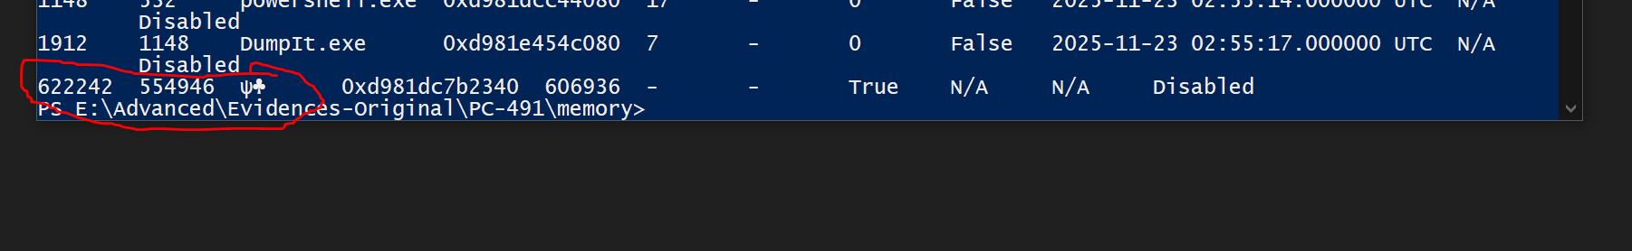
Figure 1.1

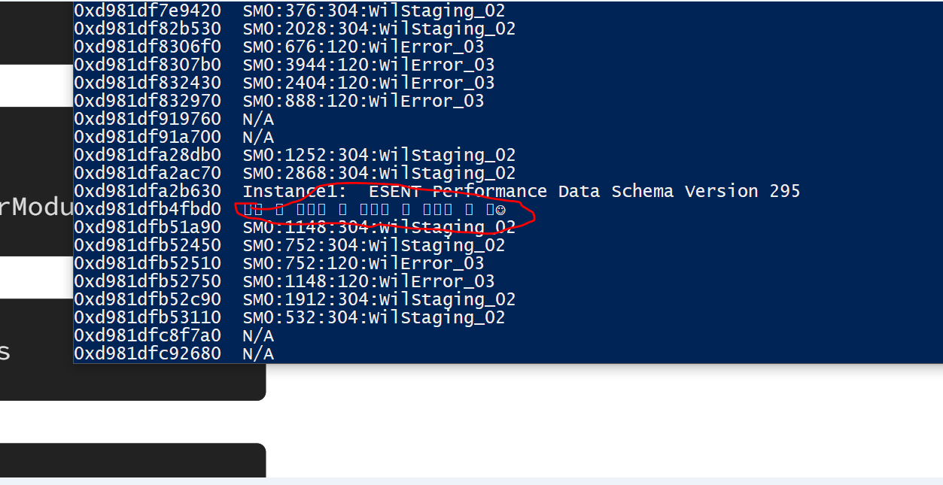
Figure 1.2
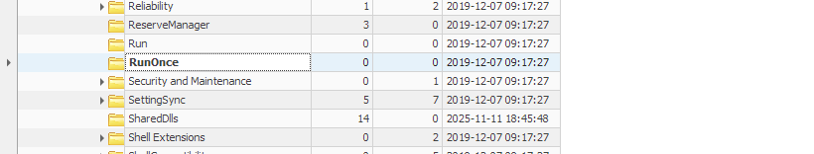
Figure 1.3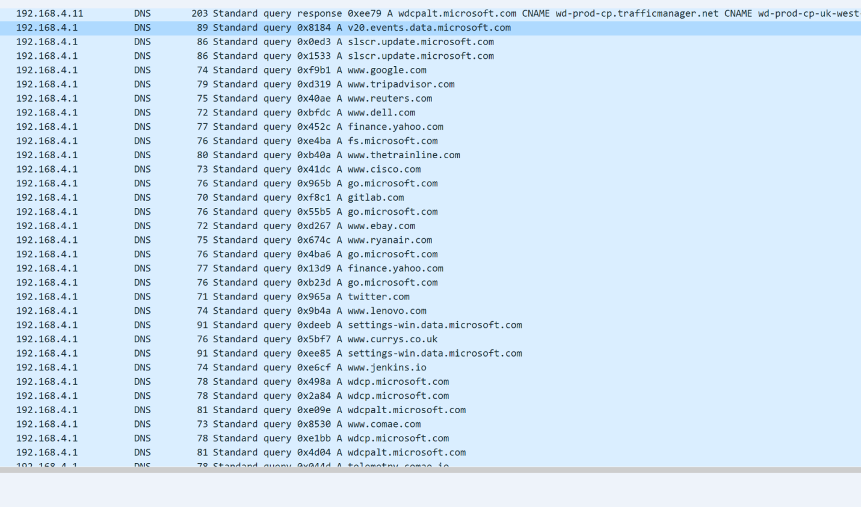
Figure 1.4
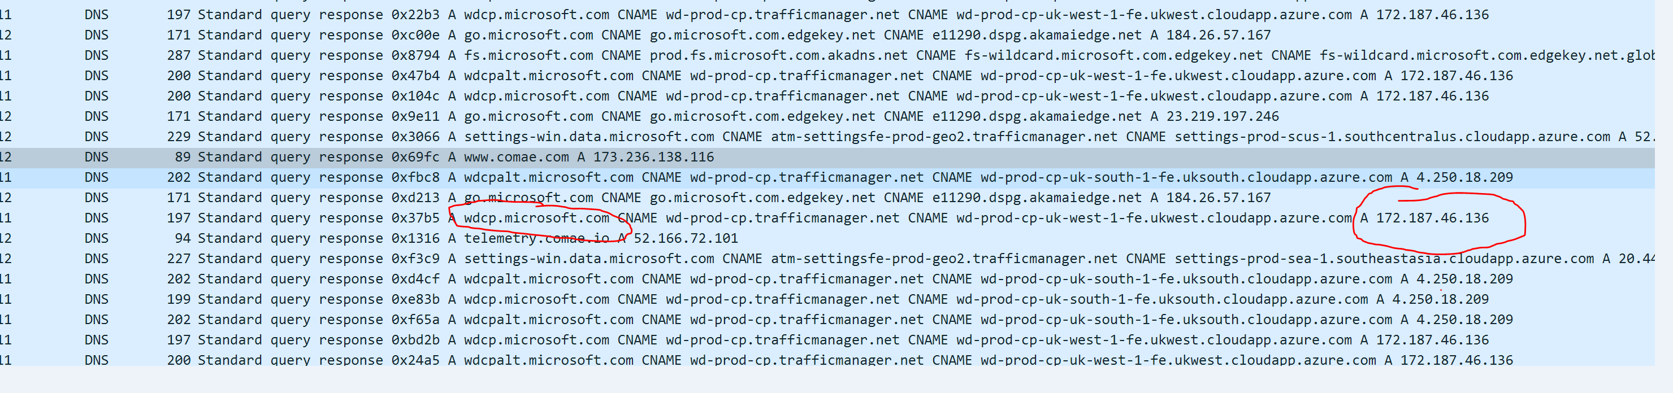
Figure 1.5

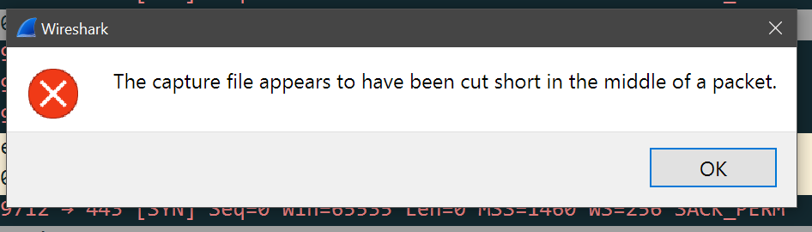
Figure 1.6

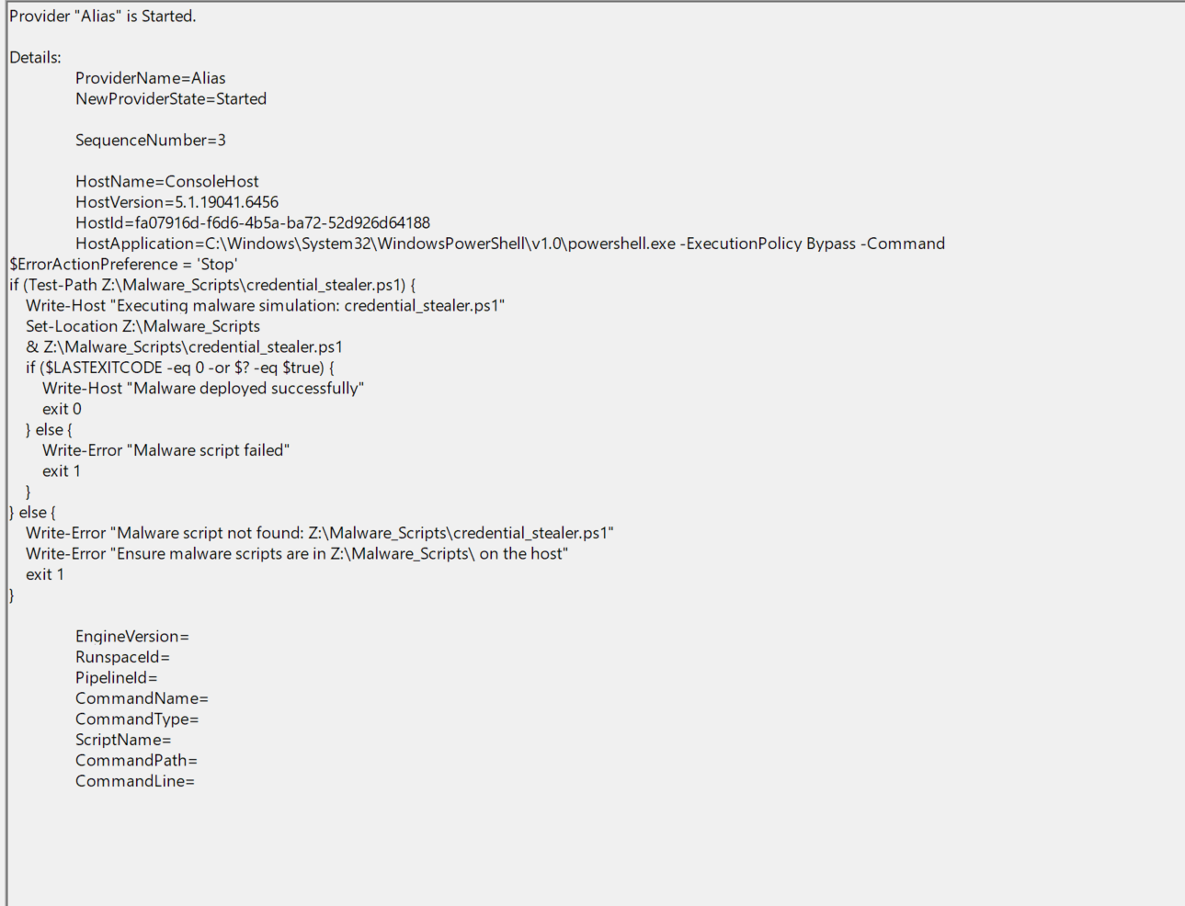
Figure 1.7

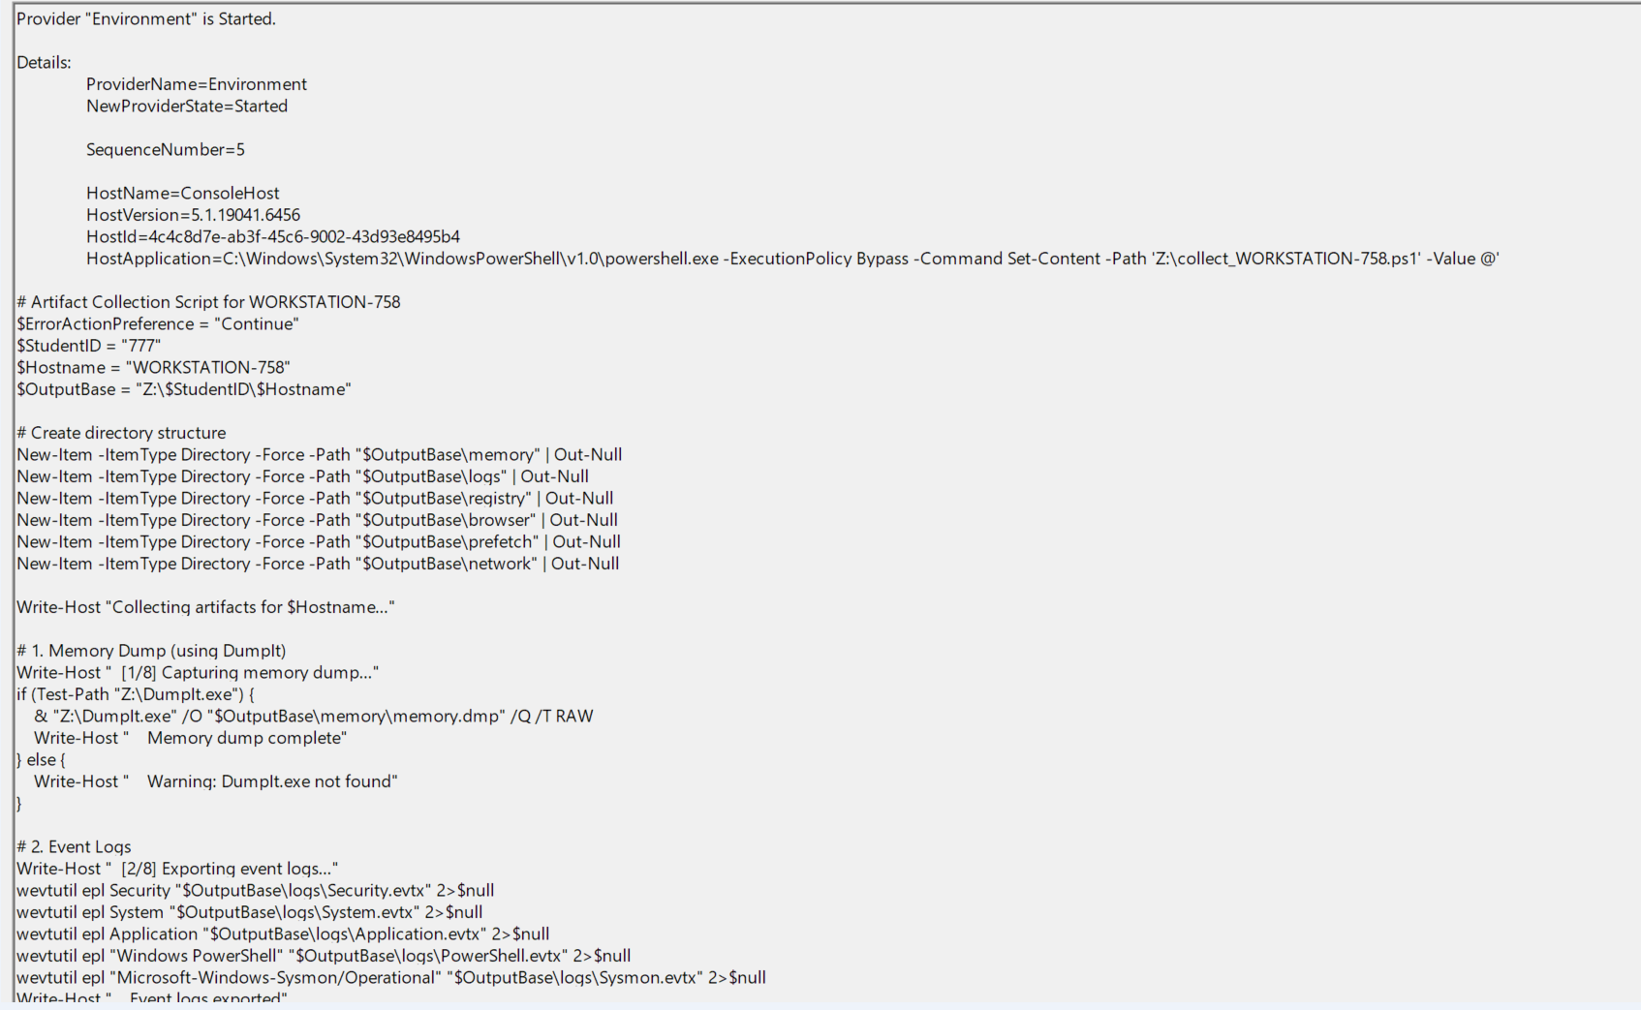
Figure 1.8

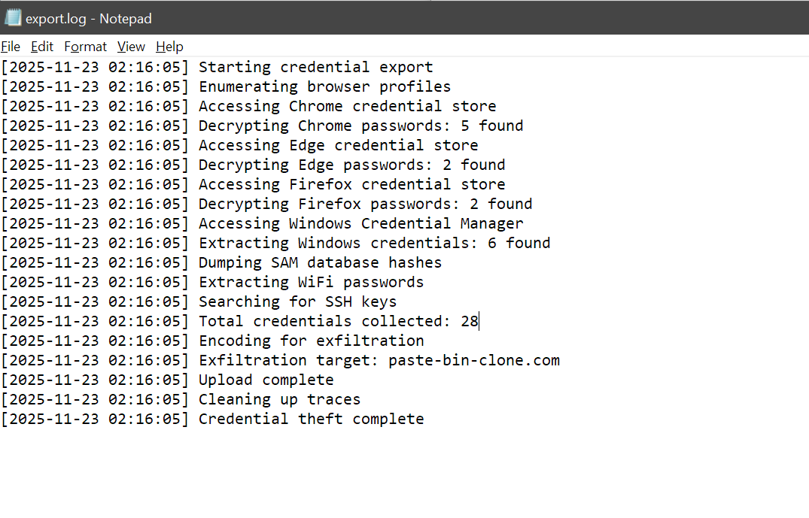
Figure 1.9

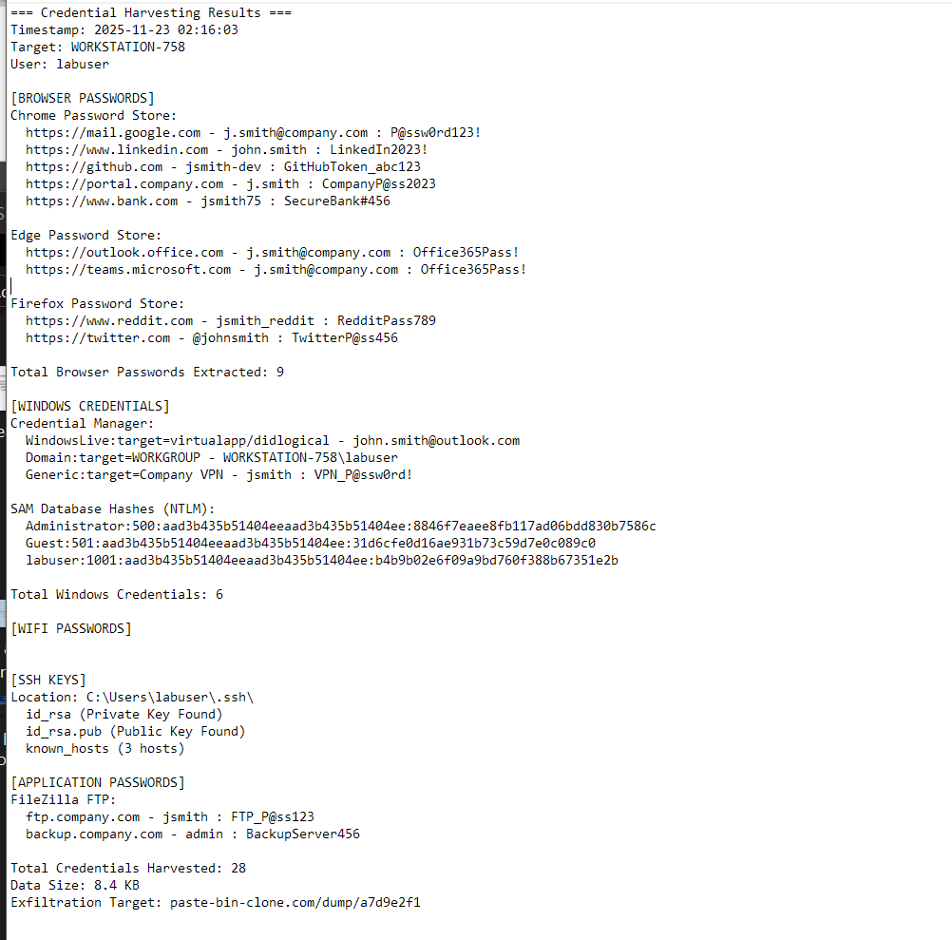
Figure 2.0

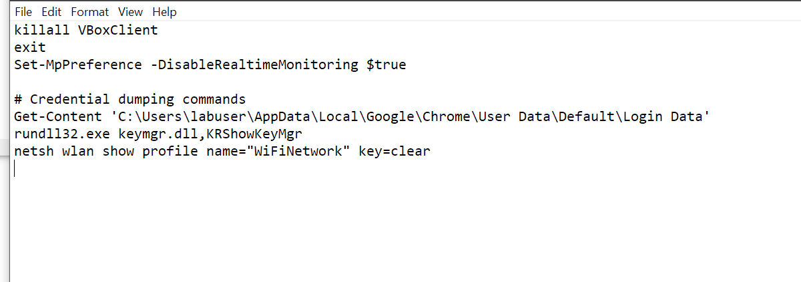
Figure 2.1

Appendix B – Scripts, code and Programs used

grep "[FORWARD]" syslog.log | grep -oP "DST=\K[0-9.]+" | sort | uniq -c | sort –rn
Results:
7201 2.20.12.70 (Akamai CDN - Windows Update distribution)
3900 192.168.4.12 (WORKSTATION-758 primary victim)
3632 192.168.4.10 (LAPTOP-142 affected host)
415 172.187.46.136 (Microsoft Azure - wdcp.microsoft.com)
244 4.250.18.209 (Level 3/Lumen ISP transit)
  - Syslog Analysis Bash command and output

"dns == 172.187.46.136"
  - Wireshark Microsoft Telemetry DNS request filter
vol.py -f HOSTNAME/memory/memory.bin windows.pslist
vol.py -f HOSTNAME/memory/memory.bin windows.psscan
vol.py -f HOSTNAME/memory/memory.bin windows.pstree
vol.py -f HOSTNAME/memory/memory.bin windows.malfind
vol.py -f HOSTNAME/memory/memory.bin windows.malware.processghosting.ProcessGhosting
vol.py -f HOSTNAME/memory/memory.bin windows.memmap
vol.py -f HOSTNAME/memory/memory.bin windows.psxview
vol.py -f HOSTNAME/memory/memory.bin windows.netscan
vol.py -f HOSTNAME/memory/memory.bin windows.filescan
vol.py -f HOSTNAME/memory/memory.bin windows.nestat
  - Top 10 Volatility commands used for each host

find ../* -type f -exec sha256sum {}

1.4 Bash command used to hash all evidence

